|  |  |
| --- | --- |
| Columns | Description |
| 1-22 | X coordinates of 22 body joints. |
| 23-44 | Y coordinates of 22 body joints. |
| 45-66 | Z coordinates of 22 body joints. |
| 67-70 | surface electromyography from right and left lumbar paraspinal (lower back) and right and left upper trapezius (upper back) muscles. |
| 71 | exercise type 1: One-leg-stand,  2: Reach-forward,  3: Bend,  4: Sit-to-stand,  5: Stand-to-sit,  6: Sitting still,  7: Standing still,  8: Walking,  0: Others |
| 72 | pain level 0: Healthy,  -1: Not reported (only for the patients),  1: Low-level pain,  2: High-level pain |
| 73 | Protective behavior (merged) label 0: Not protective,  1: Protective |
| 74-78 | Protective behavior type 0: negative, 1: positive  74- Guarding/Stiffness  74- Hesitation  76- Support/Bracing  77- Abrupt motion  78- Rubbing/Stimulation |
| 79-91 | 13 angles of 22 body joints. |
| 92-104 | 13 energy of the angles (square of the angular velocity) |



**Figures 1**. 1-22 body joints

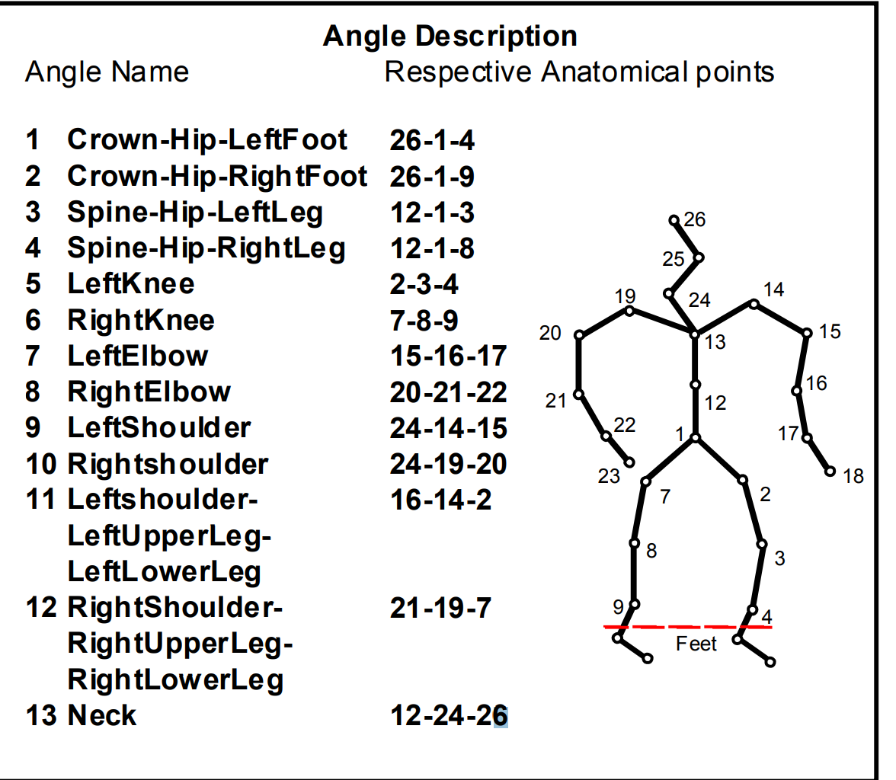

**Figures 2**. 13 angles

Paper link: https://ieeexplore.ieee.org/document/8925084