**EXPERIMENT-4**

**NAME:** SHAIKH MUBASHIRA TUFEL AHMED

**ROLL NO:** 612055 **COURSE:** ADVANCE DEVOPS(ITL504)

**BRANCH:** T.E. INFORMATION TECHNOLOGY (SEM 5)

1. **What is NO SQL, key value Databases?**

**🡺**All those databases which are modeled in means other than the tabular relations used in relational databases are known as NO SQL databases.NoSQL key-value databases are the least complicated types of NoSQL databases. They store data as a key or attribute name with its value. Each data item has a pointer and a unique key. The key-value pairs are in the form of rows of associative arrays.

1. **Create a Table in DynamoDB , Add items to the table (minimum 10 items) , Query the table .**

**Step 1: AWS Management Console Dashboard.**

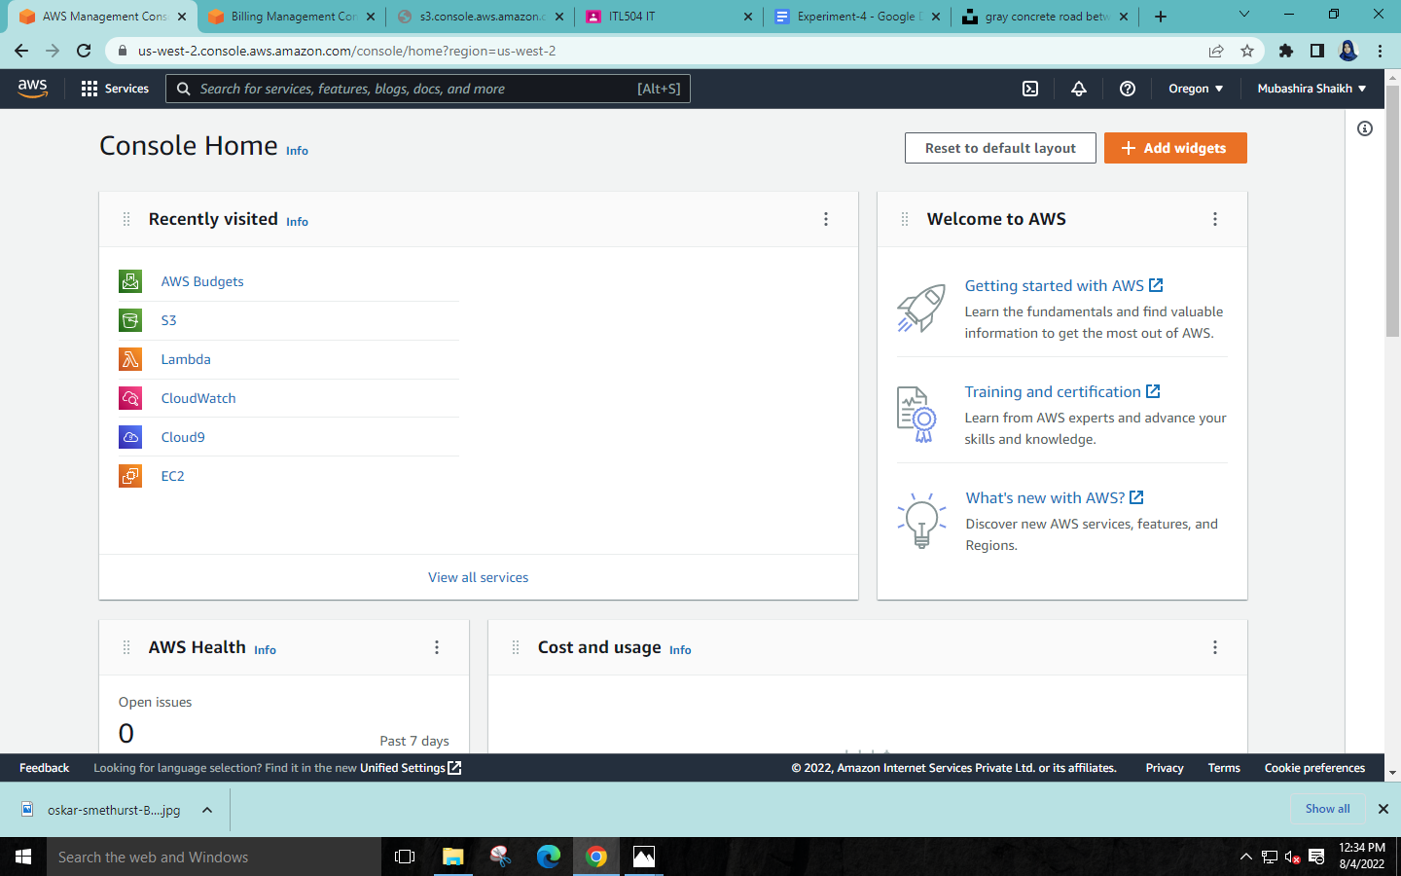

**Step 2: Search for DynamoDB and select it.**

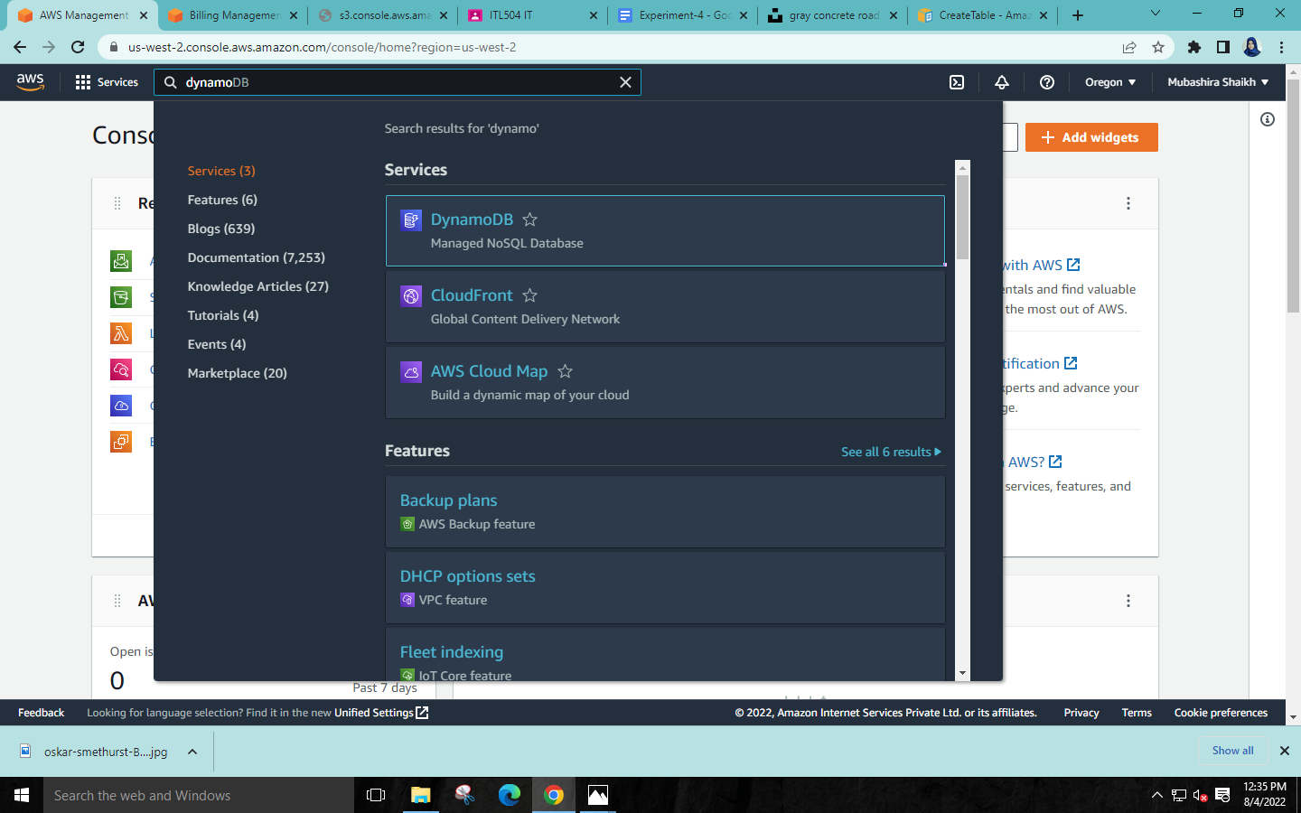

**Step 3: Click on ‘Create Table’.**

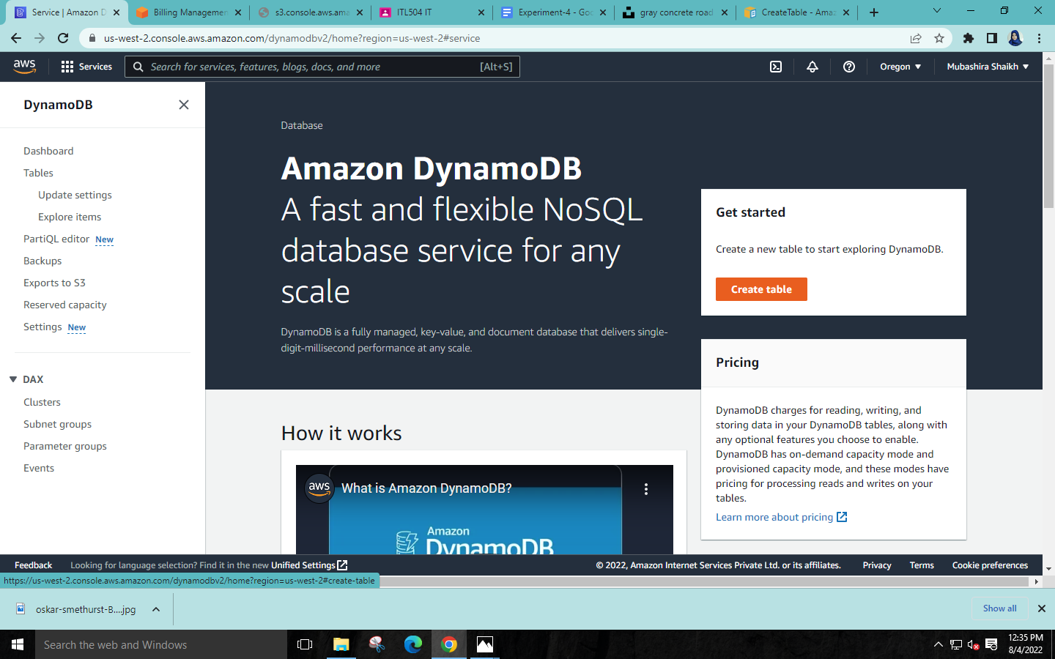

**Step 4: Name your table🡪set ‘Partition key’ & ‘Sort key’🡪select Default setting🡪Click on Create Table.**

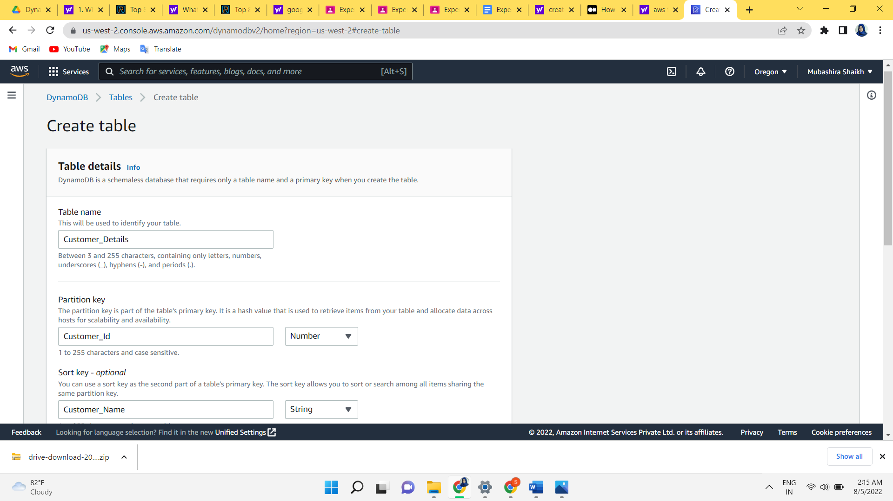

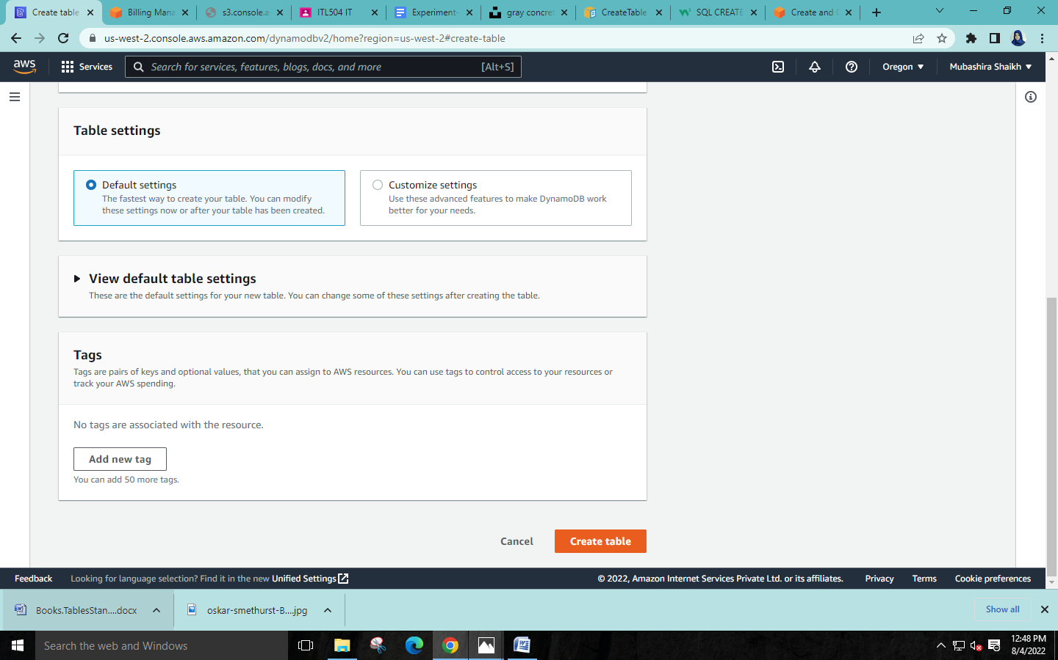

**Step 5: Table Created Successfully! From here select the blue link**

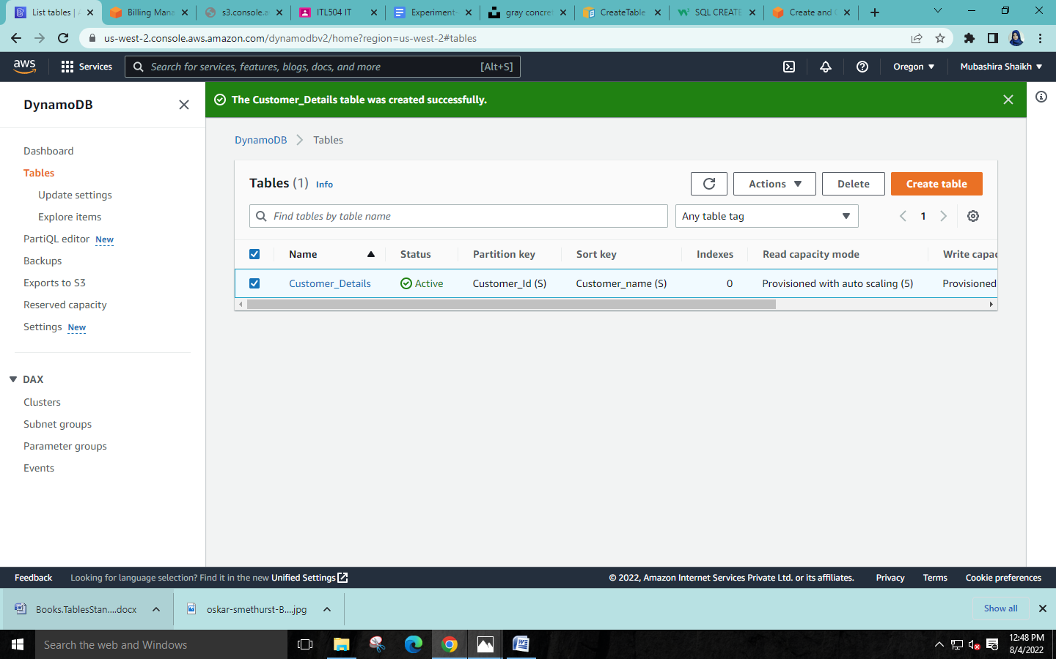

**Step 6:Click on “Explore table item”🡪”Create item”**

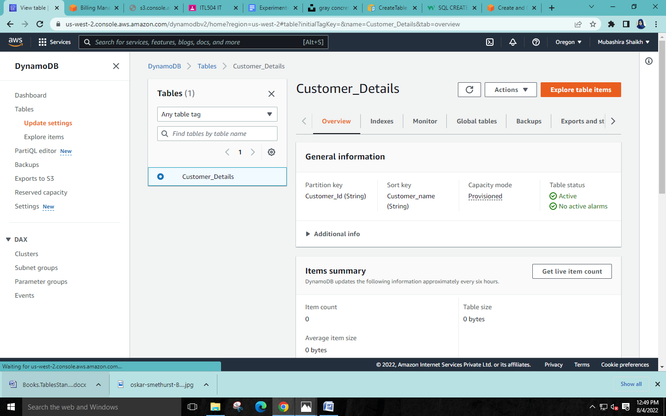

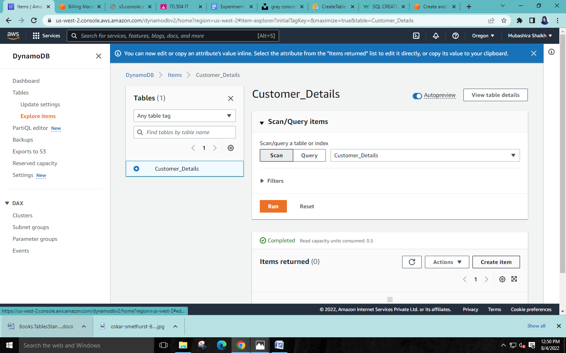

**Step 7:Add new attributes if required🡪Click on “Create item”**

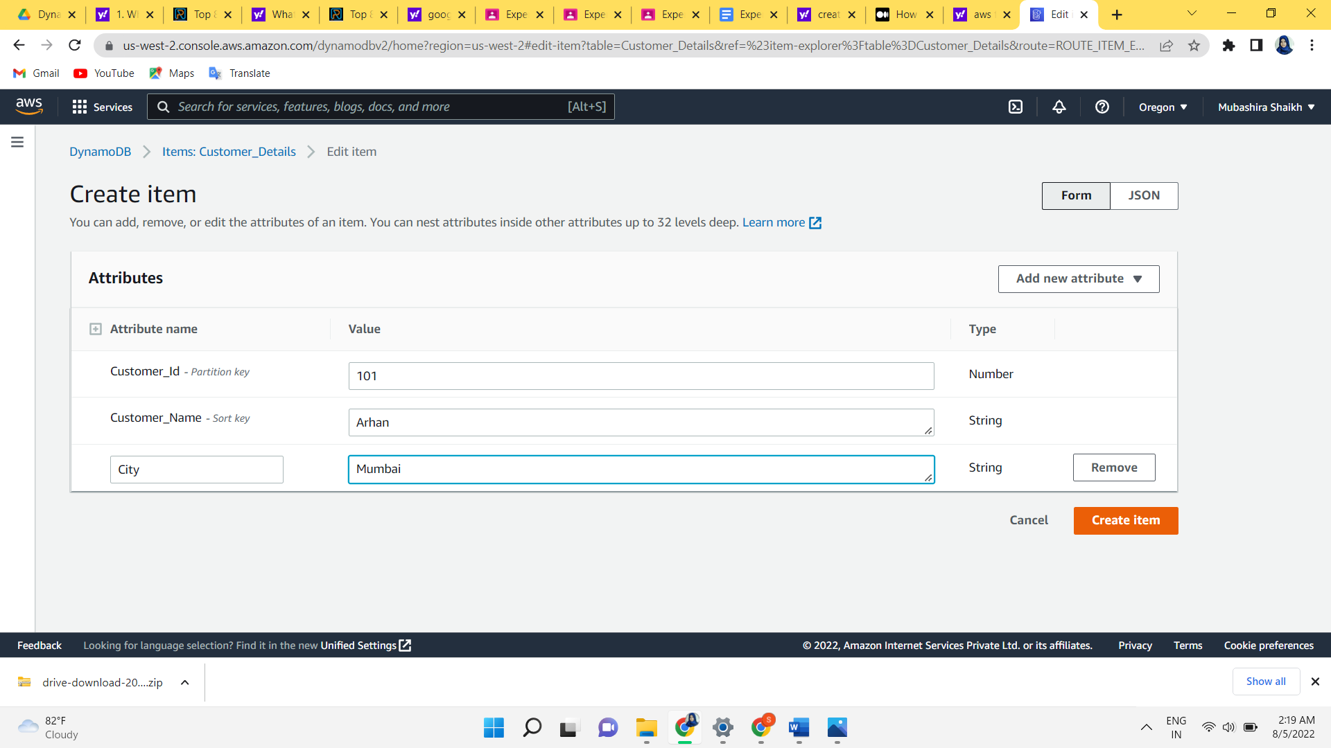

**🡪After entering each item select the “Create item” button and repeat the process until you are finished.**

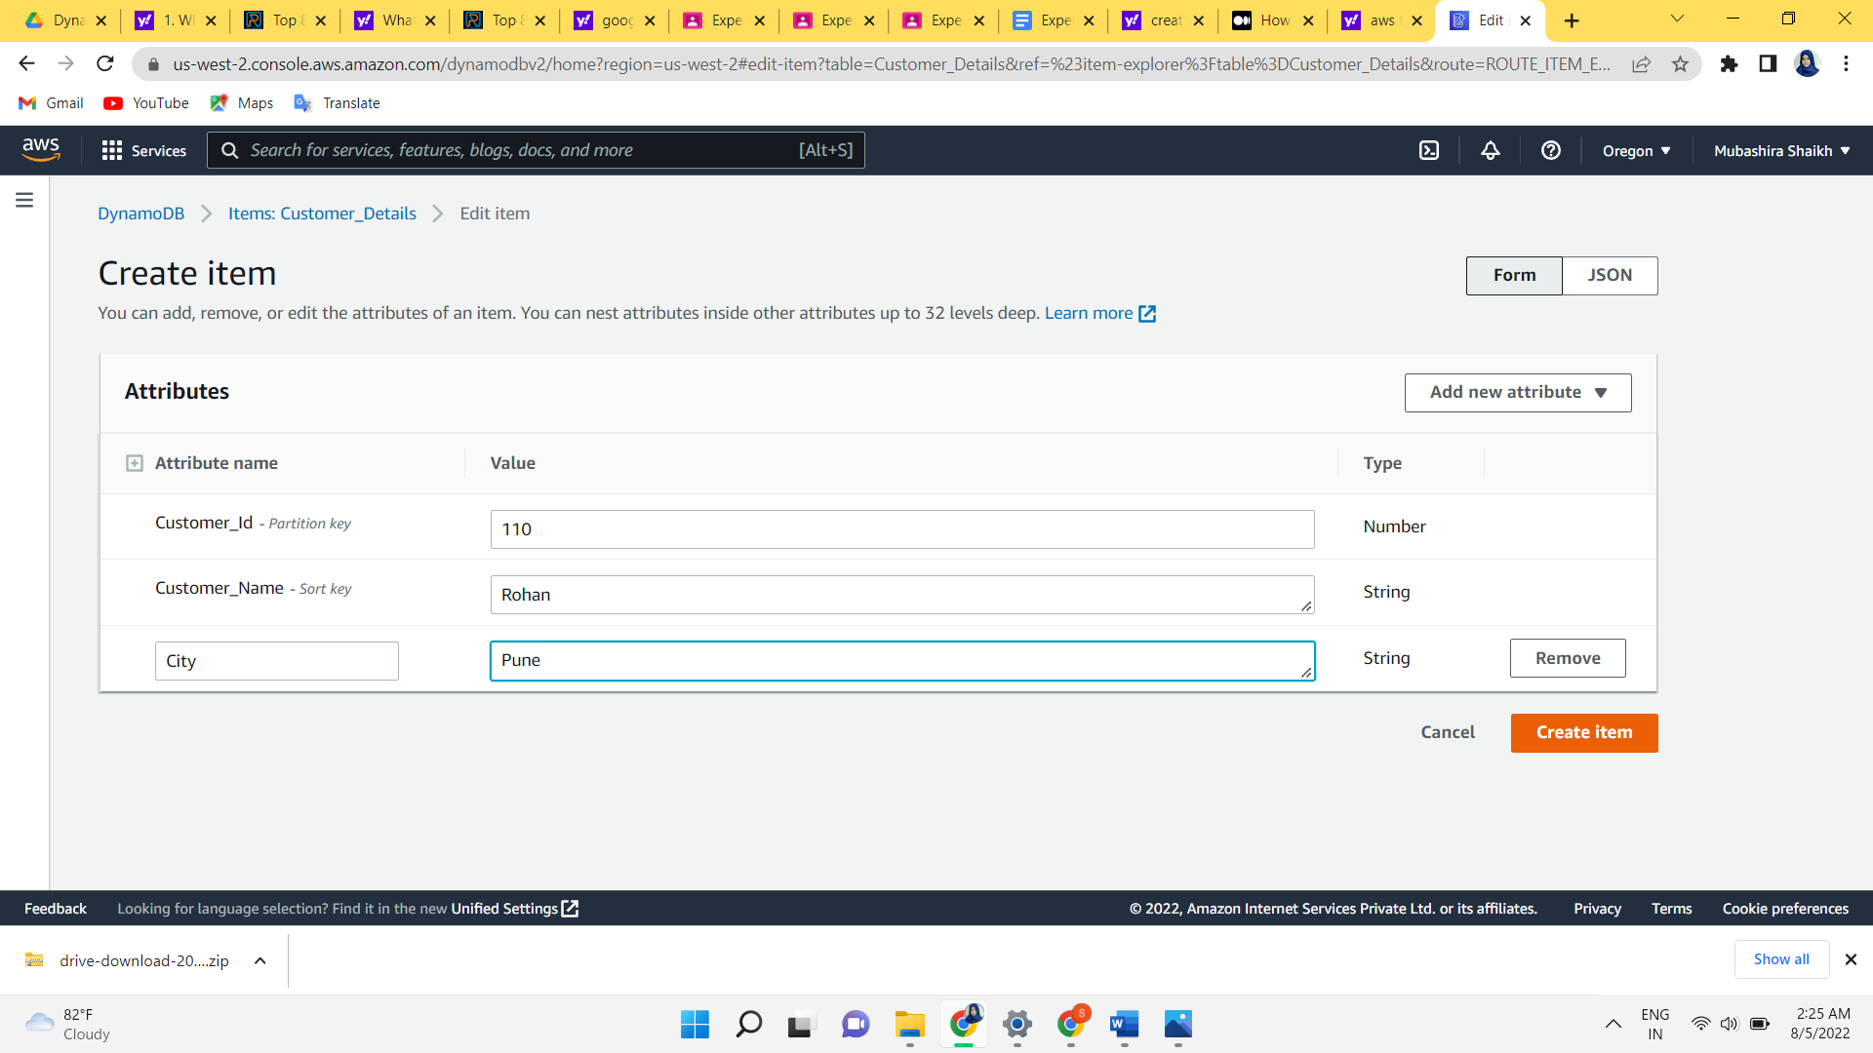

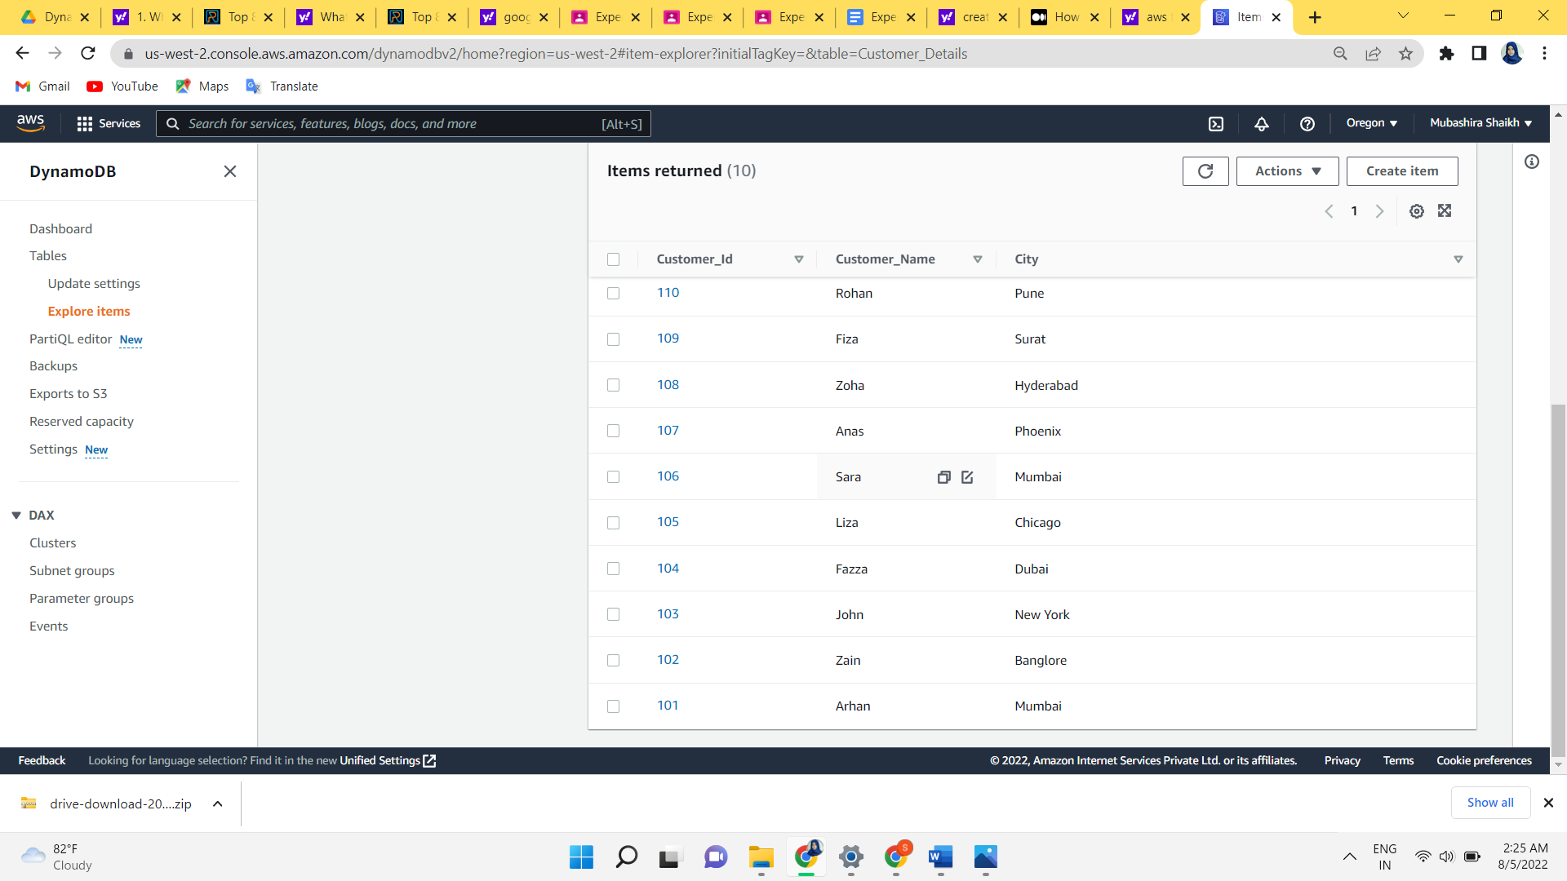

**Step 8:Run query for needed items using partition key**

**A)**

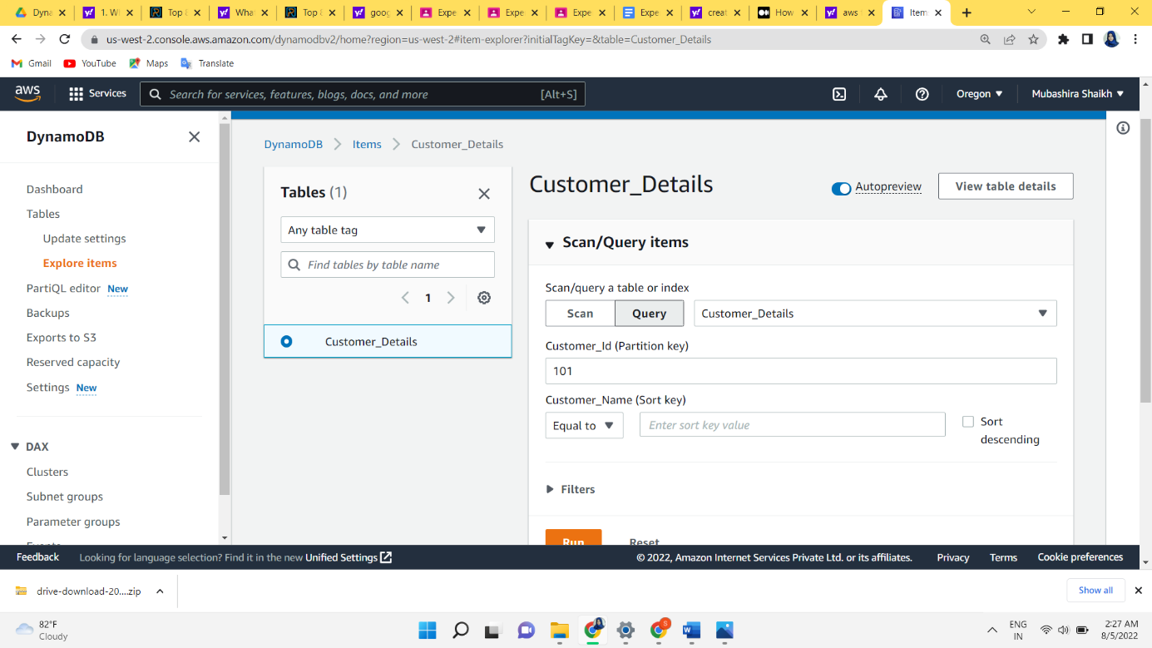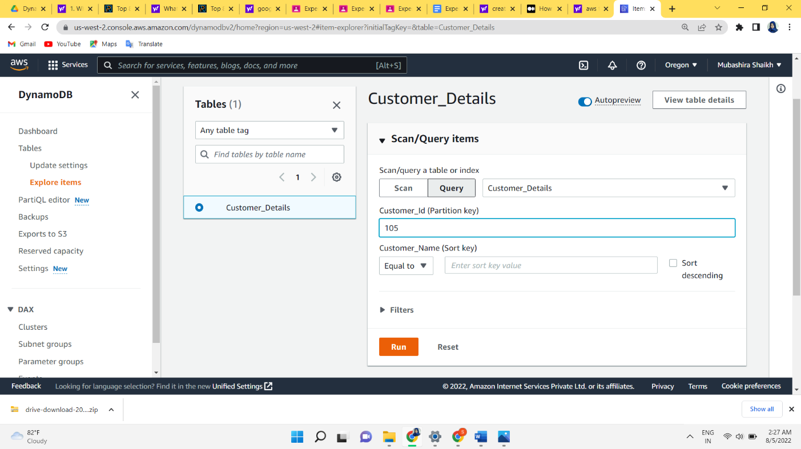

**B)**

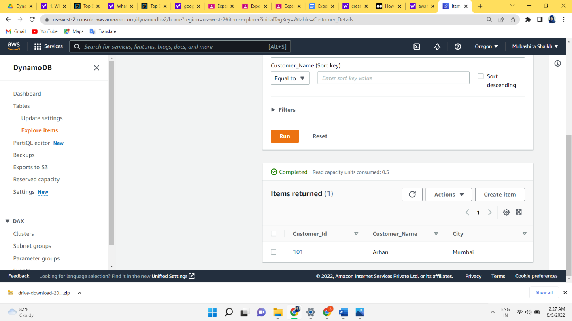

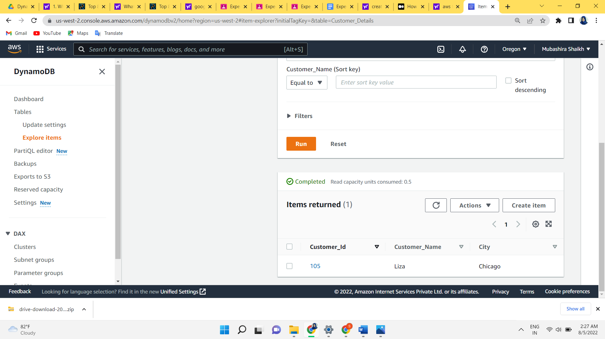**C)** 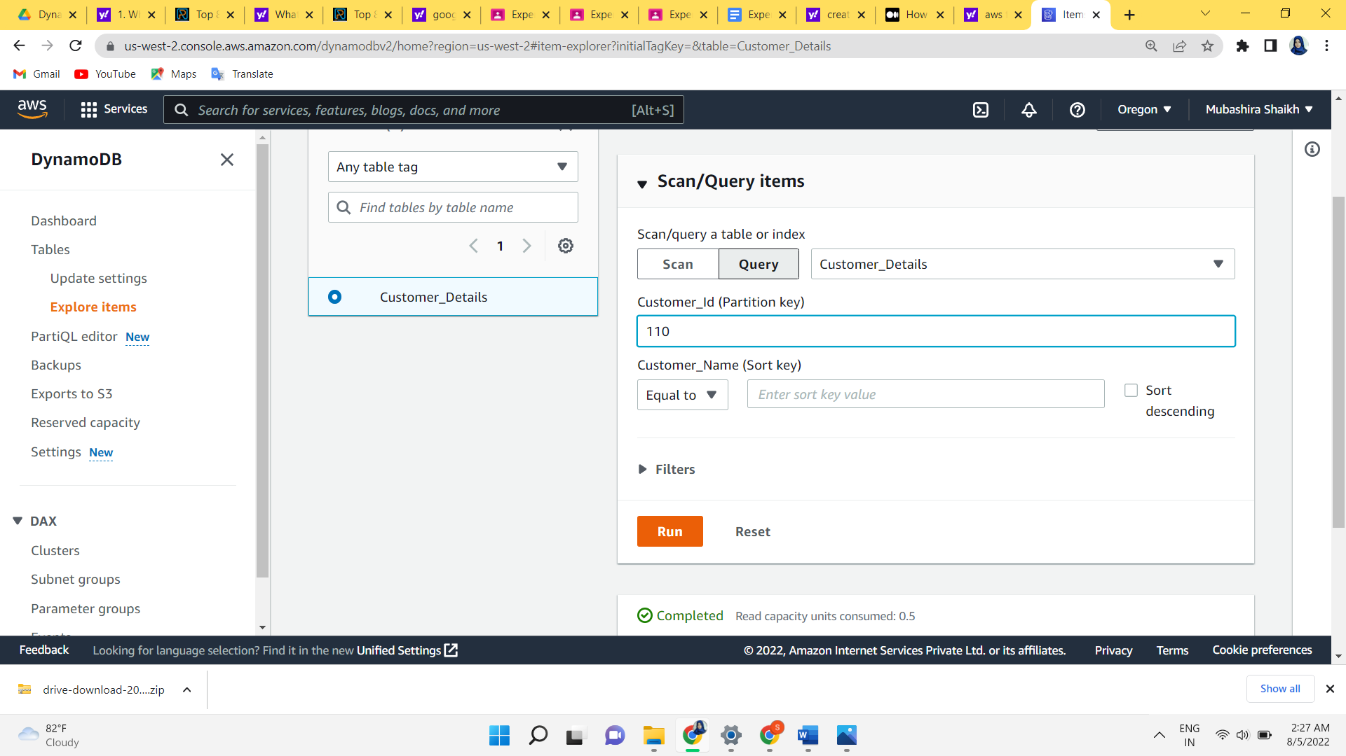 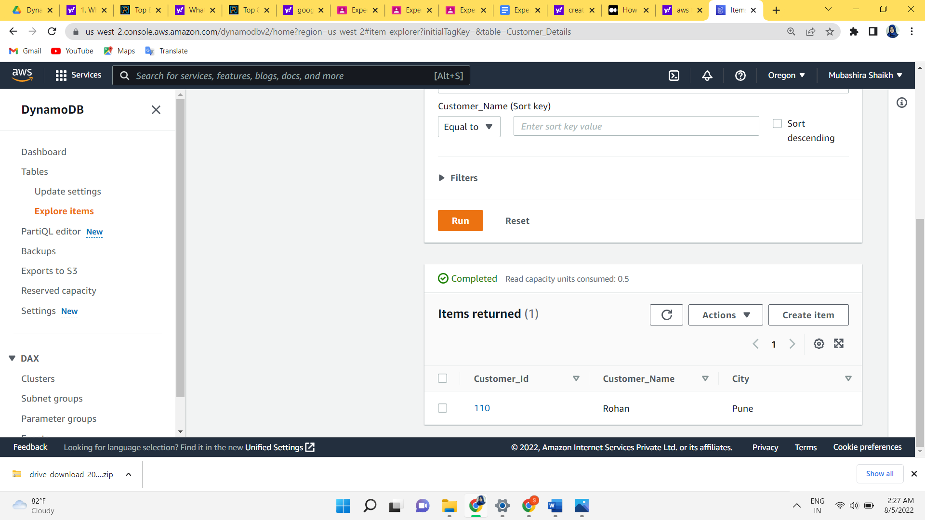

**Step 9: Finally, Select the table and click on “Delete”.**

