**EXPERIMENT-09**

**NAME:** SHAIKH MUBASHIRA TUFEL AHMED

**ROLL NO:** 612055  **COURSE:** ADVANCE DEVOPS(ITL504)

**BRANCH:** T.E. INFORMATION TECHNOLOGY (SEM 5)

**Step 1: AWS Management Console Dashboard.**

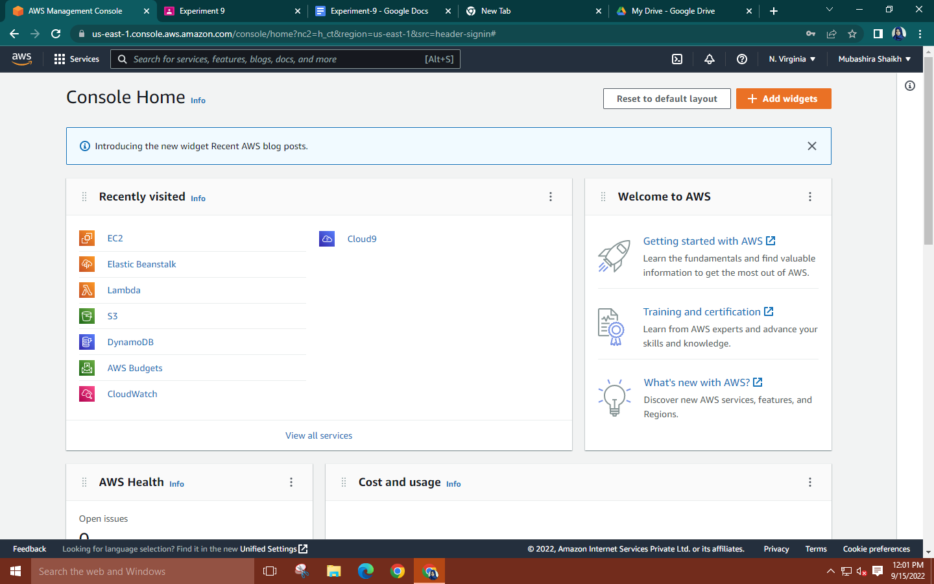

**Step 2: Search for EC2🡪 Click on Launch instance🡪 Give a name to your instance and create an Ubuntu instance with 20.04 lts version.**

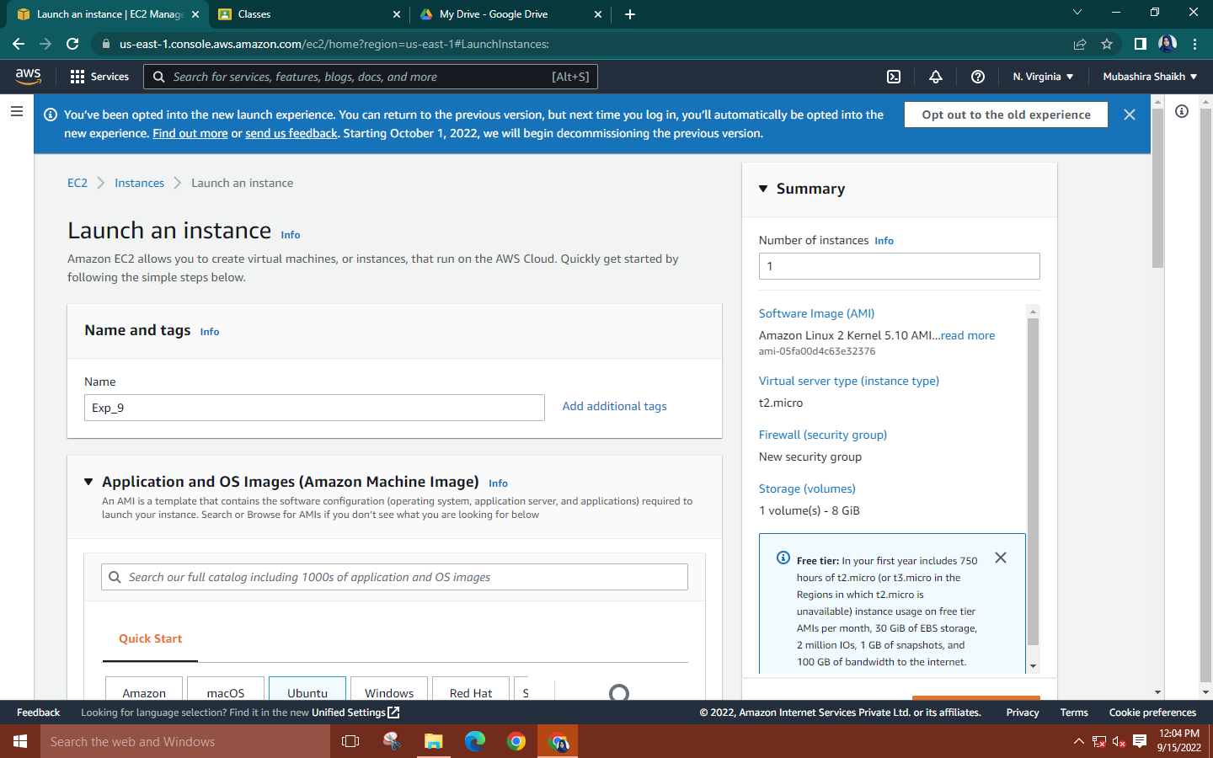

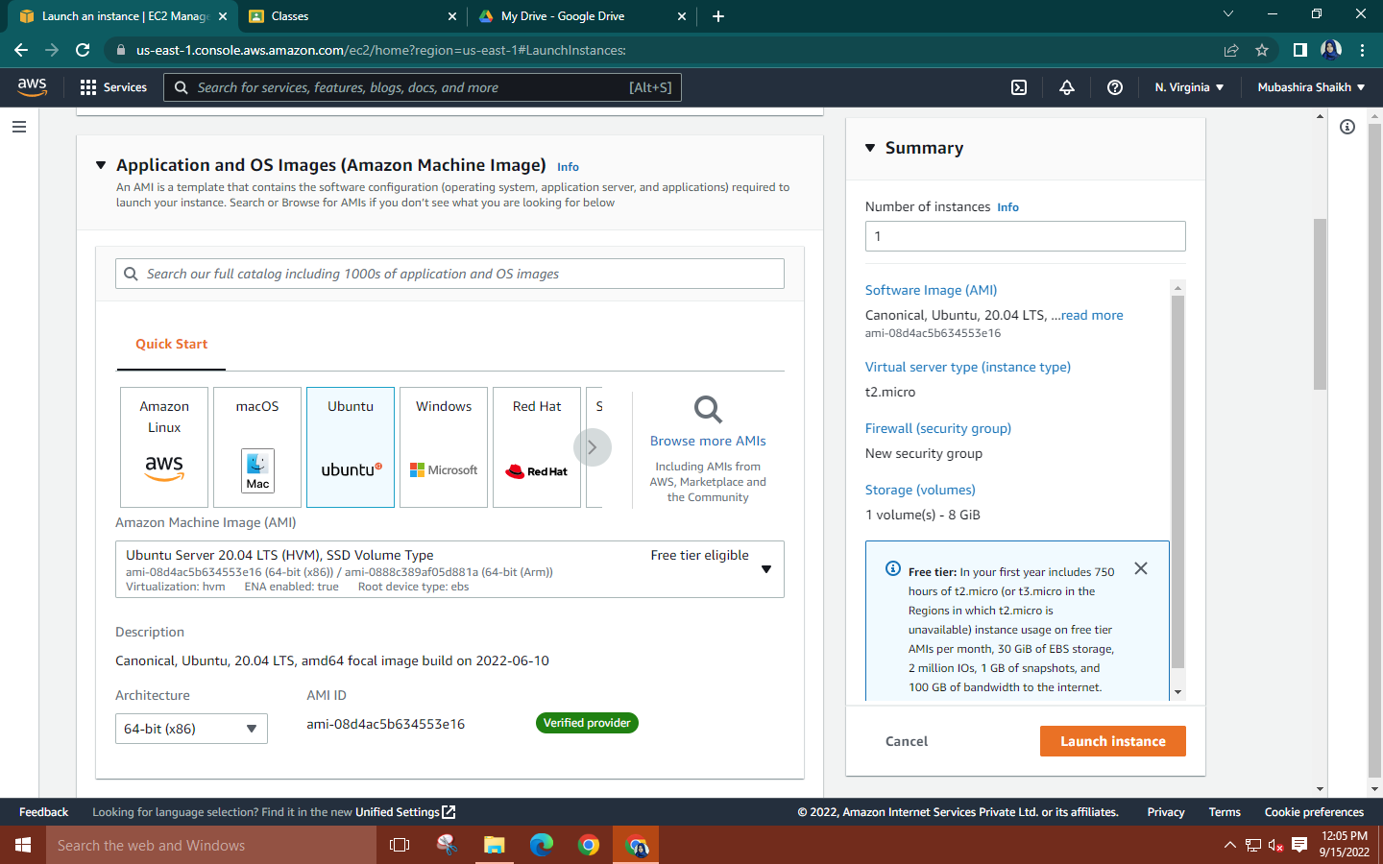

**Step 3: Create new key pair for your instance🡪Network Settings🡪allow the HTTPS and HTTP traffic.**

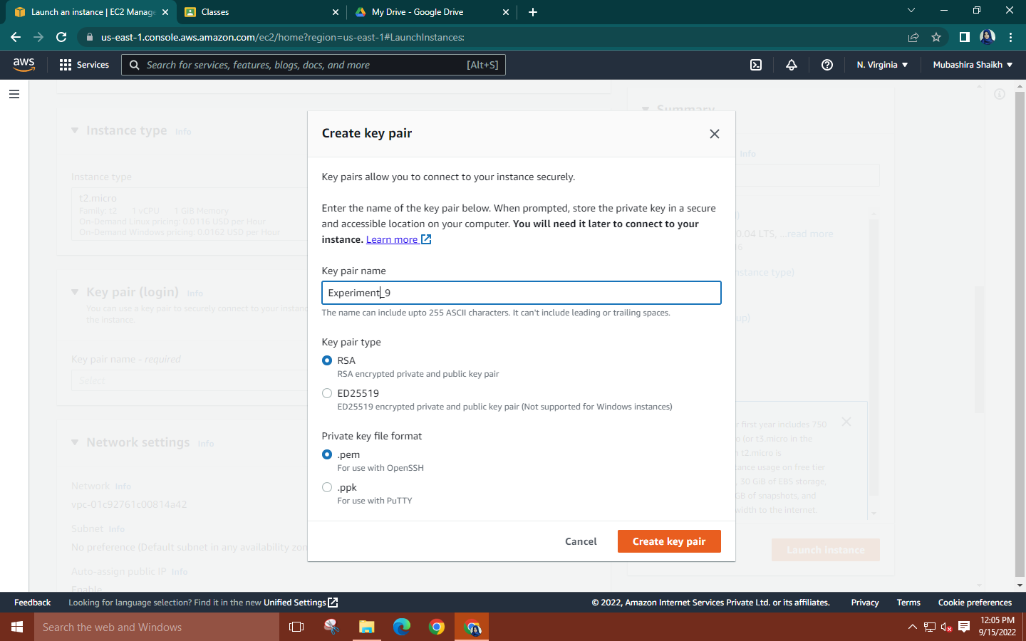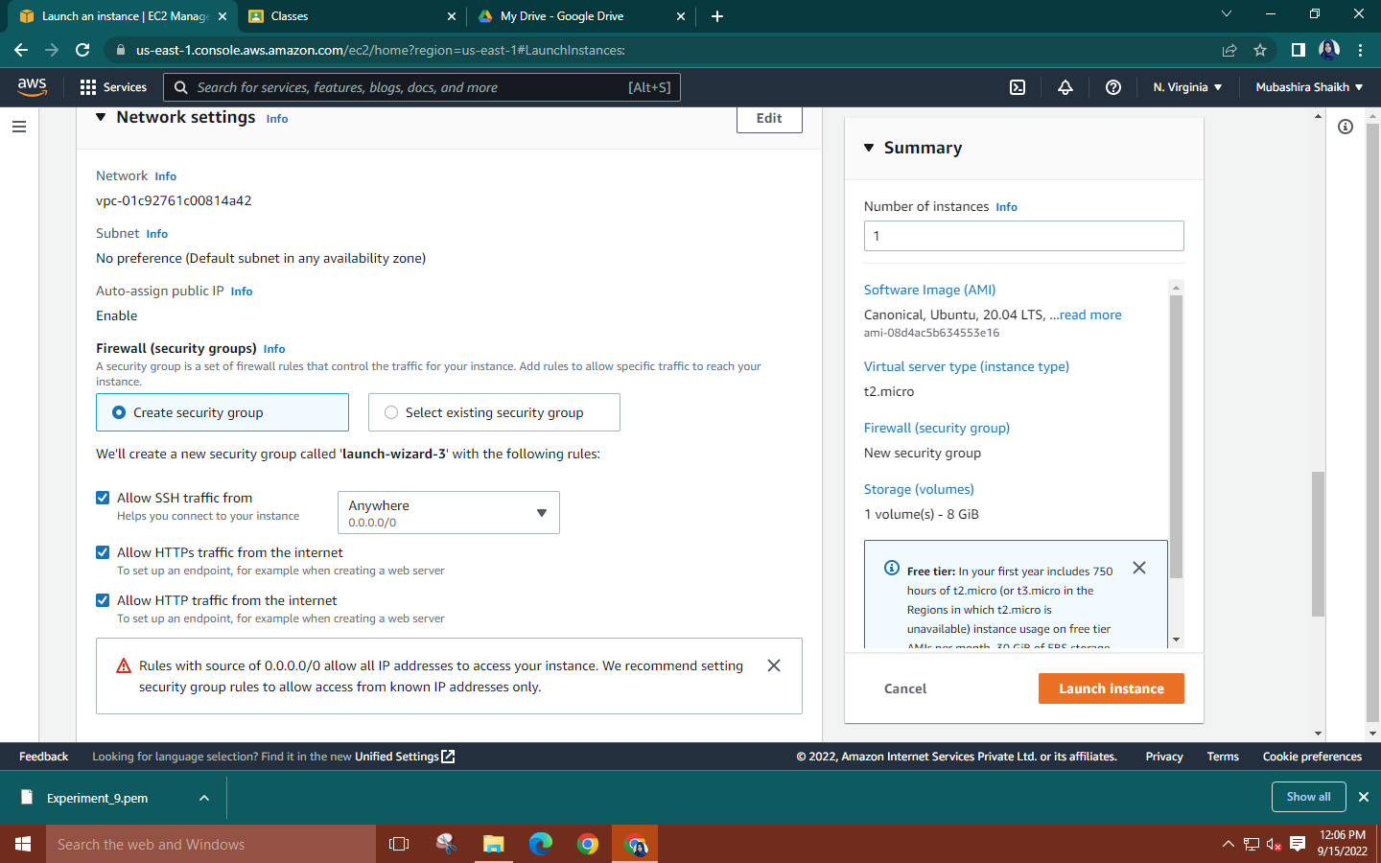

**Step 4: Launch MobaXterm🡪Select SSH session🡪Copy the public DNS of your instance and paste it into the remote host. Use the downloaded key pair as the private key.** 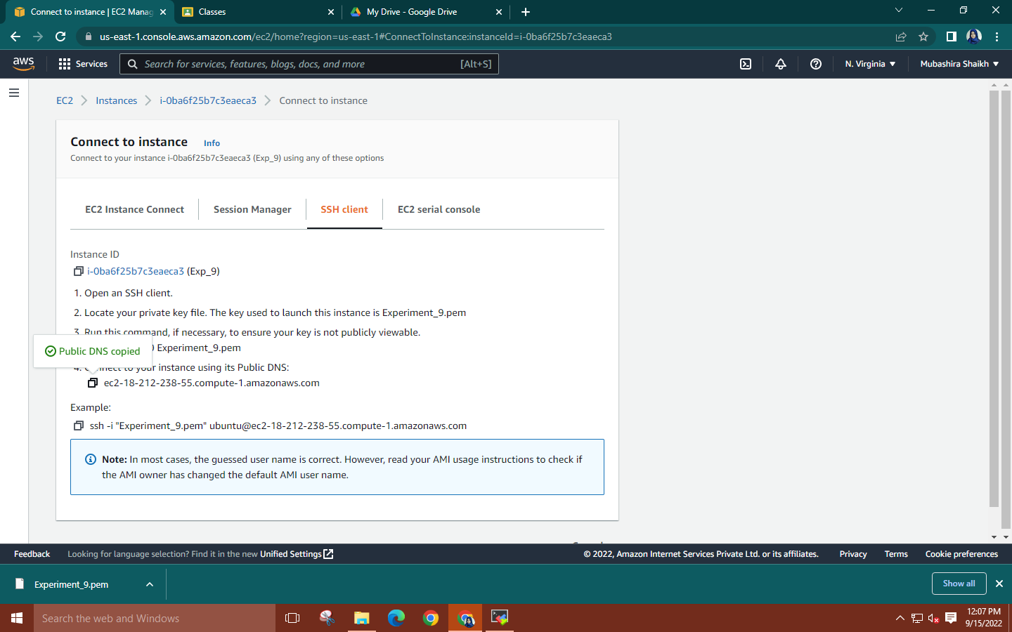

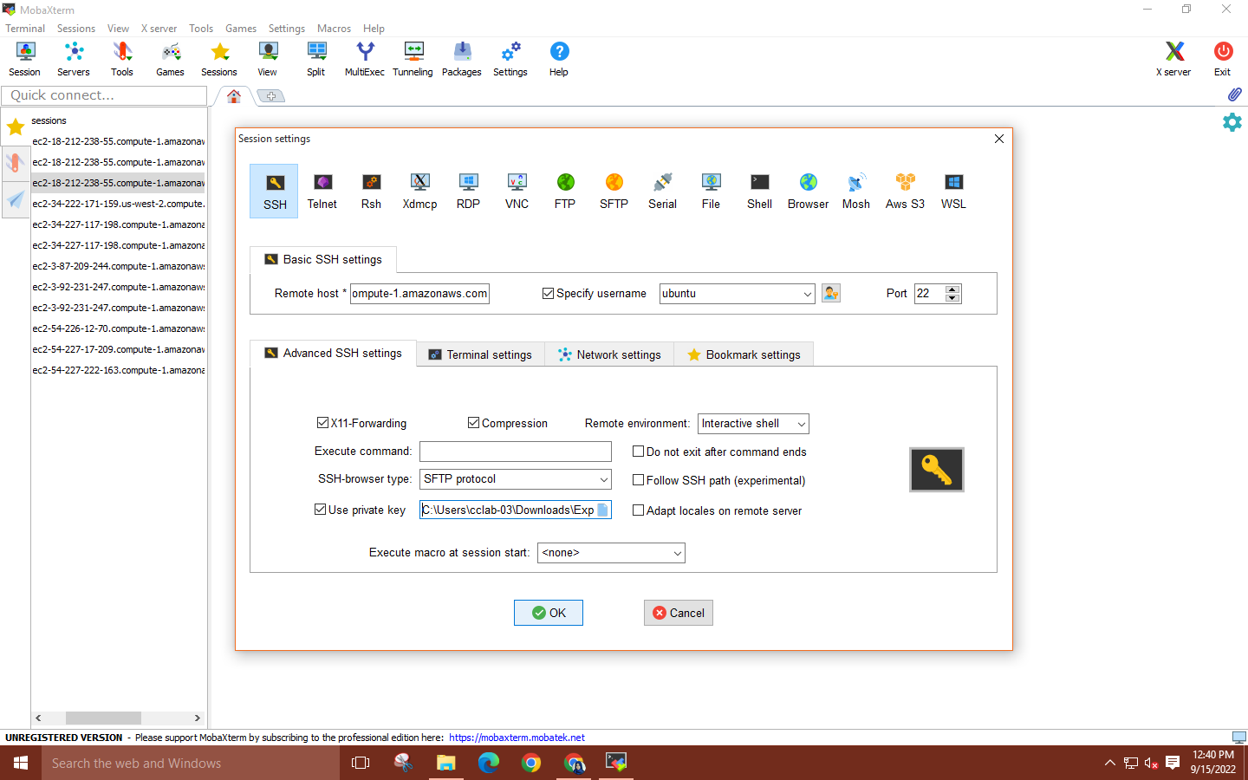

**Step 5: Run the command ‘sudo su’ to gain root user access. Then enter commands:**

**🡪curl -fsSL https://get.docker.com -o get-docker.sh and**

**🡪sh get-docker.sh**

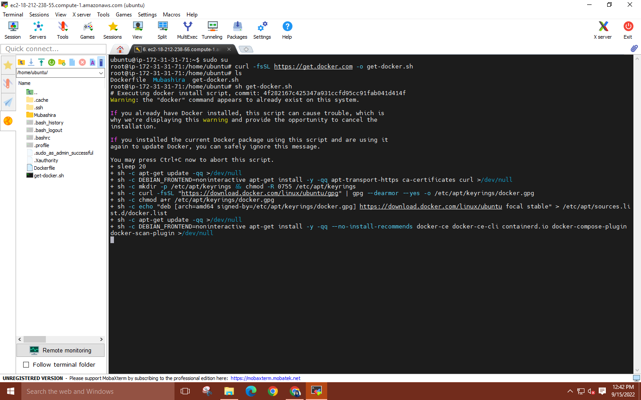

**Step 6: Enter commands ‘docker –version’ to see current docker version & ‘docker images’ to see installed images.**

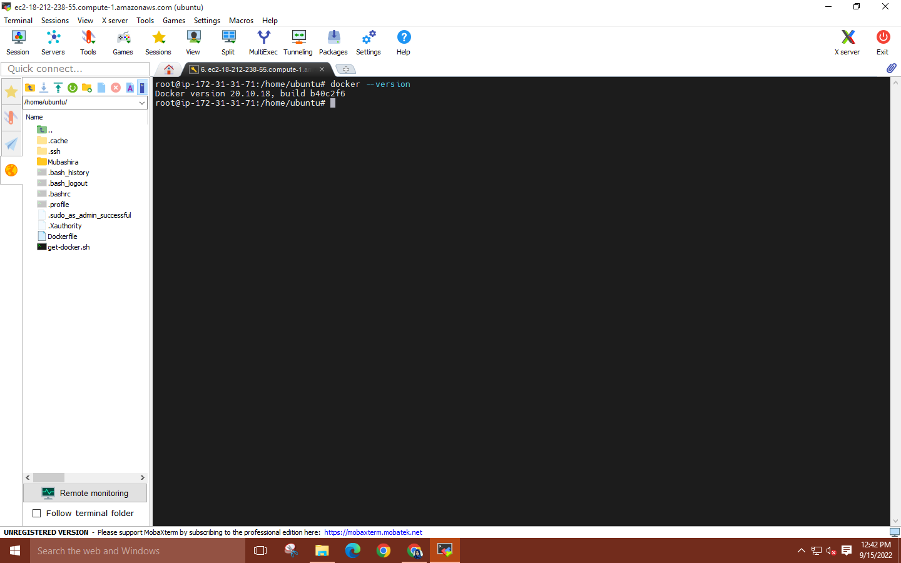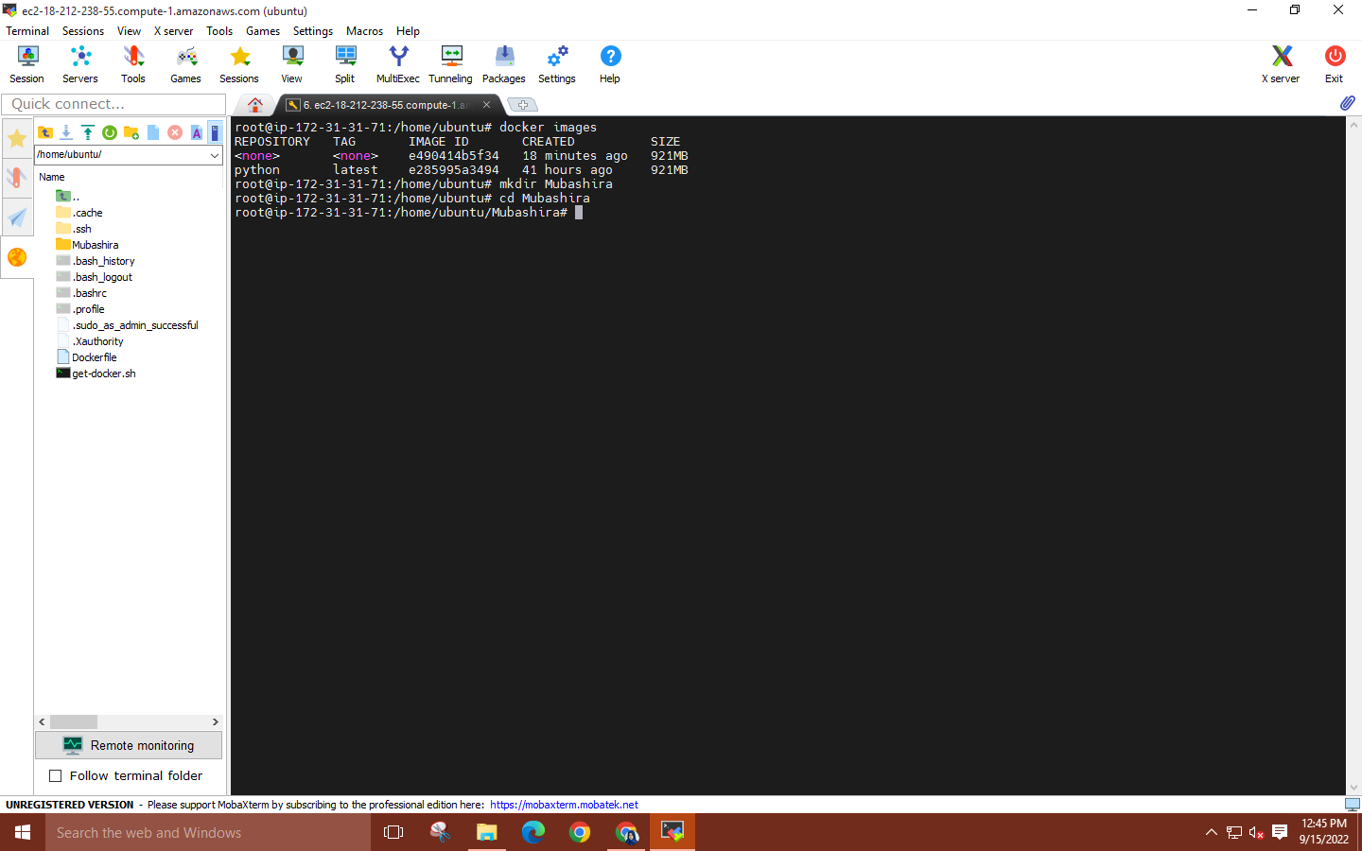

**Step 7: Now create a directory [your own name], go inside it and create another directory name as “APP” and go inside it too.**

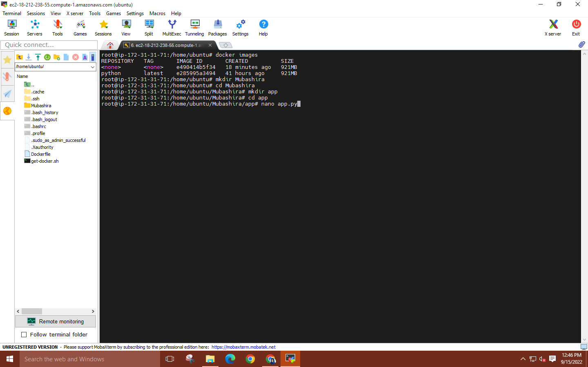

**Step 8: Now open nano editor by using command [nano app.py] and add the code of flask given in the classroom.**

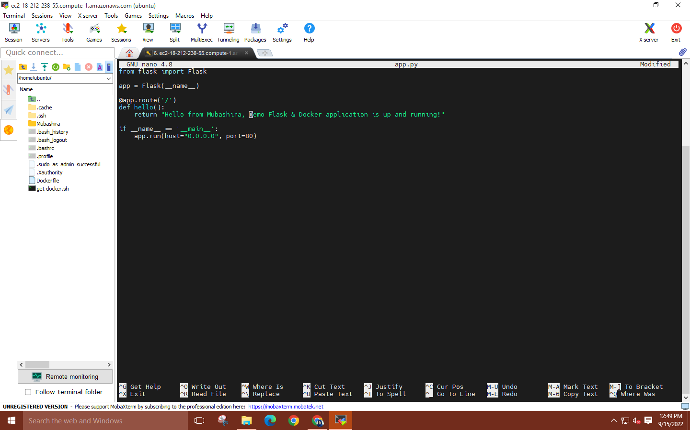

**\*To save the file press CTRL+O → ENTER → CTRL+ X.**

**Step 9: Now open nano editor by using command [requirements.txt] and write the requirements of the file to be installed on other PC.**

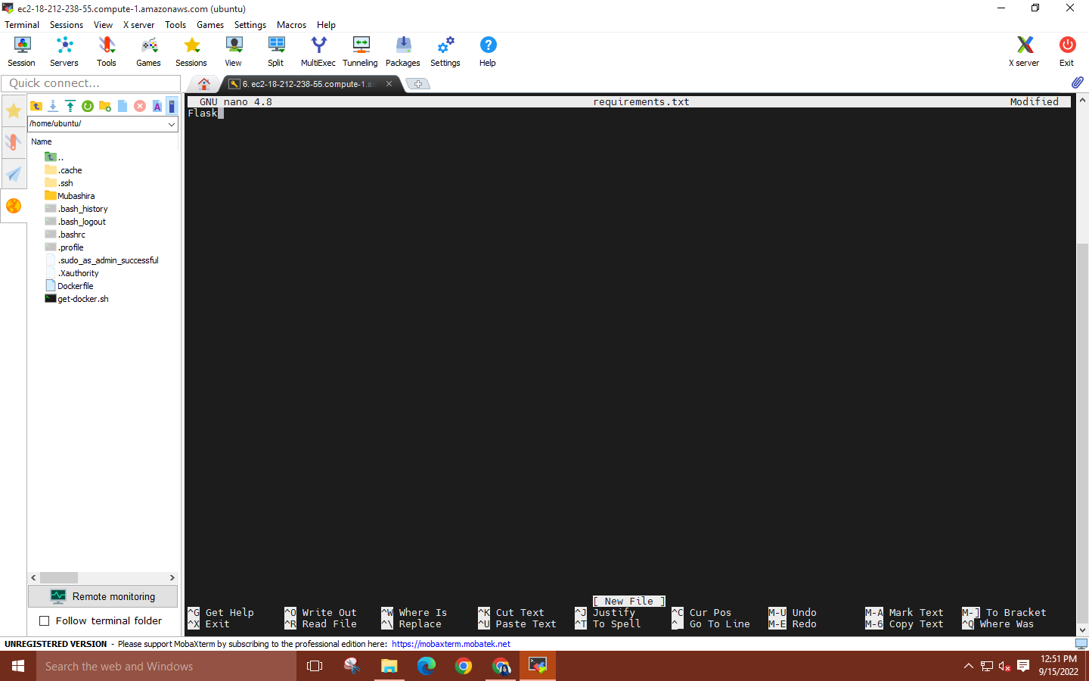

**Step 10: Now go back to your Parent Directory and write command [nano Dockerfile] and copy the code give in the classroom.**

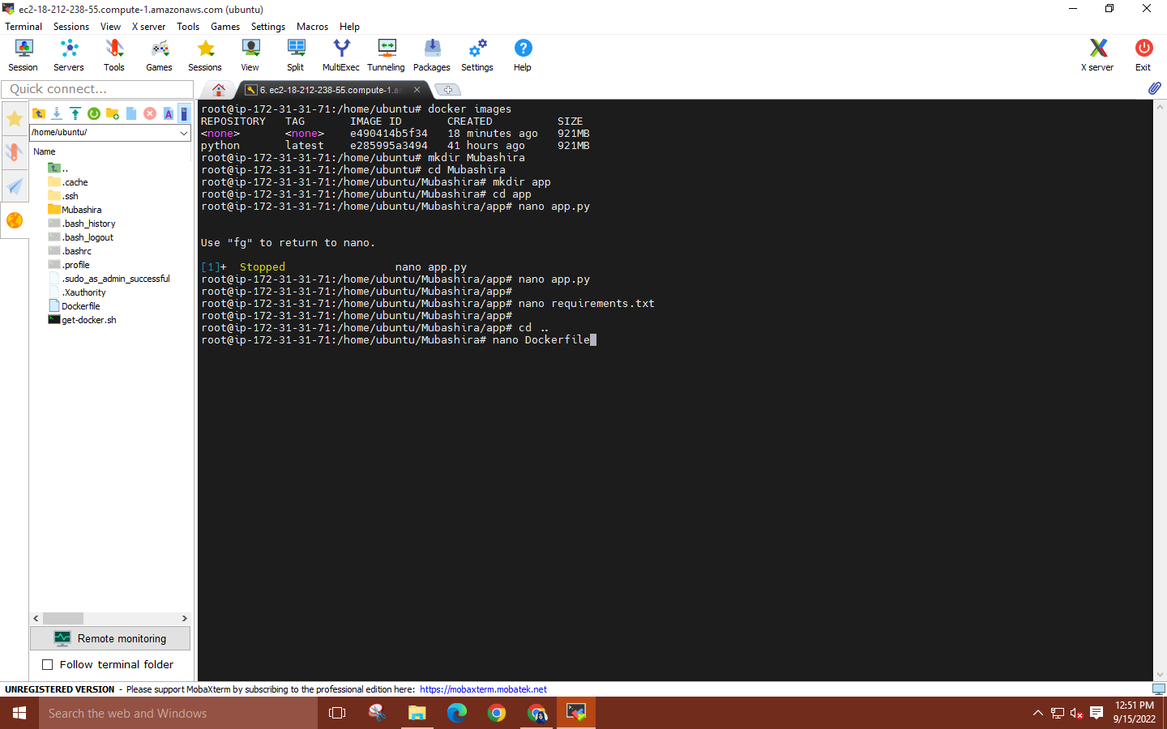

**Write code in the Dockerfile.**

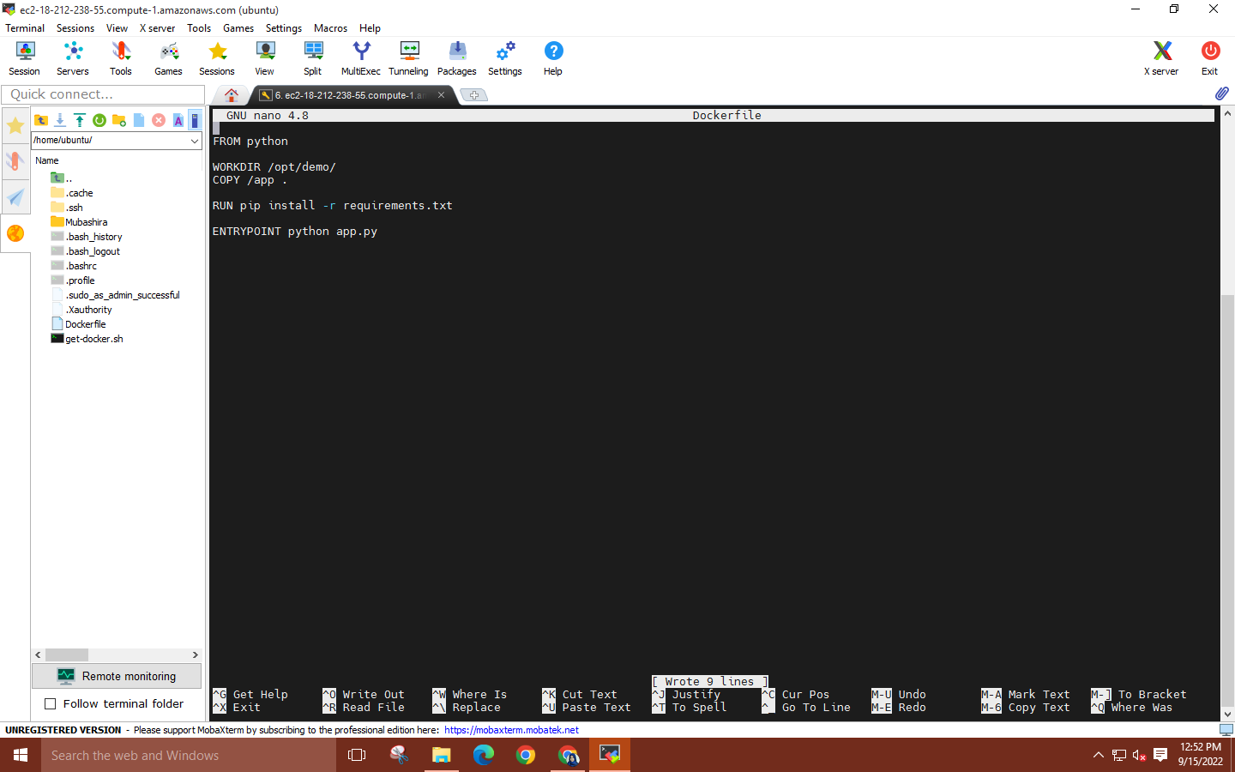

**Step 11: Now enter the command “docker build -t [file name]:latest .”**

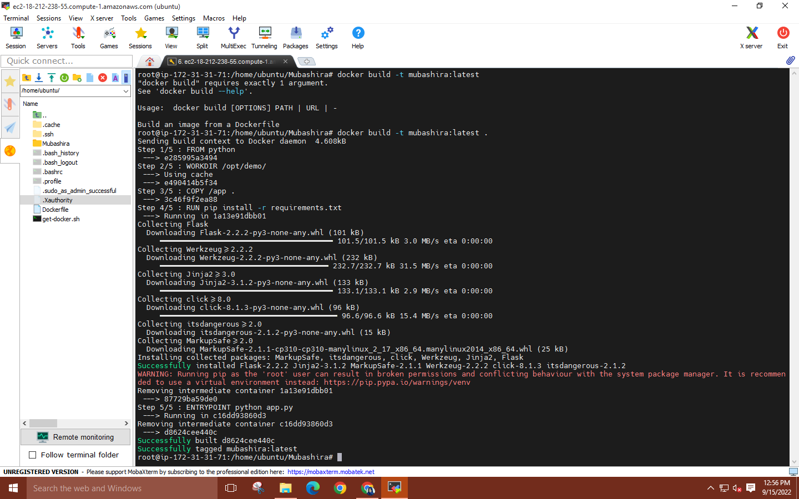

**Step 12: Now for checking the images run command as “docker images”.**

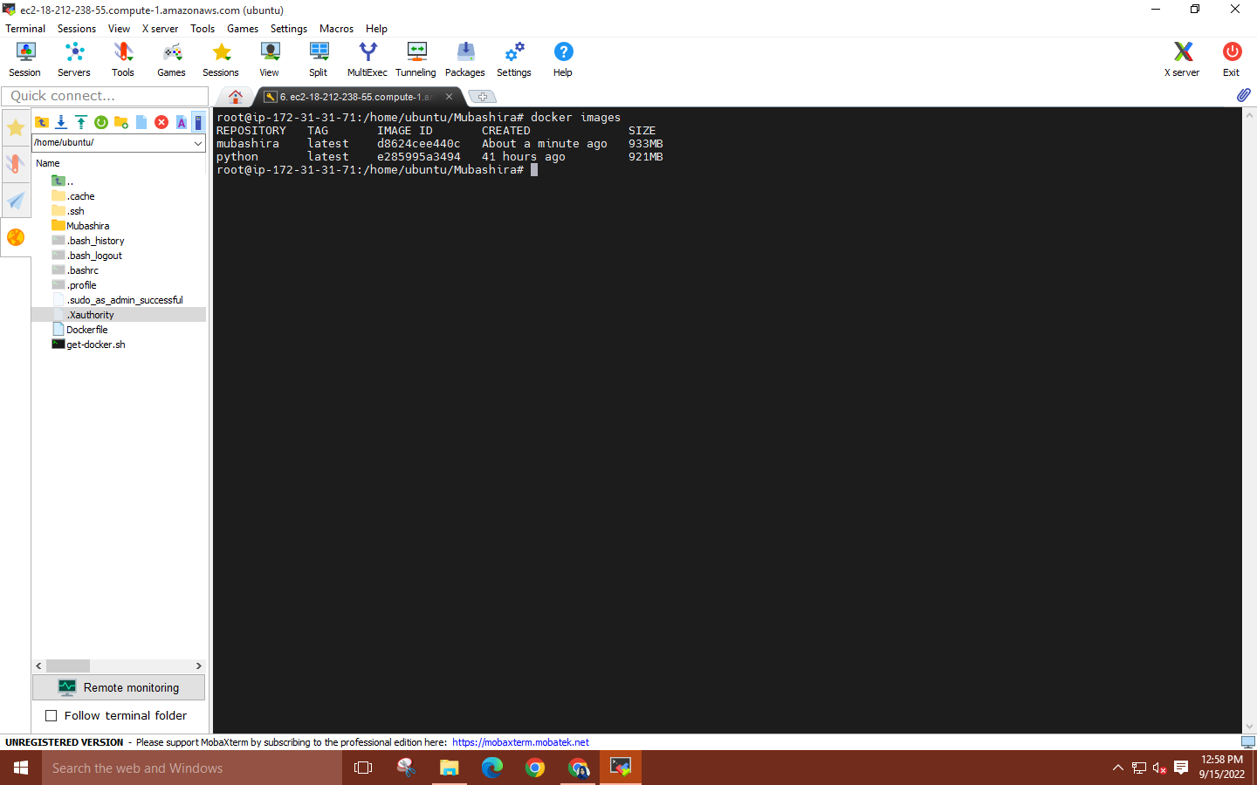

**Step 13: Run command “docker run -d -p 80:80 [directory name]”.**

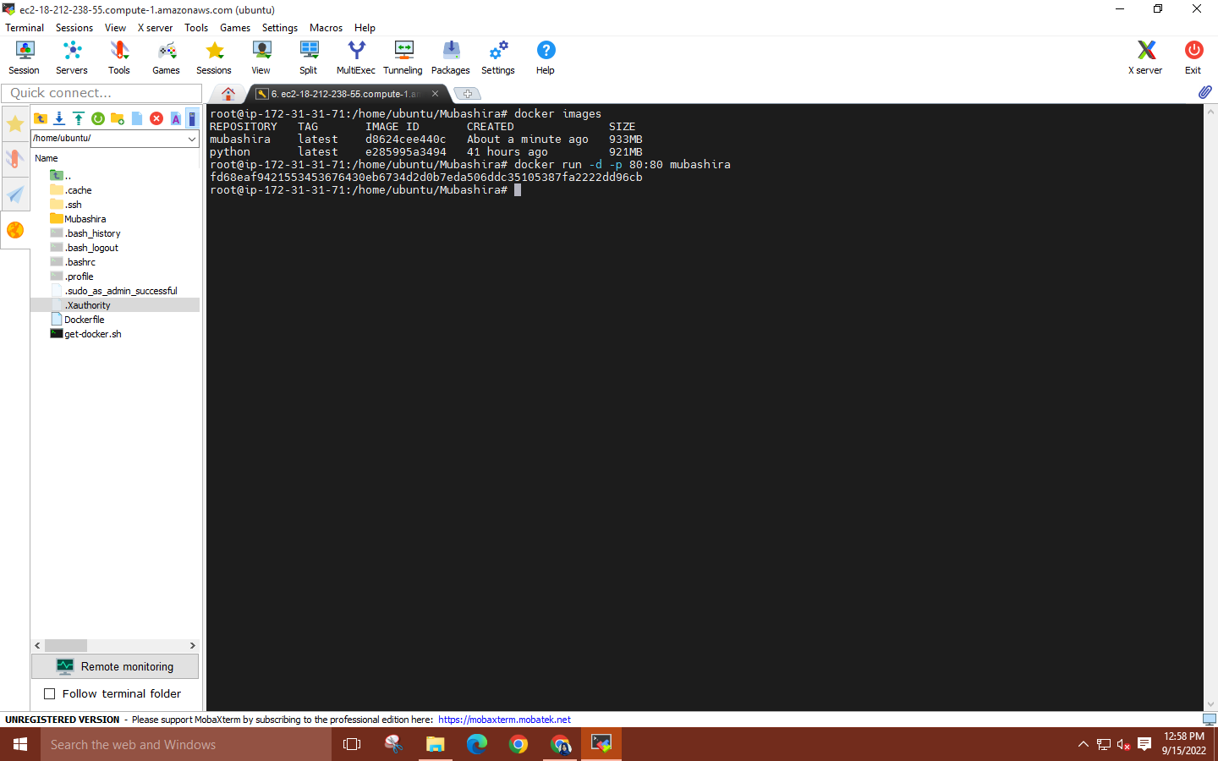

**copy the IPV4 address from the EC2 instance details and paste it into a web browser.**

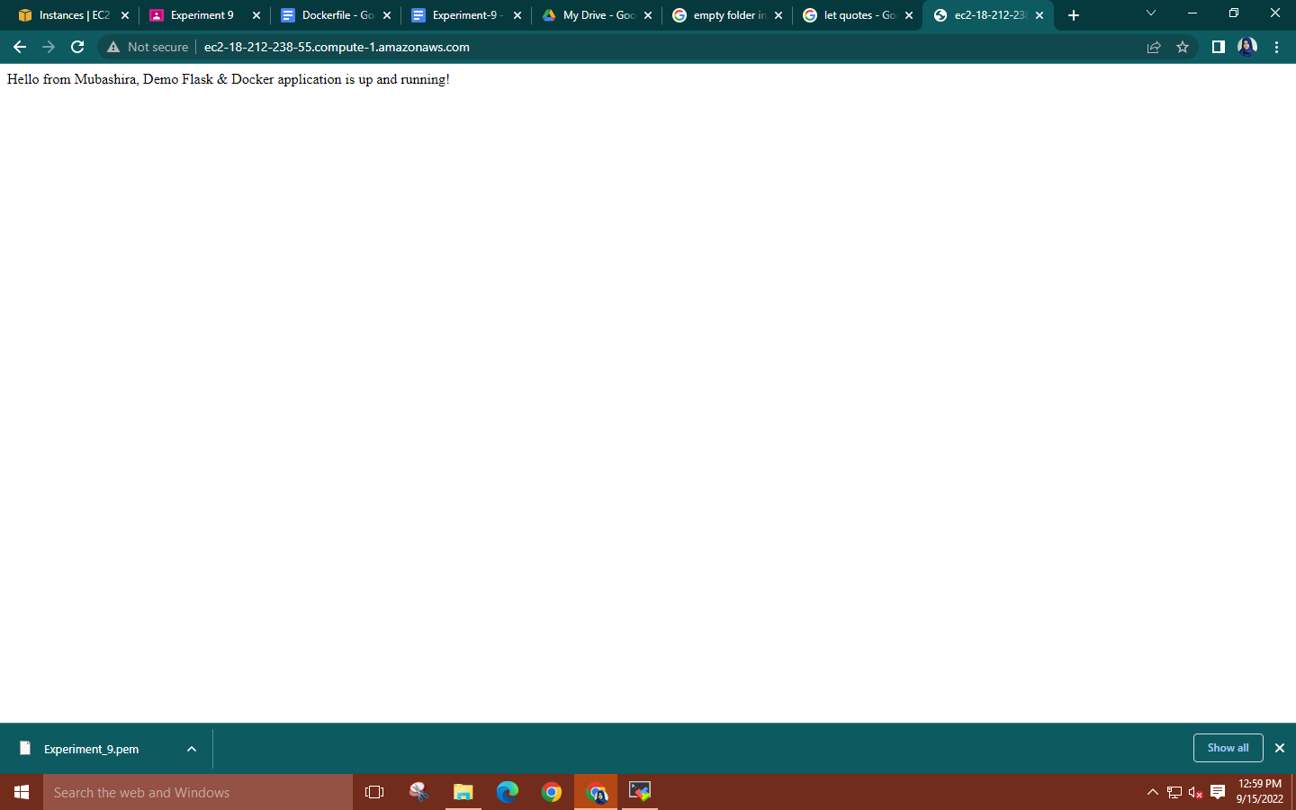

**Step 14: Run the commands ‘docker ps’ to check the number of containers and their ID’s.**

**You can use the command ‘docker ps -a’ to check the status of the container.**

**To stop a container use command: ‘docker stop (container id)’.**

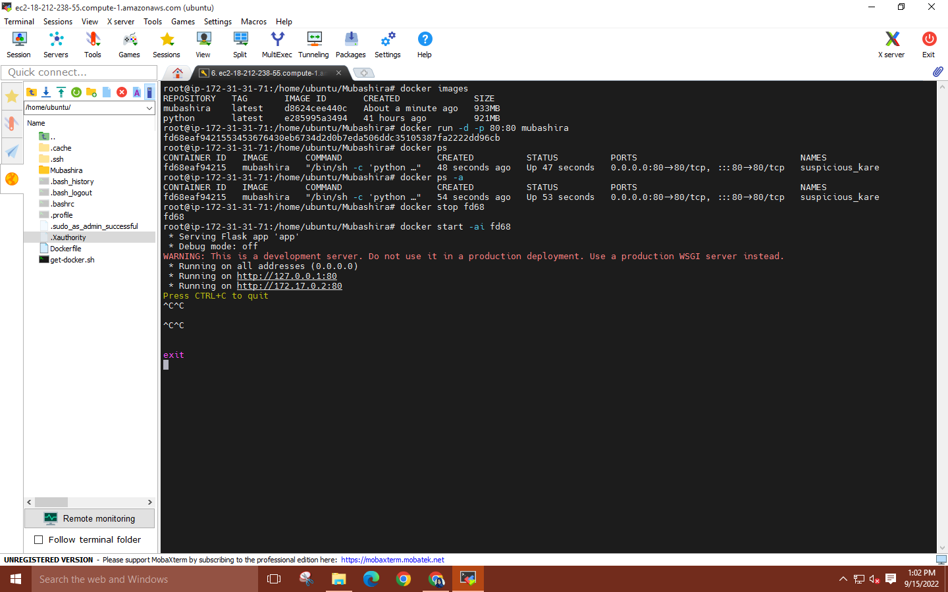

**Quit MobaXterm and then delete your EC2 instance.**