CONTENTS
LIST OF FIGURES | iii
LIST OF TABLES | iv

CHAPTER NO | TITLE | PAGE NO
1 | INTRODUCTION | 1
 | 1.1 Background | 1
 | 1.2 About the Project | 1
 | 1.3 Scope | 1
2 | OBJECTIVE | 2
 | 2.1 Problem Statement | 2
 | 2.2 Objectives | 2
 | 2.3 Expected Outcome | 2
3 | METHODOLOGY | 3
 | 3.1 Technologies and Libraries | 3
 | 3.2 Datasets | 3
 | 3.3 Approach (Steps) | 3
 | 3.4 Key Formulas | 4
4 | SYSTEM ARCHITECTURE | 5
 | 4.1 Workflow | 5
 | 4.2 Layers | 5
 | 4.3 Project Folder Structure | 5
 | 4.4 Data Flow Summary | 6
5 | IMPLEMENTATION | 7
 | 5.1 Environment Setup | 7
 | 5.2 Importing Libraries and Page Configuration | 7
 | 5.3 Loading and Cleaning Data | 7
 | 5.4 Sidebar Filters | 8
 | 5.5 KPI Cards and Tabs | 8
 | 5.6 Global Trend Tab | 9
 | 5.7 Country Comparison Tab | 9
 | 5.8 Rankings Tab | 9
 | 5.9 Map Tab | 10
 | 5.10 Data Tab | 10
6 | RESULTS AND OBSERVATIONS | 11
 | 6.1 Output Charts | 11
 | 6.2 Global Summary | 13
 | 6.3 Country and Regional Results | 13
 | 6.4 Data Verification | 14
 | 6.5 Observations and Analysis | 15
 | 6.6 Limitations | 16
 | CONCLUSION | 17
 | What Was Achieved | 17
 | What Was Learned | 17
 | Future Scope | 17
 | REFERENCES | 18
 | Datasets | 18
 | Research Papers | 18
 | Documentation and Resources | 18

LIST OF FIGURES/ILLUSTRATIONS
FIGURE NO. | FIGURE NAME | PAGE NO.
4.1 | System Architecture and Workflow Diagram | 5
6.1 | Global confirmed, recovered, active and death counts over time | 11
6.2 | Global daily new cases with 7-day moving average | 11
6.3 | Top 10 countries by confirmed cases | 12
6.4 | Cases by WHO region: recovered, active and deaths | 12
6.5 | Geographic spread of confirmed cases | 13

LIST OF TABLES
TABLE NO. | TABLE NAME | PAGE NO.
3.1 | Technologies and libraries used | 3
3.2 | Datasets used in the project | 3
6.1 | Global figures at selected dates | 13
6.2 | Top 10 countries by confirmed cases | 14
6.3 | Totals by WHO region | 14
6.4 | Data verification checks | 15

CHAPTER 1

INTRODUCTION

1.1 Background
The COVID-19 pandemic, caused by the SARS-CoV-2 virus, produced one of the largest streams of public health data in history. Countries reported confirmed cases, deaths and recoveries every day, and these figures were collected by organisations such as the Johns Hopkins University Center for Systems Science and Engineering (CSSE) and Worldometer. In their raw form the figures are large tables of numbers. A student, a journalist or a policy maker cannot easily see from such tables how fast the disease spread, which regions were most affected, or how countries compare with each other.
Data visualisation solves this problem. A dashboard places the most important indicators on one screen and lets the user explore the data by choosing a country, a period and a measure. This project builds such a dashboard for COVID-19 data.

1.2 About the Project
The COVID-19 Data Dashboard is an interactive web application written in Python. It reads five CSV data files that cover 187 countries from 22 January 2020 to 27 July 2020, cleans them, calculates additional indicators, and presents the results as KPI cards, line charts, bar charts and a world bubble map.
The application is built with Pandas for data handling, Plotly for interactive charts and Streamlit for the web interface. A user can open it in a browser, filter by WHO region, compare several countries, change the date range, and download the filtered data as a CSV file.

1.3 Scope
- Show global totals of confirmed cases, deaths, recoveries and active cases.
- Show the global trend over time with a 7-day moving average of new cases.
- Compare selected countries on any available measure.
- Rank countries by total cases, by other measures and by cases per million population.
- Show the geographic spread of cases on a world map.
- Allow the filtered table to be downloaded.
The project does not predict future cases and does not give medical advice. It is a tool for exploring and understanding historical data.
CHAPTER 2

OBJECTIVE

2.1 Problem Statement
Public COVID-19 data is published as several large CSV files, each with a different structure. Some files hold daily records for every country, some hold only the latest values, and some hold population and testing details. The files contain small errors such as negative daily corrections, and country names are written differently in different files. A person who is not trained in data analysis cannot turn these files into useful information quickly.

2.2 Objectives
1. To load and clean the five COVID-19 data files using Python and Pandas.
2. To calculate useful indicators such as the 7-day moving average of new cases, deaths per 100 cases and cases per million population.
3. To build an interactive dashboard in which the user filters by region, country, date range and measure.
4. To present trends, comparisons, rankings and geographic spread clearly with interactive charts.
5. To study the data and report what it shows about the first seven months of the pandemic.
6. To gain practical experience in data cleaning, visualisation and web application development.

2.3 Expected Outcome
A working dashboard that runs locally with a single command, shows the global situation on the latest date in the data, and lets the user explore any country or region without writing code.
CHAPTER 3

METHODOLOGY

3.1 Technologies and Libraries
Table 3.1 Technologies and libraries used
Tool / Library | Purpose
Python 3 | Core programming language
Pandas | Reading CSV files, cleaning, grouping and calculating indicators
Plotly Express | Interactive line, bar and geographic charts
Streamlit | Web interface with sidebar filters, KPI cards and tabs
Matplotlib | Static charts used in this report
VS Code / Git | Development and version control

3.2 Datasets
The project uses five CSV files that together cover the pandemic from 22 January 2020 to 27 July 2020. The data comes from Johns Hopkins CSSE and Worldometer. Each file serves a different part of the dashboard.
Table 3.2 Datasets used in the project
File | Rows | Columns | Content and use
full_grouped.csv | 35,156 | 10 | Daily record for each of 187 countries over 188 days; used for country comparison
day_wise.csv | 188 | 12 | Global totals for each day; used for KPI cards and the global trend
country_wise_latest.csv | 187 | 15 | Latest values and one-week change for each country; used for rankings and the data table
covid_19_clean_complete.csv | 49,068 | 10 | Province and state level records with latitude and longitude; used for the map
worldometer_data.csv | 209 | 16 | Population, tests and cases per million; used for per-million rankings

3.3 Approach (Steps)
1. Data collection: the five CSV files are stored in the project folder.
2. Data loading: each file is read with Pandas and the Date column is converted to a date type.
3. Data cleaning: negative daily corrections are replaced by zero, and the data is checked for duplicates and for consistency between files.
4. Feature engineering: a 7-day moving average and deaths per 100 cases are calculated for every country and for the world.
5. Visualisation: line, bar and bubble-map charts are created with Plotly.
6. Dashboard assembly: sidebar filters, KPI cards and tabs are created with Streamlit.
7. Verification: totals are compared between files and calculated columns are compared with the values supplied in the data.

3.4 Key Formulas
- Active cases = Confirmed − Deaths − Recovered
- Deaths per 100 cases = (Deaths / Confirmed) × 100
- Recovered per 100 cases = (Recovered / Confirmed) × 100
- 7-day moving average = average of the values for the current day and the six days before it. This removes the weekly pattern in reporting.
- One-week percentage increase = ((Confirmed − Confirmed last week) / Confirmed last week) × 100
- Cases per million = (Total cases / Population) × 1,000,000
CHAPTER 4

SYSTEM ARCHITECTURE

4.1 Workflow
The dashboard follows a simple pipeline. Data flows from the CSV files through loading, cleaning and feature engineering into the Streamlit interface. When the user changes a filter, the charts are drawn again from the cached data.
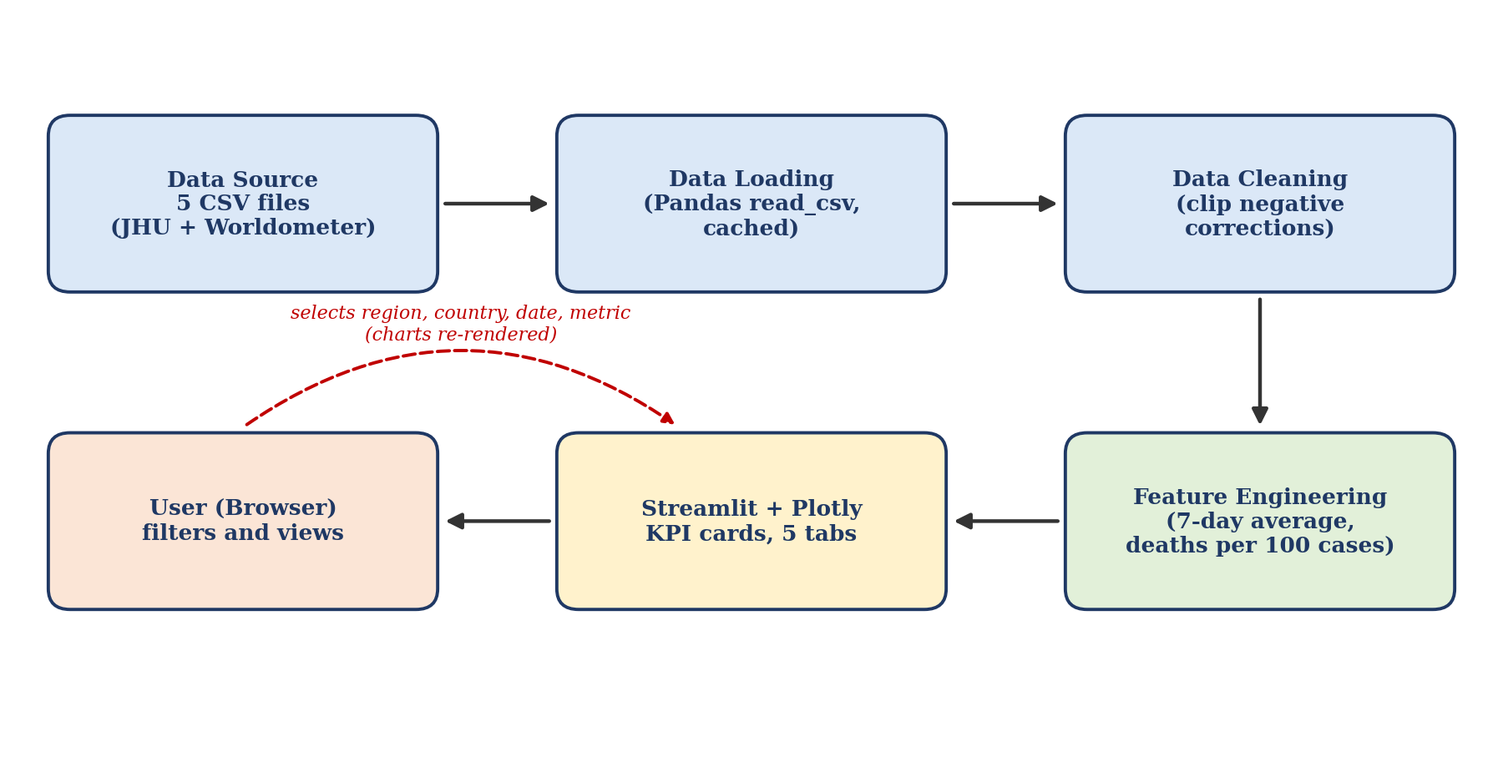
Fig 4.1 System Architecture and Workflow Diagram

4.2 Layers
1. Data layer: the five CSV files and the cached Pandas DataFrames.
2. Processing layer: cleaning steps and calculated indicators.
3. Visualisation layer: Plotly figures for trends, rankings and the map.
4. Presentation layer: Streamlit page with sidebar filters, KPI cards and five tabs.

4.3 Project Folder Structure
COVID-19-Data-Dashboard/
|-- app.py # Streamlit application
|-- requirements.txt # pandas, plotly, streamlit
|-- full_grouped.csv
|-- day_wise.csv
|-- country_wise_latest.csv
|-- covid_19_clean_complete.csv
|-- worldometer_data.csv

4.4 Data Flow Summary
Streamlit runs the script from top to bottom each time the user changes a filter. The function that loads and cleans the data is cached, so the five files are read only once. After that, only the filtering and drawing steps are repeated, which keeps the dashboard responsive.
CHAPTER 5

IMPLEMENTATION

5.1 Environment Setup
Install the required libraries and start the application from the project folder:
pip install pandas plotly streamlit
streamlit run app.py

The file requirements.txt contains one library name per line:
pandas
plotly
streamlit

5.2 Importing Libraries and Page Configuration
import pandas as pd
import plotly.express as px
import streamlit as st

st.set_page_config(page_title="COVID-19 Data Dashboard", page_icon="🦠", layout="wide")
st.title("COVID-19 Data Dashboard")
st.caption("Data: Johns Hopkins CSSE and Worldometer, 22 Jan - 27 Jul 2020")

Explanation: Pandas handles the data, Plotly Express draws the charts and Streamlit builds the web page. The wide layout uses the full width of the browser, which suits a dashboard.

5.3 Loading and Cleaning Data
@st.cache_data
def load_data():
daily = pd.read_csv("full_grouped.csv", parse_dates=["Date"])
world = pd.read_csv("day_wise.csv", parse_dates=["Date"])
latest = pd.read_csv("country_wise_latest.csv")
geo = pd.read_csv("covid_19_clean_complete.csv", parse_dates=["Date"])
wom = pd.read_csv("worldometer_data.csv")

# Cleaning: reporting corrections create small negative values
for col in ["New cases", "New deaths", "New recovered"]:
daily[col] = daily[col].clip(lower=0)
world[col] = world[col].clip(lower=0)
daily["Active"] = daily["Active"].clip(lower=0)

# Feature engineering: 7-day moving averages
daily = daily.sort_values(["Country/Region", "Date"])
for col in ["New cases", "New deaths"]:
daily[col + " (7-day avg)"] = daily.groupby("Country/Region")[col].transform(
lambda s: s.rolling(7, min_periods=1).mean())
world[col + " (7-day avg)"] = world[col].rolling(7, min_periods=1).mean()

# Rates (percent) for every country-day
cfr = daily["Deaths"] / daily["Confirmed"].where(daily["Confirmed"] > 0) * 100
daily["Deaths / 100 Cases"] = cfr.fillna(0).round(2)

# Geographic frame: only rows with cases, latest date
geo_latest = geo[(geo["Date"] == geo["Date"].max()) & (geo["Confirmed"] > 0)].copy()
return daily, world, latest, geo_latest, wom

daily, world, latest, geo_latest, wom = load_data()

Explanation:
- @st.cache_data stores the result so that the five files are read only once.
- Small negative values appear in the daily columns when countries correct earlier figures. They are replaced by zero so that charts are not distorted.
- The 7-day moving average is calculated separately for each country with groupby.
- Deaths per 100 cases is calculated only where the confirmed count is above zero, which avoids division by zero. For the latest date the result matches the values supplied in the data file.
- The map uses only the latest date and only rows with at least one confirmed case.

5.4 Sidebar Filters
# ---------------- Sidebar filters ----------------
st.sidebar.header("Filters")
regions = sorted(latest["WHO Region"].dropna().unique())
sel_regions = st.sidebar.multiselect("WHO Region", regions, default=regions)

country_pool = sorted(latest[latest["WHO Region"].isin(sel_regions)]["Country/Region"])
wanted = ["US", "Brazil", "India", "Russia"]
default_countries = [c for c in wanted if c in country_pool]
sel_countries = st.sidebar.multiselect("Countries to compare", country_pool,
default=default_countries)

dmin, dmax = daily["Date"].min().date(), daily["Date"].max().date()
date_range = st.sidebar.date_input("Date range", (dmin, dmax),
min_value=dmin, max_value=dmax)
if len(date_range) == 2:
start, end = pd.to_datetime(date_range[0]), pd.to_datetime(date_range[1])
else:
start, end = pd.to_datetime(dmin), pd.to_datetime(dmax)

metrics = ["Confirmed", "Deaths", "Recovered", "Active", "New cases", "New deaths",
"New cases (7-day avg)", "New deaths (7-day avg)", "Deaths / 100 Cases"]
metric = st.sidebar.selectbox("Metric", metrics, index=6)
top_n = st.sidebar.slider("Top N countries", 5, 20, 10)

Explanation: The WHO region filter limits the list of countries. The country list, date range, measure and the number of countries in rankings are all chosen by the user. If the date picker returns only one date, the full range is used.

5.5 KPI Cards and Tabs
# ---------------- KPI cards (global, latest day) ----------------
g = world.iloc[-1]
k1, k2, k3, k4, k5 = st.columns(5)
k1.metric("Confirmed", f"{int(g['Confirmed']):,}", f"+{int(g['New cases']):,} today")
k2.metric("Deaths", f"{int(g['Deaths']):,}", f"+{int(g['New deaths']):,} today")
k3.metric("Recovered", f"{int(g['Recovered']):,}")
k4.metric("Active", f"{int(g['Active']):,}")
k5.metric("Deaths / 100 cases", f"{g['Deaths / 100 Cases']:.2f}")

tab1, tab2, tab3, tab4, tab5 = st.tabs(
["Global Trend", "Country Comparison", "Rankings", "Map", "Data"])

Explanation: The last row of the global daily file gives the latest totals. Each KPI card shows a total, and the cards for cases and deaths also show the change on the latest day. The page is divided into five tabs.

5.6 Global Trend Tab
# ---------------- Tab 1: global trend ----------------
with tab1:
fig = px.line(world, x="Date", y=["Confirmed", "Recovered", "Active", "Deaths"],
title="Global cases over time")
st.plotly_chart(fig)
fig = px.bar(world, x="Date", y="New cases", title="Global daily new cases")
fig.add_scatter(x=world["Date"], y=world["New cases (7-day avg)"],
name="7-day average")
st.plotly_chart(fig)

Explanation: The first chart shows confirmed, recovered, active and death counts over time. The second chart shows daily new cases as bars with the 7-day average as a line on top.

5.7 Country Comparison Tab
# ---------------- Tab 2: country comparison ----------------
with tab2:
sub = daily[(daily["Country/Region"].isin(sel_countries)) &
(daily["Date"] >= start) & (daily["Date"] <= end)]
if sub.empty:
st.warning("Select at least one country and a valid date range.")
else:
fig = px.line(sub, x="Date", y=metric, color="Country/Region",
title=f"{metric} by country")
fig.update_layout(hovermode="x unified")
st.plotly_chart(fig)

Explanation: The selected countries are filtered by date and drawn as one line each for the chosen measure. A warning is shown instead of an error if nothing is selected.

5.8 Rankings Tab
# ---------------- Tab 3: rankings ----------------
with tab3:
pool = latest[latest["WHO Region"].isin(sel_regions)]
rank_col = metric if metric in pool.columns else "Confirmed"
top = pool.nlargest(top_n, rank_col)
fig = px.bar(top, x=rank_col, y="Country/Region", orientation="h",
color="WHO Region", title=f"Top {top_n} countries by {rank_col}")
fig.update_layout(yaxis={"categoryorder": "total ascending"})
st.plotly_chart(fig)

per_m = wom[wom["Population"] > 1_000_000].dropna(subset=["Tot Cases/1M pop"])
per_m = per_m.nlargest(top_n, "Tot Cases/1M pop")
fig = px.bar(per_m, x="Tot Cases/1M pop", y="Country/Region", orientation="h",
title=f"Top {top_n} countries by cases per million")
fig.update_layout(yaxis={"categoryorder": "total ascending"})
st.plotly_chart(fig)

cols = ["Recovered", "Active", "Deaths"]
region = latest.groupby("WHO Region")[cols].sum().reset_index()
fig = px.bar(region, x="WHO Region", y=["Recovered", "Active", "Deaths"],
title="Cases by WHO region")
st.plotly_chart(fig)

Explanation: The first chart ranks countries by the chosen measure, and the second ranks them by cases per million population. Only countries with more than one million people are included in the second chart, so that very small countries do not dominate it. The last chart splits each WHO region into recovered, active and death counts.

5.9 Map Tab
# ---------------- Tab 4: map ----------------
with tab4:
fig = px.scatter_geo(geo_latest, lat="Lat", lon="Long", size="Confirmed",
hover_name="Country/Region", color="WHO Region",
size_max=40, projection="natural earth",
title="Confirmed cases on the latest date")
st.plotly_chart(fig)

Explanation: Each province or country is drawn as a bubble at its latitude and longitude. The bubble size shows the number of confirmed cases and the colour shows the WHO region.

5.10 Data Tab
# ---------------- Tab 5: data ----------------
with tab5:
view = latest[latest["WHO Region"].isin(sel_regions)]
st.dataframe(view)
csv = view.to_csv(index=False).encode("utf-8")
st.download_button("Download table as CSV", csv, "covid_filtered.csv", "text/csv")

Explanation: The table shows the latest values for each country in the selected regions. A download button saves the same table as a CSV file.
CHAPTER 6

RESULTS AND OBSERVATIONS

6.1 Output Charts
The charts below are produced from the project data with the same calculations that the dashboard uses. They show the situation up to 27 July 2020, the last date in the data.
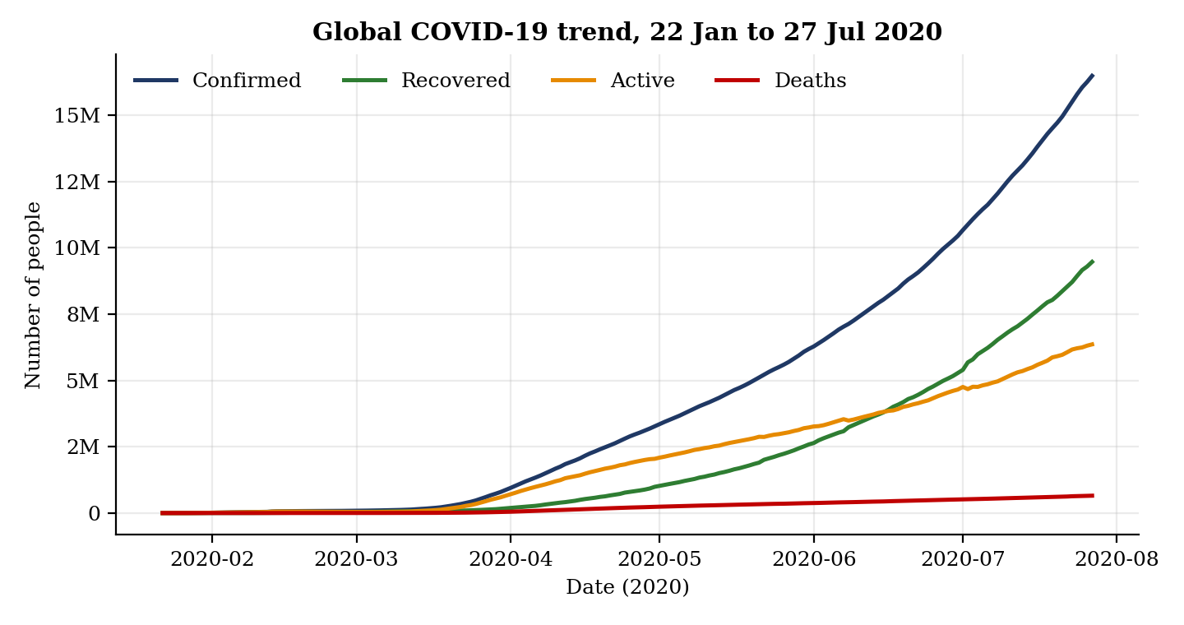
Fig 6.1 Global confirmed, recovered, active and death counts over time
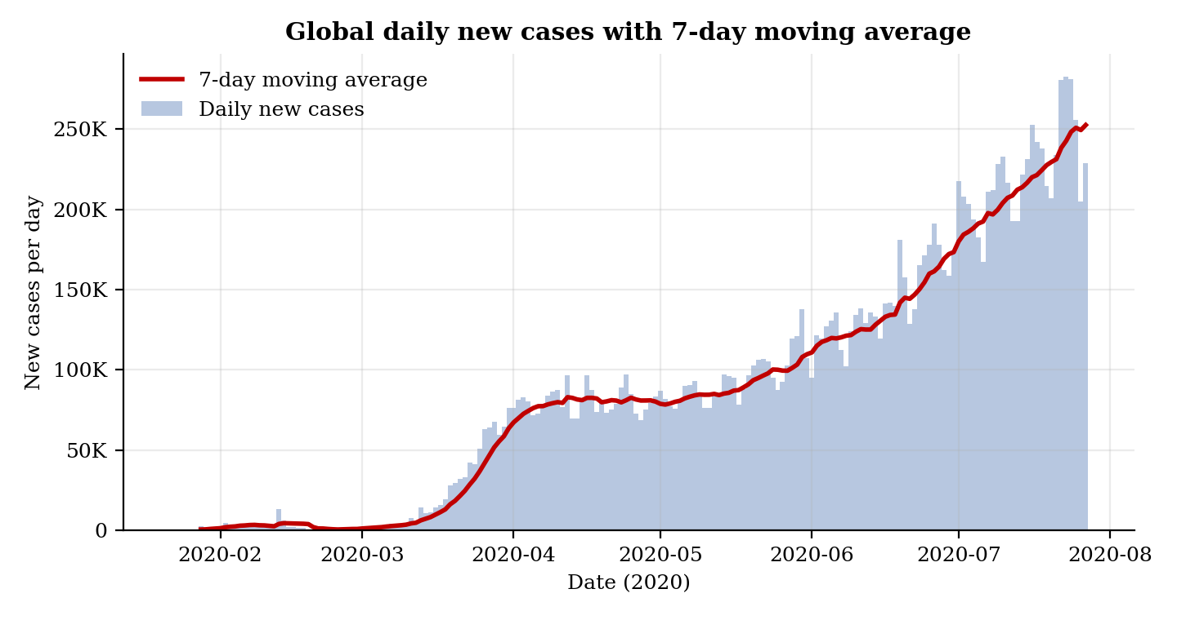
Fig 6.2 Global daily new cases with the 7-day moving average
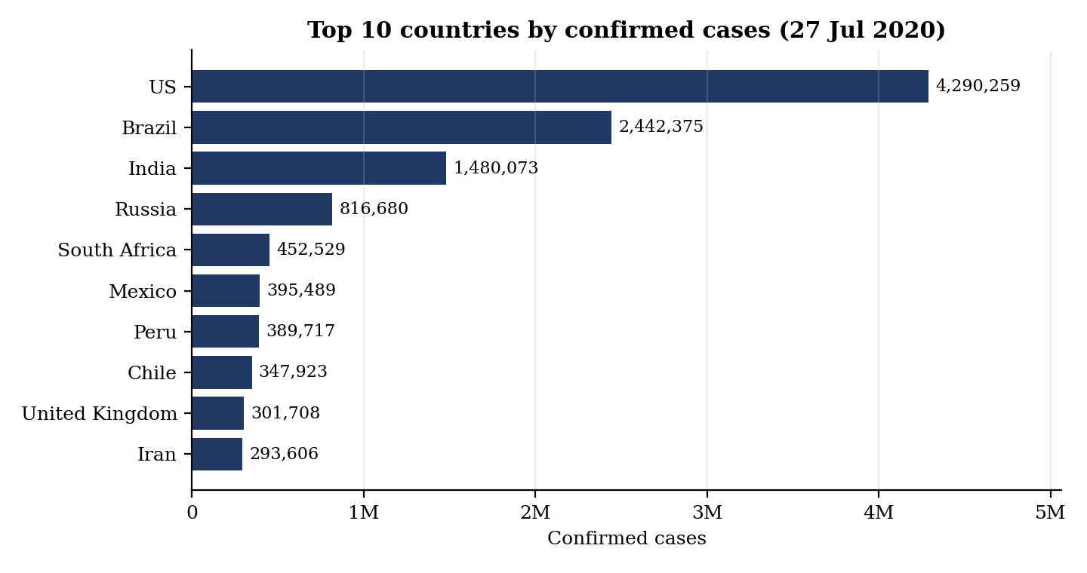
Fig 6.3 Top 10 countries by confirmed cases on 27 July 2020
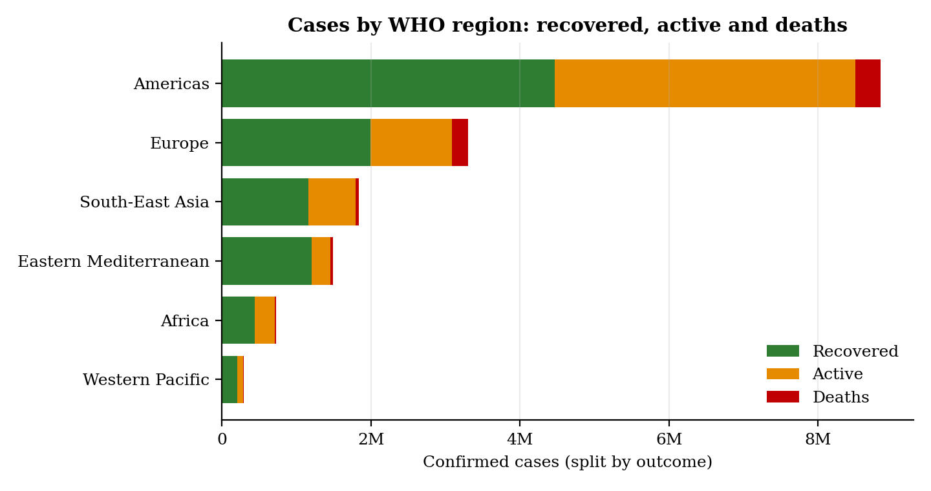
Fig 6.4 Cases by WHO region split into recovered, active and deaths
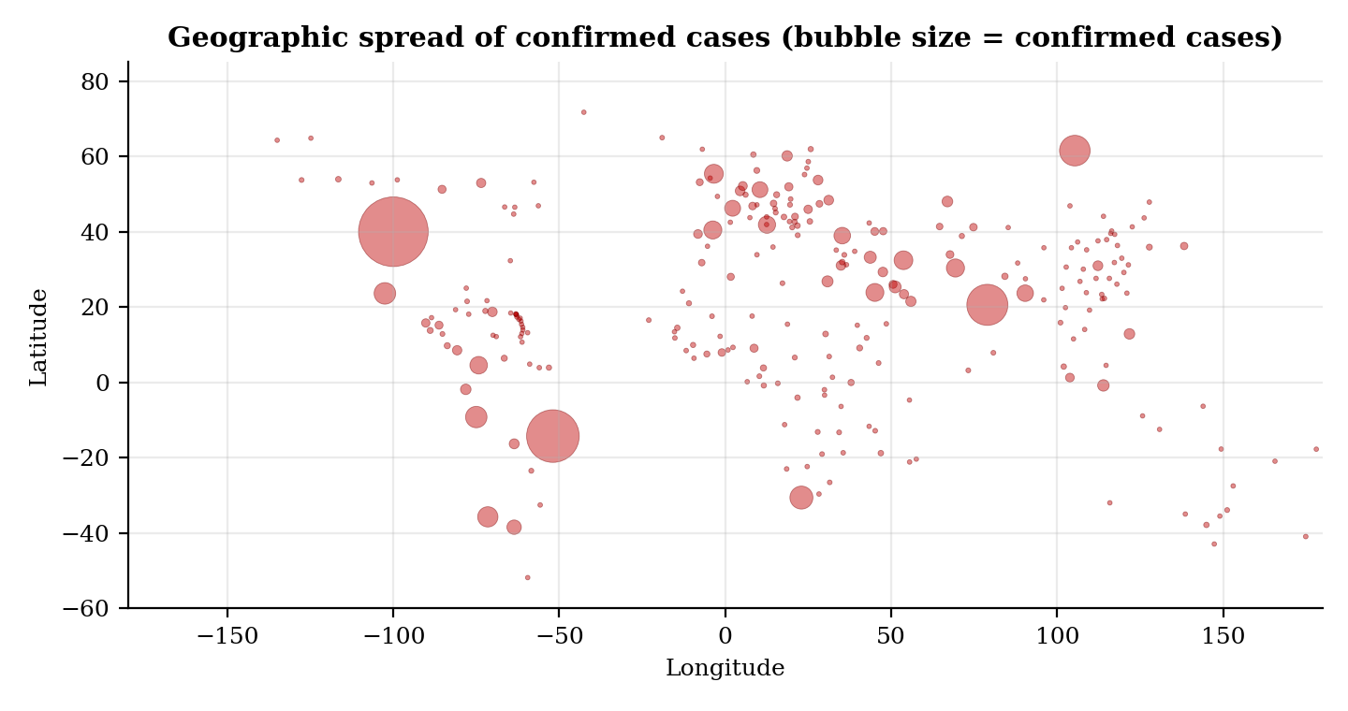
Fig 6.5 Geographic spread of confirmed cases

6.2 Global Summary
On 27 July 2020 the data records 16,480,485 confirmed cases, 654,036 deaths, 9,468,087 recoveries and 6,358,362 active cases in 187 countries. This gives 3.97 deaths per 100 confirmed cases and 57.45 recoveries per 100 confirmed cases. The number of confirmed cases first passed 100,000 on 6 March, one million on 2 April, five million on 20 May and ten million on 28 June.
Table 6.1 Global figures at selected dates
Date (2020) | Confirmed | Deaths | Recovered | Active | Countries
22 Feb | 77,967 | 2,457 | 21,849 | 53,661 | 30
22 Mar | 341,585 | 14,831 | 95,990 | 230,764 | 168
22 Apr | 2,630,314 | 187,877 | 693,207 | 1,749,230 | 184
22 May | 5,216,964 | 339,396 | 2,008,541 | 2,869,027 | 187
22 Jun | 9,071,733 | 472,756 | 4,458,093 | 4,140,884 | 187
22 Jul | 15,227,725 | 623,540 | 8,541,255 | 6,062,930 | 187
27 Jul | 16,480,485 | 654,036 | 9,468,087 | 6,358,362 | 187

6.3 Country and Regional Results
The United States, Brazil and India together account for 49.8 per cent of all confirmed cases in the data. The ten countries with the most confirmed cases are shown below.
Table 6.2 Top 10 countries by confirmed cases
Country | Confirmed | Deaths | Recovered | Active | Deaths per 100 cases
US | 4,290,259 | 148,011 | 1,325,804 | 2,816,444 | 3.45
Brazil | 2,442,375 | 87,618 | 1,846,641 | 508,116 | 3.59
India | 1,480,073 | 33,408 | 951,166 | 495,499 | 2.26
Russia | 816,680 | 13,334 | 602,249 | 201,097 | 1.63
South Africa | 452,529 | 7,067 | 274,925 | 170,537 | 1.56
Mexico | 395,489 | 44,022 | 303,810 | 47,657 | 11.13
Peru | 389,717 | 18,418 | 272,547 | 98,752 | 4.73
Chile | 347,923 | 9,187 | 319,954 | 18,782 | 2.64
United Kingdom | 301,708 | 45,844 | 1,437 | 254,427 | 15.19
Iran | 293,606 | 15,912 | 255,144 | 22,550 | 5.42

The Americas region had 8,839,286 confirmed cases, which is 53.6 per cent of the global total. The table below gives the regional totals.
Table 6.3 Totals by WHO region
WHO Region | Confirmed | Deaths | Recovered | Active
Americas | 8,839,286 | 342,732 | 4,468,616 | 4,027,938
Europe | 3,299,523 | 211,144 | 1,993,723 | 1,094,656
South-East Asia | 1,835,297 | 41,349 | 1,156,933 | 637,015
Eastern Mediterranean | 1,490,744 | 38,339 | 1,201,400 | 251,005
Africa | 723,207 | 12,223 | 440,645 | 270,339
Western Pacific | 292,428 | 8,249 | 206,770 | 77,409

6.4 Data Verification
The checks below were run on the source files before the results were used.
Table 6.4 Data verification checks
Check | Finding
Country totals compared with the global daily file | Equal: 16,480,485 confirmed and 654,036 deaths
Active = Confirmed − Deaths − Recovered | Holds in every row of the country and daily files
Duplicate date and country rows in the daily file | None found
Negative values in new deaths | 38 rows in 23 countries, the largest being −1,918 for Spain on 25 May 2020; set to zero
Negative values in active cases | 2 rows; set to zero
Missing Province/State in the map file | 34,404 of 49,068 rows (70.1 per cent), as most countries have no provinces
Country names in the latest-values file that do not match the Worldometer file | 16, for example US in one file and USA in the other
Deaths per 100 cases for 27 July 2020, calculated and compared with the value in the data | No difference

6.5 Observations and Analysis
1. Rapid growth through the spring. Confirmed cases grew from 77,967 on 22 February to 2,630,314 on 22 April. The number of countries in the data rose from 30 to 184 in the same period, so part of this growth is the spread of reporting as well as the spread of the disease.
2. Cases were still rising at the end of the data. The 7-day average of new cases was 252,425 on 27 July, the highest value in the data. Daily new cases reached 282,756 on 23 July.
3. Smoothing makes the trend readable. The daily bars in the trend chart move up and down from day to day, while the 7-day average follows the underlying direction.
4. Cases are concentrated. Three countries hold about half of all cases, and the Americas hold more than half. A few large outbreaks therefore decide the global picture.
5. Totals and per-million figures give different rankings. By total cases the United States leads. By cases per million in the Worldometer file, among countries with more than one million people, Qatar leads with 39,922, followed by Bahrain with 25,130 and Chile with 19,165.
6. Death rates differ widely and must be read with care. The median country has 2.15 deaths per 100 cases. The United Kingdom (15.19) and Mexico (11.13) are far above this, and Yemen has 28.56 on a small base of 1,691 cases. These rates depend on how many people are tested and how deaths are counted.
7. Growth was fastest in some countries with smaller totals. Among countries with at least 10,000 cases, Ethiopia had the highest one-week increase (42.52 per cent), followed by Costa Rica and Kenya. India added 324,735 cases in one week, an increase of 28.11 per cent.
8. Data revisions affect single days. On 23 July Peru's data added 3,887 deaths in one day, which is far above its normal level and produces the highest global daily death figure in the data (9,966). This looks like a revision of earlier counts.
9. Reporting is not uniform. The United Kingdom lists only 1,437 recoveries in this data, which gives 0.48 recoveries per 100 cases, so recovery figures cannot be compared across all countries.

6.6 Limitations
- The data ends on 27 July 2020, so the dashboard shows only the first seven months of the pandemic.
- The Worldometer file is from a later date than the Johns Hopkins files. For example, it lists 2,025,409 cases for India, while the other files list 1,480,073. For this reason it is used only for per-million rankings and not combined with the other files.
- Results depend on how each country tests and reports. Some countries do not report recoveries.
- Province and state data is used only for the map. The charts and rankings are at country level.
- The project does not forecast or model the spread of the disease.

CONCLUSION

What Was Achieved
The project delivered an interactive COVID-19 dashboard built from five data files. It cleans the data, calculates a 7-day moving average and deaths per 100 cases, and presents KPI cards, global trends, country comparisons, rankings, a world map and a downloadable table. Calculated values were checked against the source files, and the figures in this report come directly from the data. All the objectives listed in Chapter 2 were met.

What Was Learned
- Real data has to be checked and cleaned before it is used. The files contained negative corrections, uneven reporting and country names that differ between files.
- Moving averages and per-million figures are needed to compare countries fairly.
- Streamlit and Plotly make it possible to build an interactive dashboard with a small amount of code.
- Caching keeps a data application responsive.
- Results must be reported together with their limits, such as testing differences and the end date of the data.

Future Scope
1. Update the data automatically from a live source so the dashboard shows current figures.
2. Add forecasting models such as ARIMA or Prophet for short-term trends.
3. Add state-level views for countries such as India and the United States.
4. Add vaccination and testing data.
5. Match country names across files so that Worldometer data can be combined with the other files.
6. Deploy the dashboard online with Streamlit Community Cloud.

REFERENCES

Datasets
1. Johns Hopkins University CSSE COVID-19 data: https://github.com/CSSEGISandData/COVID-19
2. Worldometer COVID-19 data: https://www.worldometers.info/coronavirus/
3. Kaggle COVID-19 dataset compilation (the five CSV files used in this project): https://www.kaggle.com/datasets/imdevskp/corona-virus-report
4. WHO COVID-19 Dashboard: https://covid19.who.int

Research Papers
1. Dong, E., Du, H., & Gardner, L. (2020). An interactive web-based dashboard to track COVID-19 in real time. The Lancet Infectious Diseases, 20(5), 533–534.

Documentation and Resources
1. Pandas documentation: https://pandas.pydata.org/docs/
2. Plotly Python documentation: https://plotly.com/python/
3. Streamlit documentation: https://docs.streamlit.io
4. Matplotlib documentation: https://matplotlib.org/stable/
5. Python documentation: https://docs.python.org/3/

