I

**ABSTRACT**

Perturbations of stars and black holes have been one of the main topics of relativistic astrophysics for the last few decades.They are of particular importance today, because of their relevance to gravitational wave astronomy.In this review we present the theory of quasi-normal modes of compact objects from both the mathematical and astrophysical points of view.The discussion includes perturbations of black holes(Schwarzschild).

NTRODUCTION

One of the greatest creations of speculative science is the Einstein’s General Theory of Relativity. Its first solution- a black hole- is happened to be more strange mysterious. Introducing the black holes through the words of Kip Thorne,

“…..black hole: a hole in space with a definite edge into which anything can fall and out of which nothing can escape, a hole with a gravitational force so strong that even light is caught and held in its grip, a hole that curves and warps time……. Well-tested laws of physics predict firmly that black holes exist. In our galaxy alone there may be millions, but their darkness hides them from view. Astronomers have great difficulty finding them.”

-Kip S. Thorne

It is this weird nature made the black hole deeply entrenched in human imagination and one of the most studying objects in science.

**From “dark stars” to “black holes”**

The first scientific ideas on regions of gravity so strong that light cannot escape were kicked to the late 1780s. Combining Newton’s theory of gravitation with his corpuscular theory of light, John Mitchell, a British natural philosopher, presented the idea of ‘dark stars’ at Royal society, London. He argued that if a star is compact enough, the escape velocity on its surface mainly greater the velocity of light corpuscles, and the star becomes invisible. Later in 1797, mathematician Laplace promoted the same idea and he wrote on his hook,

“It is therefore possible that greatest luminous bodies in the universe are on this very account invisible.”

-Pierre-Simon Laplace

But the general acceptance of wave theory of light in the beginning of 19th century forced him to drop out the notion of dark stars.

The modern understanding of black holes begins when Karl Schwarzschild derived an exact solution for Einstein’s field equation in 1916, almost immediately after Einstein formulated his relativistic theory of gravity.

His solution showed that if the mass of the compact object confined within a critical circumference, the space will be strongly curved and the flow of time at the stars surface will be infinitely dilated. A star as small as a critical circumference, called Schwarzschild radius, must appear completely dark. This did not seem at all reasonable to physicists and astrophysicists of 1920s or even as late as the 1960s.Even Edenton, a relativity expert of his time and Einstein himself opposed the ‘Schwarzschild singularity’ theory.

But several discoveries in the 1930s made them recognized as realistic objects. Among them three major developments were,

* Chandrasekhar’s 1931 proof that there is an upper limit on the mass of white dwarfs(M≤1.4Mꙩ)
* Chadwick’s 1932 discovery of the neutron and the subsequent idea – due to Baade and Zwicky – that entire stars made up of these particles may exist. Such neutron stars would be limited to a mass less than something like 3Mꙩ.
* The seminal work on gravitational collapse by Oppenheimer and Snyder from 1939, that provided the first demonstration of how the implosion of a star forms a black hole.

Eventhough these findings confirmed that the black holes are theoretically possible, it had to wait until 1970, for the first observation evidence for the actual existence of black holes in the Universe. It came from the detection of Cygnus X-1, one of the strongest X-ray sources we can detect from Earth. It is widely believed that the Cygnus X-1 is a binary black hole system with a comparison smaller than Earth but with a mass greater than that of a neutron star.

Presently we have many black hole candidates, with stronger evidences due to the advanced optical, X-ray and radio telescopes.It is now strongly suspected that almost all galaxies contain gigantic black holes in their centers, millions or even billions of times more massive than the sun. Our own galaxy,Milky Way is expected to harbor a supermassive black hole, known as Sagittarius A*, at the center. Several gravitational wave operators are now actively searching for the signal coming from black holes and may make it possible to directly observe them in the near future.

**Characteristics of black hole**

Eventhough blackholes possess a complex mysterious nature, they have a perfect mathematical description. The mathematically defined black hole is the picture of simplicity as Chandrasekhar wrote in his monograph.

“The black holes of nature are the most perfect macroscopic objects there are in the Universe: the only elements in their construction are our concepts of space and time. And since the general theory of relativity provides only a single unique family of solutions for their descriptions, they are the simplest objects as well.”

-S. Chandrasekhar

As we mentioned already, the Schwarzschild solution is the first solution of Einstein’s field equation, represents spacetime outside a spherically symmetric massive object. The line element, which describes such a geometry is given as,

ds2 = -(1 - )dt2 + (1 - )-1  dr2 + r2(dθ2 + sin2θ dφ2) (1.1)

An important property of this solution is that it is independent of the temporal, t coordinate and depends only on r and that it is determined by only a single parameter,M , its mass. Far from the center of gravity (r $→$ ∞) the spacetime dissolve to the flat Minkowski spacetime,

ds2 = Ƞµν dxµ dxν = - dt2 + dr2 + r2(dθ2 + sin2θ dφ2) (1.2)

One can notice from Eq.(1.1) that the gravity of the massive object not only curves the space around it but warp the time near its premises. One can visualize the Schwarzschild spacetime in the embedded diagram shown in figure 1.1 and observe the following points.

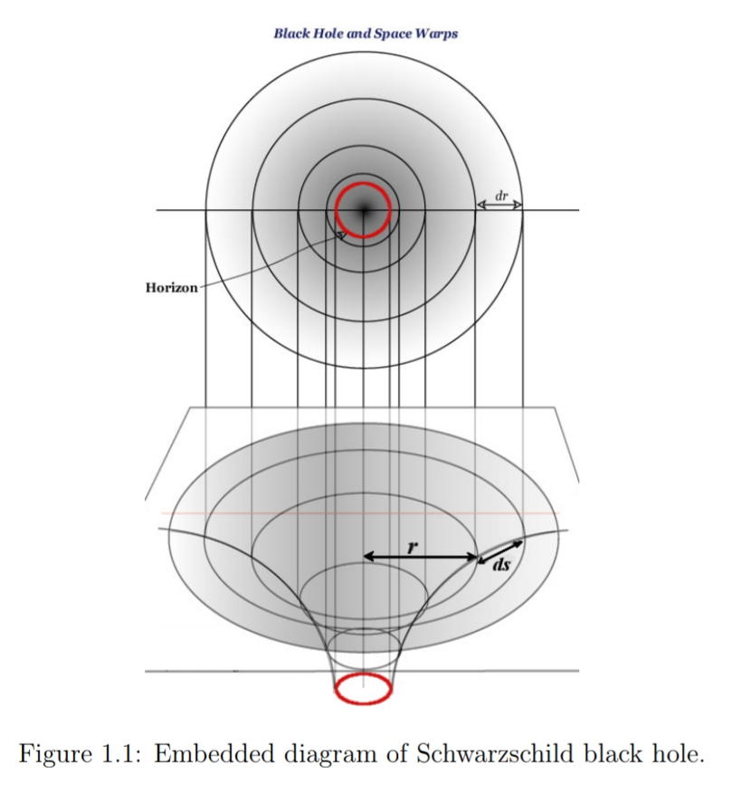

The solution is singular at two values of the radial coordinate, r=re=2M and r=0. The first one is a coordinate singularity that can be transformed away by choosing suitable coordinate systems. The second one is the actual gravitational singularity marked by an infinite curvature. The radial distance, re  is called the Schwarzschild radius and it marks a boundary called the event horizon of the black hole, which is a causality barrier through which anything can go inside but nothing can come out.

Schwarzchild black hole is the simplest case, with only one parameter determines its geometry, its mass. A theorem known as ‘no-hair theorem’ [5] limits the other properties of a black hole reaching to an external observer. According to this theorem a black hole formed by the gravitational collapse of a charged rotating star, will rapidly relax to the stationary state, characterized by only three quantities, its mass, charge and angular momentum(MQJ). Any other hair, will disappear after the collapsing body settles down to its stationary configuration(Section 1.4.2). Consequently there are four verities of black holes in GTR,

|  |
| --- |
| Black hole Signatures |
| Schwarzschild M  Reissner-Nördstrom(RN) M and Q  Kerr M and J  Kerr-Newmann M, Q and J |

We summarise this section with the words of Wheeler,

*“[The black hole] teaches us that space can be crumpled like a piece of paper into an infinitesimal dot, that time can be extinguished like a blown –out flame, and that the laws of physics that we regard as ‘sacred’, as immutable, are anything but.”*

*-John Archibald Wheeler*

**Gravitational perturbations of black holes**

The spherically symmetric uncharged stationary background spacetime is described by,

ds2 = µν dxµdxν

= - (1 - )dt2+(1 - )-1 dr2 + r2(dθ2 + sin2θ dφ2) (1.3)

Consider small perturbations, hµν in background spacetime, µν  with |hµν|/|µν|<<1, such that the total metric can be taken as the sum of unperturbed background metric and the perturbation,

ɡµν = µν + hµν.  (1.4)

Defining ψ(t,r) =(1 - $\frac{2M}{r}$) $\frac{h1}{r}$, we get a second order equation,

(ω2 - Veff)ψl = 0 (1.5)

where we have employed the radial tortoise coordinate, defines as $r_{*}$ = r +2M ln ($\frac{r}{2M}$-1), such that it pushes the event horizon, 2M all the way to -∞. As,

r $→$ +∞ , $r_{* }→ +∞ ,$

r $→2M,$ $r_{* }→-∞$,

The effective potential Veff ,usually called the Regge- Wheeler potential is given by,

Veff  = (1 - $\frac{2M}{r}$)($\frac{l(l+1)}{r^{2}} -\frac{6M}{r^{3}}$) (1.6)

The potential is positive real everywhere and has a maximum just outside the event horizon at r ≃3.3M. The asymptotic structure of the potential shows an inverse-square fall off as $r_{* }→ -∞.$ Modes with larger multipoles will experience a higher potential barrier.

Now the study of stability is reduced to finding the solution of differential equation, Eq. (1.5). With the time dependence of perturbation as $e^{-iωt}$, if the perturbation equation allow a solution with imaginaryfrequency, then the perturbations will grow exponentially in time and leads to an unstable configuration. A satisfactory explanation to this problem was first provided by Vishveshwara. By examining the asymptotic behavior of the solutions in Kruskal coordinates, he proved that the perturbations with imaginary frequency are physically unacceptable and hence that the Schwarzschild metric is stable.

Definition of quasinormal modes

Most of the problems concerning wave propagation in black hole spacetimes can be reduced to a second order partial differential equation of the form

$\frac{∂^{2}}{∂x^{2}}Ψ-\frac{∂^{2}}{∂t^{2}}Ψ-VΨ =0$ (1)

Here xis a spatial variable, usually but not always ranging(in a special coordinate system)from −∞ to +∞.when dealing with black hole spacetimes the horizon is usually at −∞, andfor the rest of this discussion we shall assume so. Also, V is an x-dependent potential .To define in a phenomenological way what a QNM is, we shall proceed in the usual way by assuming a time dependence

Ψ(t, $x$) $=e^{-iωt}ф(x)$ (2)

Inserting this in Eq.(1)we get an ordinary differential equation in the spatial variable x,

$\frac{d^{2}}{dx^{2}}ф+\left(ω^{2}-V\right)ф=0$ (3)

The form Eq.(2) is not restrictive, since once we have a solution for Eq.(3), a general time dependent solution can be given as a continuous Fourier transform of such solutions.The form (3)is ideal to study QNMs in a way that parallels a normal mode analysis.We shall now restrict ourselves to asymptotically flat spacetimes, and defer a discussion of asymptotically de Sitter (i.e., a spacetime with a positive cosmological constant) or anti-de Sitter (i.e., negative cosmological constant).In asymptotically flat spacetimes ,the potential V is positive and satisfies

V $→0, x→-∞$ (4)

V $→0, x→+∞$ (5)

Therefore, such potentials do not allow bound states,and this makes it impossible to do a normal mode expansion.The idea that the evolution of Ψ will generally involve a superposition of these QNMs can be shown to be correct by the use of Laplace transforms.Nevertheless ,we saw that the signal is somehow dominated by characteristic oscillations,so we shall blindly continue with our analysis. Having in mind the form (4)-(5) of the potential we have that near the boundaries -∞and +∞ the solution behaves as plane waves,

Ф $\sim e^{±iωx} , x →-∞$ (6)

ф $\sim e^{±iωx} , x→+∞$ (7)

The boundary conditions defining QNMs are that towards the boundaries the solutions should be purely outgoing at infinity (x=+∞)and ingoing at the horizon (x= $-$ ∞),

ф $\sim e^{-iωx} , x→-∞$ (8)

ф $\sim e^{+iωt} , x→+∞$ (9)

Here ingoing at the horizon means entering into the black hole ,therefore leaving the domain we are studying.These are physically motivated boundary conditions. Only a discrete set of complex frequencies ωQN satisfy these boundary conditions.These are the QN frequencies, and the associated wavefunctions ф, solutions of Eq.(3) are the QNMs.It has been proved by Vishveshwara that for the Schwarzschild geometry ωQN  must have a negative imaginary part; this has also been found for geometries other that Schwarzschild , for example Schwarzschild-anti-de Sitter,Schwarzschild-de Sitter, Kerr.This means on the one hand that QNMs decay exponentially in time,and the physical significance of this is that the black hole spacetime is loosing energy in the form of gravitational waves.On the other hand,this also means that the spacetime is stable. In addition,the imaginary part being negative makes the numerical calculation of QN frequencies a non-trivial task: according to the conditions(8)-(9), and to the fact the QN frequencies have a negative imaginary part, one has that QNMs grow exponentially at the boundaries.Now in order to tell if a certain frequency is or not a QN frequency one must check that, for example,there is only an out-going $e^{iωx}$ piece at infinity, or in other words, one must check that near infinity the ${e }^{-iωx}$ is absent.

However ,this last term is exponentially suppressed in relation to the other,so one must be able to distinguish numerically an exponentially small term from an exponentially large one.

ωQNM

***n l*=2*: l=3: l=4:***

**0 0.80918-0.09416i 0.37367-0.08896i 0.59944-0.09270i**

**1 0.79669-0.28449i 0.34671-0.27391i 0.58264-0.28130i**

**2 0.77271-0.47991i 0.30105-0.47828i 0.55168-0.47909i**

**3 0.73984-0.68392i 0.25150-0.70514i 0.51196-0.69034i**

Table 1 : The first four quasinormal frequencies for a Schwarzschild black hole, measured in units of the black hole mass M. To convert this to Hz one must multiply the numbers in the table by 32310 $\frac{M_{Ꙩ}}{M}$. Thus , a one solar mass black hole has a typical ringing frequency of 10 kHz in the quadrupole mode, and a damping timescale, due to gravitational wave emission, of T=3.74x10-4s.

Chandrasekhar and Detweiler have succeeded in finding some of the Schwarzschild QN frequencies this way,in 1975.Since then,numerous techniques have been developed.Some of them are analytical tools like the WKJB technique of Schutz and will,later refined to 3rd order,and recently extended to 6th order , or the “potential fit” one, in which one tries to fit the Schwarzschild potential to one which enables us to find exact results. However, the most successful attempt has been developed by Leaver,using a continued fraction form of the equations, which is rather easy to implement numerically. Exact results for QNMs of certain black hole space times only became available very recently.

In Table 1 the angular quantum number l gives the angular dependence of the gravitational wave. For example a wave with l=2, the lowest gravitational radiatable multipole, has a quadrupole distribution. Some comments are in order. First, QN frequencies come in pairs. That is, if $ω=a+ib$ is a QN frequency, then so is $ω=-a+ib.$ We only show in Table 1 frequencies with a positive real part. There are countable infinity of QN frequencies. They are usually arranged by their imaginary part. Thus, the frequency with lowest imaginary part is called fundamental frequency and is labeled with the integer $n=0$;the one with second lowest imaginary part is the first overtone $(n=1)$ and so on. The real part can be shown to be, using a WKJB type of reasoning, of the order of the height of the potentialbarrier, i.e., $Re\left[ω\right]\sim V_{max}$, where $V_{max}$ is the maximum value attained by the potential V.The real part is, in the Schwarzschild geometry, bounded from above, whereas the imaginary part seems to grow without bound for overtone number $n→∞.$

**QNMs of black holes**

The asymptotic form of the effective potentials, V( $r_{*}→±∞)→0,$ suggests that the solution behaves as plane waves near the boundaries, $r_{*}→±∞,$

$φ\sim$ $\left\{\begin{aligned}A_{in}e^{-iωr_{*}}- A_{out }e^{iωr_{* }} as{ r}_{* }→-∞, \\ B_{in}e^{-iωr_{*}} as{ r}_{* }→-∞,\end{aligned}\right.$ (1.22)

Where we have to impose purely ingoing boundary condition at the black hole event horizon $r_{*}→-∞,$ means waves entering in to the black hole and obviously nothing can come out. QNMs are the manifestation of the resonance oscillations of the black hole spacetime itself and it dominates the soon after the initial transient stage. During this stage of evolution we require a purely outgoing boundary condition at , $r_{*}→+∞.$ This means the incoming waves already passed and there is no other waves coming from $∞$ to disturb the system and we set $A_{in}$ =0 in Eq. (1.22). While applying this boundary condition in to Eq.(1.16), one can obtain a discrete set of solutions, the QNMs having the time dependence, $e^{iω_{q}t}$ with complex frequencies called the quasinormal (QN) frequencies.

$ω_{q}$ = $ω_{R}+iω_{I}$ (1.23)

The real part of the QN frequency, $ω_{R}$ corresponds to the actual oscillation frequency and the absolute value of the imaginary part, $\left| ω_{I}\right|$ represents the rate at which each mode damps or grows. If the black hole is stable against the perturbations, it should have negative imaginary part for the QN frequencies, so that the perturbations will damp exponentially and the black hole can come to its equilibrium configuration. In this case part of the energy of the perturbations is carried away to infinity in the form gravitational radiations and another part goes in to the black hole through the event horizon. In this sense these modes are not normal but ‘quasinormal’.

It was Chandrasekhar and Detweiler who first computed the quasinormal frequencies of the Schwarschild black hole and explored their properties [15].

We would like to point out here that the attempts to calculate the QNM frequencies date back to the beginning of 70s.More specifically in their study of the black hole oscillations excited by an infalling particle Davis et al.[73] found that the peak of the spectrum is (for a Schwarschild black hole) at around $M_{ω}$ =0.32 (geometrical units).This number is very close to the one calculated by much more accurate methods later.In what will follow we will describe the various methods used to calculate the QNM frequencies.

**Pöschl -Teller potential method**

Introduction

There has been great interest in the long standing issue in classical relativistic theory of gravitation: small perturbations or Quasinormal modes associated with black holes. The question of stability of a black hole was first treated by Reggae and Wheeler 1who investigated linear perturbations of the exterior Schwarzschild space time. Further work 2on this problem led to the study of quasinormal modes which is believed as a characteristic sound of black holes. Quasinormal modes(QNMs) describe the damped oscillations under perturbations in the surrounding geometry of a black hole with frequencies and damping times of oscillations entirely fixed by the black hole parameters. The study of QNMs became an intriguing subject of discussion for last few decades 3,4,5,6 and references there in. QNMs carry unique finger prints of black holes and it is well known that they are crucial in studying the gravitational and electromagnetic perturbations around black hole space times. They are also seemed to have an observational significance as the gravitational waves produced by the perturbations, in principle, can be used for unambiguous detection of black holes. This motivates us to study the quasinormal mode spectra of black holes.

The motivation of the present work is to study the signature of cosmic strings on QNMs. It has been recognized that certain gauge theories allow the possibility of topological defects, such as strings, magnetic monopoles,…. and that these defects represent objects which might have been created in the very early universe7. Cosmic strings are strand of matter which could be created in a cosmological phase transition. In 1976 Kibble suggested the possibility of strings in the early universe 8. These cosmic strings might be responsible for large-scale structure in the universe. Although little is known about these strings, it is clear that they raise a number of issues in fundamental physics and thus it seems to be of particular interest , both as a possible ”seed” for galaxy formation 9,10 and as a possible gravitational lens11.

The QNMs of scalar perturbations around a Schwarzschild black hole pierced by a cosmic string was done earlier12. We have evaluated earlier13quasinormal mode frequencies for Schwarzschild, RN extremal , SdS and near extremal SdS black hole space times with cosmic string perturbed by a massless Dirac field.in this paper we study the influence of cosmic string on the QNMs of RN black hole background space time which are perturbed by a massless Dirac field In section II, we consider the Dirac equation in a RN black hole space time with a cosmic string and its deduction into a set of second order differential equations. In section III we evaluate the Dirac quasinormal frequencies for the massless case using Pöschl-Teller potential method for RN black holes.

**Quasinormal mode frequencies**

We shall evaluate the quasi-normal frequencies for RN black hole space times perturbed by a massless Dirac field. For massless case , i.e, m=0, the equation for the potential Equation becomes,

V=*f $\left(1+\frac{Q}{Er}\right)\frac{∂}{∂r}\left(f^{\frac{1}{2}}\frac{k_{b}}{r\left(1+e\frac{Q}{Er}\right)}\right)$*+ *f ${\left(\frac{k_{b}}{r}\right)}^{2}\frac{1}{{\left(1+e\frac{Q}{Er}\right)}^{2}}$*

Where we have avoided the subscript of v1 . Here we take Q as always positive and the sign of e will be either positive or negative so that the positive sign of e actually means that the product eQ >0and vice versa.

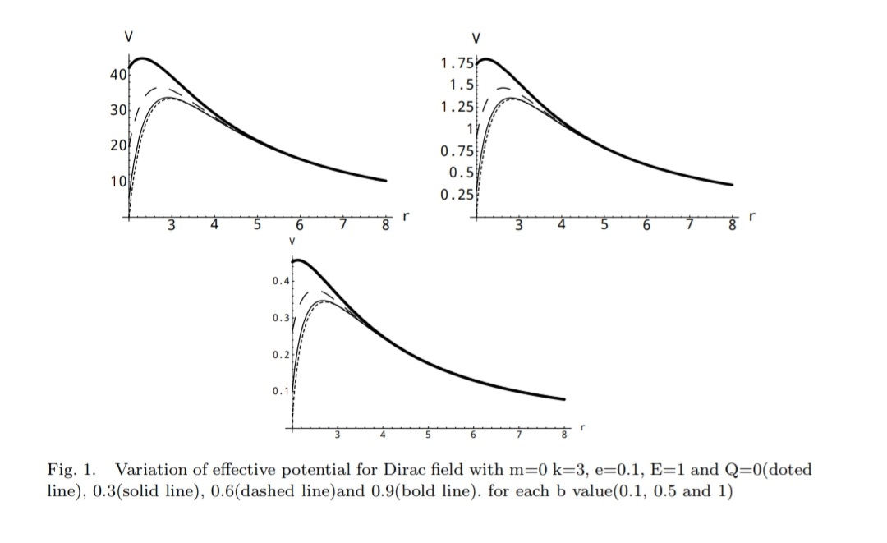

The effective potential as a function of r is plotted in fig.1. We can see that the dependence of V on Q is strong and the peak of the potential increases faster and faster with Q. When the value of b is changed from b=1 to b=0.5 and to b=0.1 the peak of the potential is increased,i.e, When the cosmic string is present the height of the potential barrier is increased.

Now we shall evaluate the QNMs using Pöschl- Tellar potential approximation proposed by Ferrari and Mashhoon18. In this method the effective potential is approximated to the pöschl-Teller potential, such that we get a good fit to the original potential at its maximum and its maximum and it allows to solve the problem analytically, and is a good approximation for the low lying frequencies. Quasinormal mode frequencies obtained by the Pöschl-Teller approximation are found to be in good agreement with the results obtained by other methods19,20. The Pöschl-Teller potential is defined as,

VPT=

The quantity V0 and b are given by the height and curvature of the potential at its maximum(r=rmax).

V0=V*r*max , =   
In Fig.2 we compare the effective potential to the corresponding Pöschl-Teller potential.

The QNMs of the Pöschl-Teller potential can be evaluated analytically;

E= $\frac{1}{b}\left[\sqrt{V_{0-}\frac{1}{4}}-\left(n+\frac{1}{2}\right)\right].$

In this case the effective potential depends both on Q and E. So we calculate the Quasinormal modes. Here we first find QNMs for the case Q=0 in which the potential is independent of E, let it be E0. We take this as the initial value E0 for a fixed *n,l* (or k) and *e* and is used to evaluate the corresponding QNMs for Q≠0. i.e, we use E0 as real to modify the potential and find E1 and repeat the process successfully to get E2,E3,E4,…….21.

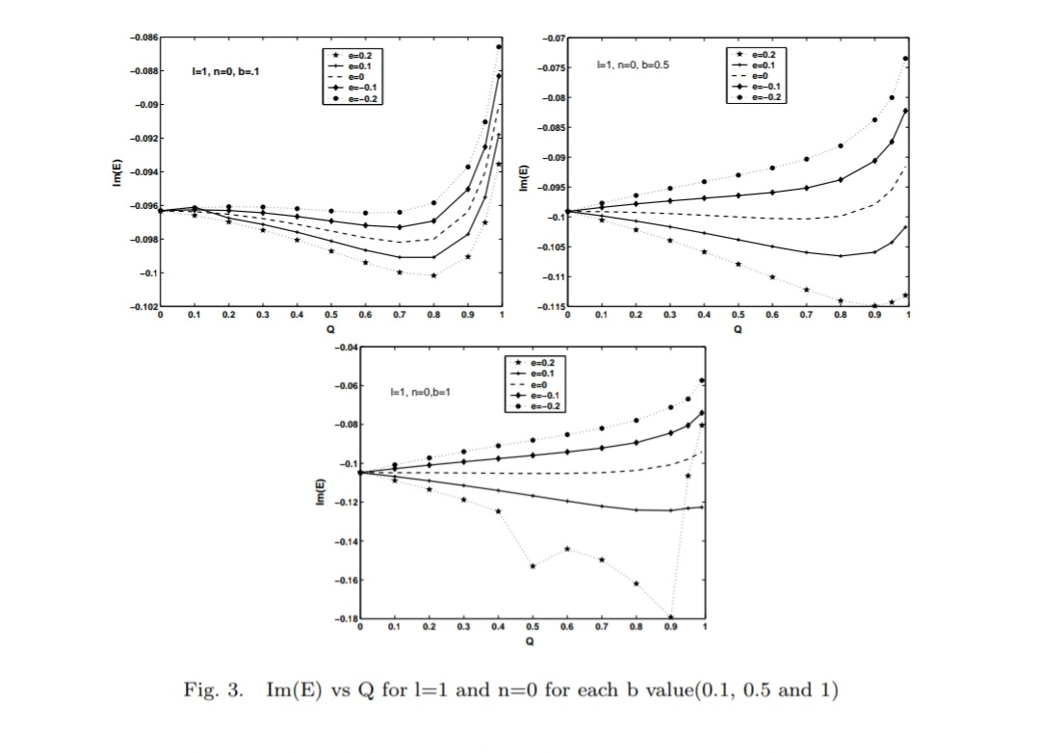 We first check the effect of positive and negative Dirac field charges ‘*e*’ on a positively charged RN black hole for a fixed *b* value. For that we plot Im(E)with black hole charge Q for different values of field charge *e* for each *b* values. Fig.3 shows the behavior of Im(E) versus Q for the mode *l*=1(k=1) and *n*=0 case. And it is clear that as black hole charge Q increases from 0 to 0.99,at first there is a small increase of |Im(E)| and then it decreases with increase of the charge Q. Also for a fixed *b* value the |Im(E)| is small for negatively charged Dirac field compared to positively charged ones. In *b*=0.1 case that is when the effect of cosmic string is high we get very good curves compared to others. When the *l* value increases the behavior is similar to the former case.

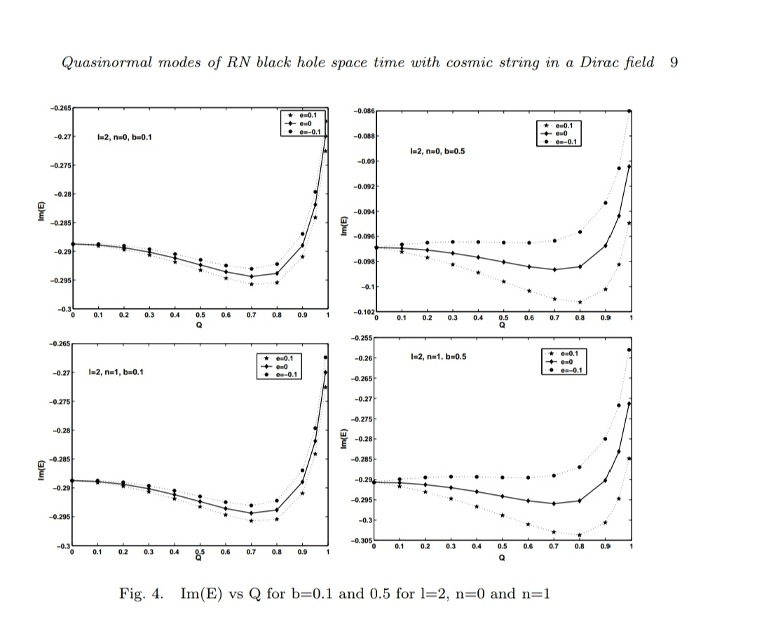

Fig.4 shows the behavior of Im(E) versus Q for *l*=2 case. Here we consider both the modes *n*=1 and *n*=0 for *b*=0.1 and *b*=0.5. Thus from this we understand that positively charged Dirac field decay faster than negatively charged Dirac field on a positively charged RN black hole with a fixed b value.

Fig.5 shows the dependence of *Re*(E) with black hole charge Q with different values of Dirac field charge e from +0.2 to -0.2 for fixed values of *b*. for all *b* values *Re*(E) is increasing with respect to Q. From the Fig.5 it is clear that *e*=-0.2 have higher *Re*(E) compared to *e*=0.2 which implies that negatively charged Dirac field have larger *Re*(E) value.

We now check for the imprint of cosmic string on the RN black hole. For this we plot Im(E) versus Q graph for various *b* values for a fixed field charge *e* as in Fig.6. Thus for the mode *l*=1,*n*=0 and when charge of the Dirac field is *e*=0.2, as Q increases |Im€| at first increases and then decreases. But when *b*=0.1 the |Im(E)| is smaller compared to others. i.e, decay is small in the case of black hole having cosmic string. This is true only for the positively charged Dirac field and for e=0. When e becomes negative, it shows another behavior. i.e., for the negatively charged Dirac field, up to some Q value(let it be Q0)|Im(E)| for b=0.1 is small compared to others. The|Im(E)| for *b*=0.1, 0.5 and 1 meets near Q0. After that |Im(E)| values for *b*=0.1 become larger than all others. i.e,up to Q0 the decay rate is small for a black hole having cosmic string and then decay rate increases.

The variation of *b* with *e* values for higher modes(for *l*=2,*n*=1 and *n*=2) are shown in Fig.7 and Fig.8. Here also |Im(E)| behaves same as above. i.e, in the case of negatively charged Dirac field, when the charge of the black hole is high, the effect due to cosmic string is suppressed.

**Perturbations by classical wave fields**

When a nearly spherical star collapses through its gravitational radius, non spherical perturbations can be expected in its electromagnetic and various other spin fields coupled to sources in the stars, along with the gravitational disturbances. One can also study the perturbation of these fields in curved spacetime, using the field theory.

If the fields are assumed to be week, the slight deformation in the background black hole spacetime, caused by the energy -momentum tensor of the field, can be neglected. The general approach to solving these problems is as follows. The field is expanded in spherical harmonics, scalar harmonics for scalar field(s=0), vector harmonics for electromagnetic field (s=1) and tensor harmonics for gravitational fields (s=2). Each spherical harmonics represented by the multipole number, l can evolve separately satisfying an equation of the form Eq. (1.16), with an effective potential characteristic of the field under consideration. For massless integer spin fields, in the Schwarzschild background spacetime, we can write[11] (A detailed derivation for various field perturbations are presented in the coming chapters),

V = $\left(1-\frac{2M}{r}\right)\left(\frac{l(l+1)}{r^{2}}+σ\frac{2M}{r^{3}}\right)$ (1.19)

Where $σ$ depends on the spin , s of the perturbing field as, $σ=1-s^{2}$ and is given by,

$σ= \left\{\begin{aligned}+1 scalar field \\ 0 electromagnetic field (1.20) \\ - 3 0dd gravitational perturbation \end{aligned}\right.$

***Normal mode frequencies for Schwarzschild***

Wr (real)

**Numerical**  **pӧschi-teller** **%**

1 0.3737 0.38895591 4.08

2 0.5994 0.60961057 1.7

3 0.8092 0.81692091 0.95

Wi (imaginary)

**Numerical**  **pӧschi-teller** **%**

1 0.0889 0.09053095 1.8

2 0.0927 0.09337064 0.7

3 0.0941 0.09454808 0.4

*Numerical results from Chandrasekhar and detweiler 1975.

***Python code***

from pylab import*

import numpy as np

r=arange(2,40,0.00001)

l=2

x=(1-2/r)

y=((l*(l+1)/r**2)-(6/r**3))

Veff=x*y

a=max(Veff)

print a

c=np.where(Veff==a)

print r[c]

r1=r[c]

l=2

k=l*(l+1)

v2=(2*(r1-2)*(-288+30*(7+k)*r1-4*(9+5*k)*r1**2+3*k*r1**3))/r1**8

print v2

b=sqrt((-2*a)/v2)

print b

wr=sqrt(a-(1/4*b**2))

print wr

n=0

wi=(2*n+1)/(2*b)

print wi

plot(r,Veff)

show()