Field-Scale Well Construction Timeline Reconstruction from WITSML Daily Drilling Reports: A Complete Operational History of the Equinor Volve Dataset
T. Appalla, Independent Researcher
IPTC-25544-MS (Control 27IPTC-P-1392-SPE)
[TJ: the proposal author block reads "Department of Mining and Energy". Change the affiliation to Independent Researcher in the IPTC author portal before uploading; the portal, not this file, sets the published front matter.]

Abstract
Daily Drilling Reports (DDRs) are the most complete operational record of how a field's wells were built, but they are rarely converted into structured, validated construction timelines, and no such timeline has been published for an openly available field dataset. This paper reconstructs field-scale well construction timelines for the Equinor Volve dataset from 1,759 WITSML DDRs covering 26 wellbores in 11 well families, and validates the result against the Norwegian Offshore Directorate (NOD) FactPages.
A deterministic, priority-ordered, rule-based classifier assigns each DDR's 24-hour narrative to one of 13 phases. The final classifier version assigns 1,303 DDRs (74.1%). A stratified audit of 50 records, drawn from the 383 unclassified DDRs that carry a genuine narrative, found 26 (52%) describing construction operations the classifier missed: drilling progress reported without a hole size, non-standard abbreviations, and operations such as fishing and fracturing for which no pattern exists. Scaled to the sampled population, this gives an estimated attainable classification rate of 85.4% (95% confidence interval 82.5 to 88.3%).
Of 24 wellbores with a defensible NOD counterpart, 22 agree exactly on total depth. 15/9-F-15 differs by 15 m, and 15/9-19 S differs by 227 m because the archive does not cover that wellbore's final drilling. All three naming mismatches between the two registers follow the Norwegian designation convention for technical sidetracks. Spud date comparison identified four WITSML data-entry errors, eight definitional offsets, and one NOD entry date that marks a later drilling campaign. The archive also stores placeholder values in 515 fields (331 depth sentinels, 7 zero depths, 176 literal "None" strings and one date sentinel) that a simple null test does not detect.
Sidetrack kick-off depths were recovered for all 15 sidetracks by one rule; where NOD records a kick-off point (12 of 15), the recovered depth agrees within 10 m for 10. The output is an open depth-time-phase dataset of 1,421 records, with per-wellbore durations to total depth, published with the classifier code. It supports days-versus-depth benchmarking and records-based screening of legacy wellbores, and the method transfers to other WITSML 1.4-series drillReport archives.

1 Introduction
Daily Drilling Reports are the primary operational record of a well construction campaign. They log depth progress, casing and cementing operations, formation encounters, and non-productive time on a per-report basis. When captured in the WITSML (Wellsite Information Transfer Standard Markup Language) exchange format (Energistics n.d.), DDRs carry both structured fields (measured depth, spud date, casing depths) and a free-text narrative summarising the preceding 24 hours of operations. Reconstructing a field-scale construction timeline from this archive requires assigning each report to a construction phase, a task complicated by inconsistent terminology, abbreviation, and the heterogeneity of narrative text accumulated over a field's multi-decade life.
This paper reconstructs such a timeline for the Equinor Volve field using 1,759 WITSML DDRs across 26 wellbores. It applies a deterministic, priority-ordered rule-based classifier to the narrative of every report, audits the unclassified residual with a formal stratified sample, and validates total depth and spud date against an independent national register, the NOD FactPages (NOD 2026a). The paper is written to be self-contained: a reader with this text, the openly available Volve dataset (Equinor 2018), and the accompanying repository should be able to reproduce every reported figure.
The contribution is the combination of three elements on a real, openly licensed field archive: a fully transparent classifier, a statistical estimate of what that classifier misses, and validation against a regulator's register across every wellbore rather than a subset. The paper also documents the data-quality characteristics of the Volve DDR archive that any other user of it will meet. The Background section situates the work against published DDR text analytics. The Data and Methods section describes extraction, classification, the audit, and wellbore matching. Data Quality and Results follow, with arithmetic shown at each step, then a Discussion of what the dataset supports, Limitations, and Conclusions.

2 Background and Related Work
Text analytics on drilling reports has developed alongside operators' interest in extracting structured information from legacy narratives. Sidahmed et al. (2015) mined free-text reports from three wells, building a dictionary of rig terms and acronyms with drilling experts and tracking weighted term frequencies over time to flag recurring operational concerns. Priyadarshy et al. (2017) presented a framework for predicting non-productive time causes from unstructured reports. Hoffimann et al. (2017) applied deep natural language processing to classify sentences in drilling reports from hundreds of wells in a single field as events, symptoms, or actions, and noted the difficulty created by technical symbols, abbreviations, misspellings, and incomplete sentences. Zhang et al. (2022) compared keyword-based and embedding-based methods for detecting operational events in drilling remarks and found that accuracy varied across report formats.
The nearest comparable published work is Karnot et al. (2025), which applies change-point detection, semi-supervised natural language processing, and sequence mining to root-cause analysis of non-productive time events. That study uses 701 DDRs from 10 wells and states that all analyses were conducted on synthetic datasets constructed for the study, not on an openly available field archive. It leaves quantitative performance assessment (precision, recall, or an equivalent accuracy measure) to future work.
The Volve dataset itself is an established benchmark for drilling analytics. Tunkiel et al. (2020), for example, derived a reference dataset for rate-of-penetration benchmarking from Volve's drilling data. Commercial analyses of Volve DDRs for subsets of wells have been described informally, but to the author's knowledge no study has published a validated, field-wide construction timeline from the Volve DDR narratives.
The common limitation across the published DDR work is that it relies on proprietary or synthetic data, so its results cannot be reproduced or extended by others. The present paper differs in three respects. It uses a deterministic, auditable classifier, trading model sophistication for transparency of every decision. It works exclusively with a real, openly licensed archive. It pairs classification with a stratified audit of the unclassified residual using a documented sampling frame and a Wilson-score interval (Wilson 1927), and with validation of total depth and spud date against a national register for the complete wellbore population.

3 Data and Methods

3.1 Data Source and Extraction
The Volve field (block 15/9, Norwegian North Sea), operated by Equinor (formerly Statoil), was released as an open dataset after decommissioning (Equinor 2018). The DDR archive was extracted from the dataset's WITSML 1.4.0.0 XML files (1,759 files, 21,315,879 bytes, each recorded with a SHA-256 hash) into a single table holding 1,759 rows, one per DDR, with no duplicate wellbore and date pairs. The rows cover 26 wellbores in 11 well families: the exploration well 15/9-19 and the platform wells 15/9-F-1, F-4, F-5, F-7, F-9, F-10, F-11, F-12, F-14, and F-15. Columns include the source XML filename, well and wellbore identifiers, report date, spud date (WITSML dTimSpud), measured depth (md_m), kick-off depth (md_kickoff_m), last casing depth (md_csg_last_m), operational parameters, and the free-text 24-hour narrative (sum24Hr). Every field is kept as a raw string at extraction, so placeholder values stay visible, and the table is regenerated from the raw files by the published code.
The md_m field is stored as a string and contains two placeholder values: the literal '-999.99', used as a missing-value sentinel, and the literal '0'. Both are excluded, and the remaining values cast to a numeric type, before any depth arithmetic.

3.2 Wellbore Designation
Norwegian wellbore names follow guidelines issued by the national regulator (NOD 2026e). Three suffix conventions matter here. "S" denotes an exploration wellbore planned to be deviated; letters A, B, and so on denote sidetracks; "R" denotes a re-entered exploration wellbore. A technical sidetrack, drilled to bypass a mechanical problem such as stuck pipe rather than to reach a new target, is designated T2 for the first, T3 for the next, and so on. The Volve WITSML archive uses the technical-sidetrack designations 15/9-19 BT2, 15/9-19 ST2, and 15/9-F-11 T2, none of which appears as a separate entry in the NOD register for the field. Section 5.4 shows that this one convention explains every naming mismatch between the two registers.

3.3 Phase Classification
Each DDR's sum24Hr narrative is classified into one of 13 phases: Spud/Conductor, Surface hole and casing, Intermediate drilling, Intermediate casing, 12¼ in. and smaller hole, Liner/Casing run, Cementing, Completion, P&A, Logging/Testing, Workover, Waiting/Downtime, and Rig move/Setup. A narrative that matches no pattern is left Unclassified. Each phase carries a fixed priority from 1 (highest) to 13 (lowest) and a set of case-insensitive regular expressions, and a DDR is assigned to the highest-priority phase with any matching pattern. Before matching, vulgar-fraction characters (½, ¼, ¾, ⅛) are replaced with ASCII equivalents, because drilling reports frequently express hole and casing sizes with these glyphs. The priority order is the order listed above. Hole and casing size separate the drilling phases: 36 in. hole and 30 in. conductor (Spud/Conductor), 26 in. hole and 20 in. casing (Surface hole and casing), 17½ in. hole (Intermediate drilling), 13⅜, 10¾ and 14 in. casing (Intermediate casing), 12¼, 8½ and 6 in. hole and coring (12¼ in. and smaller hole), and 9⅝ and 7 in. liner or casing (Liner/Casing run); the remaining phases are matched on keywords alone. Phase names describe the hole and casing sizes each pattern group matches; on Volve platform wells the 12¼ in. hole is usually the section above the reservoir. Every regular expression is listed in the repository file src/classifier_v3.py.
Three versions of the classifier were developed, each refining the pattern set for individual phases. The final version, v3, is used throughout this paper.

3.4 Stratified Audit of the Unclassified Residual
The audit estimates how many unclassified DDRs describe construction operations the pattern set failed to catch. First, a leak check reapplied the complete v3 pattern set to every unclassified record to confirm that no pipeline error had mislabelled a record that should have matched; none had. Second, every unclassified record was assigned to one of eleven descriptive categories (for example BOP_RISER, GENERIC_TRIP, PRODUCTION_MON, and EMPTY_RECORD) using patterns built from direct inspection of the unclassified population. The largest category is BOP and marine riser handling (147 of 456 records, 32.2%). The 73 records in EMPTY_RECORD have a sum24Hr field containing the literal string "None" (Section 4) and cannot be classified by any text method, so they were excluded from the sampling frame, leaving 383 records.
A stratified sample of 50 records was drawn from these 383 with a fixed random seed of 42; the rerun of the analysis from the raw files kept this sample and its strata, after confirming that each of the 50 records maps to exactly one DDR file. Two strata were defined: construction era (DDR within 730 days of the wellbore's first DDR, 296 records) and production era (more than 730 days after, 87 records); 296 + 87 = 383. Allocation was proportional, 39 construction-era and 11 production-era records (39 + 11 = 50). Each sampled record was adjudicated by the author as CONSTRUCTION or NON_CONSTRUCTION according to whether it described explicit drilling progress, coring, casing, cementing, plug activity, fishing, or completion milestones. BOP and riser handling was adjudicated NON_CONSTRUCTION unless it also named a specific hole or casing size.

3.5 External Validation Against NOD FactPages
Total depth and spud date were compared with the NOD FactPages (NOD 2026a). The Table View export was filtered to Volve wellbores and matched primarily by exact name. Three WITSML wellbores were matched by depth instead, each a technical sidetrack: 15/9-19 BT2 to NOD 15/9-19 B (both 4,250 m), 15/9-19 ST2 to NOD 15/9-19 SR (both 4,641 m), and 15/9-F-11 T2 to NOD 15/9-F-11 (4,562.1 m and 4,562.0 m). The NOD export was retrieved on 24 October 2026; its rows for the Volve wellbores are identical to an export taken on 8 September 2026 except for the register's own synchronisation date.
For the 15/9-19 series, the DDR narratives show the physical events behind the designations, and the NOD wellbore histories (NOD 2026b, 2026c, 2026d) are consistent with them. In 15/9-19 B the drillstring became stuck at 3,272 m; the string was backed off and cut, a sidetrack plug was set, and new hole was kicked off from 2,911 m under the identity 15/9-19 BT2, whose first report reads "REPORTING TRANSFERRED FROM 15/9-19B". 15/9-19 S shows the same sequence: stuck pipe at approximately 2,741 m, a backed-off and cut string, sidetrack language in the narrative ("MU BHA FOR SIDE TRACK"), and new hole from approximately 1,536 m under the identity 15/9-19 ST2. In each case NOD records the final total depth against the parent designation.

3.6 Changes Since the Conference Proposal
The work reported here supersedes the preliminary figures in the conference proposal for this paper in three respects. The unit of analysis is the wellbore (26) rather than the well. NOD validation was extended from seven wells to the full population. The formal stratified audit described above replaced a preliminary screening of an earlier classifier output, and it finds a substantially larger share of construction content in the unclassified residual than the preliminary screening suggested. The figures in this paper should be used in preference to those in the proposal.

4 Data Quality
A population survey of ten WITSML-derived columns was conducted across all 1,759 DDRs (Table 1).
Table 1: Field population survey (n = 1,759 DDRs)
Column | Populated | Count | Notes
date_report | 100.0% | 1,759
spud_date | 100.0% | 1,759 | Includes inherited and erroneous values (Section 5.5)
rig | 99.94% | 1,758 | 1 record missing (1980 sentinel)
forecast24hr (genuine) | 94.14% | 1,656 | 103 literal "None" strings excluded
operator | 99.94% | 1,758 | 1 record missing
md_csg_last_m | 96.76% | 1,702
sum24Hr (genuine narrative) | 95.85% | 1,686 | 73 literal "None" strings excluded
drill_complete | 91.70% | 1,613
md_m (excluding sentinel and zero) | 80.78% | 1,421 | 331 sentinel and 7 zero values excluded
md_kickoff_m | 14.10% | 248 | Free-text recovery required
Percentages are count / 1,759, rounded to two decimal places.
The structured kick-off field is populated in only 14.10% of rows (248 of 1,759), which is why free-text and depth-sequence methods were needed to establish sidetrack kick-off depths (Section 5.6).
A standard null-or-blank check reports 100% population for sum24Hr, but 73 records contain the literal string "None". The string is stored in the source XML itself (73 of the 1,759 files contain it), so it is a placeholder in the archive, not an artefact of extraction. A null test cannot detect a non-empty placeholder of this kind. Correcting for it, the genuine narrative population is 95.85% (1,686 of 1,759). The same placeholder appears in 103 forecast24hr values, so the genuine forecast population is 94.14% (1,656 of 1,759). Counting every placeholder in every extracted field gives 515 values: 331 depth sentinels, 7 zero depths, 176 literal "None" strings (73 narratives and 103 forecasts) and one date sentinel; 331 + 7 + 176 + 1 = 515.
A character-level survey of sum24Hr found two non-ASCII characters relevant to classification: the vulgar fraction one-half (½) in 61 DDRs (82 occurrences) and one-quarter (¼) in 10 DDRs (14 occurrences). Both are normalised before pattern matching. One further anomaly is a single record for 15/9-19 A dated 1 January 1980 (filename 15_9_19_A_1980_01_01.xml, narrative "None", no measured depth), 17.6 years before that wellbore's first genuine report on 25 July 1997. It is a date sentinel, not a drilling report. The raw files declare the ISO-8859-1 character encoding; reading them correctly repaired an encoding error that affected 103 narratives in the earlier extraction (for example the character Ø), which changes no phase.

5 Results

5.1 Classification Rate
Applying v3 to all 1,759 DDRs classifies 1,303 records (74.1%) and leaves 456 unclassified (25.9%); 1,303 + 456 = 1,759. The ported classifier was first checked against the earlier extraction: on the narratives of the earlier table it reproduced the 1,303 classified records, every per-phase count, and the earlier phase label of all 1,759 records. Applied to narratives read directly from the raw XML it gave the same phase counts, and the 103 narratives whose encoding was repaired (Section 4) changed no phase. Table 2 gives the phase distribution, and Fig. 1 shows the classified phases on depth-versus-time curves for four representative wellbores.
Table 2: Phase distribution, v3 classifier
Phase | DDR count | % of 1,759
12¼ in. and smaller hole | 256 | 14.6
Completion | 228 | 13.0
Liner/Casing run | 144 | 8.2
Waiting/Downtime | 120 | 6.8
Cementing | 100 | 5.7
Logging/Testing | 93 | 5.3
Intermediate casing | 82 | 4.7
Intermediate drilling | 77 | 4.4
Surface hole and casing | 66 | 3.8
Spud/Conductor | 52 | 3.0
P&A | 41 | 2.3
Rig move/Setup | 38 | 2.2
Workover | 6 | 0.3
Unclassified | 456 | 25.9
Total | 1,759
Percentages are rounded independently and may not sum to exactly 100.0%.

5.2 Stratified Audit and Attainable Classification Rate
Of the 50 sampled records, 26 (52%) were adjudicated CONSTRUCTION and 24 (48%) NON_CONSTRUCTION. The construction-era sample (39 records) split 23 construction to 16 non-construction, and the production-era sample (11 records) split 3 to 8. The 26 misses fall into three groups: NO_HOLE_SIZE, genuine drilling reported without a hole-size dimension (9); OTHER_MISS, operations such as hydraulic fracturing or fishing with no corresponding pattern (10); and NONSTANDARD_TERMINOLOGY, abbreviations such as "CMT" for cement (7); 9 + 10 + 7 = 26.
The sample proportion is 26/50 = 0.520, with a Wilson-score 95% interval of 0.385 to 0.652. Because the sample was drawn from the 383 records with a genuine narrative, the proportion is scaled by that population, not by all 456 unclassified records: 383/1,759 = 0.2177, so the estimated residual miss is 0.520 × 0.2177 = 0.1132, or 11.3 percentage points (approximately 199 DDRs). Adding this to the observed rate (1,303/1,759 = 0.7408) gives an estimated attainable classification rate of 85.4%. Propagating the Wilson interval gives 0.7408 + 0.385 × 0.2177 = 0.825 and 0.7408 + 0.652 × 0.2177 = 0.883, a 95% interval of 82.5 to 88.3%. Weighting the two strata by their population shares (296/383 and 87/383) gives a sample proportion of 0.518 and an attainable rate of 85.3%, so the result does not depend on whether the estimate is stratum-weighted.
The 73 EMPTY_RECORD DDRs are excluded from the attainable rate because no text method can classify them. Even a perfect pattern set would therefore leave at least 4.2% of DDRs (73/1,759) unclassified.

5.3 Timeline Dataset
The timeline dataset contains one row per DDR with a genuine md_m value. Of 1,759 DDRs, 331 carry the sentinel and 7 the zero value, giving 1,759 − 331 − 7 = 1,421 rows; recomputing the dataset from the raw XML gave the same 1,421 rows as the earlier analysis, identical in every column. Each row carries wellbore identifier, report date, days from the wellbore's first report with a recorded depth, measured depth, assigned phase, and source filename. Days are therefore counted from each wellbore's first row with a usable depth, not from its first DDR. Fig. 2 plots report number against measured depth for all 26 wellbores. The report number counts every DDR of a wellbore from its first report (1980 sentinel excluded), with or without a recorded depth, so it is the same count as the reports to TD of Table 6; only reports with a valid depth are plotted. The days_from_first_ddr column of the dataset is unchanged from v2.

5.4 Total Depth Validation
Maximum reconstructed measured depth per wellbore was compared with NOD's total depth for all 26 wellbores (Table 3, Fig. 3).
Table 3: Total depth validation, all 26 wellbores
Wellbore (WITSML) | WITSML max MD (m) | NOD TD (m) | Diff. (m) | Outcome | Note
15/9-19 A | 4,131.0 | 4,131.0 | 0.0 | Exact
15/9-19 B | 3,272.0 | n/a | n/a | Unmatched | Parent leg abandoned at stuck pipe; NOD 19 B TD matches 19 BT2
15/9-19 BT2 | 4,250.0 | 4,250.0 | 0.0 | Exact | Technical sidetrack, matched to NOD 15/9-19 B
15/9-19 S | 3,353.0 | 3,580.0 | 227.0 | Close | Archive ends before final drilling
15/9-19 ST2 | 4,641.0 | 4,641.0 | 0.0 | Exact | Technical sidetrack, matched to NOD 15/9-19 SR
15/9-F-1 | 3,632.0 | 3,632.0 | 0.0 | Exact
15/9-F-1 A | 3,682.0 | 3,682.0 | 0.0 | Exact
15/9-F-1 B | 3,465.0 | 3,465.0 | 0.0 | Exact
15/9-F-1 C | 4,094.0 | 4,094.0 | 0.0 | Exact
15/9-F-10 | 5,331.0 | 5,331.0 | 0.0 | Exact
15/9-F-11 | 347.0 | n/a | n/a | Unmatched | Parent leg; NOD 15/9-F-11 TD matches F-11 T2
15/9-F-11 A | 3,762.0 | 3,762.0 | 0.0 | Exact
15/9-F-11 B | 4,770.0 | 4,770.0 | 0.0 | Exact
15/9-F-11 T2 | 4,562.1 | 4,562.0 | 0.1 | Exact | Technical sidetrack, matched to NOD 15/9-F-11
15/9-F-12 | 3,520.0 | 3,520.0 | 0.0 | Exact
15/9-F-14 | 3,750.0 | 3,750.0 | 0.0 | Exact
15/9-F-15 | 4,090.0 | 4,105.0 | 15.0 | Close
15/9-F-15 A | 4,095.0 | 4,095.0 | 0.0 | Exact
15/9-F-15 B | 3,497.0 | 3,497.0 | 0.0 | Exact
15/9-F-15 C | 3,232.0 | 3,232.0 | 0.0 | Exact
15/9-F-15 D | 4,685.0 | 4,685.0 | 0.0 | Exact
15/9-F-4 | 3,510.0 | 3,510.0 | 0.0 | Exact
15/9-F-5 | 3,792.0 | 3,792.0 | 0.0 | Exact
15/9-F-7 | 1,085.0 | 1,085.0 | 0.0 | Exact
15/9-F-9 | 1,085.0 | 1,085.0 | 0.0 | Exact
15/9-F-9 A | 1,206.0 | 1,206.0 | 0.0 | Exact
Exact: difference of 0.5 m or less.
Of 26 wellbores, 24 have a defensible NOD counterpart. Of these, 22 agree exactly, 15/9-F-15 differs by 15 m (0.4%), and 15/9-19 S differs by 227 m. Restricting the comparison to the 19 F-series wellbores matched by literal name, 18 (94.7%) agree exactly, the exception again being 15/9-F-15. 15/9-F-7 and 15/9-F-9 share a total depth of 1,085 m; because NOD independently records 1,085 m for each, the shared value is not a duplication in the extraction.
The two unmatched wellbores and the three depth-based matches share one explanation. Each WITSML technical sidetrack (19 BT2, 19 ST2, F-11 T2) has no separate NOD entry, and NOD instead records the sidetrack's final total depth against the parent designation (19 B, 19 SR, F-11). The WITSML parent records that end short of that depth, 15/9-19 B at 3,272 m and 15/9-F-11 at 347 m, are the legs abandoned when the technical sidetrack was drilled, so they have no NOD counterpart. For 15/9-19 B the stuck-pipe event is documented in the narrative (Section 3.5); for 15/9-F-11 the designation is the evidence. The divergence is structural: the operator's WITSML system tracks each drilled leg, while the national register records the wellbore. It is not an error in either register.
15/9-19 S was an original exploration wellbore targeting the Theta Vest structure north of Sleipner East, planned as deviated, consistent with its "S" suffix. NOD's wellbore history records it as temporarily suspended at 3,569.0 m (2,394.0 m TVD RKB), immediately above the Heimdal sands (NOD 2026d). The WITSML series ends at 3,353 m, 227 m short of NOD's structured total depth (3,580.0 m) and 216 m short of the suspension depth in NOD's history text; the 11.0 m difference between those two NOD values is internal to the register. Table 3 uses the structured field, consistent with every other wellbore. The 227 m gap is a records-coverage gap: the archive does not contain reports for this wellbore's final drilling and suspension.

5.5 Spud Date Validation
Spud date was compared across three sources for every wellbore: the WITSML spud_date field, free-text spud language in the wellbore's earliest DDRs, and the NOD entry date. Table 4 summarises the outcome, and Fig. 4 plots the offset by category. The offset is the WITSML spud date minus the NOD pre-drill entry date where NOD records one, since it marks the start of top-hole drilling, and otherwise the NOD main entry date. For the four wellbores whose archive contains the NOD pre-drill entry (15/9-F-4, F-5, F-14 and F-15), the first report coincides with that date (the same day, or one day later for F-4), which supports using the pre-drill date as the spud reference. The categories were assigned by inspection of the three sources for each wellbore, and the rules in the Rule column of Table 4 were formalised afterwards to describe those assignments. Applied mechanically, the rules reproduce 25 of the 26 assignments. 15/9-F-11 was assigned Exact by inspection but is unresolved under the rule: NOD records a pre-drill campaign (6 to 17 April 2012) that is absent from the DDR archive; the archive's 2013 reports describe a fresh spud from seabed, including the 30-inch conductor, so the relationship between the two campaigns cannot be determined from these records.
Table 4: Spud date validation outcomes
Outcome | Wellbores | Rule | Detail
Exact agreement | 6 | R4: WITSML date within 1 day of the NOD date, and the first report or free-text spud follows it by at most 1 day. | 15/9-19 A, F-10, F-15 A, F-15 B, F-15 C, F-15 D
Definitional offset | 8 | R6: WITSML date within 8 days of the NOD date, and the free-text operational start follows it by 2 to 20 days. R5: a parent leg whose NOD record is claimed by a technical sidetrack and that has no free-text spud date of its own (15/9-19 B). | Administrative spud precedes operational start by days to weeks (15/9-19 B, F-1 A, F-1 B, F-1 C, F-5, F-9 A, F-11 B, F-14)
WITSML data-entry error | 4 | R2: WITSML date differs from the first report or free-text spud by more than 30 days, while the NOD date agrees with them within 3 days. | 15/9-F-4, F-7, F-12, F-15
NOD date marks later campaign | 1 | R3: WITSML date within 7 days of the first report, but more than 1 year from the NOD date. | 15/9-F-1
Inherited parent spud date | 2 | R1: the sidetrack carries the same spud date as its parent. | 15/9-F-11 A, F-11 T2
Unresolved | 5 | R5: a technical sidetrack whose NOD record is its parent leg's (15/9-19 BT2 with 19 B, 19 ST2 with 19 SR). R7: any wellbore that no other rule fits. | 15/9-19 BT2, 19 S, 19 ST2, F-9, F-11 (NOD records a pre-drill campaign, 6 to 17 April 2012, that is absent from the DDR archive; the 2013 reports describe a fresh spud from seabed, so the relationship between the campaigns cannot be determined from these records)
Total | 26
Rules are applied in the order R1 (inherited), R5 (technical sidetrack), R2 (error), R3 (later campaign), R4 (exact), R6 (definitional offset), R7 (unresolved). Unresolved includes 15/9-19 S, F-9 and F-11 (R7).

In the four error cases the structured spud_date contradicts the wellbore's own first DDR and free-text narrative by 91 to 340 days, while the first DDR, the narrative, and the NOD date agree with each other. 15/9-F-12 is the clearest example: three sources agree on 14 June 2007 and only the structured field (15 March 2007) disagrees. Two sidetracks, 15/9-F-11 A and 15/9-F-11 T2, carry a spud_date identical to their parent's, almost certainly an inherited field value rather than a spud event. 15/9-F-11 T2 is excluded from Fig. 4 because NOD does not register it separately.
15/9-F-1 required particular care. Its WITSML spud_date (28 November 2007) is four days before its first DDR (2 December 2007), which narrates drilling 36 in. hole from the seabed, an ordinary spud-to-first-report gap. The 2007 reports are top-hole only (four reports, maximum depth 226 m). F-1 was drilled to its total depth of 3,632 m in the 2013 campaign, whose first report (22 July 2013) is one day before NOD's entry date (23 July 2013). NOD records no pre-drill date for the 2007 work, unlike F-4, F-5, F-14 and F-15. NOD's date therefore marks the later campaign, not the 2007 spud, and the case is classified as NOD date marks later campaign: the WITSML value is consistent with the wellbore's own chronology.

5.6 Sidetrack Kick-Off Depth Recovery
Because the structured kick-off field is sparse, kick-off depth was recovered from the DDRs. The kick-off depth of a sidetrack is the depth at which it leaves its parent wellbore. It was read from the parent's last and the sidetrack's first reports by one rule applied to all sidetracks: the depth at which the narrative first reports new formation or departure from the parent hole; where none is stated, the depth at which the kick-off or window is started (for casing exits by a milled window, the top of the window); and where the narrative is empty, the measured depth at the parent-to-child transition.
All 15 sidetracks by designation (15/9-19 A, 19 B, 19 BT2 and 19 ST2, F-1 A, F-1 B and F-1 C, F-9 A, F-11 A, F-11 B and F-11 T2, and F-15 A to F-15 D) yielded a kick-off depth (Table 5). For 11 the depth is written in the narrative; for 3 (15/9-F-1 A, F-1 B and F-15 D) the narrative names the kick-off event but not the depth, which is taken from the measured depth of the same report; for 1 (15/9-19 ST2) both reports at the transition are empty and the depth is the measured depth there, the weakest case. For 15/9-F-1 C the last F-1 B report of 22 February 2014 reads "Commenced time drilling to1364 m. 50% formation obtained at 1364 m.", and the first F-1 C report drills 17 1/2 in. hole from that depth, so the kick-off is 1,364 m. The depth of 3,059 m that the narratives report on 13 March 2014 is the start of the 8 1/2 in. section, after casing was run, not the kick-off. 15/9-19 A is a sidetrack whose kick-off is the top of a milled window at 2,178 m (window milled from 2,178 to 2,183 m), a depth that NOD also records.
Table 5: Sidetrack kick-off depths, 15 sidetracks
Sidetrack | Parent | Kick-off depth (m MD) | Method | NOD kick-off (m) | NOD minus DDR (m) | Confidence
15/9-19 A | 15/9-19 S (per NOD) | 2,178 | depth in text | 2,178 | 0 | HIGH
15/9-19 B | 15/9-19 A | 2,231 | depth in text | 2,200 | -31 | HIGH
15/9-19 BT2 | 15/9-19 B | 2,911 | depth in text |  |  | HIGH
15/9-19 ST2 | 15/9-19 S | 1,536 | depth sequence (narrative empty) |  |  | LOW
15/9-F-1 A | 15/9-F-1 | 2,620 | event in text, depth from md | 2,620 | 0 | MEDIUM
15/9-F-1 B | 15/9-F-1 A | 2,617 | event in text, depth from md | 2,604 | -13 | MEDIUM
15/9-F-1 C | 15/9-F-1 B | 1,364 | depth in text | 1,364 | 0 | HIGH
15/9-F-9 A | 15/9-F-9 | 421.5 | depth in text | 428 | +6.5 | HIGH
15/9-F-11 T2 | 15/9-F-11 | 246 | depth in text |  |  | MEDIUM
15/9-F-11 A | 15/9-F-11 T2 | 2,586 | depth in text | 2,578 | -8 | HIGH
15/9-F-11 B | 15/9-F-11 A | 2,589 | depth in text | 2,586 | -3 | LOW
15/9-F-15 A | 15/9-F-15 | 1,381 | depth in text | 1,381 | 0 | HIGH
15/9-F-15 B | 15/9-F-15 A | 3,185 | depth in text | 3,185 | 0 | HIGH
15/9-F-15 C | 15/9-F-15 B | 2,566 | depth in text | 2,575 | +9 | MEDIUM
15/9-F-15 D | 15/9-F-15 C | 1,380 | event in text, depth from md | 1,380 | 0 | MEDIUM
Depths are m MD. NOD minus DDR is NOD's wlbKickOffPoint minus the recovered depth; blank where NOD has no value. 15/9-19 A: NOD lists 15/9-19 S as its parent wellbore. 15/9-19 S exists as a WITSML wellbore (reports of 1992), but the NOD record that ends on the day 15/9-19 A was entered (15/9-19 SR2, 18 to 25 July 1997) has no WITSML wellbore, so no WITSML parent report precedes the 15/9-19 A reports and its kick-off depth is read from those reports.
No kick-off depth exists for 15/9-19 S. Its earliest narratives describe a top-hole spud, consistent with NOD's record of it as an original exploration wellbore.
NOD's wlbKickOffPoint is available for 12 of the 15 sidetracks. It equals the recovered depth for 6 (15/9-19 A, F-1 A, F-1 C, F-15 A, F-15 B and F-15 D), differs by 10 m or less for 4 (15/9-F-9 A, F-11 A, F-11 B and F-15 C), and by more for 2 (15/9-19 B, 31 m; 15/9-F-1 B, 13 m). NOD has no kick-off value for 3 (15/9-19 BT2, 19 ST2 and F-11 T2). The least certain depths are 15/9-19 ST2, which rests on the measured depth alone, and 15/9-F-11 B, where the narrative reports cement and new formation drilled from 2,531 to 2,589 m and the end of the interval is taken as the departure.

5.7 Duration to Total Depth
Table 6 gives, for each wellbore, the first report (the 1980 date sentinel excluded), the date total depth was first reached (the maximum valid depth of Table 3), the elapsed calendar days from the first report to that date, the number of reports in that span (inclusive), the drilled length (total depth minus the kick-off depth of Table 5 for the 15 sidetracks, total depth for the other 11) and metres per report-day (drilled length divided by the number of reports). Elapsed days and reports agree where a wellbore was reported daily and differ where the archive has gaps; wellbores whose elapsed days exceed twice their reports are flagged. Seven of the 26 are flagged (15/9-19 S, F-1, F-4, F-5, F-9, F-14 and F-15). F-1 reaches its total depth of 3,632 m on 17 August 2013, 2,085 days after its first report on 2 December 2007, in 31 reports, four of them from 2007. 15/9-19 B (3,272 m) and 15/9-F-11 (347 m) end at the depth of an abandoned parent leg or stub (Section 5.4), so their durations are indicative only. Drilled lengths and rates for sidetracks depend on the kick-off depths of Section 5.6; rates are per reported day, not per elapsed day, and for F-1 they mix two campaigns. Per-phase report counts for each wellbore and well family are published with the duration table.
Table 6: Duration to total depth (TD) and drilled length, 26 wellbores
Wellbore | First report | TD (m) | TD reached | Elapsed days to TD | Reports to TD | Gap flag | Drilled length (m) | m per report-day
15/9-19 A | 1997-07-25 | 4,131 | 1997-08-22 | 28 | 29 |  | 1,953 | 67.3
15/9-19 B (indicative) | 1997-11-10 | 3,272 | 1997-11-28 | 18 | 19 |  | 1,041 | 54.8
15/9-19 BT2 | 1997-12-06 | 4,250 | 1998-01-11 | 36 | 37 |  | 1,339 | 36.2
15/9-19 S | 1992-09-09 | 3,353 | 1992-12-09 | 91 | 39 | yes | 3,353 | 86.0
15/9-19 ST2 | 1992-12-19 | 4,641 | 1993-03-12 | 83 | 68 |  | 3,105 | 45.7
15/9-F-1 | 2007-12-02 | 3,632 | 2013-08-17 | 2,085 | 31 | yes | 3,632 | 117.2
15/9-F-1 A | 2013-08-24 | 3,682 | 2013-08-26 | 2 | 3 |  | 1,062 | 354.0
15/9-F-1 B | 2013-08-30 | 3,465 | 2013-09-07 | 8 | 8 |  | 848 | 106.0
15/9-F-1 C | 2014-02-22 | 4,094 | 2014-03-15 | 21 | 22 |  | 2,730 | 124.1
15/9-F-10 | 2009-04-07 | 5,331 | 2009-06-03 | 57 | 58 |  | 5,331 | 91.9
15/9-F-11 (indicative) | 2013-03-08 | 347 | 2013-03-20 | 12 | 13 |  | 347 | 26.7
15/9-F-11 A | 2013-05-15 | 3,762 | 2013-05-22 | 7 | 7 |  | 1,176 | 168.0
15/9-F-11 B | 2013-05-29 | 4,770 | 2013-06-12 | 14 | 15 |  | 2,181 | 145.4
15/9-F-11 T2 | 2013-03-24 | 4,562.1 | 2013-05-05 | 42 | 43 |  | 4,316.1 | 100.4
15/9-F-12 | 2007-06-14 | 3,520 | 2007-08-25 | 72 | 73 |  | 3,520 | 48.2
15/9-F-14 | 2007-11-06 | 3,750 | 2008-06-15 | 222 | 61 | yes | 3,750 | 61.5
15/9-F-15 | 2007-11-19 | 4,090 | 2008-11-29 | 376 | 55 | yes | 4,090 | 74.4
15/9-F-15 A | 2008-12-12 | 4,095 | 2009-01-05 | 24 | 25 |  | 2,714 | 108.6
15/9-F-15 B | 2009-01-14 | 3,497 | 2009-01-15 | 1 | 2 |  | 312 | 156.0
15/9-F-15 C | 2009-01-19 | 3,232 | 2009-02-14 | 26 | 27 |  | 666 | 24.7
15/9-F-15 D | 2013-11-11 | 4,685 | 2013-12-02 | 21 | 22 |  | 3,305 | 150.2
15/9-F-4 | 2007-06-10 | 3,510 | 2008-02-16 | 251 | 40 | yes | 3,510 | 87.8
15/9-F-5 | 2007-11-15 | 3,792 | 2008-07-30 | 258 | 31 | yes | 3,792 | 122.3
15/9-F-7 | 2007-09-15 | 1,085 | 2007-10-06 | 21 | 22 |  | 1,085 | 49.3
15/9-F-9 | 2007-11-29 | 1,085 | 2008-08-30 | 275 | 14 | yes | 1,085 | 77.5
15/9-F-9 A | 2009-07-04 | 1,206 | 2009-07-09 | 5 | 6 |  | 784.5 | 130.8
Gap flag: elapsed days to TD exceed twice the reports to TD. Drilled length is total depth minus the Table 5 kick-off depth for sidetracks and total depth for original wellbores; for the original wellbores this is measured depth from the rig datum and includes the water depth. (indicative): TD is the depth of an abandoned parent leg or stub.

6 Discussion

6.1 What the Dataset Supports
The 1,421-row depth-time-phase dataset converts an archive of narrative reports into a form that can be queried directly. Depth-versus-report-count curves (Fig. 2) can be compared across wellbores drilled from the same platform, phase durations can be extracted for offset-well planning, and the classified phases locate casing, cementing, and P&A operations in time and depth for each wellbore. Because the classifier is deterministic and the audit quantifies its residual, a user can bound how much of any phase-based statistic may be missing: at the attainable-rate estimate, roughly 199 DDRs of construction content remain unassigned, concentrated in drilling progress reported without a hole size. Table 6 gives elapsed days, reports and metres per report-day to total depth for each wellbore as a first benchmark, with the gap flag marking wellbores whose elapsed time cannot be read as drilling time.

6.2 Data-Quality Lessons for WITSML Archive Users
Several characteristics of this archive would mislead an analysis that trusted structured fields at face value, and each is likely to recur in other WITSML archives:
- Placeholder values that pass null tests: the depth sentinel '-999.99', the zero string '0', and the string "None" (in the narrative and forecast fields), together with the date sentinel, affect 515 field values (331 + 7 + 176 + 1).
- A date sentinel (1 January 1980) that, if treated as a genuine first report, shifts a wellbore's entire drilling campaign into the wrong era of any time-based analysis.
- Structured spud dates that contradict the wellbore's own first report (four wellbores) or are inherited from the parent (two sidetracks).
- A structured kick-off field populated in only 14.10% of rows, so sidetrack geometry must be recovered from narrative.
- Technical-sidetrack designations that have no counterpart in the national register, so a join on wellbore name silently drops valid records.
None of these is an error that invalidates the archive. Each requires an explicit rule, and the rules used here are published with the code.

6.3 Relevance to Records-Based Screening of Legacy Wellbores
Assessments of depleted fields for CO2 storage, and decommissioning reviews generally, rely on an inventory of existing wellbores and on evidence of how each was constructed and abandoned. The reconstruction shows three ways in which a national register alone gives an incomplete inventory. First, abandoned parent legs below technical sidetracks (15/9-19 B to 3,272 m and 15/9-F-11 to 347 m) exist physically but are not separate register entries. Second, wellbores that share a physical interval, such as the four wellbores of the 15/9-F-1 family, which share the hole above 1,364 m MD, are not independent penetrations above their kick-off depths. Third, the archive can simply stop: 15/9-19 S has no reports covering its final 227 m. A screening assessment should record a gap of this kind as an evidence gap rather than infer the missing history. The phase-classified timeline gives the starting point for locating the casing, cementing, and plugging records that such an assessment needs.

6.4 Transferability
The audit protocol, the placeholder checks, and the wellbore-matching logic transfer directly to WITSML 1.4-series drillReport archives (tested here on 1.4.0.0). The pattern set is tuned to the English-language narratives and abbreviations of one operator over one field's life, so applying it elsewhere will require a pattern review, and the audit should be repeated to measure the new residual rather than assuming the Volve figure carries over.

7 Limitations
The classifier assigns a single primary phase to each DDR. A DDR narrating both drilling progress and cementing is assigned to the higher-priority drilling phase, so the Cementing count underrepresents days on which cementing occurred alongside another operation.
The audit adjudicated construction content only. Unclassified records describing operations that belong to non-construction phases in the classifier (for example waiting or rig moves) were adjudicated NON_CONSTRUCTION, so the attainable rate is conservative with respect to those phases. The sample of 50 was adjudicated by a single reviewer, the author, and no inter-rater agreement was measured. The interval of 82.5 to 88.3% reflects the modest sample size.
Two records were assigned to a stratum that does not reflect their operational context, although both were adjudicated correctly on content. The 1980 date sentinel for 15/9-19 A places that wellbore's 1997 drilling in the production-era stratum, and 15/9-F-1's 2013 drilling campaign reports also fall into the production-era stratum.
The timeline includes only DDRs with a genuine measured depth, and no interpolation is performed. Discontinuities where a run of DDRs carries a placeholder value are missing data, not periods without drilling.
Kick-off depths were read from the narratives by one rule, and two rest on weaker evidence: 15/9-19 ST2 on the measured depth alone and 15/9-F-11 B on an interval of cement and new formation (2,531 to 2,589 m). NOD gives no kick-off point for three sidetracks. All four wellbores of the 15/9-F-1 family (F-1, F-1 A, F-1 B and F-1 C) share the hole above 1,364 m MD, and F-1, F-1 A and F-1 B share it above approximately 2,617 to 2,620 m MD; any formation-level analysis treating them as independent must account for this. Metres per report-day are rates per reported day, not per elapsed day, and the elapsed time to total depth is affected by gaps between reports in the archive (the gap flag in Table 6).
No isolated ablation was run for the effect of Unicode normalisation on the classification rate. The survey confirms 61 DDRs contain ½ and 10 contain ¼, and the normalisation handles both, but its effect was not separated from other pattern changes between versions.
The analysis starts from the raw XML, extracted by the published code with every field kept as a raw string, but an extraction error would still propagate to every result. The near-exact agreement with NOD on total depth (22 of 24) indicates the depth fields were extracted faithfully.

8 Conclusions
- A deterministic, 13-phase rule-based classifier assigns 1,303 of 1,759 Volve WITSML DDRs (74.1%) to a construction phase, with every decision traceable to a published pattern.
- A stratified audit found that 52% of sampled unclassified narratives describe construction operations, giving an estimated attainable classification rate of 85.4% (95% CI 82.5 to 88.3%). The main gaps are drilling progress reported without a hole size, non-standard abbreviations, and fishing and fracturing operations.
- Reconstructed total depth agrees exactly with the NOD register for 22 of 24 matched wellbores. The two differences are explained: 15 m on 15/9-F-15, and a records-coverage gap of 227 m on 15/9-19 S.
- Every naming mismatch between the WITSML archive and the national register follows the Norwegian technical-sidetrack convention. Parent legs abandoned below technical sidetracks exist physically but are not separate register entries.
- The structured spud date should not be used without checking it against the first DDR: four wellbores carry data-entry errors, two sidetracks carry inherited values, and one apparent error is a NOD entry date that marks a later drilling campaign.
- Sidetrack kick-off depths were recovered for all 15 sidetracks by one rule; for 15/9-F-1 C the kick-off is 1,364 m, not the 3,059 m start of the 8 1/2 in. section, and the four wellbores of the 15/9-F-1 family share their hole above that depth.
- Placeholder values that pass a null test affect 515 field values in the archive and must be removed explicitly before analysis.
- The resulting 1,421-row depth-time-phase dataset and the classifier are published openly.
Future work should enlarge the audit sample with a second independent adjudicator, close the identified pattern gaps, validate the reconstructed timelines against the Final Well Reports and End of Well Reports held in the Volve archive, and extend the duration results to phase-level durations across the campaign.

Acknowledgements
The author thanks Equinor ASA and the Volve licence partners for releasing the Volve dataset as an open resource, and the Norwegian Offshore Directorate for the FactPages database. This work was conducted independently of the author's employer, which had no role in it.
Generative AI (Anthropic Claude, used through Claude Code) built and ran the reproducible analysis pipeline from the raw data and was used to assist with debugging, checking arithmetic and editing the manuscript text. The sidetrack kick-off depths were proposed by the AI tool from the narratives under one rule. The author rejected the tool's first proposals for three sidetracks (15/9-19 A, 15/9-F-9 A and 15/9-F-11 B) and kept the earlier values, then reviewed all 15 depths and approved every one without change. The author made all 50 audit adjudications, reviewed all AI-assisted content, and takes full responsibility for the paper.

Code and Data Availability
The classifier (v3), the extraction and analysis code, the 1,421-row timeline dataset, the audit adjudications (file name, wellbore, date, stratum, call and miss reason), the NOD comparison tables, the kick-off and duration tables, and a numbers registry tracing every reported figure to the script that produced it are available at https://github.com/985185/volve-well-construction-timeline. DDR narrative text is not redistributed: the Volve data are available from Equinor under the Equinor Open Data Licence (https://www.equinor.com/energy/volve-data-sharing), and the repository holds only file names, dates, depths, categories and quotes of 15 words or fewer. [TJ: confirm every item listed is in the public repository before you upload the manuscript; Stage 13 checks this.]

Abbreviations
BOP = blowout preventer
CI = confidence interval
DDR = Daily Drilling Report
MD = measured depth
NOD = Norwegian Offshore Directorate (formerly Norwegian Petroleum Directorate)
P&A = plug and abandonment
RKB = rotary kelly bushing
TD = total depth
TVD = true vertical depth
WITSML = Wellsite Information Transfer Standard Markup Language

References
Energistics. n.d. Wellsite Information Transfer Standard Markup Language (WITSML), data schema version 1.4.0.0, as declared in the Volve DDR files. Houston, Texas: Energistics. https://www.energistics.org/witsml-data-standards/ (accessed 24 October 2026).
Equinor. 2018. Volve Field Data Set. Released under the Equinor Open Data Licence. https://www.equinor.com/energy/volve-data-sharing.
Hoffimann, J., Mao, Y., Wesley, A., and Taylor, A. 2017. Sequence Mining and Pattern Analysis in Drilling Reports with Deep Natural Language Processing. arXiv:1712.01476. https://doi.org/10.48550/arXiv.1712.01476.
Karnot, M.H., Abdulkhaleq, H.B., Al-Mudhafar, W.J., Alibraheem, A., Alsubaih, A., and Alshawi, U. 2025. Deep Natural Language Processing for Automatic Root Cause Analysis of Non Productive Time Events in Drilling Reports. Presented at the SPE Annual Technical Conference and Exhibition, Houston, Texas, USA, 20–22 October. SPE-228268-MS. https://doi.org/10.2118/228268-MS.
Norwegian Offshore Directorate. 2026a. FactPages. https://factpages.sodir.no (accessed 24 October 2026).
Norwegian Offshore Directorate. 2026b. Wellbore History: 15/9-19 A. FactPages. https://factpages.sodir.no/en/wellbore/pageview/exploration/all/3145 (accessed 11 September 2026).
Norwegian Offshore Directorate. 2026c. Wellbore History: 15/9-19 B. FactPages. https://factpages.sodir.no/en/wellbore/pageview/exploration/all/3251 (accessed 11 September 2026).
Norwegian Offshore Directorate. 2026d. Wellbore History: 15/9-19 S and 15/9-19 SR. FactPages. https://factpages.sodir.no/en/wellbore/PageView/Exploration/By/ByEntryDate/2105 (accessed 11 September 2026).
Norwegian Offshore Directorate. 2026e. Guidelines for Designation of Wells and Wellbores. https://www.sodir.no/globalassets/1-sodir/regelverk/tematiske-veiledninger/eng/guidelines-for-designation-of-wells-and-wellbores.pdf (accessed 23 October 2026).
Priyadarshy, S., Taylor, A., Dev, A., Venugopal, S., and Nair, G.G. 2017. Framework for Prediction of NPT Causes Using Unstructured Reports. Presented at the Offshore Technology Conference, Houston, Texas, USA. OTC-27918-MS. https://doi.org/10.4043/27918-MS.
Sidahmed, M., Coley, C.J., and Shirzadi, S. 2015. Augmenting Operations Monitoring by Mining Unstructured Drilling Reports. Presented at the SPE Digital Energy Conference and Exhibition, The Woodlands, Texas, USA. SPE-173429-MS. https://doi.org/10.2118/173429-MS.
Tunkiel, A.T., Sui, D., and Wiktorski, T. 2020. Reference Dataset for Rate of Penetration Benchmarking. J Pet Sci Eng 196: 108069. https://doi.org/10.1016/j.petrol.2020.108069.
Wilson, E.B. 1927. Probable Inference, the Law of Succession, and Statistical Inference. J Am Stat Assoc 22 (158): 209–212. https://doi.org/10.1080/01621459.1927.10502953.
Zhang, Z., Hou, T., Kherroubi, J., and Khvostichenko, D. 2022. Event Detection in Drilling Remarks Using Natural Language Processing. Presented at the IADC/SPE International Drilling Conference and Exhibition, Galveston, Texas, USA. SPE-208779-MS. https://doi.org/10.2118/208779-MS.

Figures
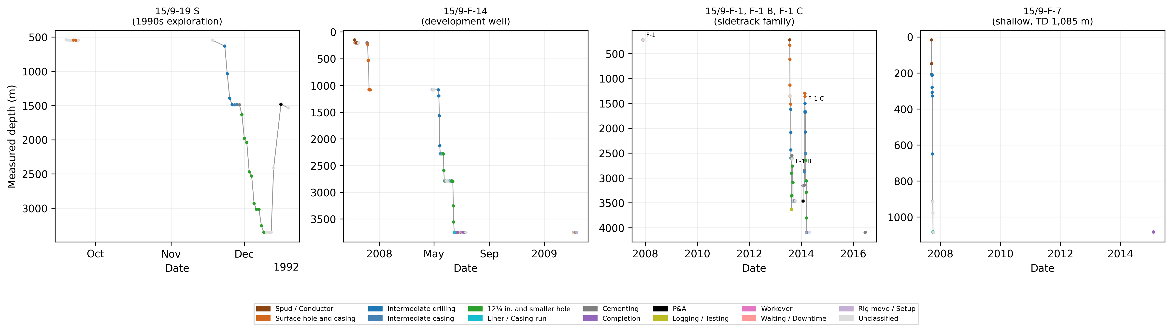
Fig. 1: Depth versus time for four representative wellbores, coloured by classified phase.
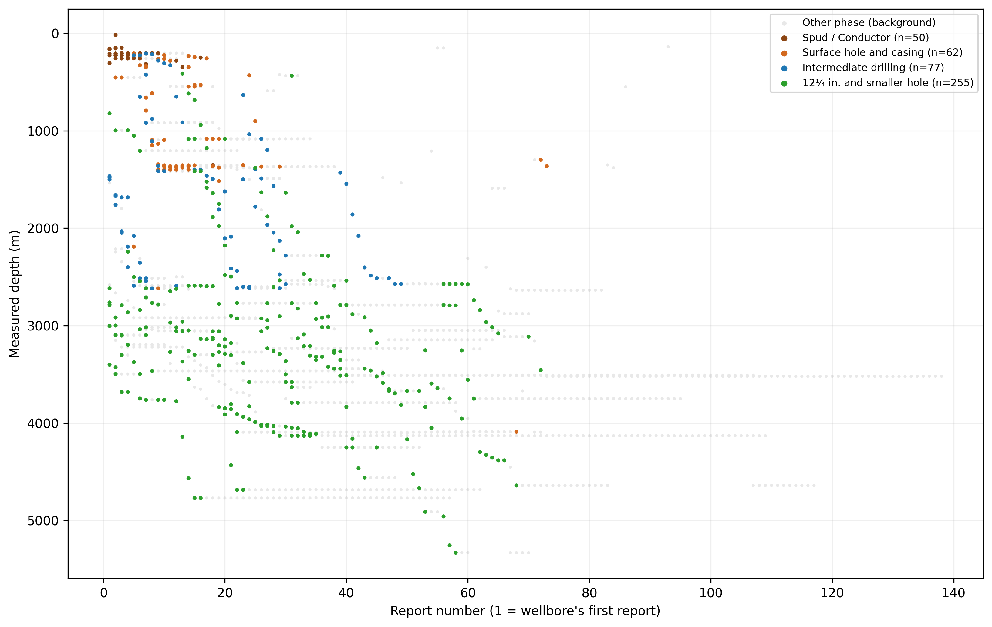
Fig. 2: Report number (1 = the wellbore's first report, as counted in Table 6) versus measured depth for all 26 wellbores, coloured by hole section (other phases and unclassified reports in grey).
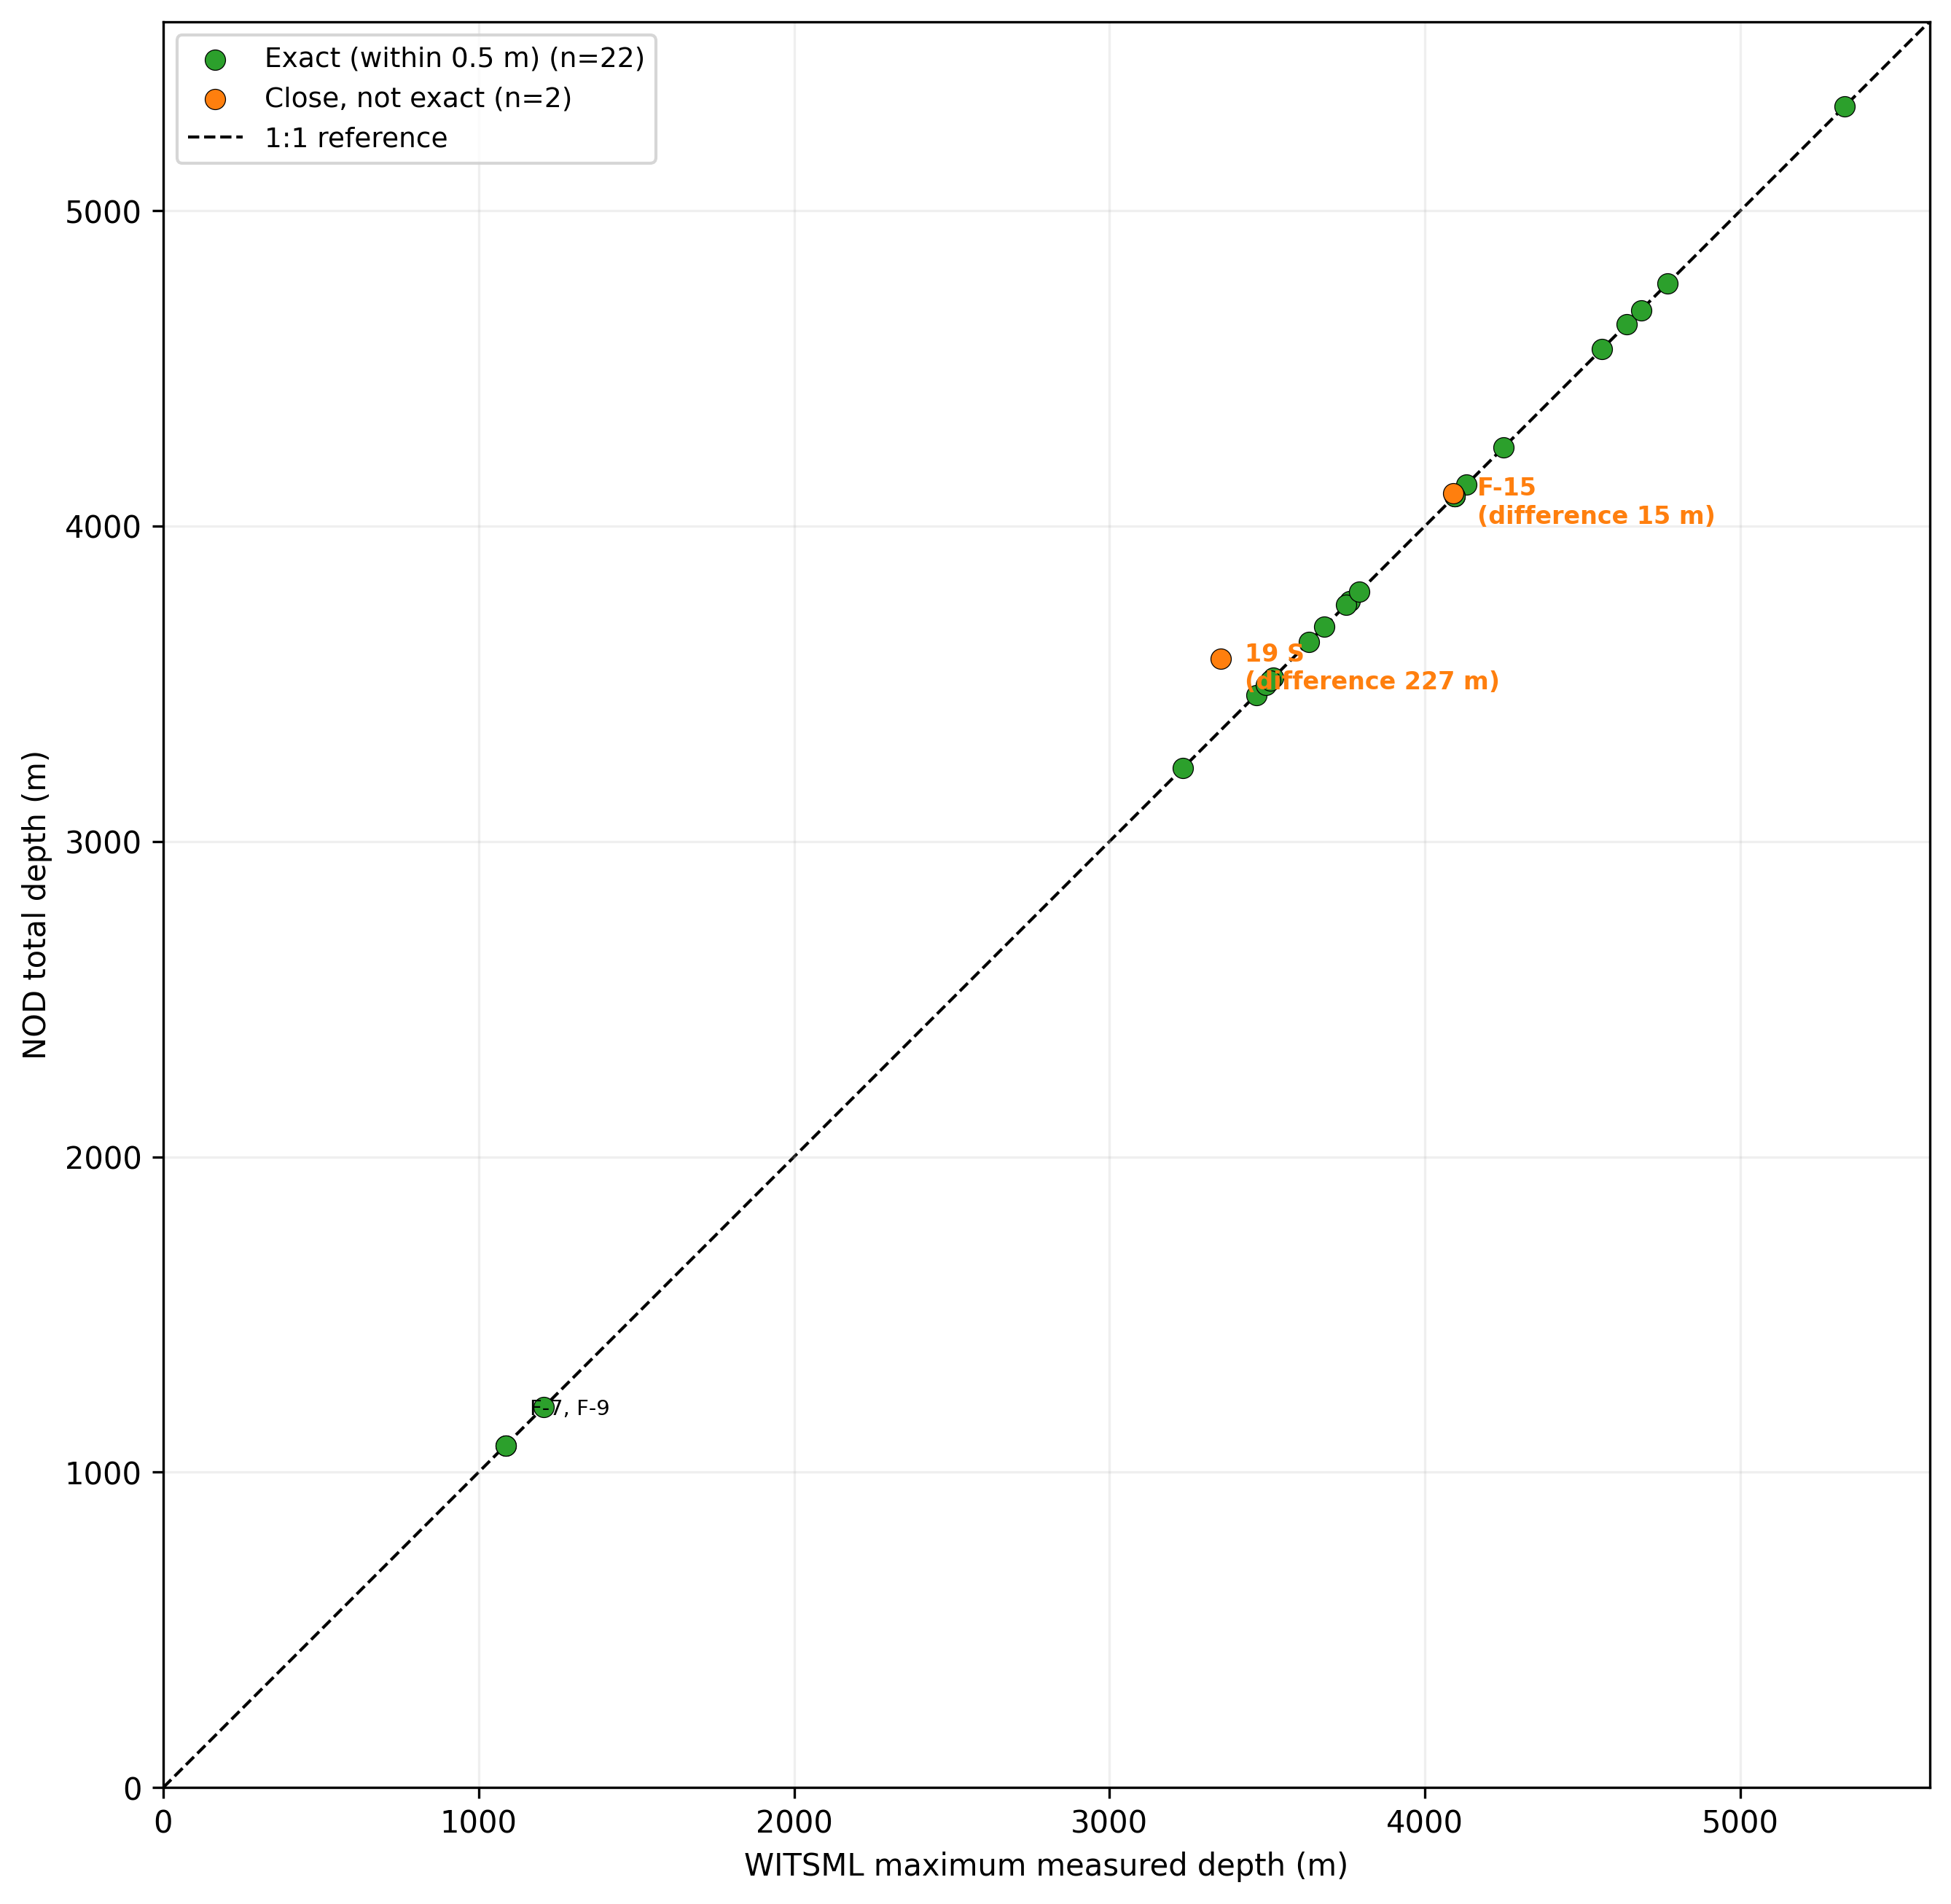
Fig. 3: Reconstructed WITSML maximum MD versus NOD total depth for the 24 matched wellbores, with 1:1 reference line. The two unmatched wellbores (15/9-19 B and 15/9-F-11) are not plotted.
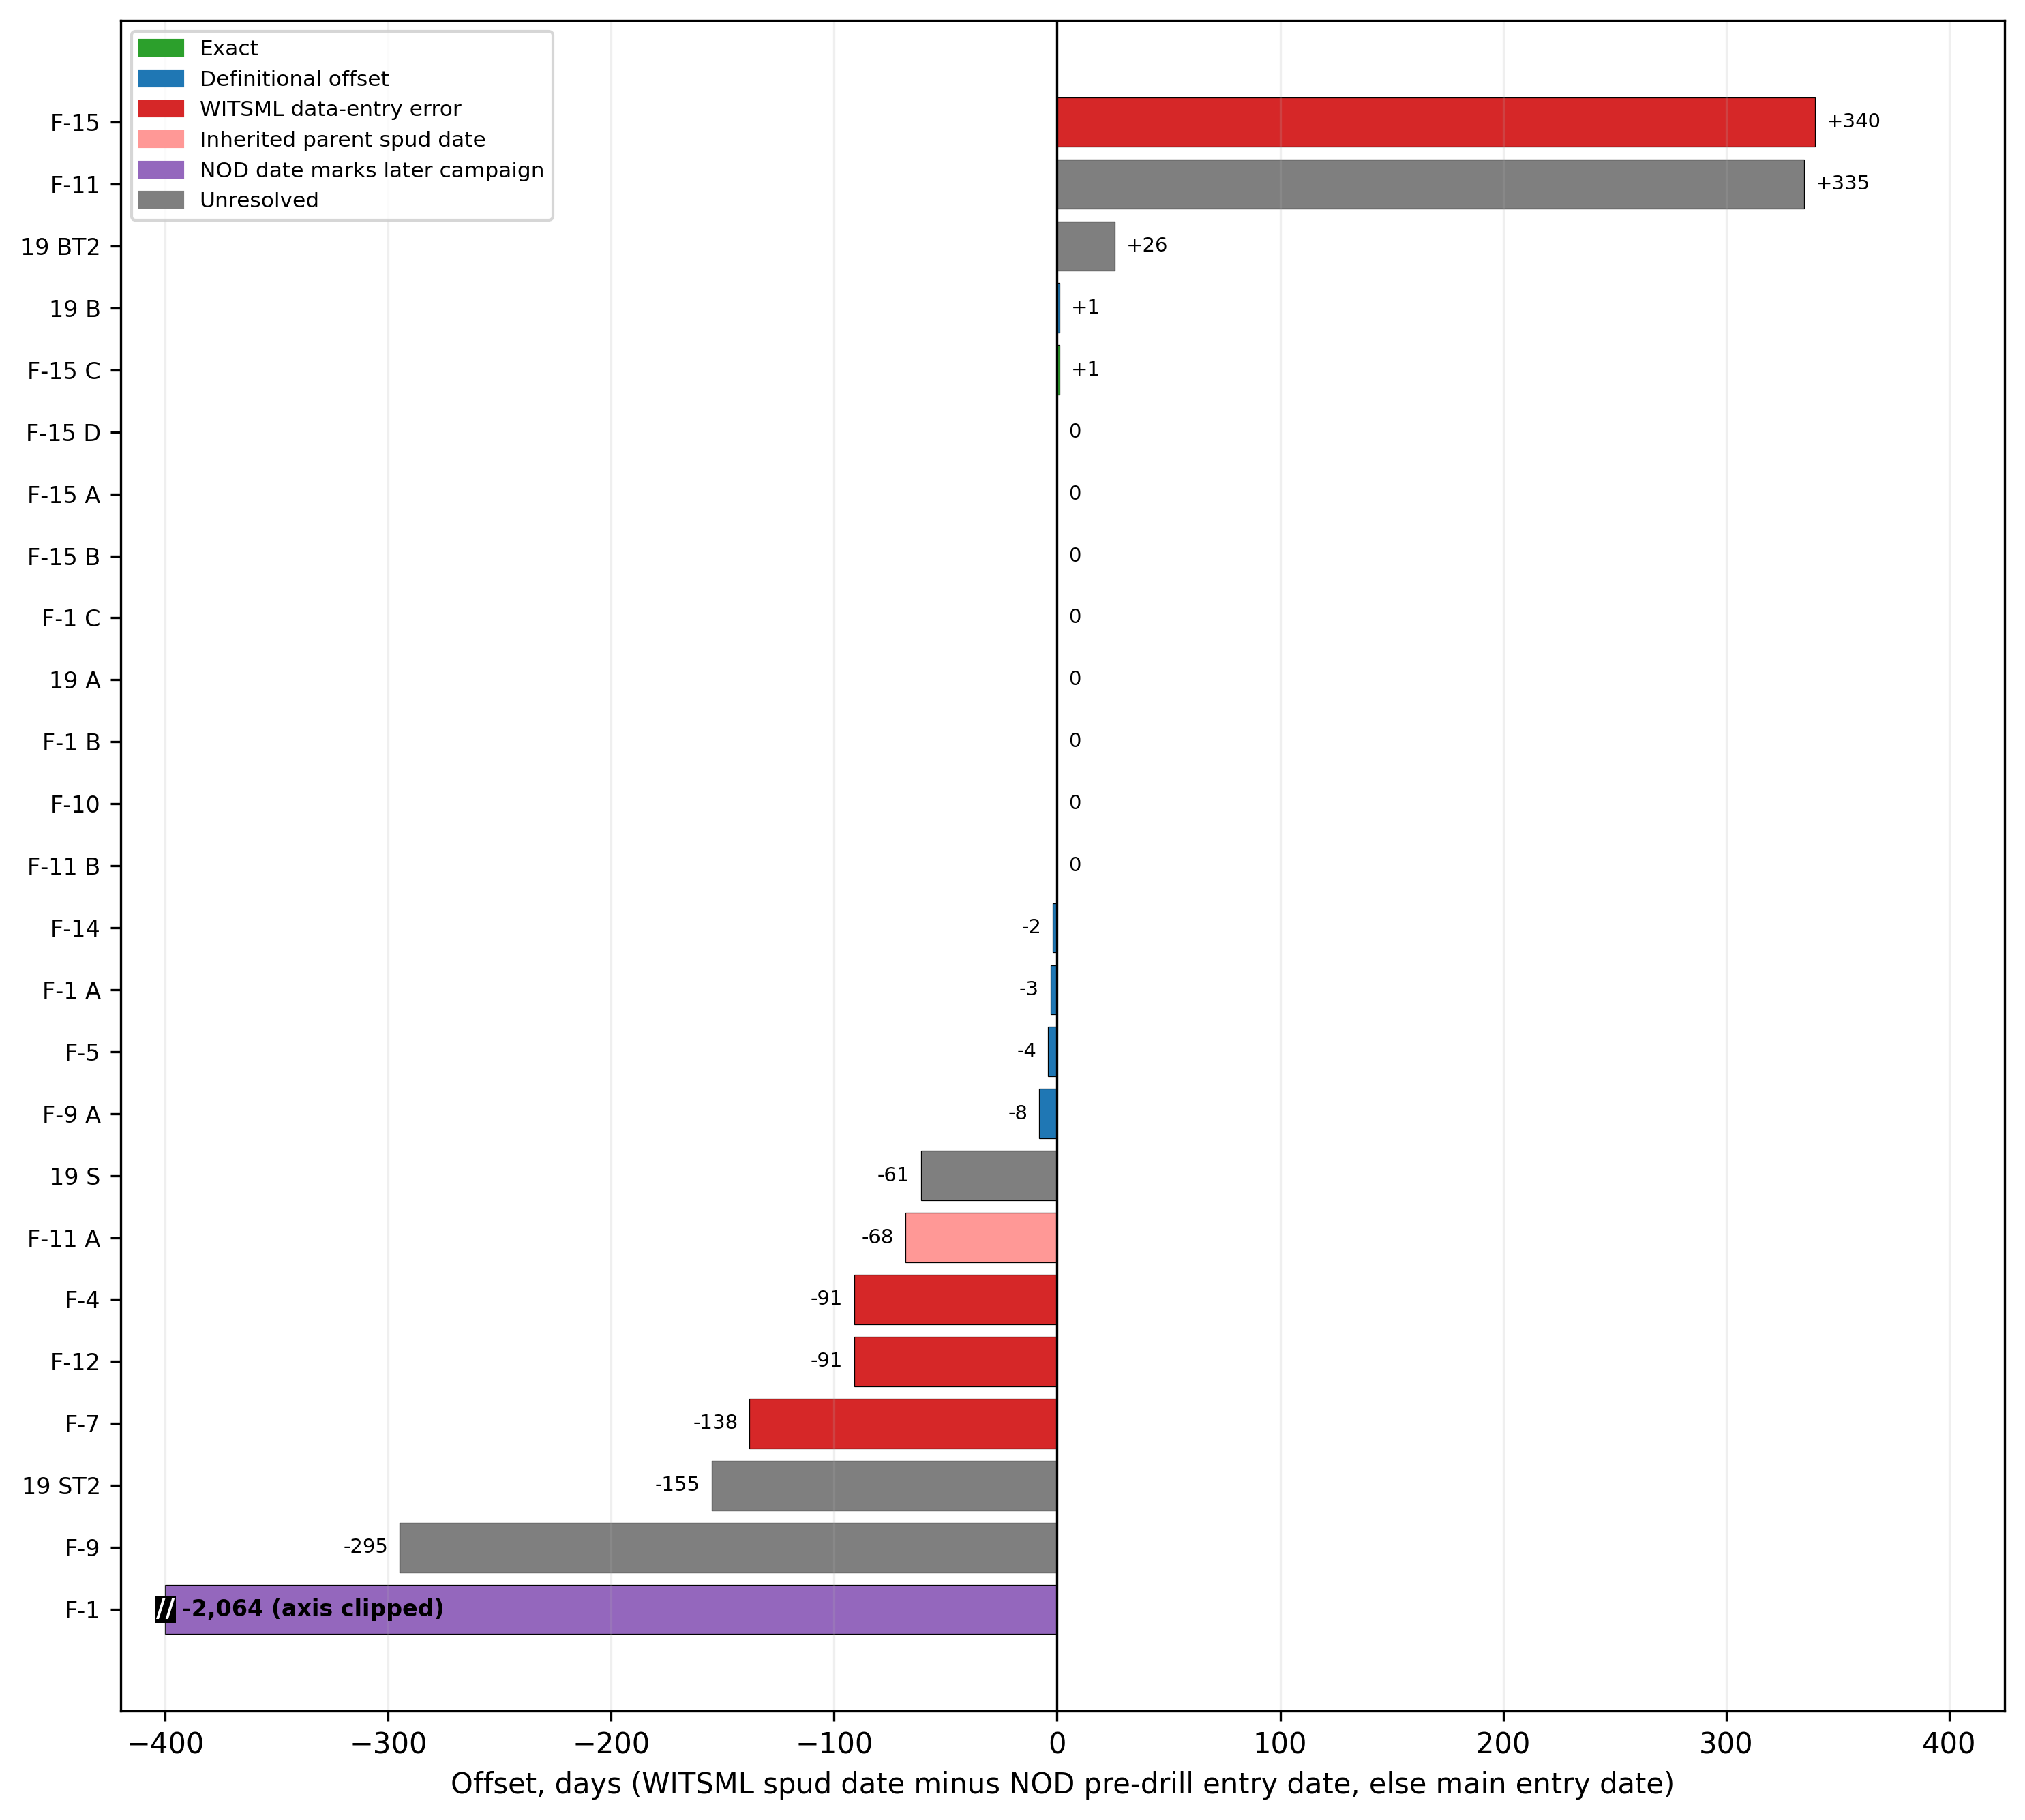
Fig. 4: Spud date offset (WITSML spud date minus the NOD pre-drill entry date where recorded, otherwise the NOD main entry date) for 25 wellbores, coloured by validation category. The bar of 15/9-F-1 (offset -2,064 days) is clipped at -400 days and labelled with its value. 15/9-F-11 T2 is excluded because NOD does not register it separately.

Appendix A: Traceability
Every quantitative figure in this paper traces to an entry in the numbers registry published in the repository (234 entries, each with the producing script and function, the SHA-256 of its input files and an execution timestamp). The audit estimates in Section 5.2 are derived arithmetically from registry entries, and the arithmetic is shown in the text.

