Field-Scale Well Construction Timeline Reconstruction from WITSML Daily Drilling Reports: An Auditable Reconstruction of the Equinor Volve Dataset
Tejaswy Appalla
IPTC-25544-MS (Control 27IPTC-P-1392-SPE)

Abstract
Daily Drilling Reports (DDRs) record how wells were drilled, completed and abandoned, but reconstructing a field-wide construction history requires reconciliation of narrative descriptions, structured fields and wellbore designations. This study reconstructs the available construction history of the Equinor Volve dataset from 1,759 WITSML DDRs covering 26 wellbores in 11 well families.
A reproducible pipeline extracts the source XML, identifies placeholder values and assigns operational labels using a deterministic, priority-ordered classifier. Reconstructed depths, dates and sidetrack relationships are compared with Norwegian Offshore Directorate (NOD) records. Separate audits examine construction content in unclassified reports and agreement between assigned phases and the author’s engineering interpretation.
The classifier assigns a phase to 1,303 reports, giving 74.1% coverage. A stratified audit of 50 unclassified narratives identifies additional construction content corresponding to approximately 198 reports. In a second audit of 52 classified reports, agreement with the author’s independently assigned labels is 61.0% after weighting by phase population. This measures agreement with engineering interpretation, not accuracy against a reference standard. Reconstructed maximum measured depth agrees with NOD total depth within 0.5 m for 19 of 21 name-matched wellbores; three additional technical sidetracks are matched using depth. The reconstruction also identifies erroneous or inherited spud dates, 515 placeholder field values, and differences between archive and register representations. Sidetrack departure depths or intervals are interpreted for all 15 sidetracks, with evidence strength recorded explicitly.
The published output comprises a 1,421-record depth–time–phase dataset, supporting tables and reproducible code. The study demonstrates the value of combining operational narratives with structured records while exposing the limitations of single-report phase classification. The reconstruction supports records-based screening of legacy wells, but does not establish well integrity or justify direct use of phase counts as operational durations.

1 Introduction
Daily Drilling Reports (DDRs) are the primary operational record of a well construction campaign. Each report logs depth progress, casing and cementing operations, formation encounters and non-productive time. In the WITSML (Wellsite Information Transfer Standard Markup Language) exchange format (Energistics n.d.), a DDR holds structured fields such as measured depth, spud date and casing depths, together with a free-text narrative of the preceding 24 hours of operations. Turning the archive of a field into a construction timeline means assigning every report to a construction phase, and the inconsistent terminology, abbreviations and narrative text that accumulate over a field's multi-decade life make that difficult. This paper reconstructs the timeline of the Equinor Volve field from 1,759 WITSML DDRs covering 26 wellbores. A deterministic, priority-ordered rule-based classifier reads the narrative of every report. A stratified sample of the unclassified remainder shows what the classifier misses, and total depth and spud date are compared for every wellbore with an independent national register, the NOD FactPages (NOD 2026a), and the unmatched and unresolved cases are reported. The data-quality problems that any other user of the archive will meet are documented along the way. A reader with this text, the openly available Volve dataset (Equinor 2018) and the accompanying repository should be able to reproduce every reported figure.

2 Background and Related Work
Several studies have extracted structured information from the free text of drilling reports. Sidahmed et al. (2015) built a dictionary of rig terms and acronyms with drilling experts and tracked weighted term frequencies over time in the reports of three wells to flag recurring operational concerns. Priyadarshy et al. (2017) presented a framework for predicting the causes of non-productive time from unstructured reports. Hoffimann et al. (2018) applied deep natural language processing to 9,670 daily reports from a field of 303 wells and classified each sentence as an event, a symptom or an action. They noted that technical symbols, abbreviations, misspellings and incomplete sentences make the text difficult to process. Zhang et al. (2022) built a rule-based detector for five unscheduled events (stuck pipe, lost circulation, water influx, gas influx and H2S) in about 128,000 free-text remarks from daily mud reports. The detector was precise but missed events, and its accuracy fell to 65.18% on a larger test set. A hybrid that used its output to train a weakly supervised deep learning model improved detection by more than 20 percentage points.
Karnot et al. (2025) combine change-point detection, semi-supervised natural language processing and sequence mining for root-cause analysis of non-productive time and apply the combination to 701 DDRs from 10 wells. Their Dataset section states that "all analyses used synthetic datasets constructed to emulate typical drilling records". Their sequence-mining section, which they describe as a proof-of-concept analysis, states that "rigorous validation and quantitative performance assessment are left for future work". Their abstract and conclusions nevertheless report an average 18.5% reduction in non-productive time in field applications.
The Volve dataset is an established benchmark for drilling analytics. Tunkiel et al. (2021) derived a reference dataset for rate-of-penetration benchmarking from its drilling data. To the author's knowledge, no validated field-wide construction timeline from the Volve DDR narratives has been published.
Published DDR work relies on proprietary or synthetic data, which prevents others from reproducing or extending its results. The present work (1) uses a deterministic, auditable classifier that trades model sophistication for transparency of every decision, (2) works exclusively with a real, openly licensed archive, and (3) pairs classification with a stratified audit of the unclassified residual, an agreement audit of classified reports against the author's labels, and a comparison of total depth and spud date with a national register for the complete wellbore population. The audit in this paper measures the weakness that Zhang et al. (2022) report, the events a rule-based classifier misses, directly on the unclassified reports.

3 Data and Methods

3.1 Data Source and Extraction
The 1,759 WITSML 1.4.0.0 XML files of the Volve dataset (21,315,879 bytes, each recorded with a SHA-256 hash) were extracted into a single table with one row per DDR and no duplicate wellbore and date pairs. The rows cover the exploration well 15/9-19 and the platform wells 15/9-F-1, F-4, F-5, F-7, F-9, F-10, F-11, F-12, F-14 and F-15, which make up 26 wellbores in 11 well families. The columns include the source XML filename, the well and wellbore identifiers, the report date, the spud date (WITSML dTimSpud), measured depth (md_m), kick-off depth (md_kickoff_m), last casing depth (md_csg_last_m), operational parameters and the free-text 24-hour narrative (sum24Hr). Every field was kept as a raw string to keep placeholder values visible, and the published code regenerates the table from the raw files.
The md_m field is stored as a string and contains two placeholders, the literal '-999.99' (a missing-value sentinel) and the literal '0'. Both were excluded and the remaining values cast to a numeric type before any depth arithmetic.
Table 1 shows a real construction report as stored in the archive, with the structured fields the pipeline uses and the full free-text summary that the classifier reads. Fig. 1 shows the same report as a page of the original PDF version of the Daily Drilling Report.
Table 1: Example DDR as stored in the archive
Field | Value | Meaning
wellbore | 15/9-F-15 D | the wellbore the report belongs to
date_report | 2013-11-23 | the day the report covers
md (m) | 2,961 | measured depth reached, along the hole
dTimSpud | 2013-11-10 | spud date in the report header, the same in every report of the wellbore
md_kickoff | absent | kick-off depth field: empty in this report, as in most reports (Table 3)
md_csg_last (m) | 2,612 | depth of the last casing shoe
forecast24hr | Drill 12 1/4" hole to section TD at approx. 3300 m MD. | the plan for the next 24 hours
sum24Hr | “Performed FIT to 1,55 sg EMW. Drilled 12 1/4" hole from 2623 m to 2961 m through Ty Fm into Shetland Gp. Bled in LCM mix while drilling Ty Fm. and maintained background concentration throughout section. Built 10 3/4" and 9 5/8" casing stands offline. Racked back 30 stands in derrick.” | free-text summary of the past 24 hours: the text the classifier reads
Phase assigned | 12¼ in. and smaller hole (priority 5) | the classifier's result: the 12¼ in. hole matches the pattern of that phase
Source: Equinor Volve dataset (Equinor 2018), file 15_9_F_15_D_2013_11_23.xml. The summary of 51 words and the forecast are quoted in full. The kick-off field is empty in this report, as in most reports (Table 3).
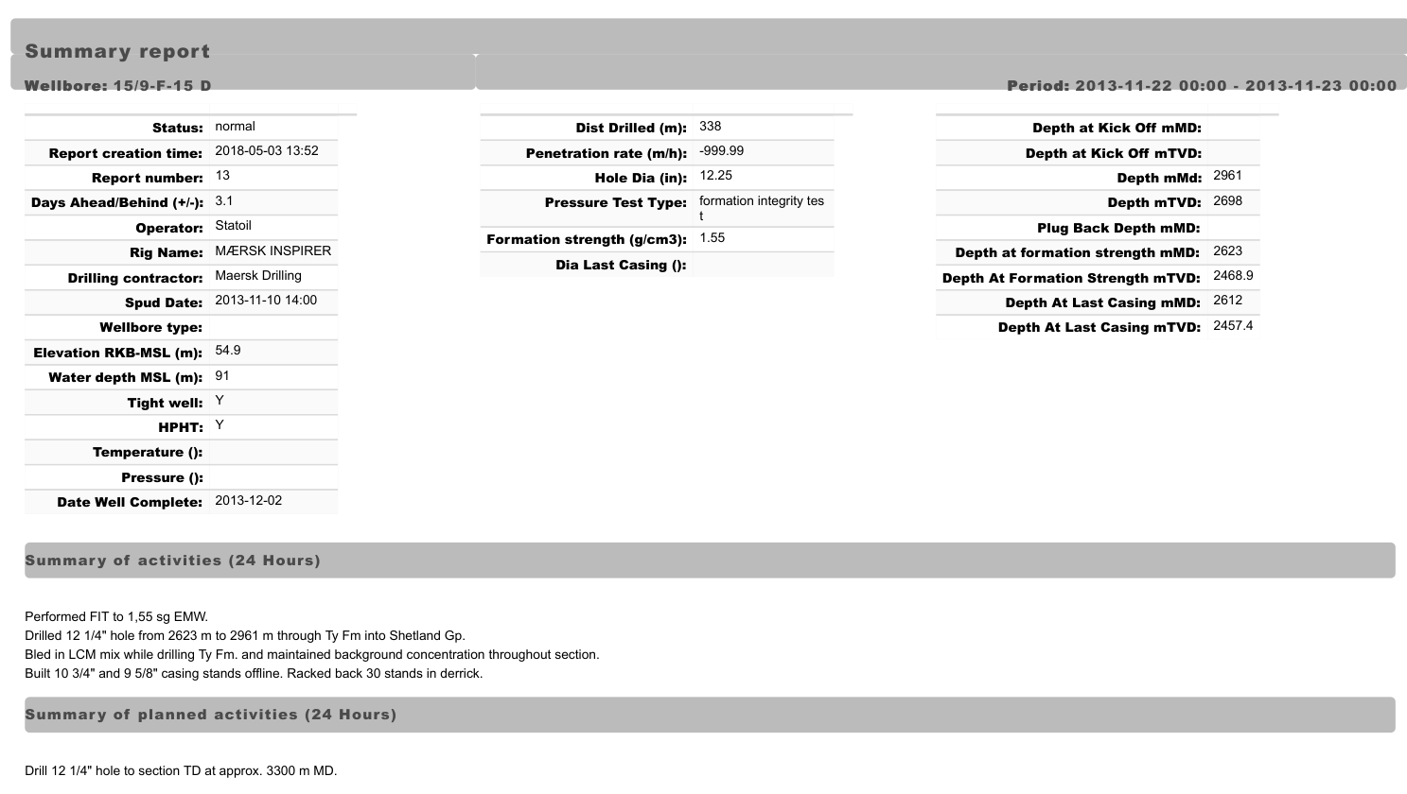
Fig. 1: Page of the original Daily Drilling Report for 15/9-F-15 D, 23 November 2013 (Equinor Volve dataset, PDF version). Table 1 shows the same report as stored in the WITSML archive.

3.2 Wellbore Designation
Norwegian wellbore names follow the designation guidelines of the national regulator (NOD 2025). The suffix "S" marks an exploration wellbore planned to be deviated, letters A, B and so on mark sidetracks, and "R" marks a re-entered exploration wellbore. A technical sidetrack, drilled to bypass a mechanical problem such as stuck pipe, is designated T2 for the first and T3 for the next. The Volve WITSML archive uses the technical-sidetrack designations 15/9-19 BT2, 15/9-19 ST2 and 15/9-F-11 T2, and none of them appears as a separate entry in the NOD register for the field. This one convention explains every naming mismatch between the two registers (Section 5.5).

3.3 Phase Classification
The classifier assigns the sum24Hr narrative of each DDR to one of 13 phases: Spud/Conductor, Surface hole and casing, Intermediate drilling, Intermediate casing, 12¼ in. and smaller hole, Liner/Casing run, Cementing, Completion, P&A, Logging/Testing, Workover, Waiting/Downtime and Rig move/Setup. Each phase has a fixed priority from 1 (highest) to 13 (lowest), in the order listed, and a set of case-insensitive regular expressions. A DDR takes the highest-priority phase with a matching pattern, and a narrative that matches no pattern stays Unclassified. Fraction characters such as ½ and ¼, routine in the mixed units of drilling reports, are stored as single special characters that a pattern written as "1/2" does not match. They are converted to that form before matching. The phase names refer to the hole and casing sizes that each pattern group matches. On Volve platform wells the 12¼ in. hole usually ends above the reservoir (Hugin Formation); in 15/9-F-4, for example, the 12¼ in. section ended at 2,770 m MD and pressure samples were taken in the Hugin Formation at 3,417.5 m MD, in the 8½ in. section. Every regular expression is listed in the repository file src/classifier_v3.py.
Table 2 gives the 13 phases in priority order with representative triggers from the pattern table in the repository (outputs/stage4_priority_rules.csv). The patterns match sizes in the spellings found in the reports, for example 17 1/2 or 17.5, and words in any case. Each phase has further patterns that the table does not show.
Table 2: Phases in priority order with representative triggers
Priority | Phase | Hole and casing sizes (in.) | Example trigger words
1 | Spud/Conductor | 36, 30 | spud, tagged sea bottom
2 | Surface hole and casing | 26, 20 | (size only)
3 | Intermediate drilling | 17½ | (size only)
4 | Intermediate casing | 13⅜, 10¾, 14 | (size only)
5 | 12¼ in. and smaller hole | 12¼, 8½, 6 | cut core, coring
6 | Liner/Casing run | 9⅝, 7 | liner, surface tieback
7 | Cementing | none | cement, cemented, cementing, bumped plug
8 | Completion | none | completion, production packer, packer, tubing
9 | P&A | none | EZSV, EVO plug, P&A, abandon
10 | Logging/Testing | none | logging, LWD, MWD, VSP
11 | Workover | none | workover, coiled tubing, sidetrack, whipstock
12 | Waiting/Downtime | none | WOW, waiting on weather, rig maintenance, general maintenance
13 | Rig move/Setup | none | skidded rig, positioned rig, mooring, ballast
A report is assigned to the highest-priority phase with a match; a report that matches no pattern is Unclassified. The triggers shown are simplified: the actual expressions impose context and distance limits (for example, a size must lie close to the word hole or casing), and all of them are listed in src/classifier_v3.py. Both casing sizes in the table occur in the reports: 14 in. in 31 DDRs (15/9-F-11 B, 15/9-F-11 T2, 15/9-F-12, 15/9-F-14) and 10¾ in. in 104 DDRs (11 wellbores), 68 of which also mention a tie-back or the combined 9⅝ x 10¾ in. string.

3.4 Stratified Audit of the Unclassified Residual
The audit estimates how many unclassified DDRs describe construction operations that the pattern set failed to catch. A leak check first reapplied the complete pattern set to every unclassified record and found no record that should have matched. Every unclassified record was then assigned to one of eleven descriptive categories, for example BOP and riser handling, generic trips, production monitoring and empty records, using patterns built from inspection of the unclassified population. BOP and marine riser handling is the largest category (147 of 456 records, 32.2%). The 73 empty records have a sum24Hr field that holds the literal string "None" (Section 4). These records contain no operational narrative in the sum24Hr field for the classifier to interpret. They were excluded from the sampling frame, leaving 383 records.
A stratified sample of 50 records was drawn from the 383. The unclassified reports were split into two strata, an early construction group (reports within 730 days of the wellbore's first report, 296 records) and a later production group (reports more than 730 days after it, 87 records), and a random sample was drawn from each in proportion to its size, 39 records from the construction group and 11 from the production group. The random draw is recorded in the repository and allows the same sample to be drawn again. The author read each sampled report and labelled it construction if it described work that builds the well (drilling ahead, coring, running or cementing casing, setting plugs, fishing or completion). Reports that described only BOP or riser handling, tripping, waiting or production were labelled non-construction unless they also named a hole or casing size.

3.5 External Validation Against NOD FactPages
Total depth and spud date were compared with the NOD FactPages (NOD 2026a). The Table View export was filtered to the Volve wellbores and matched by exact name wherever possible. Three WITSML wellbores, all technical sidetracks, were matched by depth (15/9-19 BT2 to NOD 15/9-19 B, both 4,250 m; 15/9-19 ST2 to NOD 15/9-19 SR, both 4,641 m; and 15/9-F-11 T2 to NOD 15/9-F-11, 4,562.1 m and 4,562.0 m). The export was retrieved on 24 October 2026. Its rows for the Volve wellbores match an export of 8 September 2026 except for the register's own synchronisation date. All comparisons are against the current register as accessed in October 2026.
In the 15/9-19 series the DDR narratives describe the events behind the designations, and the NOD wellbore histories (NOD 2026b, 2026c, 2026d) are consistent with them. The drillstring in 15/9-19 B became stuck at 3,272 m. A backoff attempt released the string too high, the string was cut at 3,164 m, a sidetrack plug was set between 2,983 and 2,835 m, and new hole was drilled from 2,911 m as 15/9-19 BT2, whose first report reads "REPORTING TRANSFERRED FROM 15/9-19B". Well 15/9-19 S followed a similar sequence. The hole packed off at 2,732 m and attempts to work the pipe free were made at 2,741 m, a cutter was detonated at 2,658 m, the pipe was cut at 2,516 m, three cement plugs were set (the last from 1,543 to 1,430 m), and the narrative uses sidetrack language ("MU BHA FOR SIDE TRACK"). Cement was then drilled out to 1,486 m, and new hole was drilled as 15/9-19 ST2 from a depth between 1,486 m and 1,536 m, the measured depth of the first ST2 report. In both cases NOD records the final total depth against the parent designation.

4 Data Quality
The population of ten WITSML-derived columns was surveyed across all 1,759 DDRs (Table 3).
Table 3: Field population survey (n = 1,759 DDRs)
Column | Populated | Count | Notes
date_report | 100.0% | 1,759
spud_date | 100.0% | 1,759 | Includes inherited and erroneous values (Section 5.6)
rig | 99.94% | 1,758 | 1 record missing (1980 sentinel)
forecast24hr (genuine) | 94.14% | 1,656 | 103 literal "None" strings excluded
operator | 99.94% | 1,758 | 1 record missing
md_csg_last_m | 96.76% | 1,702
sum24Hr (genuine narrative) | 95.85% | 1,686 | 73 literal "None" strings excluded
drill_complete | 91.70% | 1,613
md_m (excluding sentinel and zero) | 80.78% | 1,421 | 331 sentinel and 7 zero values excluded
md_kickoff_m | 14.10% | 248 | Free-text recovery required
Percentages are count / 1,759, rounded to two decimal places.
The structured kick-off field is populated in only 14.10% of rows (248 of 1,759), so sidetrack kick-off depths had to be recovered from the narratives and from depth sequences (Section 5.7).
A standard null-or-blank check reports 100% population for sum24Hr, but 73 records hold the literal string "None". The string sits in the source XML, in 73 of the 1,759 files, and is a placeholder of the archive. A null test cannot detect it, and the genuine narrative population is 95.85% (1,686 of 1,759). The same placeholder fills 103 forecast24hr values, which leaves a genuine forecast population of 94.14% (1,656 of 1,759). The archive holds 515 placeholder values across all extracted fields, made up of 331 depth sentinels, 7 zero depths, 176 literal "None" strings (73 narratives and 103 forecasts) and one date sentinel.
A character-level survey of sum24Hr found two non-ASCII characters that matter for classification, the one-half sign (½) in 61 DDRs (82 occurrences) and the one-quarter sign (¼) in 10 DDRs (14 occurrences). Both are normalised before pattern matching. The raw files declare the ISO-8859-1 character encoding, and reading them with another encoding turns ½ into Â½ (for example 'due to double 3-½" DP' for 'due to double 3 ½" DP'). The encoding must therefore be set explicitly. One further anomaly is a single record for 15/9-19 A dated 1 January 1980 (filename 15_9_19_A_1980_01_01.xml, narrative "None", no measured depth), 17.6 years before the first genuine report of the wellbore on 25 July 1997. It is a date sentinel.

5 Results

5.1 Coverage
The classifier assigns a phase to 1,303 of the 1,759 DDRs, a coverage of 74.1%, and leaves 456 unclassified (25.9%) (Table 4). Coverage is the share of reports that match a pattern. It does not measure whether the phase is correct (Section 5.3). The classifier was also checked against an independent earlier extraction of the same archive by the author, with identical results for all 1,759 reports. Fig. 2 shows the classified phases on the depth-versus-time curves of representative wellbores in four panels. The phase colours are single-report labels.
Table 4: Phase distribution
Phase | DDR count | % of 1,759
12¼ in. and smaller hole | 256 | 14.6
Completion | 228 | 13.0
Liner/Casing run | 144 | 8.2
Waiting/Downtime | 120 | 6.8
Cementing | 100 | 5.7
Logging/Testing | 93 | 5.3
Intermediate casing | 82 | 4.7
Intermediate drilling | 77 | 4.4
Surface hole and casing | 66 | 3.8
Spud/Conductor | 52 | 3.0
P&A | 41 | 2.3
Rig move/Setup | 38 | 2.2
Workover | 6 | 0.3
Unclassified | 456 | 25.9
Total | 1,759
Percentages are rounded independently and may not sum to exactly 100.0%. Phases are single-report labels assigned by the classifier (Section 5.3).

5.2 Stratified Audit and Estimated Recoverable Coverage
Of the 50 sampled reports, 26 (52%) were labelled construction and 24 (48%) non-construction. The construction group (39 reports) split 23 construction to 16 non-construction, and the production group (11 reports) split 3 to 8. Of the 26 construction reports that the classifier missed, 9 reported genuine drilling without a hole size, 10 described other operations with no corresponding pattern, such as hydraulic fracturing or fishing, and 7 used non-standard terms, such as "CMT" for cement. Weighting the two groups by their share of the 383-report frame gives 51.8% construction (design-based 95% interval 39.1 to 64.5%, normal approximation, with only 11 records in the production group), which corresponds to about 198 reports. The estimated recoverable coverage is therefore 85.3% (95% interval 82.6 to 88.1%): the share of the 1,759 reports that would carry a phase if the patterns also caught the construction content of the unclassified reports. It estimates how much construction content the patterns leave unassigned and does not guarantee that a recovered report would receive the correct phase. The arithmetic, with the Wilson interval for comparison, is in Appendix B.

The 73 DDRs whose sum24Hr field contains the literal string “None” provide no operational narrative for the classifier used here. They are excluded from the recoverable-coverage estimate. A classifier relying only on each report’s sum24Hr field would therefore leave at least 4.2% of the 1,759 reports unclassified for lack of narrative content. Other information, such as neighbouring reports or additional fields, might support an interpretation, but was not used for this estimate.

5.3 Phase Label Agreement
The classified phases were checked with a second audit. Four reports were drawn at random from each of the 13 phases, 52 of the 1,303 classified reports, with the seed recorded in the repository. The author, a petroleum engineer, labelled the main operation of each day from the report alone, without seeing the assigned phase, as an engineer would read it. That reading is not the classifier's priority rule. The result is therefore agreement with engineering interpretation and not accuracy against a reference standard.
The frequency-weighted agreement is 61.0%. It weights the agreement rate of each phase (reports agreeing out of four) by the share of the 1,303 classified reports that the phase holds, the sum over the 13 phases of (N_h / 1,303) × (k_h / 4), where N_h is the number of classified reports in phase h. The raw count is 30 of 52 reports (58%). The stratified design-based 95% interval of the weighted agreement is 44.9 to 77.2% (normal approximation, finite-population correction). With four reports per phase, and 4 of the 13 phases at 0 of 4 or 4 of 4, the interval is approximate and fragile. For comparison only, the Wilson interval for 30 of 52, which treats the reports as one simple random sample, is 44.2 to 70.1% (Wilson 1927). Agreement by phase, out of four reports each, was P&A 4, Spud/Conductor 4, 12¼ in. and smaller hole 3, Completion 3, Intermediate drilling 3, Logging/Testing 3, Surface hole and casing 3, Intermediate casing 2, Liner/Casing run 2, Rig move/Setup 2, Waiting/Downtime 1, Cementing 0, Workover 0. All four sampled Cementing reports and all four Workover reports disagreed.
The audit identified substantial disagreement between the classifier and the author's single-report labels. Post-hoc inspection suggested incidental keyword matches, differences in phase interpretation and possible dependence on campaign context. The effect of adding neighbouring reports was not tested. The AI tool assigned indicative causes to the 22 disagreements from the narratives: 8 an incidental keyword, 5 campaign context (for example, pulling tubing during an abandonment campaign, or waiting on weather before retrieving a riser), 4 whipstock or window milling that the classifier assigns to Workover and the author labelled Intermediate drilling, 2 casing runs that the size-based phase names place in Intermediate casing and the author labelled Liner/Casing run, 1 a day that mixes waiting and rigging up, and 2 unexplained. The author did not assign the causes. Coverage (Section 5.1) counts the reports that carry a phase, and the agreement indicates how far the assigned phase matches the author's reading of a report on its own. Table 4 and the phase colours in Figs. 2 and 3 should be read as single-report labels.

5.4 Timeline Dataset
The timeline dataset holds 1,421 rows, one for each DDR with a genuine md_m value. Of the 1,759 DDRs, 331 carry the sentinel and 7 the zero value. Each row gives the wellbore identifier, the report date, the days from the wellbore's first report with a recorded depth, the measured depth, the assigned phase and the source filename. Days are counted from the first row with a usable depth in each wellbore. Fig. 3 plots report number against measured depth for the reports of all 26 wellbores, pooled. The report number counts every DDR of a wellbore from its first report (1980 sentinel excluded), with or without a recorded depth, and so matches the reports to TD in Table 8. Only reports with a valid depth are plotted.

5.5 Total Depth Validation
Maximum reconstructed measured depth per wellbore was compared with NOD's total depth for all 26 wellbores (Table 5, Fig. 4).
Table 5: Total depth validation, all 26 wellbores
Wellbore (WITSML) | WITSML max MD (m) | NOD TD (m) | Diff. (m) | Outcome | Note
15/9-19 A | 4,131.0 | 4,131.0 | 0.0 | Within 0.5 m
15/9-19 B | 3,272.0 | n/a | n/a | Unmatched | Parent leg abandoned at stuck pipe; NOD 19 B TD matches 19 BT2
15/9-19 BT2 | 4,250.0 | 4,250.0 | 0.0 | Within 0.5 m (by depth) | Technical sidetrack, matched by depth to NOD 15/9-19 B
15/9-19 S | 3,353.0 | 3,580.0 | 227.0 | More than 0.5 m | Archive ends before final drilling
15/9-19 ST2 | 4,641.0 | 4,641.0 | 0.0 | Within 0.5 m (by depth) | Technical sidetrack, matched by depth to NOD 15/9-19 SR
15/9-F-1 | 3,632.0 | 3,632.0 | 0.0 | Within 0.5 m
15/9-F-1 A | 3,682.0 | 3,682.0 | 0.0 | Within 0.5 m
15/9-F-1 B | 3,465.0 | 3,465.0 | 0.0 | Within 0.5 m
15/9-F-1 C | 4,094.0 | 4,094.0 | 0.0 | Within 0.5 m
15/9-F-10 | 5,331.0 | 5,331.0 | 0.0 | Within 0.5 m
15/9-F-11 | 347.0 | n/a | n/a | Unmatched | Parent leg; NOD 15/9-F-11 TD matches F-11 T2
15/9-F-11 A | 3,762.0 | 3,762.0 | 0.0 | Within 0.5 m
15/9-F-11 B | 4,770.0 | 4,770.0 | 0.0 | Within 0.5 m
15/9-F-11 T2 | 4,562.1 | 4,562.0 | 0.1 | Within 0.5 m (by depth) | Technical sidetrack, matched by depth to NOD 15/9-F-11
15/9-F-12 | 3,520.0 | 3,520.0 | 0.0 | Within 0.5 m
15/9-F-14 | 3,750.0 | 3,750.0 | 0.0 | Within 0.5 m
15/9-F-15 | 4,090.0 | 4,105.0 | 15.0 | More than 0.5 m | TD stated as 4,090 m in the reports; cause of the 15 m difference unresolved
15/9-F-15 A | 4,095.0 | 4,095.0 | 0.0 | Within 0.5 m
15/9-F-15 B | 3,497.0 | 3,497.0 | 0.0 | Within 0.5 m
15/9-F-15 C | 3,232.0 | 3,232.0 | 0.0 | Within 0.5 m
15/9-F-15 D | 4,685.0 | 4,685.0 | 0.0 | Within 0.5 m
15/9-F-4 | 3,510.0 | 3,510.0 | 0.0 | Within 0.5 m
15/9-F-5 | 3,792.0 | 3,792.0 | 0.0 | Within 0.5 m
15/9-F-7 | 1,085.0 | 1,085.0 | 0.0 | Within 0.5 m
15/9-F-9 | 1,085.0 | 1,085.0 | 0.0 | Within 0.5 m
15/9-F-9 A | 1,206.0 | 1,206.0 | 0.0 | Within 0.5 m
Within 0.5 m: difference of 0.5 m or less. The three technical sidetracks (15/9-19 BT2, 19 ST2 and F-11 T2) have no NOD record of their own and are matched to the NOD record whose total depth agrees. Agreement within 0.5 m is therefore the matching condition for them.
Of the 26 wellbores, 21 are matched to NOD by name, 3 technical sidetracks are matched by depth and 2 parent legs are unmatched (below). Of the 21 name-matched wellbores, 19 agree on total depth within 0.5 m. 15/9-F-15 differs by 15 m (0.4%) and 15/9-19 S by 227 m. The reports state the total depth of 15/9-F-15 as 4,090 m ("Drilled 8 1/2" hole from 3889m to 4090m (TD)."), NOD records 4,105 m, and the cause of the 15 m difference is unresolved. Among the 19 F-series wellbores matched by literal name, 18 (94.7%) agree within 0.5 m, and 15/9-F-15 is again the exception. The 3 depth-matched sidetracks agree by construction of the match. 15/9-F-7 and 15/9-F-9 share a total depth of 1,085 m, and NOD independently records 1,085 m for each, which rules out a duplication in the extraction.
One explanation covers the two unmatched wellbores and the three depth-based matches. Each WITSML technical sidetrack (19 BT2, 19 ST2, F-11 T2) has no separate NOD entry, and NOD records the final total depth of the sidetrack against the parent designation (19 B, 19 SR, F-11). The WITSML parent records that end short of that depth, 15/9-19 B at 3,272 m and 15/9-F-11 at 347 m, are the legs abandoned when the technical sidetrack was drilled, and they have no NOD counterpart. The stuck-pipe event of 15/9-19 B is documented in the narrative (Section 3.5), and the designation itself is the evidence for 15/9-F-11. The operator's WITSML system tracks each drilled leg while the national register records the wellbore. The two registers therefore differ by construction, and neither is in error.
The WITSML series of 15/9-19 S ends at 3,353 m, 227 m short of NOD's structured total depth (3,580.0 m). The well was an original exploration wellbore targeting the Theta Vest structure north of Sleipner East and planned as deviated, consistent with its "S" suffix. NOD's wellbore history records it as temporarily suspended at 3,569.0 m (2,394.0 m TVD RKB), immediately above the Heimdal sands (NOD 2026d), which is 216 m deeper than the last WITSML depth. The 11.0 m difference between the two NOD values lies within the register itself, and Table 5 uses the structured field for this wellbore as for every other. The archive holds no reports for the final drilling and suspension of 15/9-19 S, and the 227 m gap reflects those missing records. The reports it does hold are incomplete throughout, 39 reports over 91 days (Table 8), and the records do not show why.

5.6 Spud Date Validation
Spud date was compared across three sources for every wellbore, the WITSML spud_date field, free-text spud language in the earliest DDRs of the wellbore and the NOD entry date. The offset is the WITSML spud date minus the NOD pre-drill entry date where NOD records one, because it marks the start of top-hole drilling, and otherwise the NOD main entry date. Table 6 summarises the outcome and Fig. 5 plots the offset by category. For the four wellbores whose archive contains the NOD pre-drill entry (15/9-F-4, F-5, F-14 and F-15), the first report falls on that date, or one day later for F-4, which supports the pre-drill date as the spud reference. The categories were first assigned by inspection of the three sources for each wellbore, and the rules in the Rule column of Table 6 were formalised afterwards to describe those assignments. The final category of 15/9-F-11 is Unresolved: NOD records a pre-drill campaign (6 to 17 April 2012) that is absent from the DDR archive, and the archive's 2013 reports describe a fresh spud from seabed, including the 30-inch conductor. The records do not show how the two campaigns relate. The earlier call of Exact, made by inspection, was not retained.
Table 6: Spud date validation outcomes
Outcome | Wellbores | Rule | Detail
Exact agreement | 6 | R4: WITSML date within 1 day of the NOD date, and the first report or free-text spud follows it by at most 1 day. | 15/9-19 A, F-10, F-15 A, F-15 B, F-15 C, F-15 D
Definitional offset | 8 | R6: WITSML date within 8 days of the NOD date, and the free-text operational start follows it by 2 to 20 days. R5a: a parent leg whose NOD record is claimed by a technical sidetrack and that has no free-text spud date of its own (15/9-19 B). | Administrative spud precedes operational start by days to weeks (15/9-19 B, F-1 A, F-1 B, F-1 C, F-5, F-9 A, F-11 B, F-14)
WITSML data-entry error | 4 | R2: WITSML date differs from the first report or free-text spud by more than 30 days, while the NOD date agrees with them within 3 days. | 15/9-F-4, F-7, F-12, F-15
NOD date marks later campaign | 1 | R3: WITSML date within 7 days of the first report, but more than 1 year from the NOD date. | 15/9-F-1
Inherited parent spud date | 2 | R1: the sidetrack carries the same spud date as its parent. | 15/9-F-11 A, F-11 T2
Unresolved | 5 | R5b: a technical sidetrack whose NOD record is its parent leg's (15/9-19 BT2 with 19 B, 19 ST2 with 19 SR). R7: any wellbore that no other rule fits. | 15/9-19 BT2, 19 S, 19 ST2, F-9, F-11 (for F-11 see the text)
Total | 26
Rules are applied in the order R1 (inherited), R5a (parent leg) and R5b (technical sidetrack), R2 (error), R3 (later campaign), R4 (exact), R6 (definitional offset), R7 (unresolved). Unresolved includes 15/9-19 S, F-9 and F-11 (R7).

In the four error cases the structured spud_date differs from the first report and its narrative by 91 to 340 days, while the first report and the NOD date agree with each other. 15/9-F-12 is the clearest case. Its first report (14 June 2007) describes making up the 36 in. hole opener and agrees with the NOD entry date, and only the structured field (15 March 2007) disagrees. Two sidetracks, 15/9-F-11 A and 15/9-F-11 T2, carry a spud_date identical to that of their parent, which is almost certainly an inherited field value. NOD does not register 15/9-F-11 T2 separately, and Fig. 5 excludes it for that reason.
The spud date of 15/9-F-1 needed particular care. Its WITSML spud_date (28 November 2007) falls four days before its first DDR (2 December 2007), which narrates drilling 36 in. hole from the seabed, an ordinary gap between spud and first report. The 2007 reports cover the top hole only (four reports, maximum depth 226 m). The well was drilled to its total depth of 3,632 m in the 2013 campaign, whose first report (22 July 2013) is one day before the NOD entry date (23 July 2013). NOD records no pre-drill date for the 2007 work, unlike F-4, F-5, F-14 and F-15. The NOD date therefore marks the later campaign, and the case is classified as "NOD date marks later campaign". The WITSML value is consistent with the chronology of the wellbore.

5.7 Sidetrack Kick-Off Depth Recovery
Kick-off depth was recovered from the DDRs because the structured kick-off field is sparse. Kick-off here means the depth at which a sidetrack departs its parent wellbore, not the depth at which an original wellbore begins to build angle; the structured kick-off field of 15/9-19 S (562 m in all its reports) is consistent with the latter and is not used. The depth was read from the last report of the parent and the first report of the sidetrack, in a fixed order of preference: (1) a depth stated for the point where the narrative first reports new formation or departure from the parent hole, or where the kick-off started; (2) for a casing exit by a milled window, the top of the window; (3) where the narrative names the kick-off event but gives no depth, the measured depth of the same report; (4) where the narrative is empty, the measured depth at the parent-to-child transition. The first step with evidence is used. A milled window gives a window interval and no single departure depth. Step 2 therefore applies to it. Confidence follows from the evidence: HIGH where the narrative states the depth together with the departure or the window top, MEDIUM where it states the start of the kick-off or the event without a departure depth, and LOW where the evidence is an interval or the narrative is empty. These definitions describe the grades assigned in Table 7.
A kick-off depth was recovered for all 15 sidetracks (Table 7). The depth is written in the narrative for 11 of them (step 1 for 9 and step 2 for 2). For 3 (15/9-F-1 A, F-1 B and F-15 D) the narrative names the kick-off event but gives no depth, and the depth is taken from the measured depth of the same report (step 3). For 15/9-19 ST2 both reports at the transition are empty (step 4). The kick-off lies between 1,486 m, the depth to which cement was drilled out in the 15/9-19 S report of 18 December 1992 (the day before the transition), and 1,536 m, the measured depth at the transition. Three cement plugs had been set above it, the last from 1,543 to 1,430 m, and the confidence is LOW. The last report of F-1 B (22 February 2014) reads "Commenced time drilling to1364 [sic] m. 50% formation obtained at 1364 m.", and the first report of F-1 C drills 17½ in. hole from that depth, so the well was sidetracked at 1,364 m. The narratives report 3,059 m on 13 March 2014, but that depth marks the start of the 8½ in. section after casing was run. The sidetrack 15/9-19 A kicked off at the top of a milled window at 2,178 m (window milled from 2,178 to 2,183 m), a depth that NOD also records.
Table 7: Sidetrack kick-off depths, 15 sidetracks
Sidetrack | Parent | Kick-off depth (m MD) | Method | NOD kick-off (m) | NOD minus DDR (m) | Confidence
15/9-19 A | 15/9-19 S (per NOD) | 2,178 | depth in text | 2,178 | 0 | HIGH
15/9-19 B | 15/9-19 A | 2,231 | depth in text | 2,200 | -31 | HIGH
15/9-19 BT2 | 15/9-19 B | 2,911 | depth in text |  |  | HIGH
15/9-19 ST2 | 15/9-19 S | 1,486 to 1,536 | depth sequence (narrative empty) |  |  | LOW
15/9-F-1 A | 15/9-F-1 | 2,620 | event in text, depth from md | 2,620 | 0 | MEDIUM
15/9-F-1 B | 15/9-F-1 A | 2,617 | event in text, depth from md | 2,604 | -13 | MEDIUM
15/9-F-1 C | 15/9-F-1 B | 1,364 | depth in text | 1,364 | 0 | HIGH
15/9-F-9 A | 15/9-F-9 | 421.5 | depth in text | 428 | +6.5 | HIGH
15/9-F-11 T2 | 15/9-F-11 | 246 | depth in text |  |  | MEDIUM
15/9-F-11 A | 15/9-F-11 T2 | 2,586 | depth in text | 2,578 | -8 | HIGH
15/9-F-11 B | 15/9-F-11 A | 2,589 | end of stated interval (2,531 to 2,589 m) | 2,586 | -3 | LOW
15/9-F-15 A | 15/9-F-15 | 1,381 | depth in text | 1,381 | 0 | HIGH
15/9-F-15 B | 15/9-F-15 A | 3,185 | depth in text | 3,185 | 0 | HIGH
15/9-F-15 C | 15/9-F-15 B | 2,566 | depth in text | 2,575 | +9 | MEDIUM
15/9-F-15 D | 15/9-F-15 C | 1,380 | event in text, depth from md | 1,380 | 0 | MEDIUM
Depths are m MD. NOD minus DDR is NOD's wlbKickOffPoint minus the recovered depth; blank where NOD has no value. For 15/9-19 A, NOD’s wellbore history states that the sidetrack was kicked off from 15/9-19 SR at 2,178 m MD. NOD records the 1997 re-entry and plugback preceding that sidetrack as 15/9-19 SR2, a re-entry of 15/9-19 SR. The WITSML archive contains no reports designated 15/9-19 SR2; the kick-off is therefore read from the 15/9-19 A reports and compared with the NOD record.
No kick-off depth exists for 15/9-19 S. Its earliest narratives describe a top-hole spud, consistent with NOD's record of it as an original exploration wellbore.
NOD's wlbKickOffPoint agrees with the recovered depth to within 10 m for 10 of the 12 sidetracks for which it is available. It equals the recovered depth for 6 (15/9-19 A, F-1 A, F-1 C, F-15 A, F-15 B and F-15 D), differs by 10 m or less for 4 (15/9-F-9 A, F-11 A, F-11 B and F-15 C) and by more for 2 (15/9-19 B, 31 m; 15/9-F-1 B, 13 m). NOD has no kick-off value for the other 3 (15/9-19 BT2, 19 ST2 and F-11 T2). The least certain depths are 15/9-19 ST2, which lies between 1,486 and 1,536 m and rests on the measured depth at the transition, and 15/9-F-11 B, where cement and new formation were drilled from 2,531 to 2,589 m and the end of the interval is taken as the departure.

5.8 Duration to Total Depth
Table 8 gives the duration of each wellbore from its first report (the 1980 date sentinel excluded) to the date total depth was first reached, which is the maximum valid depth of Table 5. It lists the elapsed calendar days, the number of reports in that span (inclusive), the drilled length and the metres per report. The drilled length is total depth minus the kick-off depth of Table 7 for the 15 sidetracks and total depth for the other 11, and metres per report divides it by the number of reports. With inclusive counting, the number of reports equals the elapsed days plus 1 for a wellbore reported daily, and falls short of that where the archive has gaps. Seven of the 26 wellbores, whose elapsed days exceed twice their reports, are flagged (15/9-19 S, F-1, F-4, F-5, F-9, F-14 and F-15). F-1 reaches its total depth of 3,632 m on 17 August 2013, 2,085 days after its first report on 2 December 2007, in 31 reports, four of them from 2007. The totals of 15/9-19 B (3,272 m) and 15/9-F-11 (347 m) are the depths of an abandoned parent leg or stub (Section 5.5) and make their durations indicative only. Drilled lengths and metres per report for sidetracks depend on the kick-off depths of Section 5.7. Metres per report is not a rate of penetration. It includes non-drilling days, gaps between reports and, for F-1, two campaigns. Per-phase report counts for each wellbore and well family are published with the duration table.
Table 8: Duration to total depth (TD) and drilled length, 26 wellbores
Wellbore | First report | TD (m) | TD reached | Elapsed days to TD | Reports to TD | Gap flag | Drilled length (m) | m per report
15/9-19 A | 1997-07-25 | 4,131 | 1997-08-22 | 28 | 29 |  | 1,953 | 67.3
15/9-19 B (indicative) | 1997-11-10 | 3,272 | 1997-11-28 | 18 | 19 |  | 1,041 | 54.8
15/9-19 BT2 | 1997-12-06 | 4,250 | 1998-01-11 | 36 | 37 |  | 1,339 | 36.2
15/9-19 S | 1992-09-09 | 3,353 | 1992-12-09 | 91 | 39 | yes | 3,353 | 86.0
15/9-19 ST2 | 1992-12-19 | 4,641 | 1993-03-12 | 83 | 68 |  | 3,105 | 45.7
15/9-F-1 | 2007-12-02 | 3,632 | 2013-08-17 | 2,085 | 31 | yes | 3,632 | 117.2
15/9-F-1 A | 2013-08-24 | 3,682 | 2013-08-26 | 2 | 3 |  | 1,062 | 354.0
15/9-F-1 B | 2013-08-30 | 3,465 | 2013-09-07 | 8 | 8 |  | 848 | 106.0
15/9-F-1 C | 2014-02-22 | 4,094 | 2014-03-15 | 21 | 22 |  | 2,730 | 124.1
15/9-F-10 | 2009-04-07 | 5,331 | 2009-06-03 | 57 | 58 |  | 5,331 | 91.9
15/9-F-11 (indicative) | 2013-03-08 | 347 | 2013-03-20 | 12 | 13 |  | 347 | 26.7
15/9-F-11 A | 2013-05-15 | 3,762 | 2013-05-22 | 7 | 7 |  | 1,176 | 168.0
15/9-F-11 B | 2013-05-29 | 4,770 | 2013-06-12 | 14 | 15 |  | 2,181 | 145.4
15/9-F-11 T2 | 2013-03-24 | 4,562.1 | 2013-05-05 | 42 | 43 |  | 4,316.1 | 100.4
15/9-F-12 | 2007-06-14 | 3,520 | 2007-08-25 | 72 | 73 |  | 3,520 | 48.2
15/9-F-14 | 2007-11-06 | 3,750 | 2008-06-15 | 222 | 61 | yes | 3,750 | 61.5
15/9-F-15 | 2007-11-19 | 4,090 | 2008-11-29 | 376 | 55 | yes | 4,090 | 74.4
15/9-F-15 A | 2008-12-12 | 4,095 | 2009-01-05 | 24 | 25 |  | 2,714 | 108.6
15/9-F-15 B | 2009-01-14 | 3,497 | 2009-01-15 | 1 | 2 |  | 312 | 156.0
15/9-F-15 C | 2009-01-19 | 3,232 | 2009-02-14 | 26 | 27 |  | 666 | 24.7
15/9-F-15 D | 2013-11-11 | 4,685 | 2013-12-02 | 21 | 22 |  | 3,305 | 150.2
15/9-F-4 | 2007-06-10 | 3,510 | 2008-02-16 | 251 | 40 | yes | 3,510 | 87.8
15/9-F-5 | 2007-11-15 | 3,792 | 2008-07-30 | 258 | 31 | yes | 3,792 | 122.3
15/9-F-7 | 2007-09-15 | 1,085 | 2007-10-06 | 21 | 22 |  | 1,085 | 49.3
15/9-F-9 | 2007-11-29 | 1,085 | 2008-08-30 | 275 | 14 | yes | 1,085 | 77.5
15/9-F-9 A | 2009-07-04 | 1,206 | 2009-07-09 | 5 | 6 |  | 784.5 | 130.8
Gap flag: elapsed days to TD exceed twice the reports to TD. Drilled length is total depth minus the Table 7 kick-off depth for sidetracks and total depth for original wellbores; for the original wellbores this is measured depth from the rotary kelly bushing (RKB) and includes the water depth. (indicative): TD is the depth of an abandoned parent leg or stub. For 15/9-19 ST2 the kick-off used is 1,536 m, the deeper end of the range of 1,486 to 1,536 m (Table 7), so its drilled length is a minimum (3,105 m, or 3,155 m at 1,486 m, which gives 45.7 to 46.4 m per report).

6 Discussion

6.1 What the Dataset Supports
The 1,421-row depth-time-phase dataset can be queried directly. Depth-versus-report-count curves (Fig. 3) allow wellbores drilled from the same platform to be compared, and the classified phases locate casing, cementing and P&A operations in time and depth for each wellbore as single-report labels. Phase counts and durations should not be used directly for offset-well planning, because the phases are single-report labels that agree with the author's labels for 61.0% of reports weighted by phase size (Section 5.3) and the archive has gaps. The residual audit estimates the aggregate amount of construction content left unassigned. It does not establish phase-specific completeness or bound errors in phase counts and durations. The estimate is roughly 198 reports, mostly drilling progress reported without a hole size. Table 8 gives elapsed days, reports and metres per report to total depth for each wellbore. Metres per report is not a rate of penetration. It includes non-drilling days, gaps between reports and, for 15/9-F-1, two campaigns. The gap flag marks wellbores whose elapsed time cannot be read as drilling time.

6.2 Data-Quality Lessons for WITSML Archive Users
Five characteristics of this archive would mislead an analysis that took the structured fields at face value, and each is likely to recur in other WITSML archives.
- Placeholder values pass null tests. The depth sentinel '-999.99', the zero string '0', the string "None" (in the narrative and forecast fields) and the date sentinel affect 515 field values.
- A date sentinel (1 January 1980) shifts the entire drilling campaign of a wellbore into the wrong era of any time-based analysis if it is treated as a genuine first report.
- Structured spud dates contradict the first report of the same wellbore in four wellbores and are inherited from the parent in two sidetracks.
- The structured kick-off field is populated in only 14.10% of rows, which forces the recovery of sidetrack geometry from the narrative.
- Technical-sidetrack designations have no counterpart in the national register, and a join on wellbore name silently drops the valid records.
None of these invalidates the archive, but each needs an explicit rule, and the rules used here are published with the code.

6.3 Relevance to Records-Based Screening of Legacy Wellbores
Assessments of depleted fields for CO2 storage, and decommissioning reviews generally, rely on an inventory of existing wellbores and on evidence of how each was constructed and abandoned. The reconstruction shows that a national register alone gives an incomplete inventory in three ways. Abandoned parent legs below technical sidetracks (15/9-19 B to 3,272 m and 15/9-F-11 to 347 m) exist physically but have no register entry of their own. A sidetrack shares the hole of its parent above its kick-off depth. The wellbores of one family are therefore not independent penetrations above that depth. The 15/9-F-1 family shares the hole above 1,364 m MD, the five wellbores of the 15/9-F-15 family share it above about 1,380 m MD, and 15/9-19 S, ST2 and A share it above the kick-off of each sidetrack (In the 15/9-19 family, the interpreted 15/9-19 ST2 departure from 15/9-19 S lies between 1,486 and 1,536 m MD. NOD describes 15/9-19 A as kicked off from 15/9-19 SR at 2,178 m MD, following the 1997 re-entry and plugback designated 15/9-19 SR2). The archive can also stop, as it does for 15/9-19 S, which has no reports covering its final 227 m. A screening assessment should record such a gap as an evidence gap without inferring the missing history. The phase-classified timeline is a starting point for locating the casing, cementing and plugging records that such an assessment needs.

6.4 Transferability
The audit protocol, the placeholder checks and the wellbore-matching logic can be applied to WITSML 1.4-series drillReport archives after adaptation and validation (tested here on 1.4.0.0). The pattern set is tuned to the English-language narratives and abbreviations of one operator over the life of one field. Applying it elsewhere requires a pattern review. The audit should be repeated to measure the new residual, since the Volve figure cannot be assumed to carry over.

7 Limitations
The classifier assigns a single primary phase to each DDR. A DDR that narrates both drilling progress and cementing takes the higher-priority drilling phase. The Cementing count therefore underrepresents the days on which cementing occurred alongside another operation. Each report is also classified on its own, without the neighbouring reports or the state of the campaign. The author's labels of 52 classified reports, made on the same terms, agreed with the classifier for 61.0% of reports weighted by phase size (30 of 52; Section 5.3). This is agreement with the author's interpretation and not accuracy against a reference standard, and the effect of adding neighbouring reports was not tested. The causes of the disagreements were assigned by the AI tool from the narratives.
The audit labelled construction content only. Unclassified records that describe operations belonging to non-construction phases of the classifier, for example waiting or rig moves, were labelled non-construction, which makes the recoverable coverage conservative with respect to those phases. The coverage counts construction content found in unclassified reports and does not guarantee that a recovered report would receive the correct phase. The sample of 50 was labelled by a single reviewer, the author, and no inter-rater agreement was measured. The design-based interval of 82.6 to 88.1% reflects the modest sample size and rests on a normal approximation, which is optimistic with 11 records in one group.
Two sampled records sit in a group that does not match their operational context, although both were labelled correctly on content. The 1980 date sentinel of 15/9-19 A places the 1997 drilling of that wellbore in the production group, and the 2013 drilling campaign reports of 15/9-F-1 also fall into the production group.
The timeline includes only DDRs with a genuine measured depth and applies no interpolation. A discontinuity where a run of DDRs carries a placeholder value marks missing data and allows no conclusion about drilling activity in that period.
Kick-off depths were read from the narratives in a fixed order of preference (Section 5.7), and two of them rest on weaker evidence, 15/9-19 ST2 on the measured depth at the transition (between 1,486 and 1,536 m) and 15/9-F-11 B on an interval of cement and new formation (2,531 to 2,589 m). NOD gives no kick-off point for three sidetracks. A sidetrack shares the hole of its parent above its kick-off depth. The four wellbores of the 15/9-F-1 family share the hole above 1,364 m MD (F-1, F-1 A and F-1 B share it above approximately 2,617 to 2,620 m MD), the five wellbores of the 15/9-F-15 family share it above about 1,380 m MD, and the same holds for 15/9-19 S, ST2 and A. Any formation-level analysis that treats these wellbores as independent must account for this. Metres per report are not rates of penetration, and gaps between reports in the archive affect the elapsed time to total depth (the gap flag in Table 8).
No isolated ablation was run for the effect of Unicode normalisation on coverage. The survey finds ½ in 61 DDRs and ¼ in 10, and the normalisation handles both, but its effect was not separated from other refinements of the pattern set.
The analysis starts from the raw XML, which the published code extracts with every field kept as a raw string, and an extraction error would still propagate to every result. The agreement with NOD on total depth (19 of 21 name-matched wellbores within 0.5 m) indicates that the depth fields were extracted faithfully.

8 Conclusions
The Volve case shows that reconstructing a well’s construction history is a records-reconciliation problem as well as a classification problem. Structured fields provide a useful starting point, but placeholder values, inherited dates, incomplete reporting and differences in wellbore designation require examination of the underlying narratives. Comparison with NOD records supports the reconstructed maximum depths for most name-matched wellbores, while the remaining discrepancies are retained explicitly rather than forced into agreement.
The phase classifier provides a transparent and reproducible way to organise the reports, but its labels should not be treated as verified operational phases. The agreement audit demonstrates substantial differences between the classifier’s priority rules and the author’s interpretation of the main operation. The principal contribution is therefore an auditable reconstruction of the available archive, with documented evidence gaps and interpretation limits—not a complete operational history or an automated well-integrity assessment. For legacy-well screening, the practical value is a traceable route from a wellbore inventory to the reports needed for further engineering assessment.

- Reproducible reconstruction: the archive, wellbore population and 1,421-record output.
- Classification performance and limits: 74.1% coverage, 61.0% weighted agreement, and the distinction between the two.
- External comparison: 19/21 name-matched depth agreements, with depth-assisted matches and unresolved discrepancies reported separately.
- Records reconciliation: placeholders, spud-date problems and technical-sidetrack representation.
- Engineering application: a starting point for locating and assessing construction evidence, not proof of well integrity.

Further work should establish a common phase-labelling protocol with independent reviewers, evaluate classification using neighbouring reports and campaign context, and compare the reconstruction with Final Well Reports and End of Well Reports. These steps would test whether the dataset can support more detailed operational analysis beyond the records-based screening demonstrated here.

Acknowledgements
The author thanks Equinor ASA and the Volve licence partners for releasing the Volve dataset as an open resource, and the Norwegian Offshore Directorate for the FactPages database. This work was conducted independently of the author's employer, which had no role in it.
Generative AI (Anthropic Claude, used through Claude Code) built and ran the reproducible analysis pipeline from the raw data and was used to assist with debugging, checking arithmetic and editing the manuscript text. The sidetrack kick-off depths were proposed by the AI tool from the narratives under a fixed order of preference. The author rejected the tool's first proposals for three sidetracks (15/9-19 A, 15/9-F-9 A and 15/9-F-11 B) and kept the earlier values, then reviewed all 15 depths and approved every one without change. The author made all audit labels (50 in the audit of unclassified reports and 52 phase labels in the agreement check), reviewed all AI-assisted content, and takes full responsibility for the paper. The causes of the 22 disagreements in the agreement check were assigned by the AI tool from the narratives and are indicative.

Code and Data Availability
The classifier, the extraction and analysis code, the 1,421-row timeline dataset, the audit labels (file name, wellbore, date, stratum, call and miss reason), the phase-agreement labels (record id, wellbore, date, assigned phase and the author's phase, with the category and proposed cause of each disagreement; no narrative text), the NOD comparison tables, the kick-off and duration tables, and a numbers registry tracing every reported figure to the script that produced it are available at https://github.com/985185/volve-well-construction-timeline. DDR narrative text is not redistributed: the Volve data are available from Equinor under the Equinor Open Data Licence (https://www.equinor.com/energy/volve-data-sharing), and the data files of the repository hold only file names, dates, depths, categories and quotes of 15 words or fewer. The check against the author's earlier extraction (Section 5.1) is reported but is not needed to reproduce any figure. Agreement between the classifier and the author's labels can be recomputed from the published paired labels, but checking the labels themselves requires the source narratives from the Equinor dataset.

Abbreviations
BHA = bottom-hole assembly
BOP = blowout preventer
CI = confidence interval
DDR = Daily Drilling Report
DP = drill pipe
EMW = equivalent mud weight
EZSV = drillable cement retainer or bridge plug (Halliburton trade name)
FIT = formation integrity test
LCM = lost circulation material
LWD = logging while drilling
MD = measured depth
MWD = measurement while drilling
NOD = Norwegian Offshore Directorate (formerly Norwegian Petroleum Directorate)
P&A = plug and abandonment
RKB = rotary kelly bushing
SG = specific gravity
TD = total depth
TVD = true vertical depth
VSP = vertical seismic profile
WITSML = Wellsite Information Transfer Standard Markup Language
WOW = waiting on weather

References
Energistics. n.d. Wellsite Information Transfer Standard Markup Language (WITSML), data schema version 1.4.0.0, as declared in the Volve DDR files. Houston, Texas: Energistics. https://www.energistics.org/witsml-data-standards/ (accessed 24 October 2026).
Equinor. 2018. Volve Field Data Set. Released under the Equinor Open Data Licence. https://www.equinor.com/energy/volve-data-sharing.
Hoffimann, J., Mao, Y., Wesley, A., and Taylor, A. 2018. Sequence Mining and Pattern Analysis in Drilling Reports with Deep Natural Language Processing. Presented at the SPE Annual Technical Conference and Exhibition, Dallas, Texas, USA, 24–26 September. SPE-191505-MS. https://doi.org/10.2118/191505-MS.
Karnot, M.H., Abdulkhaleq, H.B., Al-Mudhafar, W.J., Alibraheem, A., Alsubaih, A., and Alshawi, U. 2025. Deep Natural Language Processing for Automatic Root Cause Analysis of Non Productive Time Events in Drilling Reports. Presented at the SPE Annual Technical Conference and Exhibition, Houston, Texas, USA, 20–22 October. SPE-228268-MS. https://doi.org/10.2118/228268-MS.
Norwegian Offshore Directorate. 2025. Guidelines for Designation of Wells and Wellbores (revision of 28 March 2025). https://www.sodir.no/globalassets/1-sodir/regelverk/tematiske-veiledninger/eng/guidelines-for-designation-of-wells-and-wellbores.pdf (accessed 23 October 2026).
Norwegian Offshore Directorate. 2026a. FactPages. https://factpages.sodir.no (accessed 24 October 2026).
Norwegian Offshore Directorate. 2026b. Wellbore History: 15/9-19 A. FactPages. https://factpages.sodir.no/en/wellbore/pageview/exploration/all/3145 (accessed 11 September 2026).
Norwegian Offshore Directorate. 2026c. Wellbore History: 15/9-19 B. FactPages. https://factpages.sodir.no/en/wellbore/pageview/exploration/all/3251 (accessed 11 September 2026).
Norwegian Offshore Directorate. 2026d. Wellbore History: 15/9-19 S and 15/9-19 SR. FactPages. https://factpages.sodir.no/en/wellbore/PageView/Exploration/By/ByEntryDate/2105 (accessed 11 September 2026).
Priyadarshy, S., Taylor, A., Dev, A., Venugopal, S., and Nair, G.G. 2017. Framework for Prediction of NPT Causes Using Unstructured Reports. Presented at the Offshore Technology Conference, Houston, Texas, USA, 1–4 May. OTC-27918-MS. https://doi.org/10.4043/27918-MS.
Sidahmed, M., Coley, C.J., and Shirzadi, S. 2015. Augmenting Operations Monitoring by Mining Unstructured Drilling Reports. Presented at the SPE Digital Energy Conference and Exhibition, The Woodlands, Texas, USA, 3–5 March. SPE-173429-MS. https://doi.org/10.2118/173429-MS.
Tunkiel, A.T., Sui, D., and Wiktorski, T. 2021. Reference Dataset for Rate of Penetration Benchmarking. J Pet Sci Eng 196: 108069. https://doi.org/10.1016/j.petrol.2020.108069.
Wilson, E.B. 1927. Probable Inference, the Law of Succession, and Statistical Inference. J Am Stat Assoc 22 (158): 209–212. https://doi.org/10.1080/01621459.1927.10502953.
Zhang, Z., Hou, T., Kherroubi, J., and Khvostichenko, D. 2022. Event Detection in Drilling Remarks Using Natural Language Processing. Presented at the IADC/SPE International Drilling Conference and Exhibition, Galveston, Texas, USA. SPE-208779-MS. https://doi.org/10.2118/208779-MS.

Figures
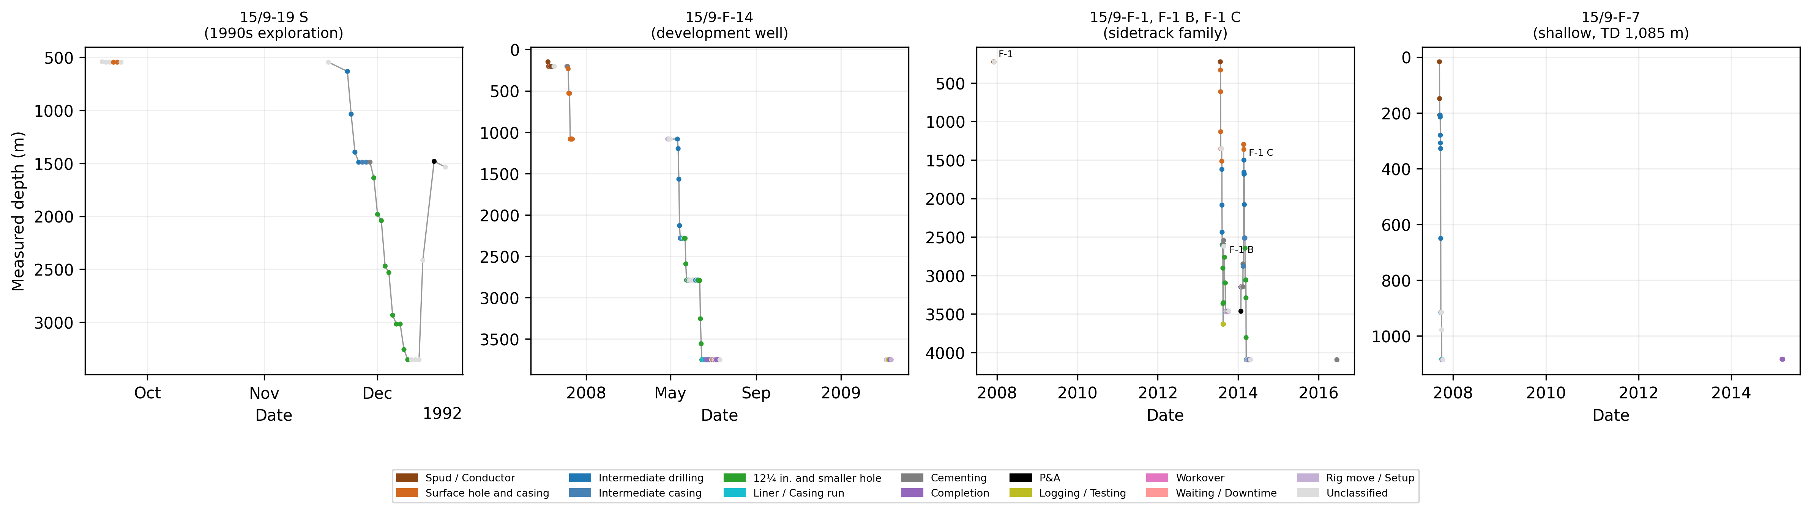
Fig. 2: Depth versus time for six wellbores in four panels (15/9-19 S; 15/9-F-14; 15/9-F-1, F-1 B and F-1 C; 15/9-F-7), coloured by the phase assigned to each report. The phases are single-report labels.
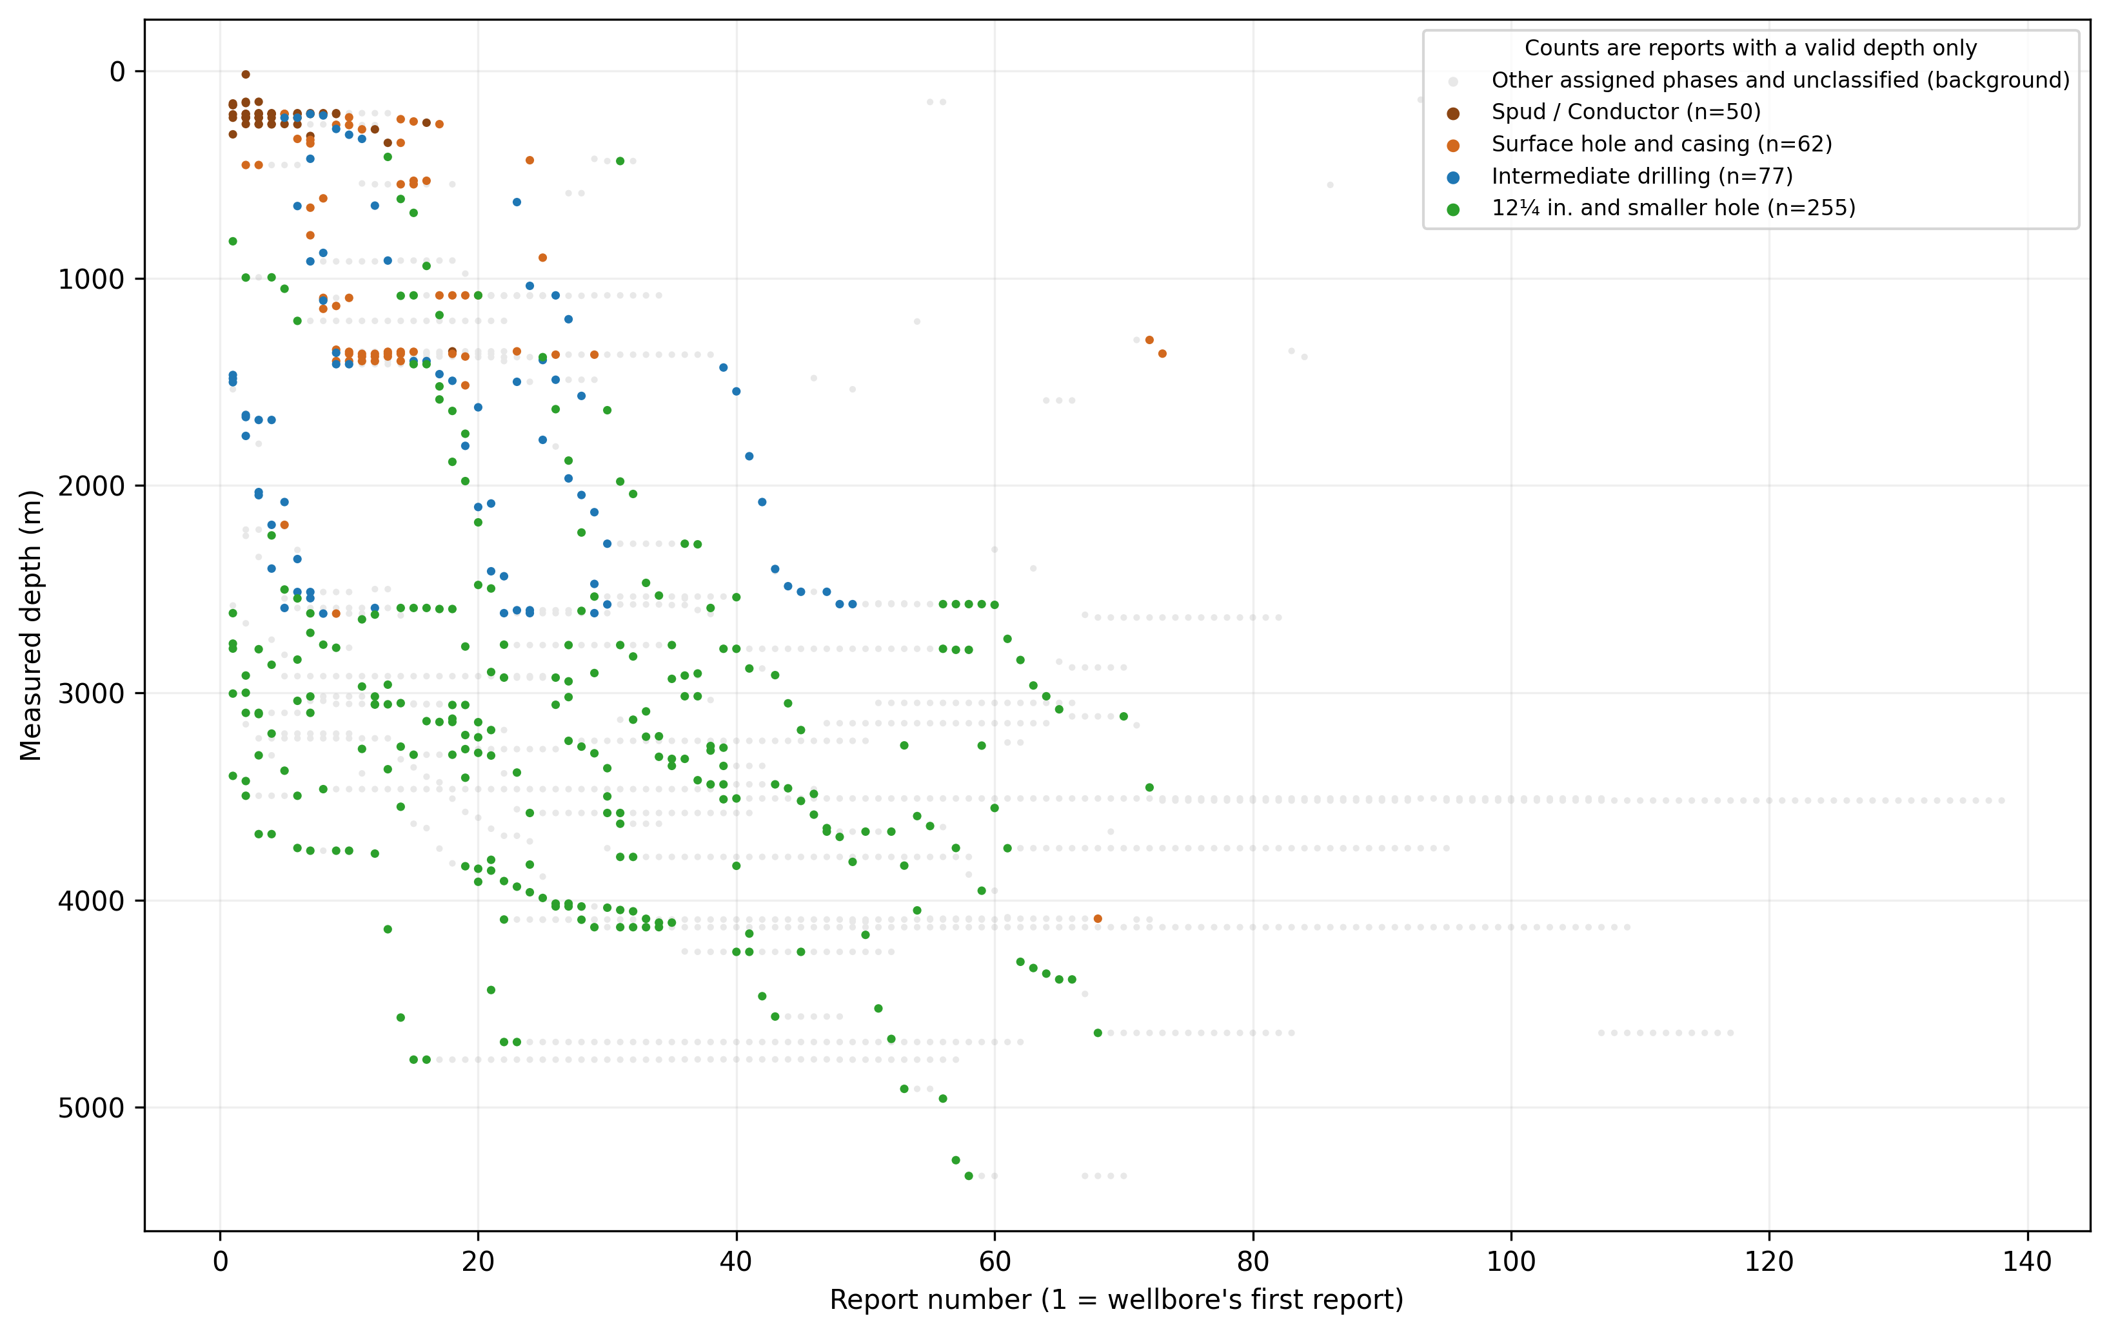
Fig. 3: Report number (1 = the wellbore's first report, as counted in Table 8) versus measured depth, with the reports of all 26 wellbores pooled (individual wellbore curves are not identified) and coloured by selected assigned phase categories (grey: other assigned phases and unclassified reports). The counts in the legend are reports with a valid depth only, and the phases are single-report labels.
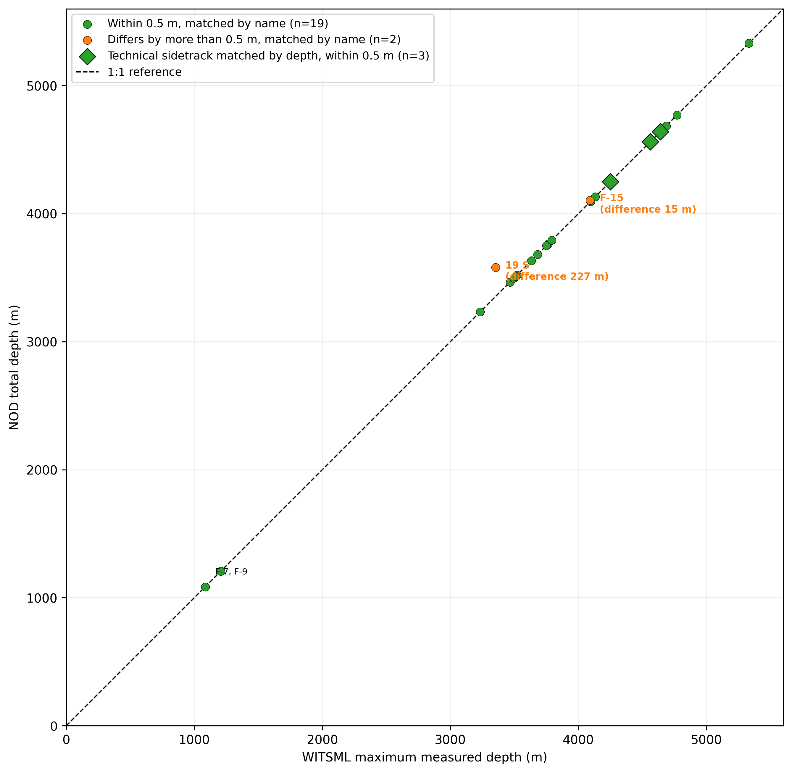
Fig. 4: Reconstructed WITSML maximum MD versus NOD total depth for the 24 matched wellbores, with 1:1 reference line. The two unmatched wellbores (15/9-19 B and 15/9-F-11) are not plotted. Circles mark the 21 wellbores matched by name and diamonds the 3 technical sidetracks matched by depth.
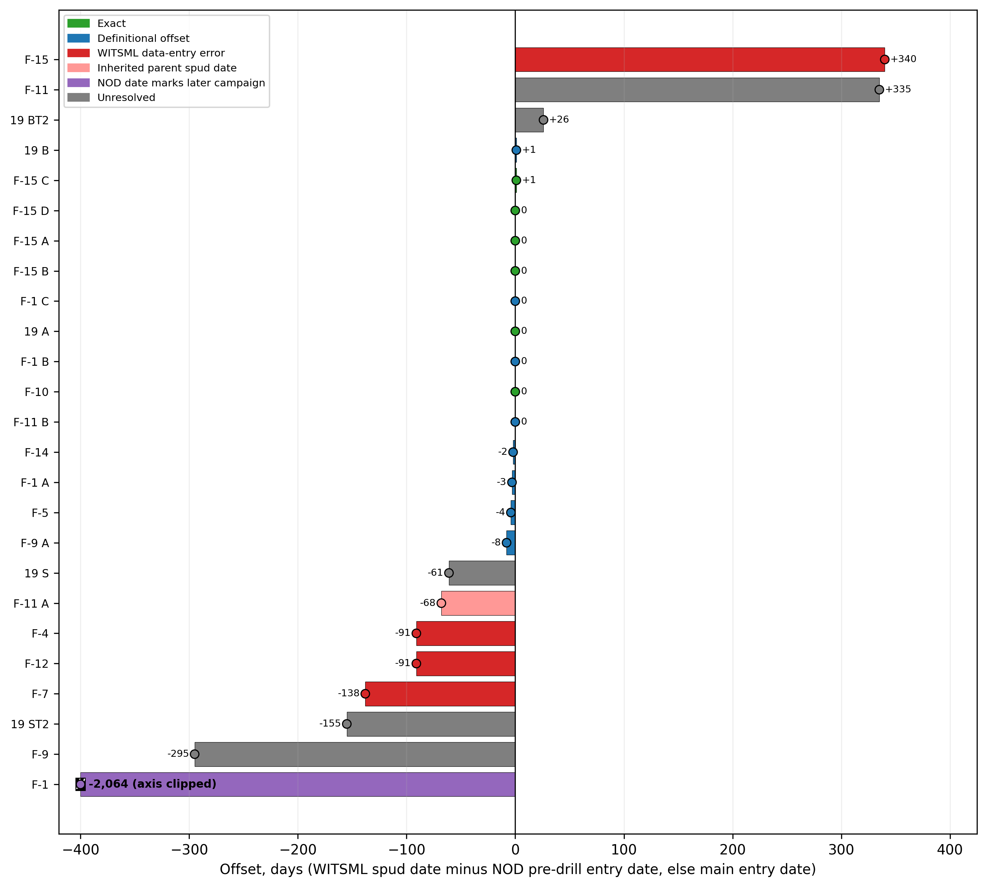
Fig. 5: Spud date offset (WITSML spud date minus the NOD pre-drill entry date where recorded, otherwise the NOD main entry date) for 25 wellbores, coloured by validation category. The bar of 15/9-F-1 (offset -2,064 days) is clipped at -400 days and labelled with its value. 15/9-F-11 T2 is excluded because NOD does not register it separately. A dot coloured by category marks the end of every bar and makes zero-day offsets visible, and 15/9-F-11 is shown as Unresolved.

Appendix A: Traceability
Every quantitative figure in this paper traces to an entry in the numbers registry published in the repository (305 entries, each with the producing script and function, the SHA-256 of its input files and an execution timestamp). The audit estimates in Section 5.2 are derived arithmetically from registry entries, and the arithmetic is shown in Appendix B.

Appendix B: Audit Arithmetic
This appendix gives the arithmetic behind the estimated recoverable coverage of Section 5.2.
The two groups were sampled in near-proportion to their size (39 of 296, 13.2%, and 11 of 87, 12.6%). The sample proportions of construction reports are 23/39 = 0.5897 and 3/11 = 0.2727, and the group weights are 296/383 = 0.7728 and 87/383 = 0.2272. The stratified proportion is therefore 0.7728 × 0.5897 + 0.2272 × 0.2727 = 0.5177. Its variance is the sum over the two groups of W² (1 − f) p (1 − p) / (n − 1), where f is the sampling fraction. The sum is 0.0042, the standard error is 0.0648, and the 95% interval is 0.5177 ± 1.96 × 0.0648, or 0.391 to 0.645 (normal approximation, with only 11 records in the production group). The sample comes from the 383 records with a genuine narrative among the 456 unclassified records, and the proportion is scaled by 383/1,759 = 0.2177. The estimated residual is 0.5177 × 0.2177 = 0.1127, or 11.3 percentage points (approximately 198 DDRs). Adding the observed coverage (1,303/1,759 = 0.7408) gives an estimated recoverable coverage of 85.3%. Scaling the interval in the same way gives 0.7408 + 0.391 × 0.2177 = 0.826 and 0.7408 + 0.645 × 0.2177 = 0.881, a 95% interval of 82.6 to 88.1%.
For comparison, the unstratified sample proportion is 26/50 = 0.520 with a Wilson-score 95% interval (Wilson 1927) of 0.385 to 0.652. Scaling by 0.2177 gives a residual of 0.1132 (approximately 199 DDRs) and an estimated recoverable coverage of 85.4%, with the interval 0.7408 + 0.385 × 0.2177 = 0.825 and 0.7408 + 0.652 × 0.2177 = 0.883, or 82.5 to 88.3%. The two estimates differ by 0.1 percentage point.

