RS485 MODBUS I/O Devices
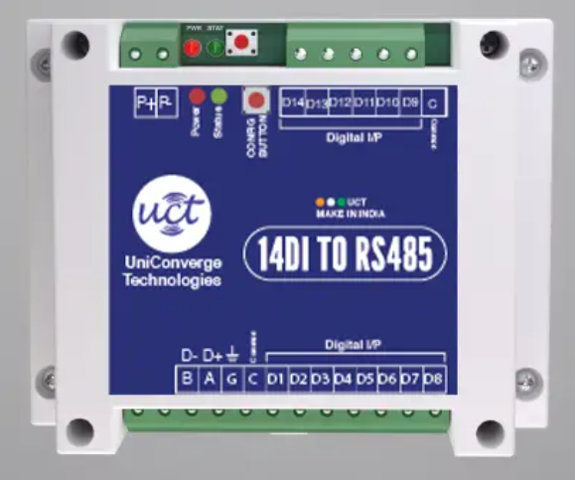

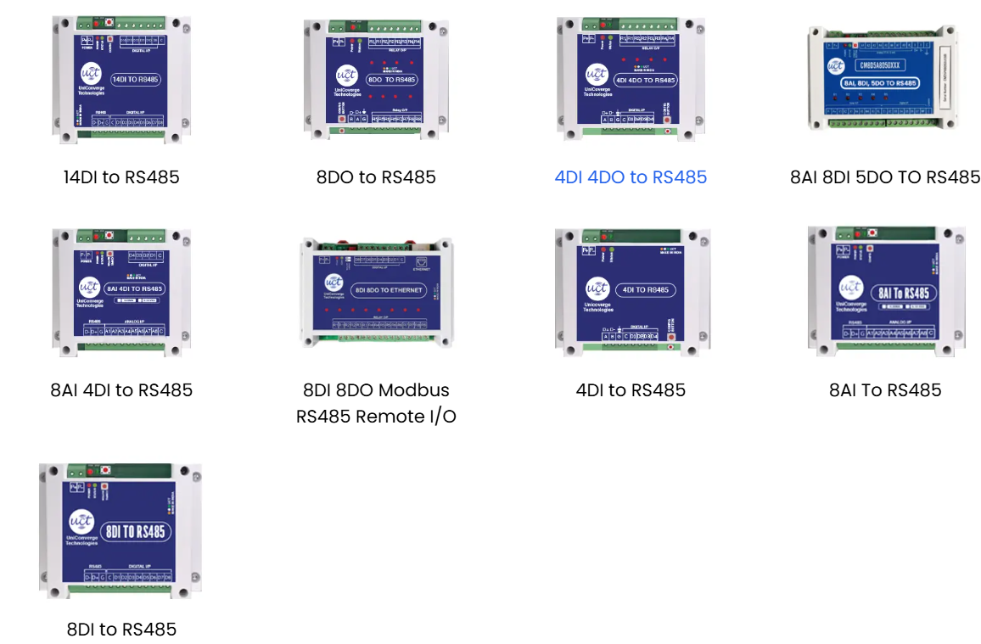

Working Operation
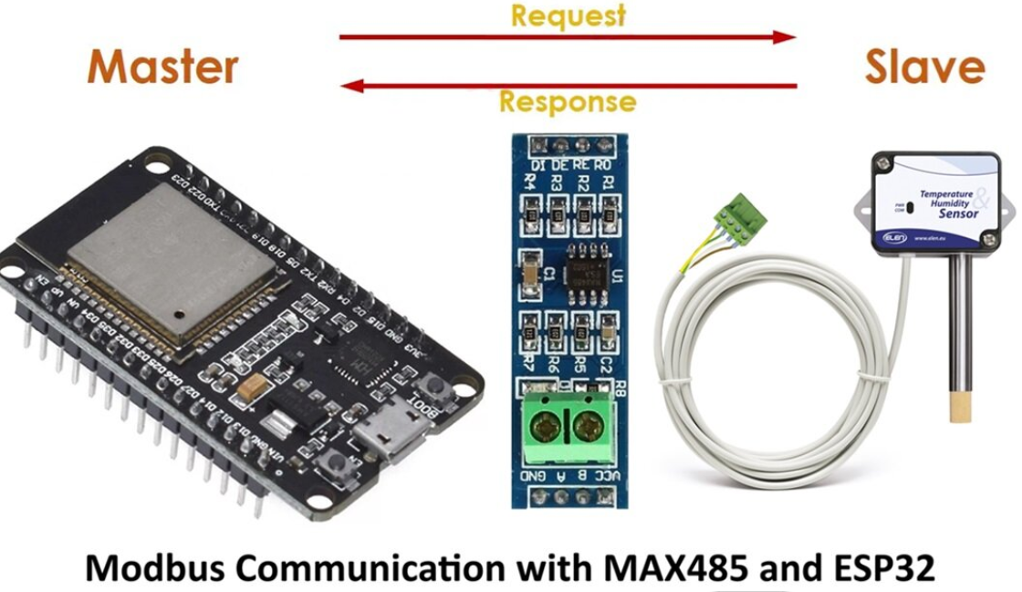

The MAX485 TTL to RS485 Modus Module is a popular RS-485/RS-422 transceiver chip manufactured by Maxim Integrated. It’s commonly used in applications where long-distance serial communication is required, such as industrial control systems, building automation, and instrumentation.

MAX485 Modbus Module
A MAX485 module typically includes the MAX485 chip along with necessary support components like voltage regulators, termination resistors, and connectors. These modules make it easier to incorporate RS-485 communication into projects as they provide a convenient interface for microcontroller or other devices.

Overview of MAX485 Module:
- MAX485 Chip: The heart of the module, it’s responsible for converting between the UART signals of the microcontroller and the differential signals required for RS-485 communication.
- Voltage Regulators: MAX485 operates at a higher voltage (usually 5V), but RS-485 communication lines might operate at different voltage levels. Voltage regulators ensure proper voltage levels for both the chip and the communication lines.

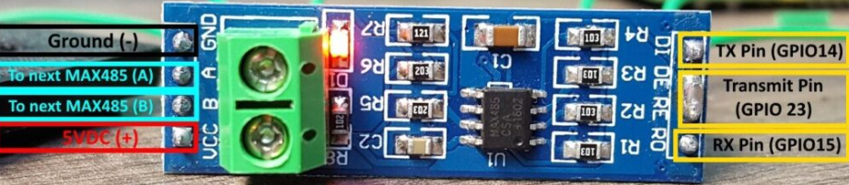

- Termination Resistors: RS-485 communication lines typically require termination resistors to minimize reflections and ensure signal integrity, especially in long-distance communication.
- Connectors: These modules usually come with connectors for easy connection to other devices. They may include terminal blocks, RJ45 connectors, or pin headers.
- Driver/Receiver Circuitry: MAX485 includes both driver and receiver circuitry necessary for bidirectional communication over the RS-485 bus.
- Direction Control Pins: MAX485 modules often include control pins to manage the direction of communication (receive or transmit) between the microcontroller and the RS-485 bus.
- LED Indicators: Some modules feature LEDs to indicate power and communication activity, aiding troubleshooting.
When using a MAX485 TTL to RS485 module, you typically connect it to a microcontroller or other devices via UART. You’ll also need to connect the RS-485 lines to the network you want to communicate with. Finally, you’ll configure the direction control pins to switch between transmit and receive modes as needed.
Overall, MAX485 modules simplify the implementation of RS-485 communication in projects by providing a ready-made interface with necessary support components.
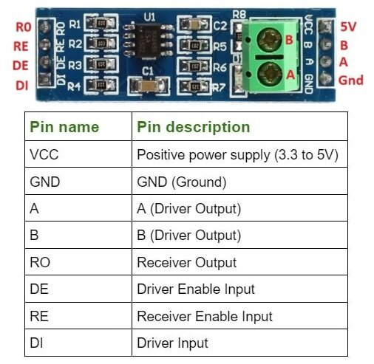

Implementing Master Slave Modus Communication by ESP32 and Arduino:
To implement Master Slave communication using ESP32 and MAX485, you’ll need to set up the ESP32 as the Master and the MAX485 as the Slave. Here’s a basic example using Arduino code

Master Code (ESP32):
#include <SoftwareSerial.h>

#define RX_PIN 16 // ESP32 RX pin
#define TX_PIN 17 // ESP32 TX pin
#define DE_PIN 2 // MAX485 DE pin
#define RE_PIN 3 // MAX485 RE pin

SoftwareSerial mySerial(RX_PIN, TX_PIN); // RX, TX

void setup() {
Serial.begin(9600);
mySerial.begin(9600);
pinMode(DE_PIN, OUTPUT);
pinMode(RE_PIN, OUTPUT);
digitalWrite(DE_PIN, HIGH);
digitalWrite(RE_PIN, HIGH);
}

void loop() {
digitalWrite(DE_PIN, HIGH); // Set DE pin high for transmitting
digitalWrite(RE_PIN, HIGH); // Set RE pin high for receiving
mySerial.println("Hello from ESP32");
delay(1000);
}

Slave Code (Arduino):
#include <SoftwareSerial.h>

#define RX_PIN 2 // MAX485 RX pin
#define TX_PIN 3 // MAX485 TX pin
#define DE_PIN 4 // MAX485 DE pin
#define RE_PIN 5 // MAX485 RE pin

SoftwareSerial mySerial(RX_PIN, TX_PIN); // RX, TX

void setup() {
Serial.begin(9600);
mySerial.begin(9600);
pinMode(DE_PIN, OUTPUT);
pinMode(RE_PIN, OUTPUT);
digitalWrite(DE_PIN, LOW);
digitalWrite(RE_PIN, LOW);
}

void loop() {
if (mySerial.available()) {
String message = mySerial.readString();
Serial.println("Received: " + message);
}
}

Wireless I/O Modules
