**PT3: PYTHON PROGRAMMING WORKSHOP**

**THEORETICAL QUESTIONS:**

1. **What is the syntax to call a constructor of a base class from child class**

**Solution: using super() function method.**

**Here the class child inherits the class parent**

1. **How is a class made as inherited class (syntax of child class)**

**Solution:**

**class Base:**

**success**

**class child(Base):**

**success**

1. **Print an element of a nested dictionary**

**Solution:**

**About_me = {1: {'name': 'mayank, 'age': '20', 'sex': 'Male'},**

**2: {'work': 'student', 'class': '4A', 'course': 'B.tech'}}**

**print(about_me[1][‘name’])**

**PROGRAMMING QUESTIONS**

**Question1**

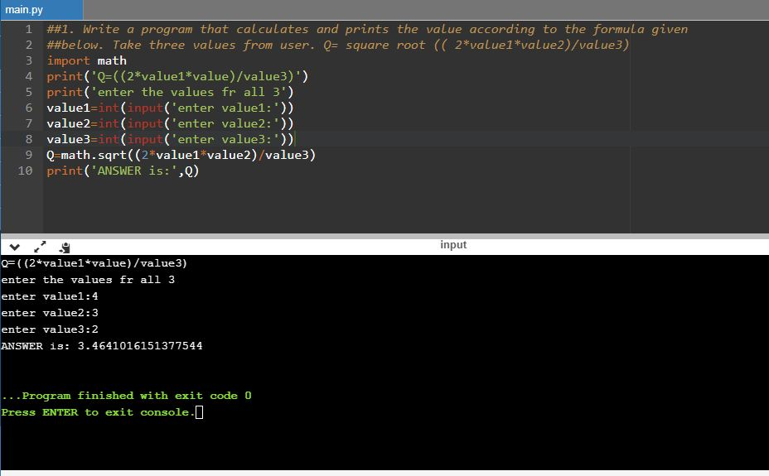

**Question 2:**

