Arrays

**1.import** java.util.Scanner;

**import** java.util.Scanner.*;

**public** **class** Sum_Average {

**public** **static** **void** main(String[] args) {

**int** n, sum = 0;

**float** average;

Scanner s = **new** Scanner(System.***in***);

System.***out***.print("Enter no. of elements you want in array:");

n = s.nextInt();

**int** a[] = **new** **int**[n];

System.***out***.println("Enter all the elements:");

**for**(**int** i = 0; i < n ; i++)

{

a[i] = s.nextInt();

sum = sum + a[i];

}

System.***out***.println("Sum:"+sum);

average = (**float**)sum / n;

System.***out***.println("Average:"+average);

}

}

OUTPUT:

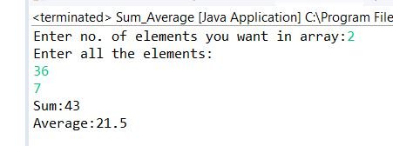

**2.public** **class** MinMaxExample {

**public** **static** **void** main(String[] args) {

**int** array[] = **new** **int**[]{10, 11, 88, 2, 12, 120};

**int** max = *getMax*(array);

System.***out***.println("Maximum Value is: "+max);

**int** min = *getMin*(array);

System.***out***.println("Minimum Value is: "+min);

}

**public** **static** **int** getMax(**int**[] inputArray){

**int** maxValue = inputArray[0];

**for**(**int** i=1;i < inputArray.length;i++){

**if**(inputArray[i] > maxValue){

maxValue = inputArray[i];

}

}

**return** maxValue;

}

**public** **static** **int** getMin(**int**[] inputArray){

**int** minValue = inputArray[0];

**for**(**int** i=1;i<inputArray.length;i++){

**if**(inputArray[i] < minValue){

minValue = inputArray[i];

}

}

**return** minValue;

}

}

OUTPUT:

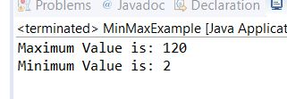

3. **import** java.util.Arrays;

**import** java.util.stream.IntStream;

**public** **class** GFG {

**private** **static** **void** check(**int**[] arr, **int** toCheckValue)

{

**int** test = -1;

**for** (**int** element : arr) {

**if** (element == toCheckValue) {

test = -1;

**break**;

}

}

System.***out***.println("Is " + toCheckValue

+ " present in the array: " + test);

} **public** **static** **void** main(String[] args)

{

**int** arr[] = {1, 4, 36, 56, 7 };

**int** toCheckValue = 7;

System.***out***.println("Array: " + Arrays.*toString*(arr));

*check*(arr, toCheckValue);

}

}

OUTPUT:

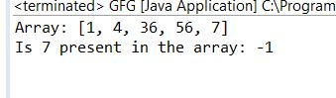

4. **package** cse;

**public** **class** AsciiValue {

**public** **static** **void** main(String[] args) {

**char** ch = 'a';

**int** ascii = ch;

**int** castAscii = (**int**) ch;

System.***out***.println("The ASCII value of " + ch + " is: " + ascii);

System.***out***.println("The ASCII value of " + ch + " is: " + castAscii);

}

}

OUTPUT:

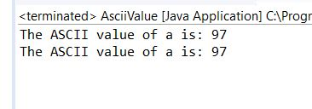

5. **package** cse;

**import** java.util.Scanner;

**public** **class** largest_and_second {

**public** **static** **void** main(String[] args) {

Scanner scn = **new** Scanner (System.***in***);

System.***out***.print("Enter no. of elements you want in array:");

**int** n = scn.nextInt();

**int** array[] = **new** **int**[n];

System.***out***.println("Enter all the elements:");

**for** (**int** i = 0; i < array.length; i++)

{

array[i] = scn.nextInt();

}

**int** largest1, largest2, temp;

largest1 = array[0];

largest2 = array[1];

**if** (largest1 < largest2)

{

temp = largest1;

largest1 = largest2;

largest2 = temp;

}

**for** (**int** i = 2; i < array.length; i++)

{

**if** (array[i] > largest1)

{

largest2 = largest1;

largest1 = array[i];

}

**else** **if** (array[i] > largest2 && array[i] != largest1)

{

largest2 = array[i];

}

}

System.***out***.println ("The First largest is " + largest1);

System.***out***.println ("The Second largest is " + largest2);

}

}

OUTPUT:

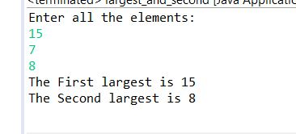

6. **package** cse;

**import** java.util.Scanner;

**public** **class** Ascending_order {

**public** **static** **void** main(String[] args) {

**int** n, temp;

Scanner s = **new** Scanner(System.***in***);

System.***out***.print("Enter no. of elements you want in array:");

n = s.nextInt();

**int** a[] = **new** **int**[n];

System.***out***.println("Enter all the elements:");

**for** (**int** i = 0; i < n; i++)

{

a[i] = s.nextInt();

}

**for** (**int** i = 0; i < n; i++)

{

**for** (**int** j = i + 1; j < n; j++)

{

**if** (a[i] > a[j])

{

temp = a[i];

a[i] = a[j];

a[j] = temp;

}

}

}

System.***out***.print("Ascending Order:");

**for** (**int** i = 0; i < n - 1; i++)

{

System.***out***.print(a[i] + ",");

}

System.***out***.print(a[n - 1]);

}

}

OUTPUT:

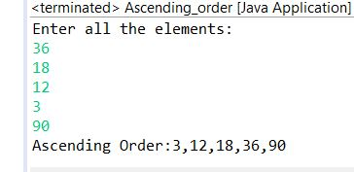

7. **package** cse;

**public** **class** RemoveDuplicateInArrayExample {

**public** **static** **int** removeDuplicateElements(**int** arr[], **int** n){

**if** (n==0 || n==1){

**return** n;

}

**int**[] temp = **new** **int**[n];

**int** j = 0;

**for** (**int** i=0; i<n-1; i++){

**if** (arr[i] != arr[i+1]){

temp[j++] = arr[i];

}

}

temp[j++] = arr[n-1];

**for** (**int** i=0; i<j; i++){

arr[i] = temp[i];

}

**return** j;

}

**public** **static** **void** main(String[] args) {

**int** arr[] = {12,34,12,45,67,89};

**int** length = arr.length;

length = *removeDuplicateElements*(arr, length);

//printing array elements

**for** (**int** i=0; i<length; i++)

System.***out***.print(arr[i]+" ");

}

}

OUTPUT:

