OrganMatch+ – Blockchain-Based Secure Organ Donation Platform

Team Members
Name | Course | Specialization | Semester | IAR No
Disha Girase | B.Tech CE | AI | 5 | 14099
Meet Mochi | B.Tech CE | AI | 5 | 14502

Guide / Mentor
- Dr.Maitri Patel

Abstract
OrganMatch+ is a blockchain-powered decentralized application (DApp) designed to ensure transparency, security, and trust in organ donation and transplantation.
The system leverages smart contracts to automate donor-recipient matching, prevent data tampering, and provide a decentralized, tamper-proof ledger for hospitals and authorities.
Keywords: Blockchain, Smart Contracts, Organ Donation, DApp, Security, Transparency

1. Introduction
Problem Statement:
Traditional organ donation systems face challenges like fraud, manual record errors, lack of transparency, and unauthorized access.
Purpose:
OrganMatch+ provides a secure, decentralized solution using blockchain technology to manage donor-recipient records ethically and efficiently.
Scope:
- Hospitals and authorized administrators
- Donors and recipients
- Real-time tracking and verification of organ donation

2. Objectives
- Ensure authenticity and transparency of donor and recipient data
- Prevent data manipulation and unauthorized access
- Automate donor-recipient matching with smart contracts
- Provide a decentralized platform for hospitals and authorities
- Promote ethical organ donation practices

3. System Analysis
Existing System:
- Centralized manual record keeping
- Prone to data tampering and unauthorized access
- No automated matching system
Limitations:
- Slow and error-prone
- Lack of transparency
Proposed System:
- Blockchain-based decentralized ledger
- Automated donor-recipient matching using smart contracts
- Secure and transparent transaction logs
Advantages:
- Tamper-proof data storage
- Ethical and transparent organ allocation
- Easy verification by authorized hospitals

4. System Design
4.1 Architecture Diagram
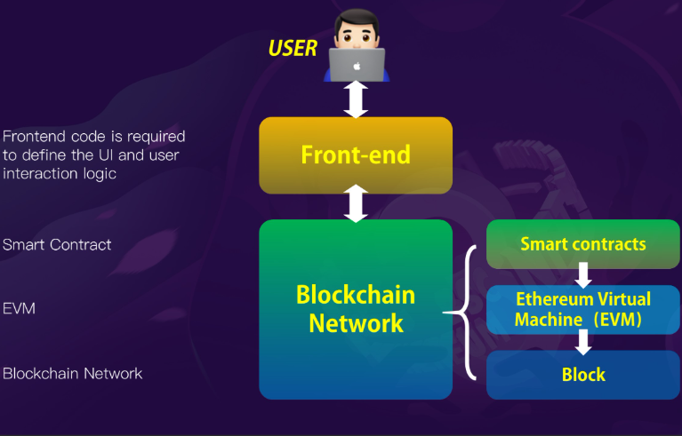
4.2 Data Flow Diagram (DFD)
- Level 0: High-level process flow
- Level 1: Detailed flow of donor/recipient registration and matching
4.3 UML Diagrams
- Use Case Diagram – Shows donor, recipient, hospital, and admin interactions
- Class Diagram – Classes for smart contracts, users, and transactions
- Sequence Diagram – Flow of organ donation request, verification, and confirmation

5. Technology Used
Layer | Technology
Blockchain Framework | Ethereum / Hardhat
Smart Contract Language | Solidity
Frontend | React + Vite
Backend | Python Flask / Node.js
Storage | IPFS (for decentralized files)
Wallet Integration | MetaMask
Tools | Remix IDE, Hardhat, VS Code

6. Implementation
Smart Contract Overview:
- OrganDonation.sol – handles registration, verification, and matching
- Deployment via Hardhat scripts
Backend:
- Flask API connects frontend with blockchain
Frontend:
- React DApp allows donors and recipients to register and view matches
Screenshots:
- Donor Registration Form
- Recipient Approval Screen
- Transaction Confirmation on Blockchain
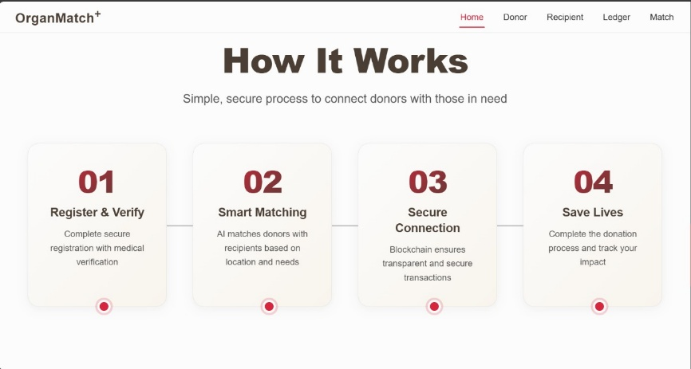
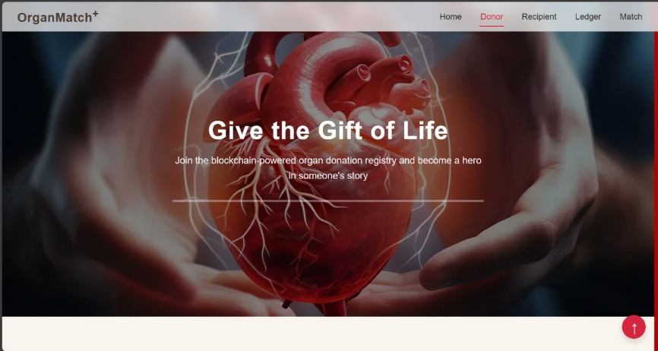
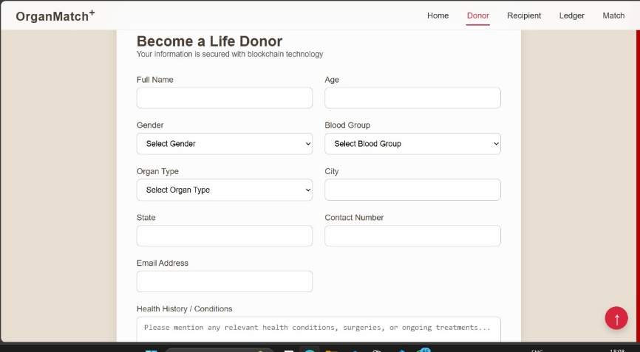

7. Testing & Results
- Unit tests executed using Hardhat
- Test cases include registration, verification, and successful matching
- Blockchain logs captured for each transaction
- Screenshots of test execution
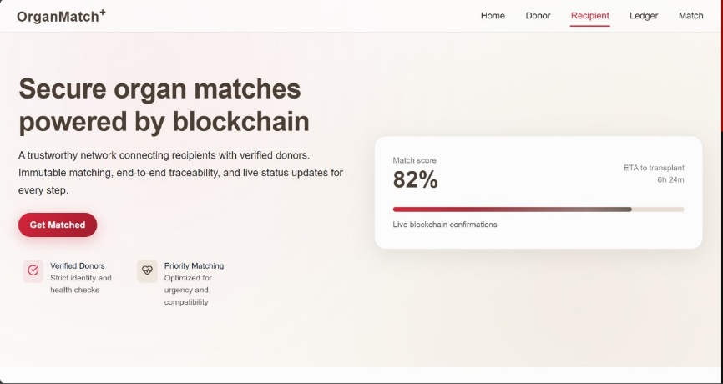
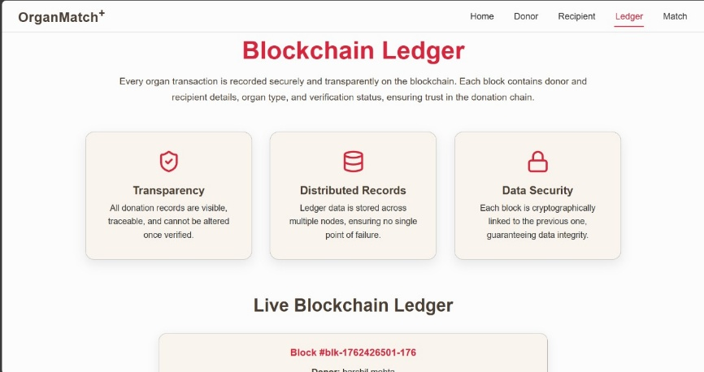
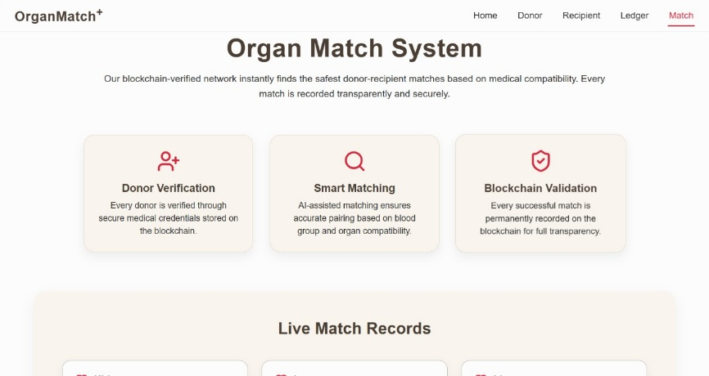

8. Conclusion & Future Scope
Conclusion:
OrganMatch+ successfully provides a secure, transparent, and decentralized organ donation system. It minimizes fraud, automates matching, and ensures ethical management of donor-recipient data.
Future Scope:
- Integration with government health databases
- AI-based donor-recipient matching
- Multi-hospital collaboration
- Storage of medical files using IPFS

9. References / Bibliography
- Ethereum.org – Ethereum Documentation
- Solidity Docs – Solidity Language Reference
- Hardhat.org – Ethereum Development Environment
- Flask Documentation – Python Web Framework
- ReactJS Docs – Frontend Library

10. Acknowledgments
- Special thanks to our project guide for guidance and support
- References: Hardhat, Remix IDE, ReactJS, MetaMask

