Practical 10
Developing and deploying web service in Java
Creating SOAP Web Service using Maven & Tomcat 9
Steps: -

✅ STEP 1: Install Required Software
- Install JDK 8 (not necessary)
- Install Apache NetBeans 14
- Download and extract Tomcat 9
Example location:
C:\apache-tomcat-9.0.xx

✅ STEP 2: Add Tomcat 9 in NetBeans
- Open NetBeans
- Go to:
Tools → Servers
- Click Add Server
- Select:
Apache Tomcat or TomEE
- Browse Tomcat folder
- Finish
Tomcat will appear in:
Services → Servers

✅ STEP 3: Create Maven Web Application
- File → New Project
- Select:
Java with Maven → Web Application
- Click Next
- Project Name:
prac10
- Group ID:
com.mycompany
- Next
- Select:
Server → Apache Tomcat 9
Java EE Version → Java EE 7 Web
- Finish

✅ STEP 4: Update pom.xml
Open pom.xml
🔹 Ensure Packaging is:
<packaging>war</packaging>

🔹 Add Dependency inside <dependencies>:
<dependency>
<groupId>com.sun.xml.ws</groupId>
<artifactId>jaxws-rt</artifactId>
<version>2.3.3</version>
</dependency>

🔹 Add Build Plugin before </project>:
<build>
<plugins>
<plugin>
<groupId>org.apache.maven.plugins</groupId>
<artifactId>maven-war-plugin</artifactId>
<version>3.3.2</version>
</plugin>
</plugins>
</build>

Save file.
Right click project → Clean and Build

✅ STEP 5: Create Web Service Class
Go to:
Source Packages
Right click → New → Java Package
Name:
com.mycompany.prac10
Right click package → New → Java Class
Name:
HelloService
Replace code with:
package com.mycompany.prac10;

import javax.jws.WebService;
import javax.jws.WebMethod;

@WebService
public class HelloService {

@WebMethod
public String sayHello(String name) {
return "Hello " + name;
}
}

Save.

✅ STEP 6: Create WEB-INF Folder
Right click:
Web Pages → New → Folder
Name:
WEB-INF

✅ STEP 7: Create web.xml
Right click:
WEB-INF → New → XML Document
Name:
web
Paste:
<?xml version="1.0" encoding="UTF-8"?>
<web-app xmlns="http://xmlns.jcp.org/xml/ns/javaee"
version="3.1">

<listener>
<listener-class>
com.sun.xml.ws.transport.http.servlet.WSServletContextListener
</listener-class>
</listener>

<servlet>
<servlet-name>HelloService</servlet-name>
<servlet-class>
com.sun.xml.ws.transport.http.servlet.WSServlet
</servlet-class>
</servlet>

<servlet-mapping>
<servlet-name>HelloService</servlet-name>
<url-pattern>/HelloService</url-pattern>
</servlet-mapping>

</web-app>

Save.

✅ STEP 8: Create sun-jaxws.xml
Right click:
WEB-INF → New → XML Document
Name:
sun-jaxws
Paste:
<?xml version="1.0" encoding="UTF-8"?>
<endpoints
xmlns="http://java.sun.com/xml/ns/jax-ws/ri/runtime"
version="2.0">

<endpoint
name="HelloService"
implementation="com.mycompany.prac10.HelloService"
url-pattern="/HelloService"/>
</endpoints>

Save.

✅ STEP 9: Run the Project
- Right click project → Run
- Wait until deployment success

✅ STEP 10: Check WSDL
Open browser:
http://localhost:8080/prac10/HelloService?wsdl
If correct, you will see XML starting with:
<definitions>
That means SOAP Web Service is successfully deployed.

🎯 Expected Output
- WAR file created
- Application deployed
- WSDL file generated
- Service accessible in browser

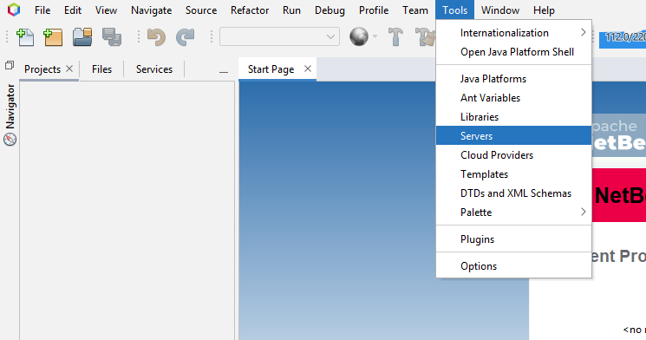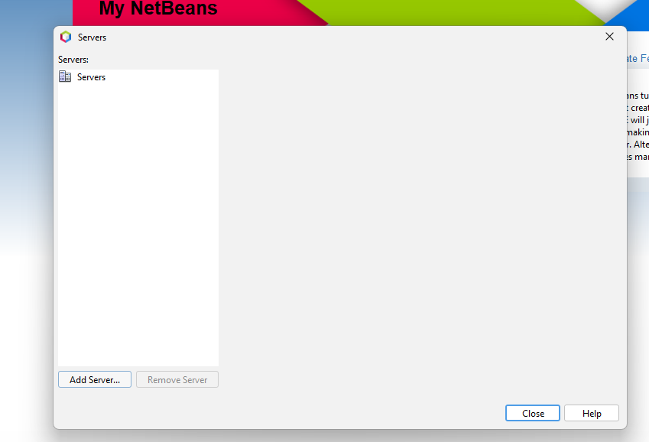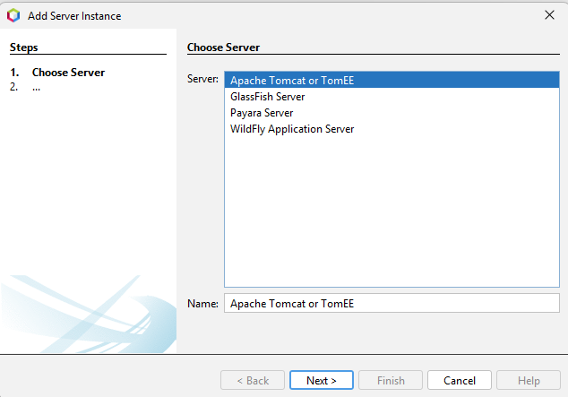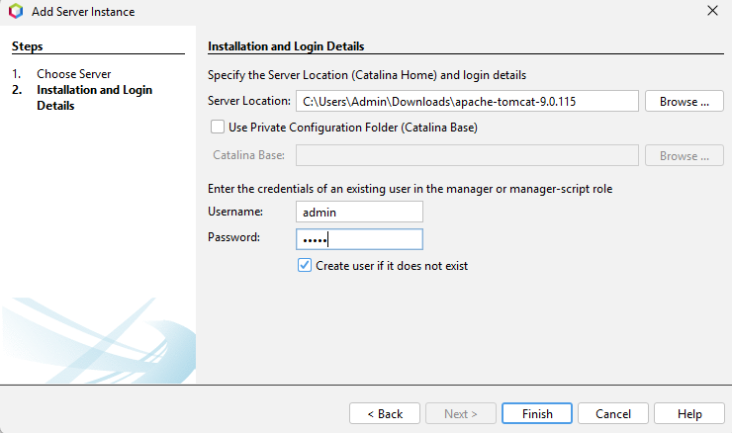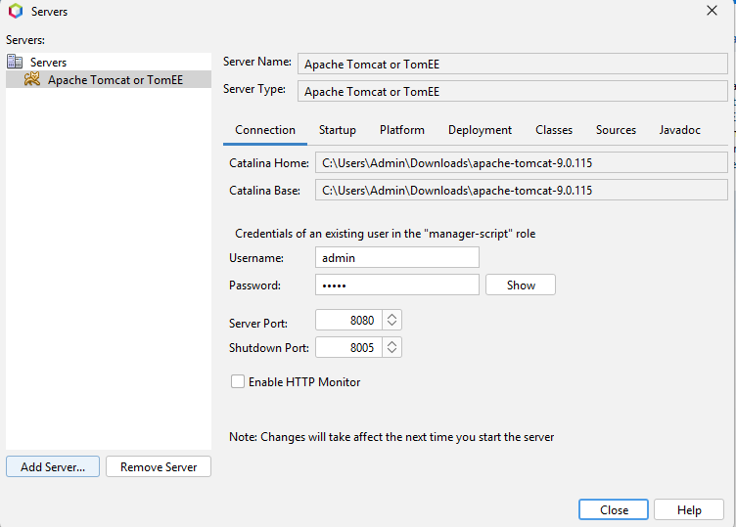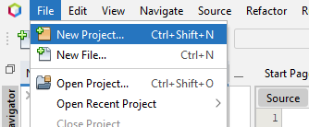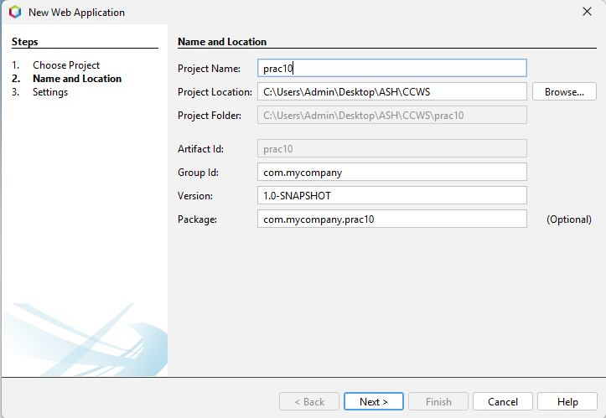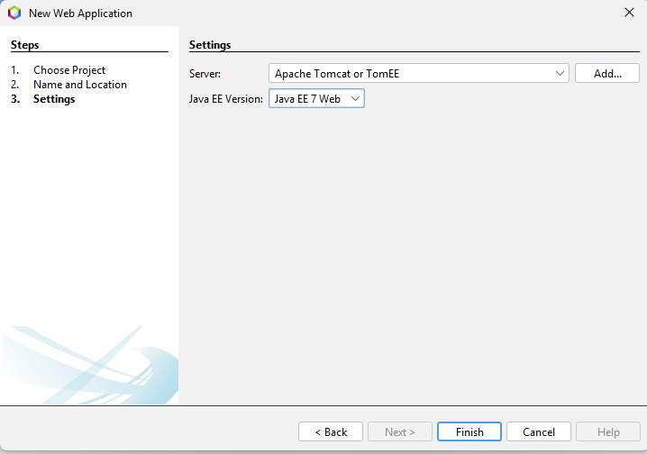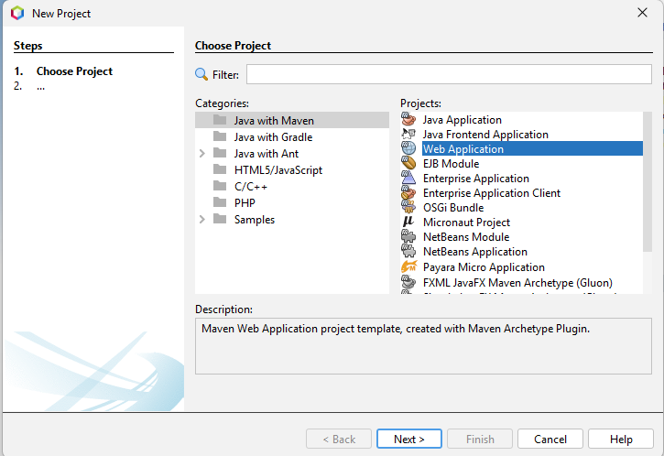

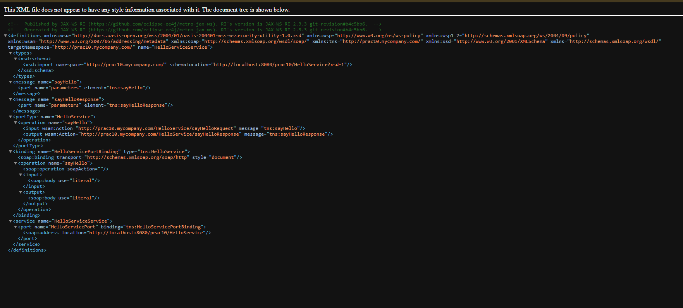
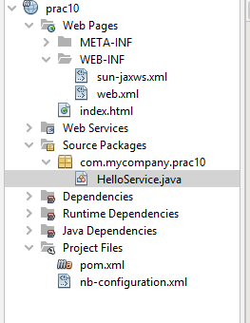

Steps to Test WSDL in SOAP UI
1️⃣ Open SOAP UI
Launch the SOAP UI application.

2️⃣ Create New SOAP Project
Go to:
File → New SOAP Project

3️⃣ Enter Project Details
- Project Name:
- HelloServiceTest
- Initial WSDL:
- http://localhost:8080/prac10/HelloService?wsdl
✔ Keep “Create Requests” checked.
Click OK.

4️⃣ Open the Generated Request
On the left panel:
HelloServiceTest
→ HelloServiceSoapBinding
→ sayHello
→ Request 1
Double-click Request 1.

5️⃣ Edit the Request XML
Find this line:
<arg0>?</arg0>
Replace it with:
<arg0>YourName</arg0>
Example:
<arg0>Ashlesha</arg0>

6️⃣ Send the Request
Click the green ▶ Submit button.

7️⃣ Verify the Response
You should see response like:
<return>Hello Ashlesha</return>

✅ Result
The SOAP Web Service is successfully tested using SOAP UI.

