Gesture Recognition Write-Up

Google Drive Link:

<https://drive.google.com/drive/folders/1T7zi3eRZnFIV7LoinbtOkmFs3DCS_tNU?usp=sharing>

Model Path: model_init_2022-05-2521_49_00.765099\model-00030-1.48737-0.34161-1.84481-0.14474.h5

GitHub Repo:

<https://github.com/98abhilash/Gesture-Recognition>

Problem Statement

Imagine you are working as a data scientist at a home electronics company which manufactures state of the art **smart televisions**. You want to develop a cool feature in the smart-TV that can **recognise five different gestures** performed by the user which will help users control the TV without using a remote

The gestures are continuously monitored by the webcam mounted on the TV. Each gesture corresponds to a specific command:

* Thumbs up:  Increase the volume
* Thumbs down: Decrease the volume
* Left swipe: 'Jump' backwards 10 seconds
* Right swipe: 'Jump' forward 10 seconds
* Stop: Pause the movie

Each video is a sequence of 30 frames (or images).

## **Understanding the Dataset**

The training data consists of a few hundred videos categorised into one of the five classes. Each video (typically 2-3 seconds long) is divided into a **sequence of 30 frames(images)**. These videos have been recorded by various people performing one of the five gestures in front of a webcam - similar to what the smart TV will use.

The data is in a zip file. The zip file contains a 'train' and a 'val' folder with two CSV files for the two folders. These folders are in turn divided into subfolders where each subfolder represents a video of a particular gesture. Each subfolder, i.e. a video, contains 30 frames (or images).

Approach

Experiment 1: Type Conv3d

Frames Considered: 18 Frames

Batch Size = 16

Activation Functions: Relu and Softmax

Kernel Size = 3,3,3

Number of Trainable Parameters: 12,322,949

Image Size = 100,100

Epochs = 30

Optimizer = SGD(lr=0.001, decay=1e-6, momentum=0.9, nesterov=True)

Model Path = model_init_2022-05-2423_40_30.698988\model-00030-0.86914-0.65424-4.02549-0.25000.h5

Model Summary:

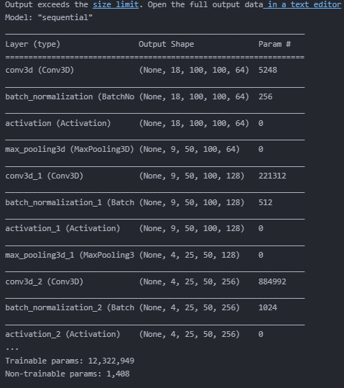

Accuracy and Loss:

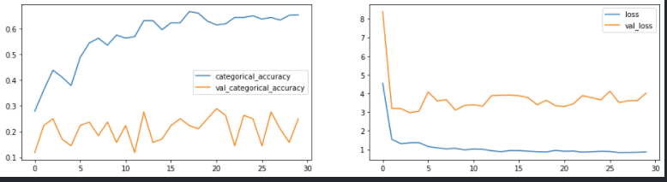

Experiment 2: Type Conv3d

Frames Considered: 15 Frames (alternate)

Batch Size = 16

Activation Functions: Relu and Softmax

Kernel Size = 3,3,3

Number of Trainable Parameters: 40,437,125

Image Size = 100,100

Epochs = 30

Optimizer = SGD(lr=0.001, decay=1e-6, momentum=0.9, nesterov=True)

Epoch 00030: saving model to model_init_2022-05-2500_25_39.273273\model-00030-0.35095-0.88406-3.17772-0.28947.h5

Model Summary:

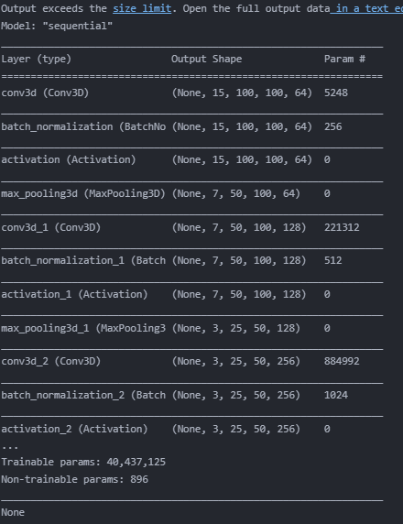

Accuracy and Loss:

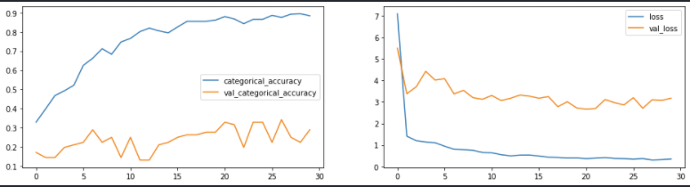

Experiment 3: Type Conv3d

Frames Considered: 15 Frames (alternate)

Batch Size = 16

Activation Functions: Relu and Softmax

Kernel Size = 3,3,3

Number of Trainable Parameters: 40,437,125

Image Size = 100,100

Epochs = 30

Optimizer = Adam(lr=0.001, decay=1e-6)

Epoch 00030: saving model to model_init_2022-05-2500_51_37.032489\model-00030-0.17731-0.93789-2.08135-0.28947.h5

Model Summary:

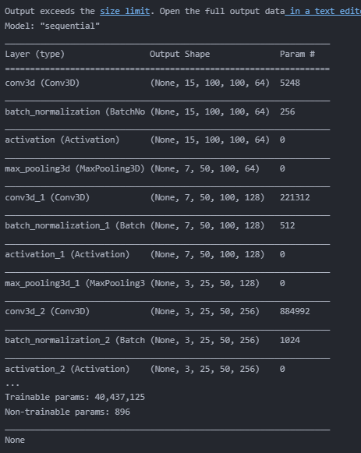

Accuracy and Loss:

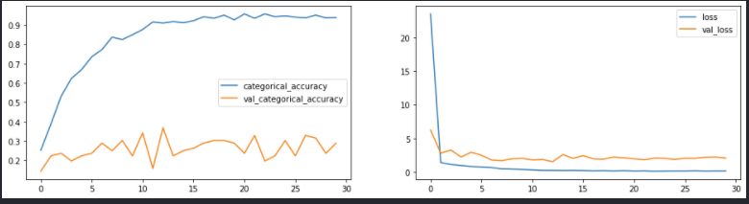

Experiment 4: Type Conv3d

Frames Considered: 30 Frames

Batch Size = 8

Activation Functions: Relu and Softmax

Kernel Size = 3,3,3

Number of Trainable Parameters: 12,322,949

Image Size = 100,100

Epochs = 30

Optimizer = Adam(lr=0.001, decay=1e-6)

Epoch 00030: saving model to model_init_2022-05-2502_08_27.982955\model-00030-0.04855-0.98585-3.42767-0.30682.h5

Model Summary:

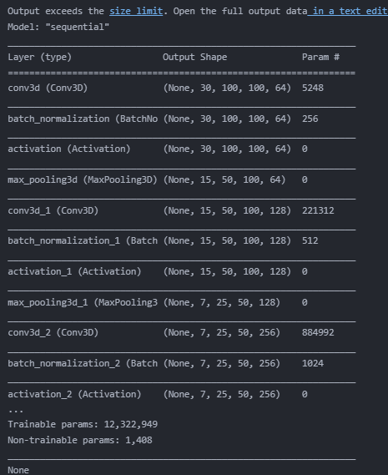

Accuracy and Loss:

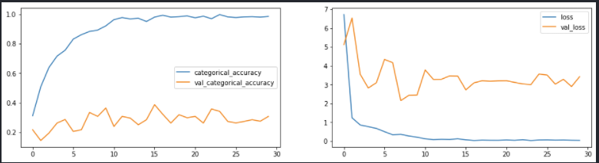

Experiment 5: Type Conv3d

Frames Considered: 30 Frames

Batch Size = 8

Activation Functions: Relu and Softmax

Kernel Size = 3,3,3

Number of Trainable Parameters: 12,322,949

Image Size = 100,100

Epochs = 30

Optimiser = .SGD(lr=0.001, decay=1e-6, momentum=0.9, nesterov=True)

Epoch 00030: saving model to model_init_2022-05-2503_10_26.268891\model-00030-0.20177-0.91667-3.79952-0.29545.h5

Model Summary:

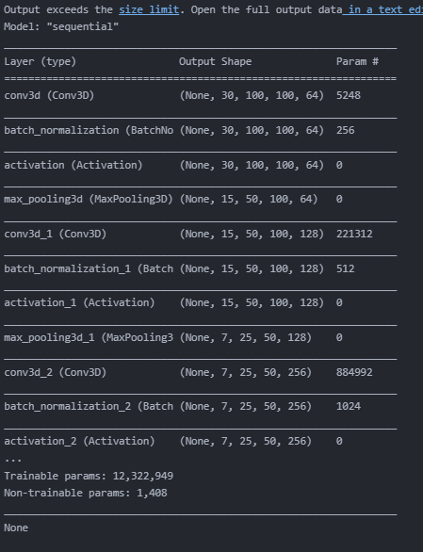

Accuracy and Loss:

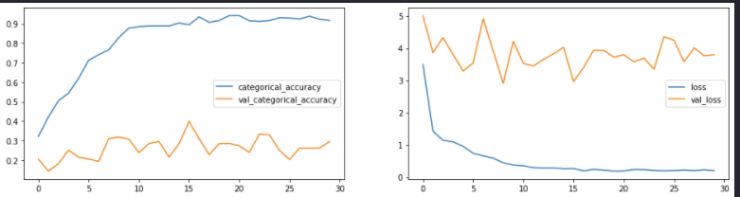

Experiment 6: Type Conv3d

Frames Considered: 10 Frames (middle)

Batch Size = 16

Activation Functions: Relu and Softmax

Kernel Size = 3,3,3

Number of Trainable Parameters: 40,437,125

Image Size = 100,100

Epochs = 30

Optimiser = .SGD(lr=0.001, decay=1e-6, momentum=0.9, nesterov=True)

Epoch 00030: saving model to model_init_2022-05-2504_11_39.296931\model-00030-1.09299-0.54658-4.04598-0.25000.h5

Model Summary:

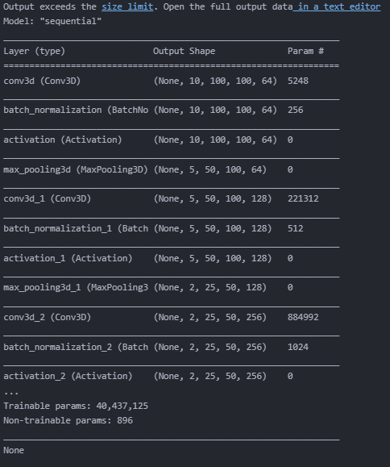

Accuracy and Loss:

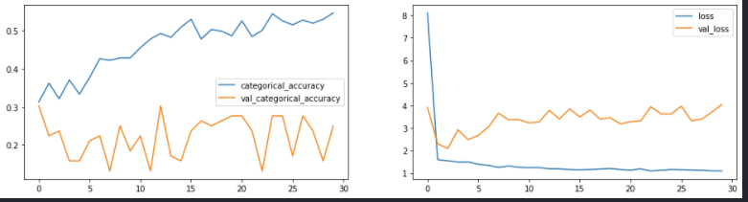

Experiment 7: Type Conv3d

Frames Considered: 18 Frames

Batch Size = 16

Activation Functions: Relu and Softmax

Kernel Size = 3,3,3

Number of Trainable Parameters: 19,157,189

Image Size = 100,100

Epochs = 30

Optimiser = .SGD(lr=0.001, decay=1e-6, momentum=0.9, nesterov=True)

Epoch 00030: saving model to model_init_2022-05-2510_45_50.623547\model-00030-9.83907-0.67288-14.37144-0.25000.h5

Model Summary:



Accuracy and Loss:

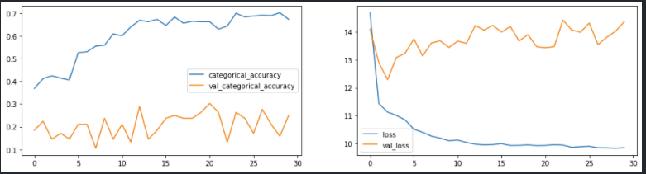

Experiment 8: Type LSTM

Frames Considered: 18 Frames

Batch Size = 16

Activation Functions: Relu and Softmax

Kernel Size = 3,3,3

Number of Trainable Parameters: 1,647,877

Image Size = 100,100

Epochs = 15

Optimiser = Adam()

Epoch 00015: saving model to model_init_2022-05-2514_00_28.262800\model-00015-1.15772-0.49896-1.61810-0.18421.h5

Model Summary:

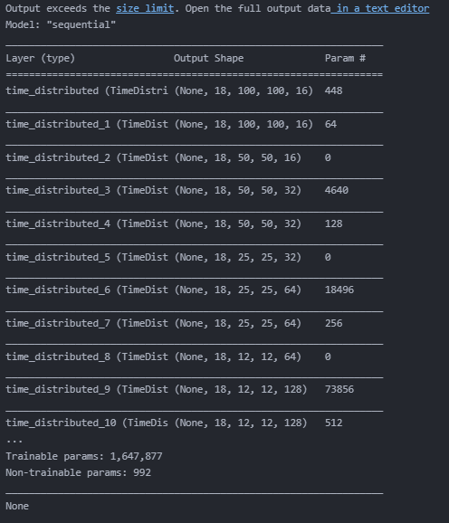

Accuracy and Loss:

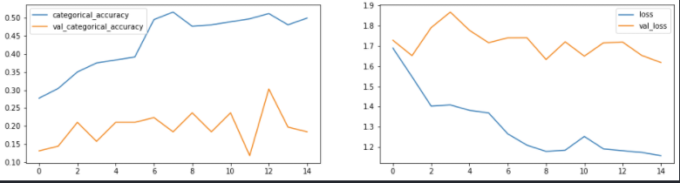

Experiment 9: Type LSTM

Frames Considered: 18 Frames

Batch Size = 16

Activation Functions: Relu and Softmax

Kernel Size = 3,3,3

Number of Trainable Parameters:999,813

Image Size = 100,100

Epochs = 15

Optimiser = Adam()

Epoch 00015: saving model to model_init_2022-05-2515_35_43.990920\model-00015-0.91924-0.65217-1.63753-0.18421.h5

Model Summary:

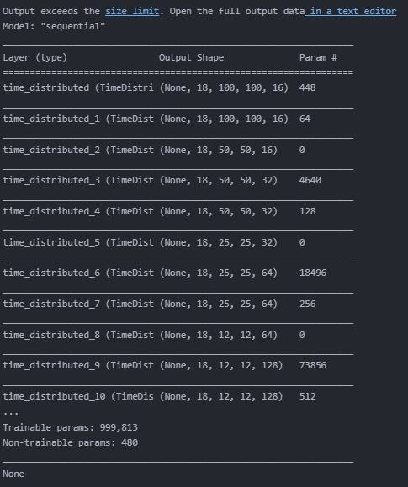

Accuracy and Loss:

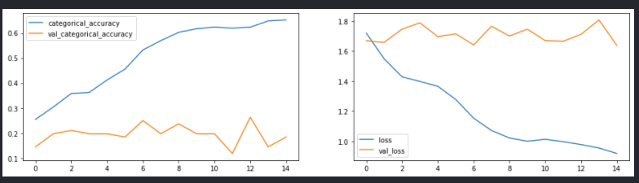

Experiment 10: Type GRU

Frames Considered: 18 Frames

Batch Size = 16

Activation Functions: Relu and Softmax

Kernel Size = 3,3,3

Number of Trainable Parameters:1,925,893

Image Size = 100,100

Epochs = 30

Optimiser =SGD(lr=0.001, decay=1e-6)

Epoch 00030: saving model to model_init_2022-05-2519_53_48.104918\model-00030-1.58027-0.25673-1.77449-0.17105.h5

Model Summary:

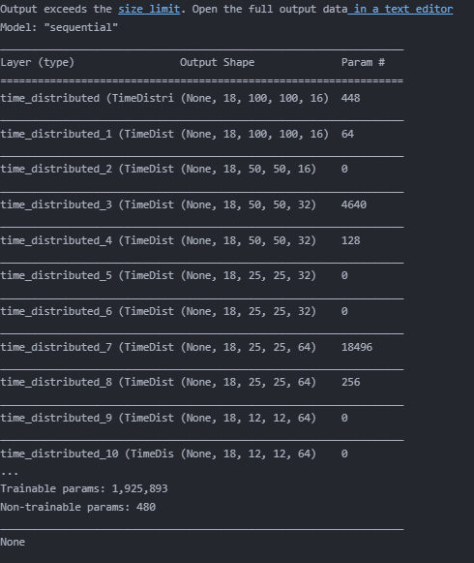

Accuracy and Loss:

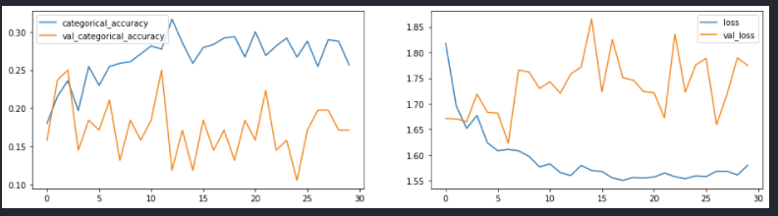

Experiment 11: Type GRU

Frames Considered: 18 Frames

Batch Size = 16

Activation Functions: Relu and Softmax

Kernel Size = 3,3,3

Number of Trainable Parameters::748,549

Image Size = 100,100

Epochs = 30

Optimiser =SGD(lr=0.001, decay=1e-6)

Epoch 00030: saving model to model_init_2022-05-2521_49_00.765099\model-00030-1.48737-0.34161-1.84481-0.14474.h5

Model Summary:

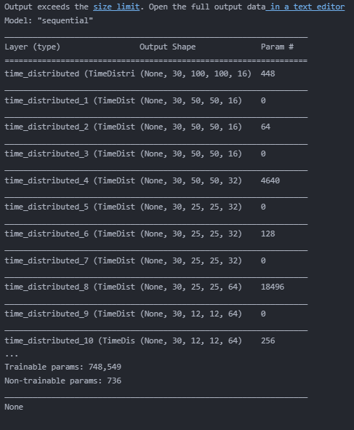

Accuracy and Loss:

