**3.1**

Inserting the following input into hash tables of size 10:

{4371, 1323, 6173, 4199, 4344, 9679, 1989}

a. Separate Chaining

0:

1: 4371 ->

2:

3: 1323 -> 6173 ->

4: 4344 ->

5:

6:

7:

8:

9: 4199 -> 9679 -> 1989 ->

b. Linear Probing

0: 9679

1: 4371

2: 1989

3: 1323

4: 6173

5: 4344

6:

7:

8:

9: 4199

c. Quadratic Probing

f(i) = i^2

0: 4371

1: 1989

2:

3: 1323

4: 6173

5: 4344

6:

7:

8: 9679

9: 4199

d. Double Hashing

H1(x) = x mod 10

H2(x) = 7 − (x mod 7)

0: 1989

1: 4371

2:

3: 1323

4: 6173

5: 9679

6:

7:4344

8:

9: 4199

**3.2**

Rehashing 3.1 tables to size of next prime, 23, all result in the same table since there's no collisions.

0:

1: 4371

2:

3:

4:

5:

6:

7:

8:

9: 6173

10:

11: 1989

12: 1323

13: 4199

14:

15:

16:

17:

18:

19: 9679

20: 4344

21:

22:

**3.3**

**Separate Chaining Hashing**

Advantage

- Collided elements do not occupy another location in the hash table.

- Another element can always be added.

Disadvantage

- Some hash indexes may become essentially a linked list, defeating the purpose by diminishing performance.

**Linear Probing**

Advantage

- Solves the disadvantage of separate chaining.

- An available index will always be found if there's room in the table.

Disadvantage

- Does not prevent blocks of indexes in the table from being occupied, resulting in primary clustering.

**Quadratic Probing**

Advantage

- Eliminates primary clustering issue with linear probing.

Disadvantage

- Causes secondary clustering instead of primary clustering.

- There is no guarantee that an empty cell can be found if the table is more than half full.

- To maintain a half-full table, rehashing is needed, and is time expensive.

**Double Hashing**

Advantage

- Solves secondary clustering with quadratic probing.

Disadvantage

- Requires a second hash function - must be well chosen, adds to runtime.

Double Hashing is the fastest, since it minimizes the inefficiency caused by clustering, while not needing the second hash function that double hashing uses.

**3.5**

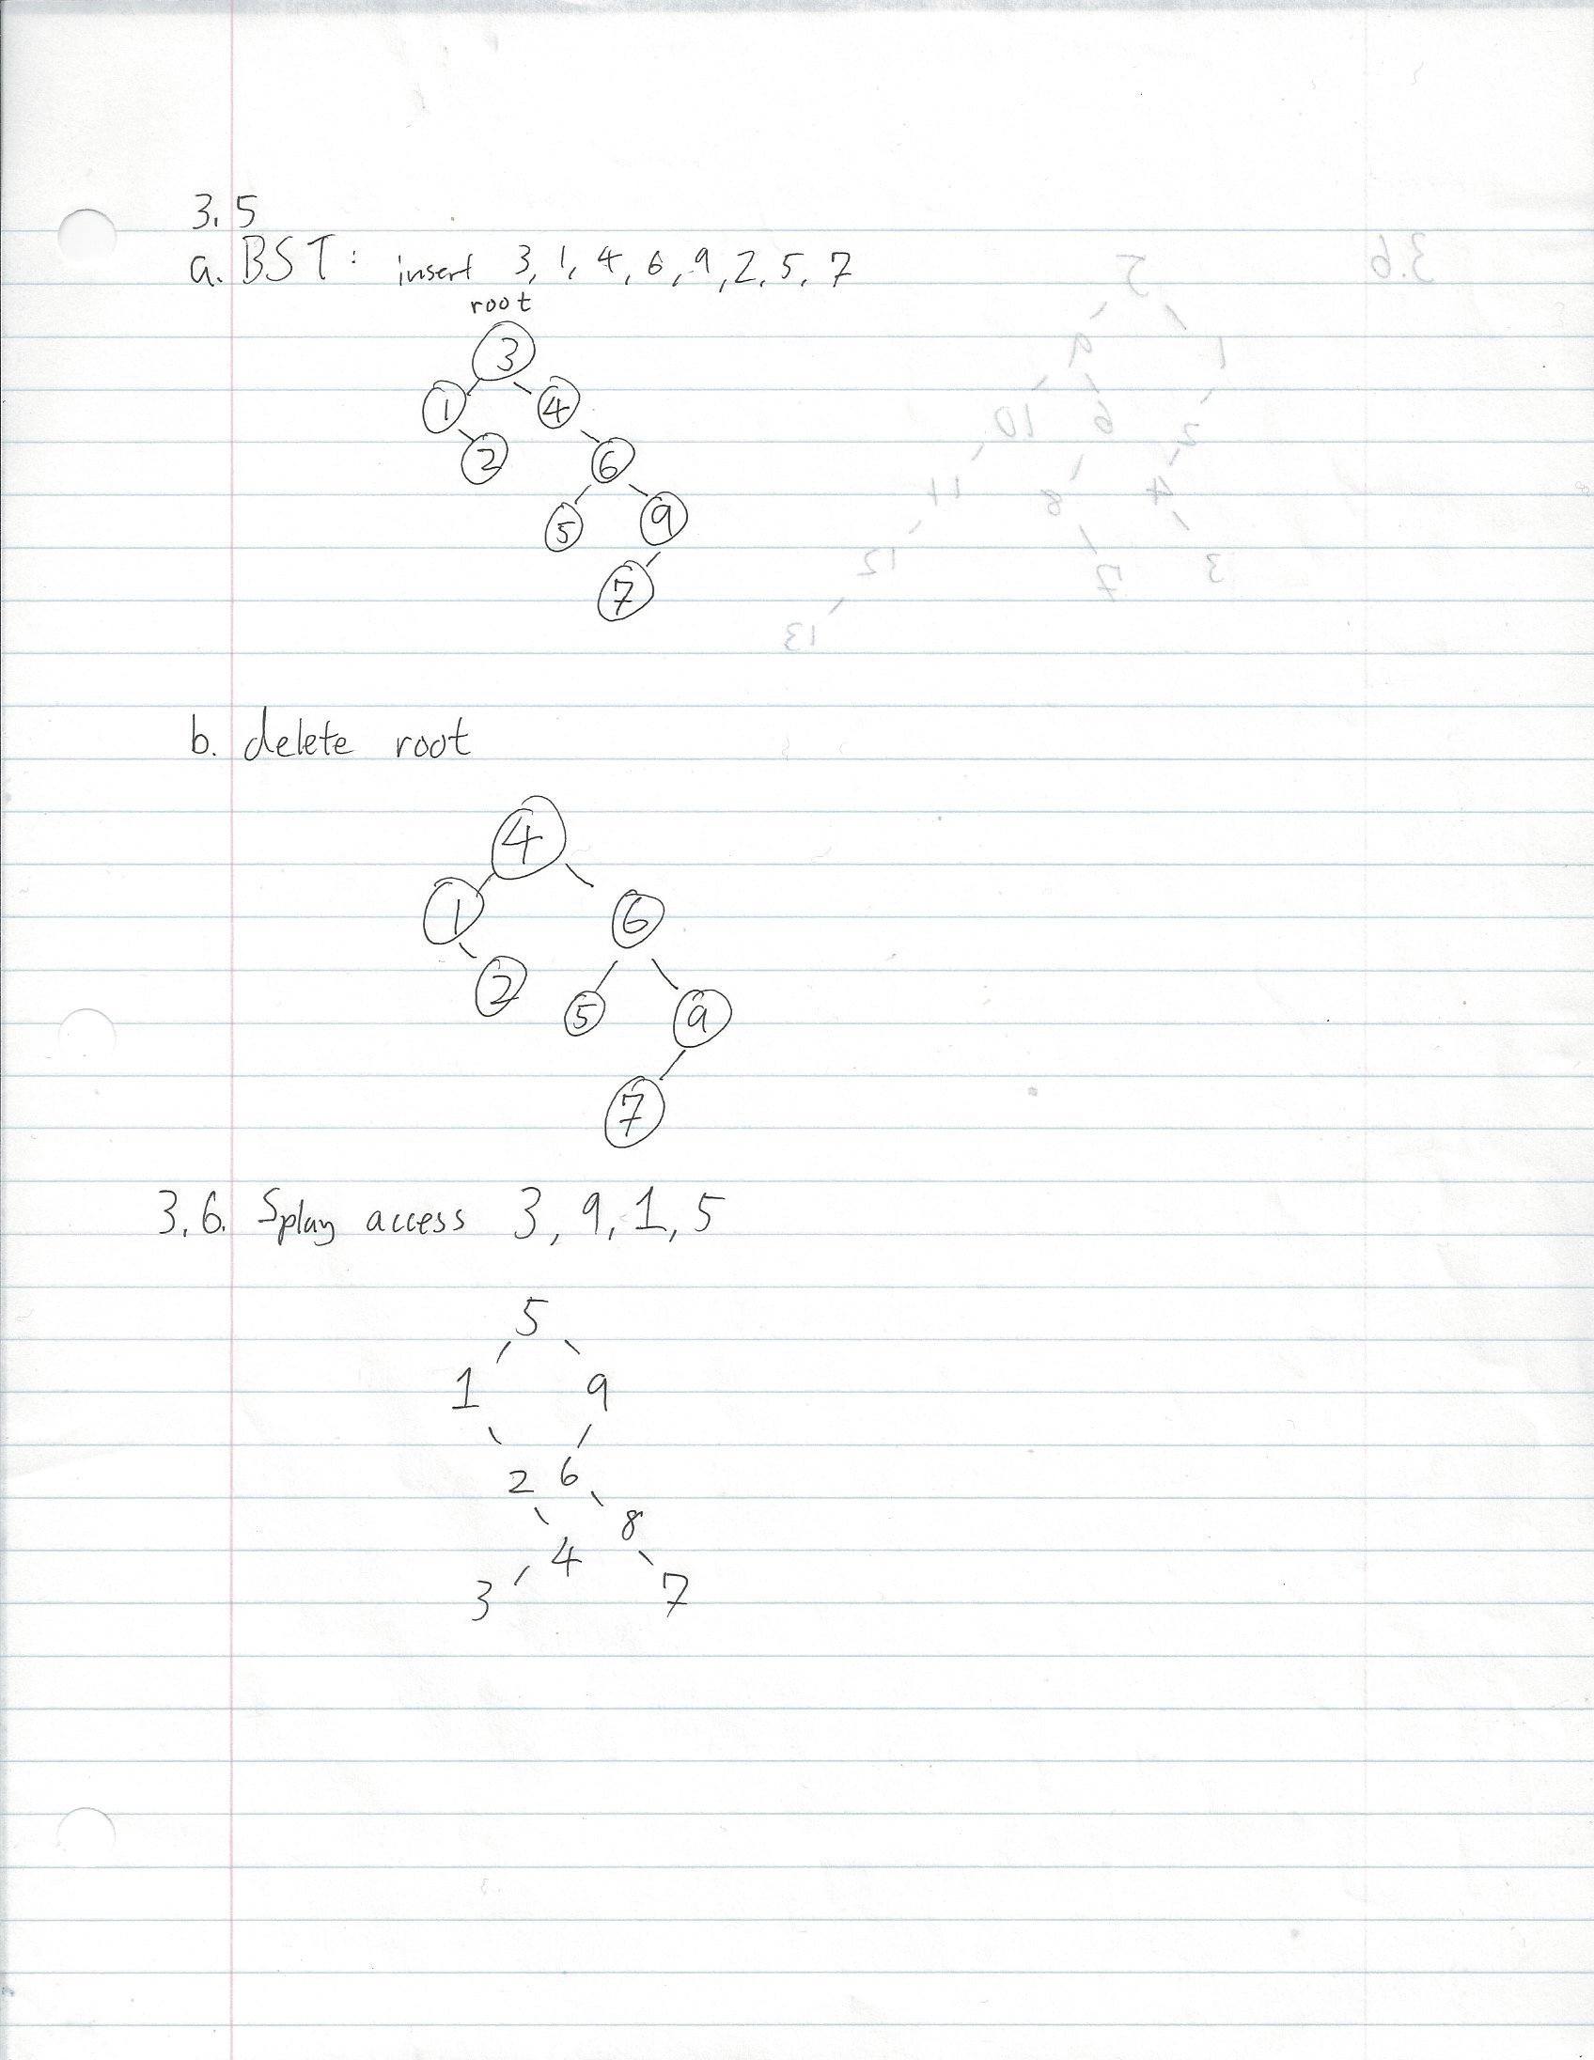

3.6

