**Assignment 3**

CS-XXXX.YYY

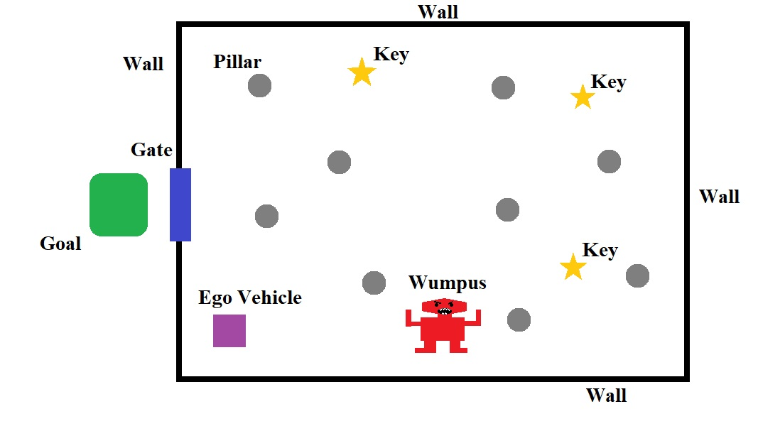**Scenario**

Figure

* **Goal**: Collect all three keys and escape the Wumpus!
* **Constraints:**
  + Use only the sensor data which is given through the RTOS.
  + Use only the actuators that are given by the RTOS.
  + Don’t hit the pillars.
  + Don’t hit the walls.
  + Don’t let the Wumpus touch you.

**Sensors**

* A 5 pixel by 5 pixel color camera
* A compass that gives the direction to the gate
* A speedometer
* A microphone
* The current position of the Ego vehicle
* A key buffer which contains the password to open the gate

**Actuators**

* Acceleration Subsystem
* Brakes
* Steering Controller
* Signal Transmitter

**Problem 1: Key Search (20 points)**

The gate to exit the Wumpus dungeon is locked. To open the gate, you must find 3 keys which have been placed randomly in the dungeon. To pick up a key, simply touch it. During this search however, the Ego vehicle cannot touch any of the randomly placed pillars or the walls of the dungeon.

You might find it helpful to ignore the Wumpus for now, and simply focus on searching for the keys.

You may use any search strategy you wish. Due to the nature of the Wumpus dungeon, the “right hand rule” described in Assignment 2 won’t work. You will need to implement a new search strategy.

**Problem 2: Wumpus Avoidance (30 points)**

The Wumpus is a deadly monster that lives in this dungeon, and its favorite food is robotic vehicles. The Ego vehicle must avoid capture by the Wumpus, or else it will be eaten!

The Wumpus is placed randomly into the dungeon, and will wander around looking for food. The Wumpus breathes very loudly, such that the microphone will hear the Wumpus when you are close to it. If you can hear the Wumpus, you are in danger!

Lucky for you, the Wumpus has very poor eyesight. If you hear the Wumpus, there is still a chance that the Wumpus has not detected you. The Ego vehicle does not make noise when it moves, so you may be able to sneak away.

If the Wumpus detects the Ego vehicle, it will release a mighty roar. The microphone can hear this roar, which sounds different than the Wumpus breathing. The Wumpus will then chase the Ego vehicle, and try to eat it.

Remember: the Wumpus has poor eyesight. If you are far enough away from the Wumpus, it will stop chasing you. When you can no longer hear the Wumpus roar on the microphone, you are safe. The Wumpus will stop chasing you, and it will return to searching for food.

**Problem 3: Escape the Dungeon (40 points)**

The gate will only open when two conditions are met:

1. The Ego vehicle can see the gate with its camera.
2. The Ego vehicle transmits the password to open the gate.

The password to open the gate can be accessed by reading from the key buffer. However, if you have not collected all 3 keys, then the key buffer will return a string of 0’s. The password is guaranteed to **not** be a string of 0’s.

Thus, once you have collected all 3 keys, you must proceed to the gate until at least one pixel on the color camera can detect it. Then you must transmit the password using the transmitter, and the gate will open.

You must then exit the dungeon through the gate, and enter the “green zone”, which is filled with flowers. The Wumpus is a sad and angry animal, so it will recoil from the beautiful flowers and you will finally be safe.

**Problem 4: Documentation (10 points)**

You must document and describe your implementation in a final report. This documentation must include:

* Information about the tasks which you defined to control the Ego vehicle
  + Task name
  + Task description
  + Dependencies on other tasks and/or sensor data
  + Is it periodic, aperiodic, or sporadic?
  + Period
  + Deadline
* Functional and non-functional requirements of the system
* A graph showing the task schedule for at least two cycles of the simulation.
  + This can be generated by examining the debug options located in RTOS panel on the Ego vehicle object in the Unity scene.
  + Describe the graph. Point out which tasks are being executed, and explain at what point in the simulation the task is occurring at.

Please note that while bad documentation may lose you at most 10 points, a complete lack of documentation will result in an automatic -50 points penalty.