Leading University

**Department of Computer Science and Engineering**

**CSE- 3300**

**MEET DOCTOR**

Naeem Ahsan Chowdhury 1912020107

Md. Tanzim Ferdous 1912020112

Pritom Jyoti Talukdar 1912020117

Department of Computer Science and Engineering

**Supervisor**

Syeda Tamanna Alam Monisha

Lecturer

Department of Computer Science and Engineering

20th March,2022

**Recommendation Letter from the Project Supervisor**

The project entitled ***Meet Doctor***submitted by the students

1. Naeem Ahsan Chowdhury

ID: 1912020107

1. Md. Tanzim Ferdous

ID: 1912020112

1. Pritom Jyoti Talukdar

ID: 1912020117

is a record of research work carried out under my supervision and I, hereby, approve that the report be submitted in partial fulfillment of the requirements for the award of their Bachelor Degrees.

Signature of the Supervisor

**Syeda Tamanna Alam Monisha**

Lecturer

Department of Computer Science & Engineering

Leading University, Sylhet

Date: 20th March,2022

**Declaration**

We hereby declare that this project has been done by us under the supervision of **Syeda Tamanna Alam Monisha**, Lecturer, Department of Computer Science & Engineering, Leading University, Sylhet. We also declare that neither this project nor any part of this project has been submitted elsewhere for the award of any degree or diploma. Only the members of the group come up with the idea and build the project; nobody else is involved.

**Submitted by:**

**Naeem Ahsan Chowdhury**

ID:1912020107

Department of Computer Science & Engineering

Leading University.

**Md. Tanzim Ferdous**

ID:1912020112

Department of Computer Science & Engineering

Leading University.

**Pritom Jyoti Talukdar**

ID:1912020117

Department of Computer Science & Engineering

Leading University.

**Certificate of Acceptance of the Project**

The project Meet Doctor by the students

1. Naeem Ahsan Chowdhury

ID: 1912020107

1. Md. Tanzim Ferdous

ID: 1912020112

1. Pritom Jyoti Talukdar

ID:1912020117

on 20th March,2022 is, hereby, accepted as the partial fulfillment of the requirements for the award of their Bachelor Degrees.

**Head of the Dept.** **Chairman, Exam. Committee** **Supervisor**

Shafkat Kibria Shafkat Kibria Syeda Tamanna Alam

Assistant Professor & Head Assistant Professor & Head Monisha

Department of Compuer Department of Computer Lecturer

Science and Engineering Science and Engineering Department of Computer Science and Engineering

**Abstract**

**Meet Doctor** is an app that will connect patients with doctors. This is an app where any patient from all over the country can easily book an appointment with a doctor. On the other hand, the appointed doctor can see the booked patient on the respective days. Furthermore, a patient can also look for diagnostic centers right through the app. Apart from that, anyone can get health tips, learn about prescribed medicine, and also calculate his/her BMI, ideal weight, etc. This app is convenient for both the doctor and the patient.

**Acknowledgements**

We would like to thank the Department of Computer Science and Engineering, Leading University, Sylhet 3112, Bangladesh, for supporting this course work.

**Dedication**

We would want to dedicate our work to our parents and friends, who have always been supportive of us. We will be eternally grateful to you.

**Contents**

Table of Contents

[**Chapter 1: Introduction** 1](#_Toc98594864)

[1.1 Background 1](#_Toc98594865)

[1.2 Motivation 1](#_Toc98594866)

[**Chapter 2: Background Study** 2](#_Toc98594867)

[2.1 Review Previous Work 2](#_Toc98594868)

[**Chapter 3: Methodology** 3](#_Toc98594869)

[**Chapter 4: Structural Design** 4](#_Toc98594870)

[4.1 User case diagram 4](#_Toc98594871)

[4.2 Activity diagram 6](#_Toc98594872)

[**Chapter 5: Tools & Technology Used** 7](#_Toc98594873)

[**Chapter 6: Result & Outcome** 8](#_Toc98594874)

[6.1 Snapshots 8](#_Toc98594875)

[Fig 6.1.1: Sign in page 8](#_Toc98594876)

[Fig 6.1.2: Sign up for Doctor & Patient 9](#_Toc98594877)

[Fig 6.1.3: Verification, Forget passwords texts 9](#_Toc98594878)

[Fig 6.1.4: Patient’s Home page activities 10](#_Toc98594879)

[Fig 6.1.5: App features 10](#_Toc98594880)

[Fig 6.1.7: Doctor’s Home Page 11](#_Toc98594881)

[Fig 6.1.8: Patient’s Lists 11](#_Toc98594882)

[Fig 6.1.9: Chat Feature 12](#_Toc98594883)

[Fig 6.1.10: Availability Settings 12](#_Toc98594884)

[Fig 6.1.11: Profile Settings 13](#_Toc98594885)

[Fig 6.1.12: Drawer options 13](#_Toc98594886)

[**Chapter 7: Limitations and Future Work** 14](#_Toc98594887)

[7.1 Limitations 14](#_Toc98594888)

[7.2 Future Work 14](#_Toc98594889)

[**Chapter 8: Conclusion** 15](#_Toc98594890)

[**References** 16](#_Toc98594891)

# **Chapter 1: Introduction**

## 1.1 Background

Sylhet is a bustling metropolis. We frequently find that in order to arrange an appointment with a doctor, a person must first go to the doctor's chamber and obtain the doctor's serial number and appointment time. He must once again accompany the patient to the doctor's chamber and wait for the number to be called. That person will have to rush to numerous diagnostic institutions for testing and other procedures. During the booking time, a receptionist is responsible for ensuring that the doctor and the patient are able to meet. During that period, a slew of unanticipated challenges arise. Taking bribes to get the patient's name first in the sequence, quarrels between the patient's relative and the receptionist, and so on.

As a result, we are developing an app that will make it simple for patients to schedule a doctor's visit. A doctor can also check his patient list for the day at a glance. A patient can also use the app to locate diagnostic centers. A patient can also obtain health advice, learn about prescription medications, and determine his /her BMI, optimal weight, among other things.

## 1.2 Motivation

Since the very beginning of our childhood till now whenever we see our parents or any of our relatives get sick, everyone starts to panic and call other relatives suggest for doctors and then they call to book an appointment .This seems hassling to us now. It’s very time consuming and a slow process to have an emergency service. For this reason, we are trying to build an app where you can easily get the appointment of a doctor just by few clicks. It will be time saving and easy for both the patient and doctor. In future, we are planning to launch our app that would be quite user convenient for people of all strata. Even people from distant area can reach out to the specialist in no time. They would not need to travel a great distance twice for the appointment and checkup respectively.

# **Chapter 2: Background Study**

Although several comparable apps share the same work module, there are some important variances. The applications' main function was to establish a close relationship between the doctor and the patients. We'll take a look back at earlier work on the subject and see how far we've come especially in recent occasions.

## 2.1 Review Previous Work

We all believe that health is an important sector, and that we should do something to improve it. As a result, a variety of projects have been undertaken in that area. Grameenphone did an outstanding job among them. They released an app called **Tonic**, which provides service by dialing 20000 from any phone number. Furthermore, everyone can benefit from a live video consulting service. They also offer a chat feature where patients may communicate with the doctor [1]. Furthermore, numerous health insurance packages are available. **Doctor Dekhao** and **Shebhagor** are two applications that focus on the same type of job [2], Anyone may book a doctor online and receive assistance through video consultation. They also provide an e-prescription service. Other applications function specifically in the medicine field. They providing medicine at door steps by calling them. **BanglaMeds.com.bd**, **pharmacy.com.bd, Oshudhwala** etc are the apps that work on that sector [3]. Even **Foodpanda** is now in medicine delivery service [4]. However, the apps that we talked about are in video consultancy and medicine providing app but we want to carry this process a step ahead. We want to work directly with the doctor and patient where a patient can come see the doctor without any hassle receiving from the receptionists or the brokers that work for the medicine company. Apart from that we want to provide them a service where they can get the health tips and also keep a healthy life by calculating their BMI, body fat and optimal weight, among other things. In COVID-19 situation, we all felt maximum need for the doctors and their consultancy [5]. So, we all should work for the betterment of that process.

# 

# **Chapter 3: Methodology**

**Meet Doctor** is a user-friendly app with some easy features. This app is constructed for both the patient end and doctor end. A patient can access to his/her account and can able to use feature like meet doctor where easily he/she can see the categories of doctor. From the category, one can choose the desired doctor and see the information like the location of doctor’s chamber, schedule of visit, availability and also can book for an appointment. After booking an appointment one can chat with the doctor for seeking follow up help. Other features are also available for a patient. Like one can regularly see the health tips where various kind of article will be provided regarding to maintain a healthy life. Another important feature is in the app which will help to locate the diagnostic centers. We often see after an appointment a patient must have to go for various kind of tests like blood test urine test, X-ray etc. For that reason, they have to look for the diagnostic centers. In our app, they can see the list of diagnostic center closer to them. They can also see for the medicine that would be prescribed by the doctor. There they can know about everything about a particular medicine like the use of the medicine along with the price tag. Also, a health calculator is provided in the app by which they can calculate the BMI, optimal weight, among other things.

We typically monitor the ID for 24-48 hours after a doctor signs in to our app for doctor authentication. Meanwhile, we double-check the doctor's qualifications. The doctor must fill out a form to sign in, which requires the doctor to supply basic details to establish his or her identity as well as information about the booking procedure. The doctor can readily see the assigned patient list from his end. He can call the patient using the serial number supplied in the app. In addition, the doctor has the option of selecting an available time period. The doctor can choose the availability option if he is available and ready to be scheduled, or the away option if he is not. The patient will be unable to schedule an appointment as a result of this. This is an important feature for doctors, since we have given them the flexibility in determining their own available time. Other features like health tips and diagnostic centers are common in the both ends.

# **Chapter 4: Structural Design**

We have included a user case diagram and an activity diagram to help you visualize our app.

## 4.1 User case diagram

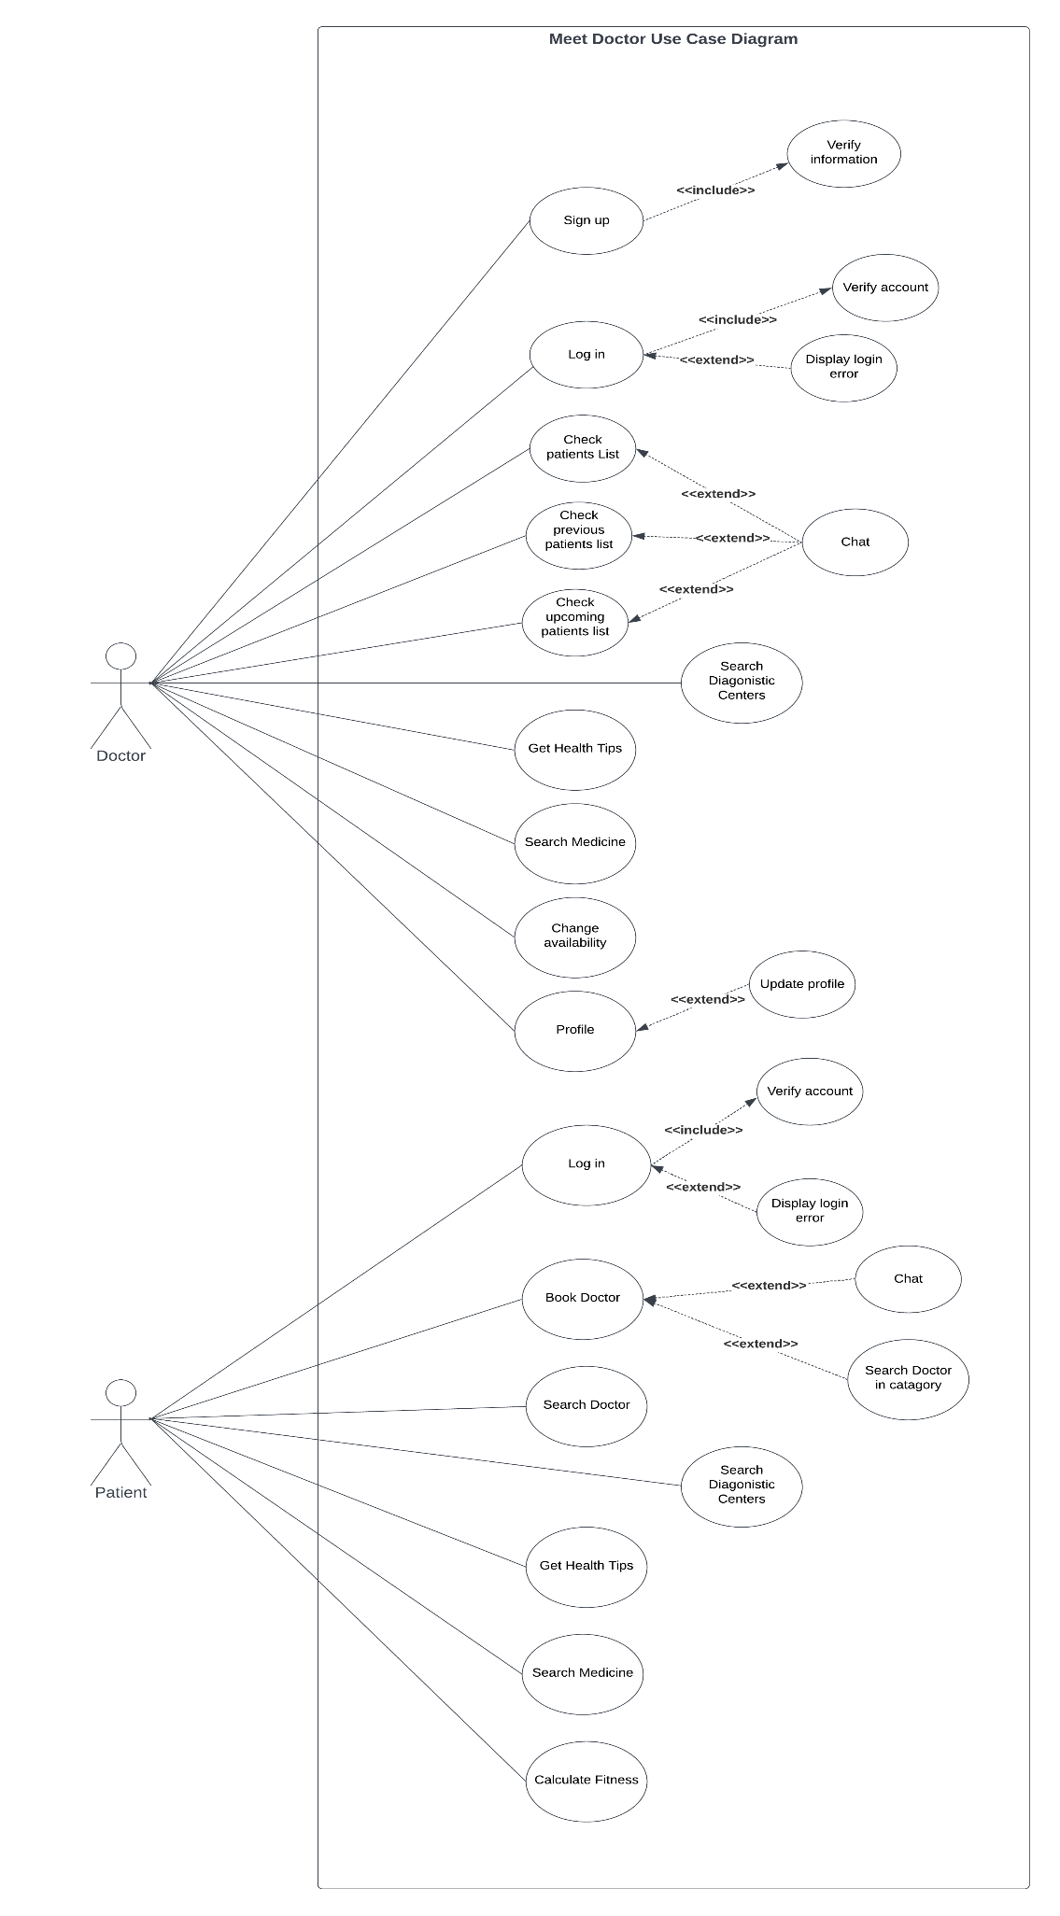

## 4.2 Activity diagram

# 

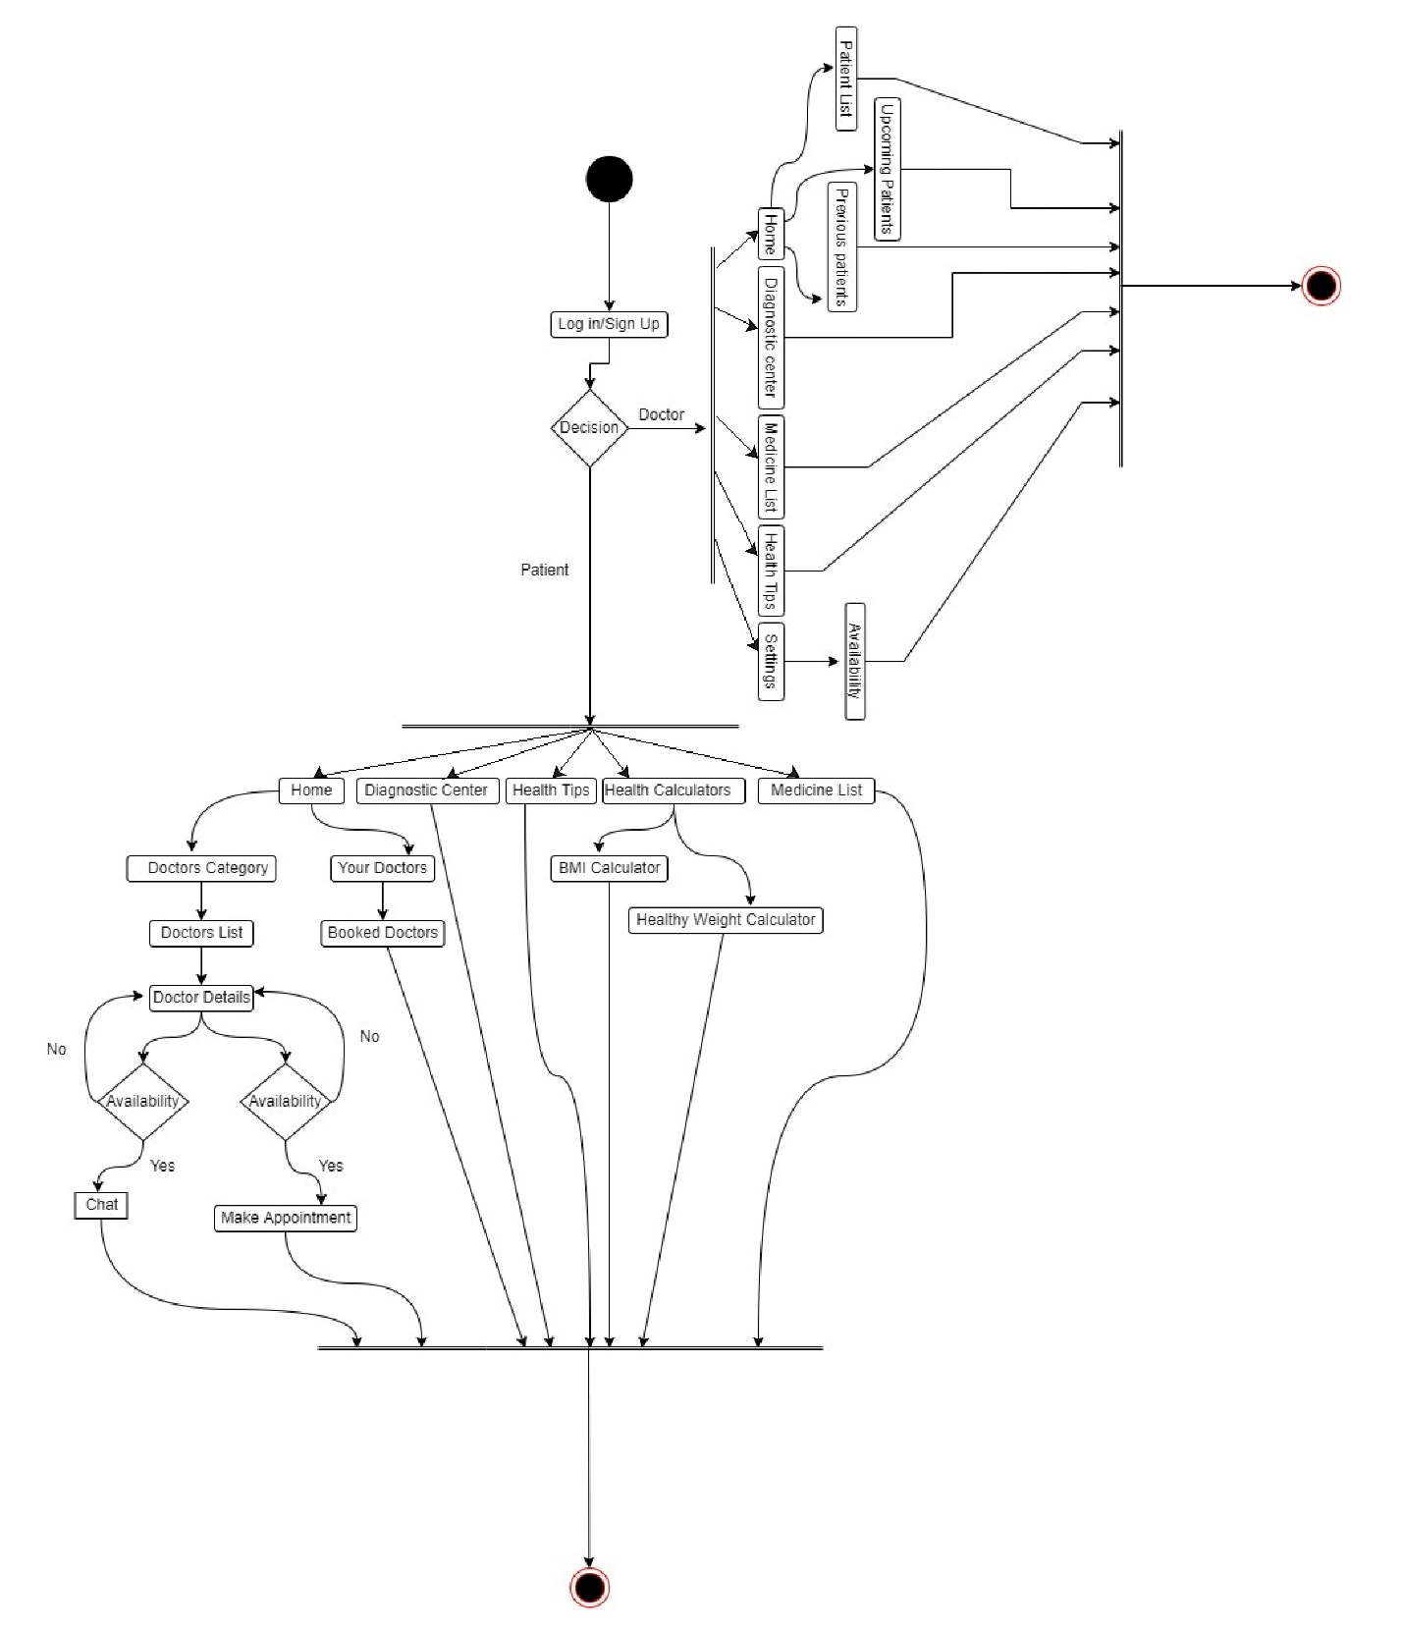

# **Chapter 5: Tools & Technology Used**

Some of the tools and techniques that are used in programme and design of the project are outlined below:

* Android Studio
* Flutter
* Firebase
* Dart
* Adobe Photoshop
* Draw.io
* Lucidchart

# **Chapter 6: Result & Outcome**

We arranged our app in sequential order. Where we provided some snapshots of the app that shows the final result and outcome of the app.

## 6.1 Snapshots

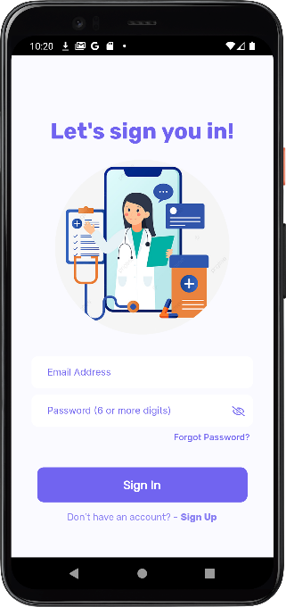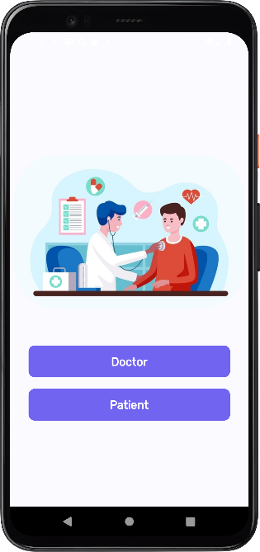

### Fig 6.1.1: Sign in page

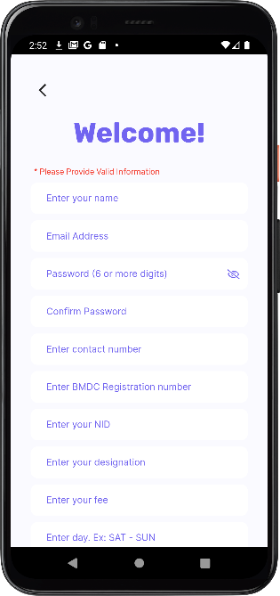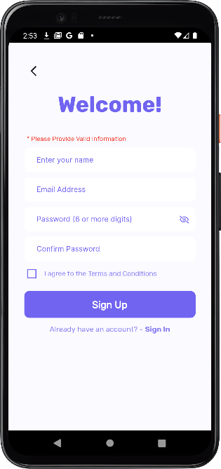

### Fig 6.1.2: Sign up for Doctor & Patient

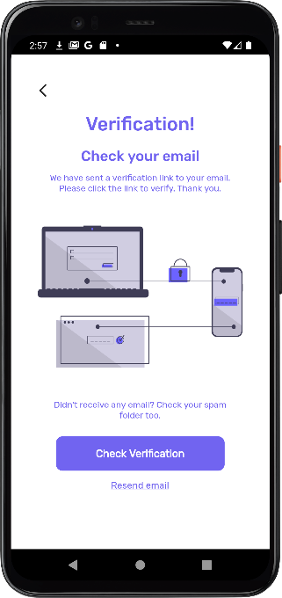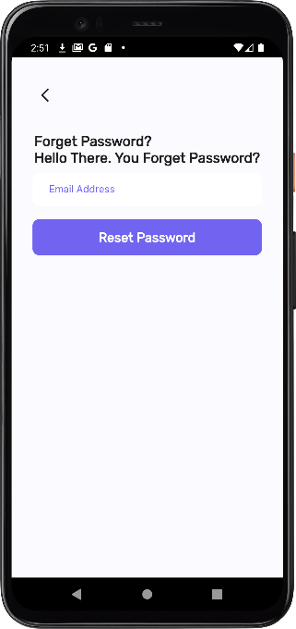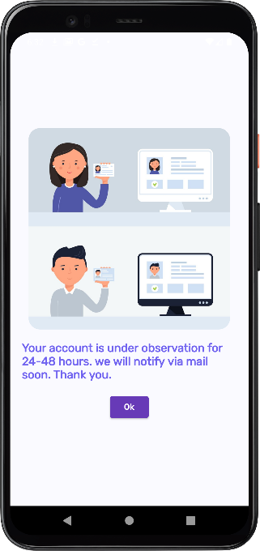

### Fig 6.1.3: Verification, Forget passwords texts

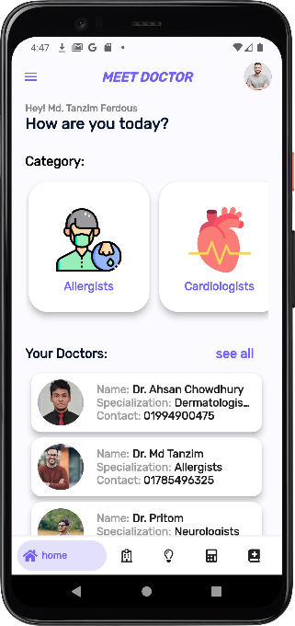 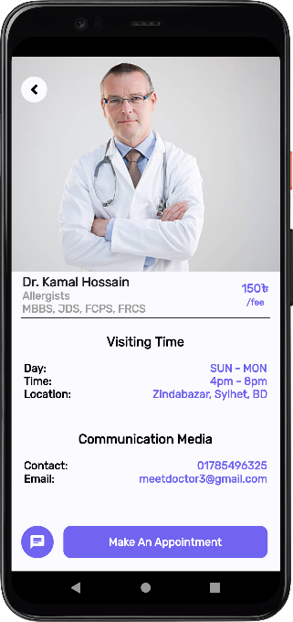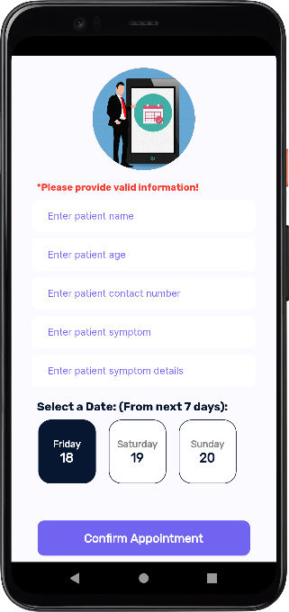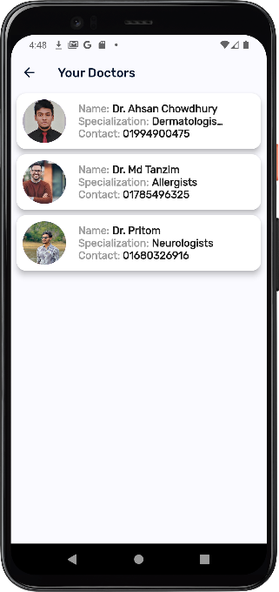

### Fig 6.1.4: Patient’s Home page activities

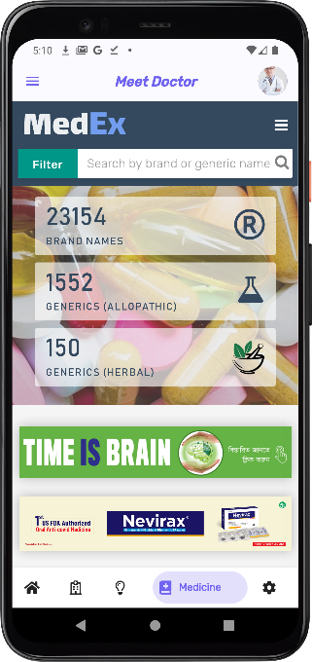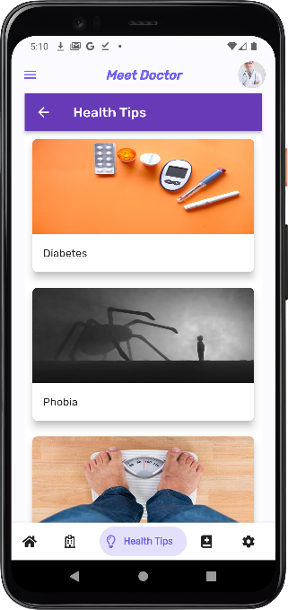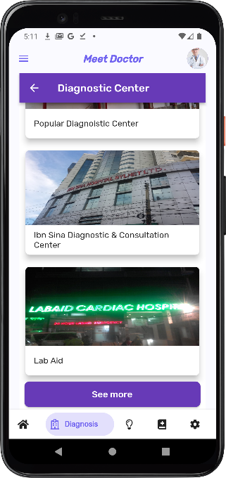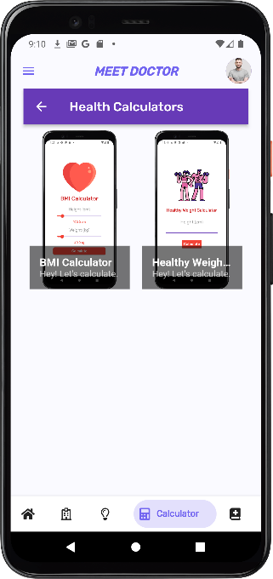

### Fig 6.1.5: App features

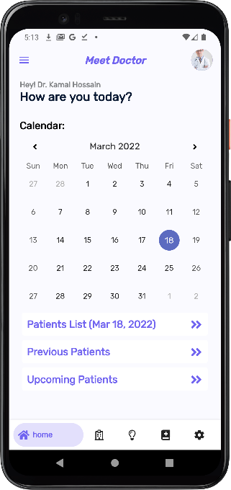

### Fig 6.1.7: Doctor’s Home Page

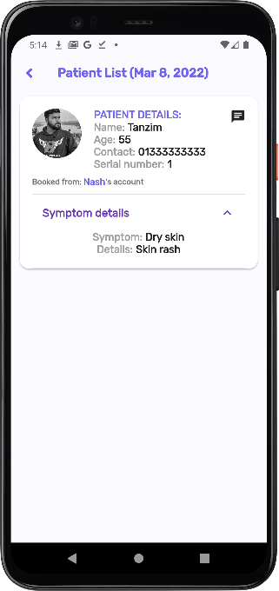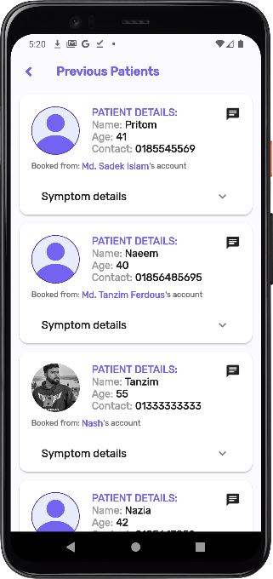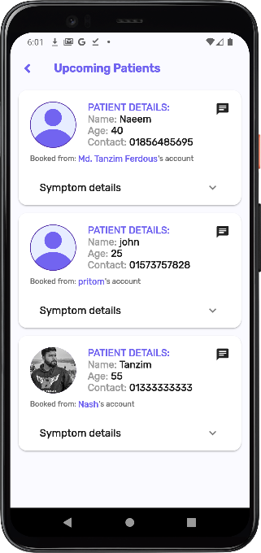

### Fig 6.1.8: Patient’s Lists

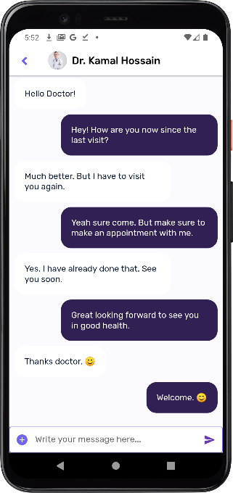

### Fig 6.1.9: Chat Feature

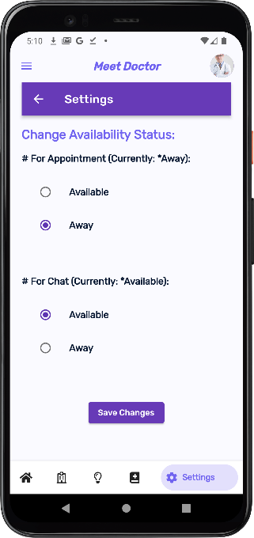

### Fig 6.1.10: Availability Settings

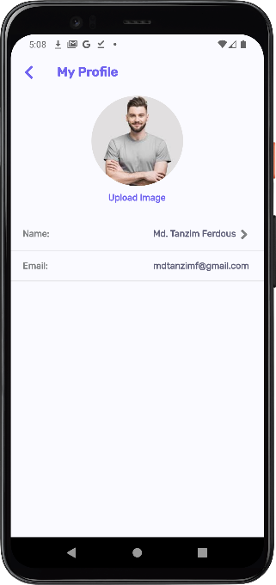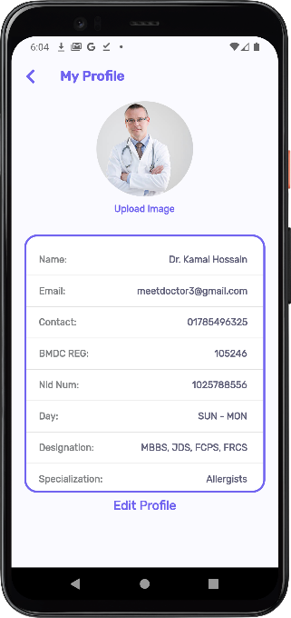

### Fig 6.1.11: Profile Settings

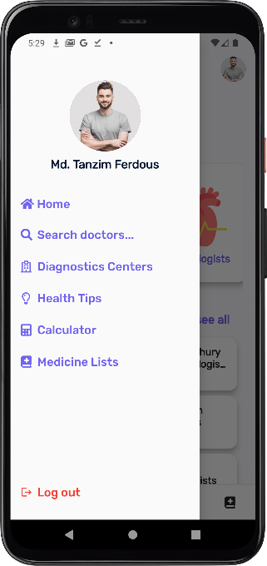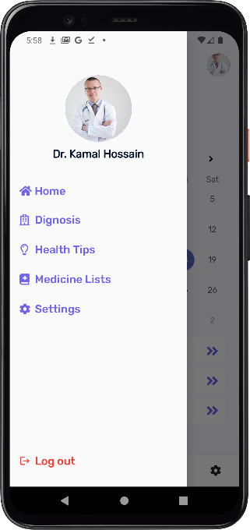

### Fig 6.1.12: Drawer options

# **Chapter 7: Limitations and Future Work**

## 7.1 Limitations

As this is our very first app for our third year project there is some limitations and restrictions of feature that we tried to implement but we could not due to less expertise and time. Some of the limitations of our app we point out below:

1. Payment gateway system
2. Minimum SDK version 21
3. Notification for chats
4. Only in English language

## 7.2 Future Work

**Meet Doctor** is app that will focus on the medical field. We are always in need of doctors in our daily lives. In our country, health is a priority. And many of us are missing out on that crucial component for various reasons. That is why we want to launch this app so that anyone may seek medical treatment in the blink of an eye. Life is the greatest gift that the Almighty can bestow upon anybody, and we want to save it at all costs with the aid of our app. However, we need to add some features in future in our app. They are:

1. Heath insurance system
2. Online Video calling appointment
3. Health packages
4. Rating system
5. Medicine Delivery

Individuals in Sylhet are now our target audiences. We want to make this available to a larger region in the near future, with other capabilities that will be introduced over time.

# **Chapter 8: Conclusion**

We've done our best to provide a detailed description of the project above. The parameters of this project have been addressed. People’s health efficiency will improve as a result of this. We'll cover every details to ensure that our program satisfies all of the standards.

# **References**

[1] *‘Tonic is the New Face of Digital Health Services for Telenor’* in Telenor group, June 2016.

[2] Nafiz Tahmid *‘Top health apps for online doctor consultation in Bangladesh’* in United News of Bangladesh, April 24, 2021

[3] Rifat Tabassum ‘*Online Pharmacy: Where to buy medicine in Dhaka during coronavirus home quarantine*’ in United News of Bangladesh, December 18, 2020

[4] Ruhul Kabir ‘*With Pandamart, Foodpanda Aims to Become Everything Delivery Service’* in Future Startup, October 12, 2020

[5] [Mohammad Monirujjaman Khan](https://www.scirp.org/journal/articles.aspx?searchcode=Mohammad+Monirujjaman++Khan&searchfield=authors&page=1), [S. M. Tahsinur Rahman](https://www.scirp.org/journal/articles.aspx?searchcode=S.+M.+Tahsinur++Rahman&searchfield=authors&page=1), [Sabik Tawsif AnjumIslam](https://www.scirp.org/journal/articles.aspx?searchcode=Sabik+Tawsif++AnjumIslam&searchfield=authors&page=1" \t "_blank), ‘*The Use of Telemedicine in Bangladesh during COVID-19 Pandemic*’ in Scientific Research, March,2021, [10.4236/etsn.2021.101001](https://doi.org/10.4236/etsn.2021.101001)