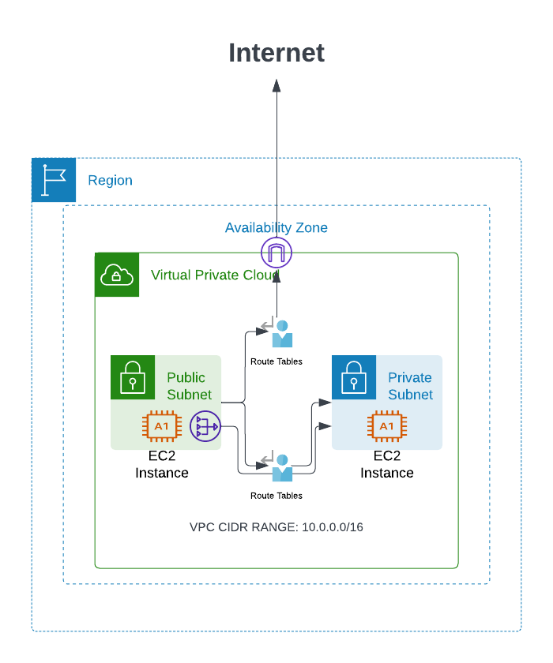

**From the diagram, the following have been filled:**

1. It has been one VPC and also private subnet and public subnet
2. Also, Two EC2 machines (private and public)
3. Created a security group and it has only allowed 22 port
4. The VPC also has two Route Tables. A Route Table is a set of rules that controls how traffic is routed within a VPC. The Route Table in this image has two rules:  
     
   A rule that routes all traffic from the public subnet to the private subnet.  
   A rule that routes all traffic from the public subnet to the internet.

| **The diagram shows the following connections:**   1. The public subnet is connected to the internet. 2. The private subnet is connected to the public subnet through a route table.   **In the terraform.tfvars file has resource values as follows**   1. region = "us-east-1" 2. vpc_cidr_block = "10.0.0.0/16" 3. public_subnet_cidr_block = "10.0.1.0/24" 4. private_subnet_cidr_block = "10.0.2.0/24" 5. ami_id = "ami-0230bd60aa48260c6" 6. instance_type = "t2.micro" 7. key_pair_name = "test-Ruchira-key" 8. ssh_ingress_cidr_blocks = ["0.0.0.0/0"] 9. vpc_name = "Ruchira-VPC" 10. public_subnet_name = "Ruchira-Public-Subnet" 11. private_subnet_name = "Ruchira-Private-Subnet" 12. internet_gateway_name = "Ruchira-igw" 13. ec2_public_instance_name = "Ruchira-EC2-Public" 14. ec2_private_instance_name = "Ruchira-EC2-Private"   **so you can change that value as you need** |
| --- |

**Run the following command to initialize Terraform and download the necessary providers**

* **terraform init**

**Run the following command to Generate the Execution Plan**

* **Terraform plan**

**If the execution plan looks correct Run the following command to apply the changes**

* **Terraform apply**