**WEEK4 ASP.NET Core 8.0 Web API**

**Task 1: First Web Api using .Net core**

**Source code**

**ValuesController.cs**

using Microsoft.AspNetCore.Mvc;

using System.Collections.Generic; // ✅ THIS IS MISSING

namespace FirstWebApi.Controllers

{

    [ApiController]

    [Route("[controller]")]

    public class ValuesController : ControllerBase

    {

        [HttpGet]

        public IEnumerable<string> Get()

        {

            return new string[] { "value1", "value2" };

        }

    }

}

**Program.cs**

using Microsoft.AspNetCore.Builder;

using Microsoft.Extensions.DependencyInjection;

using Microsoft.Extensions.Hosting;

var builder = WebApplication.CreateBuilder(args);

// Add services to the container.

builder.Services.AddControllers();

builder.Services.AddEndpointsApiExplorer();

builder.Services.AddSwaggerGen();

var app = builder.Build();

// Configure the HTTP request pipeline.

if (app.Environment.IsDevelopment())

{

    app.UseSwagger();

    app.UseSwaggerUI();

}

app.UseAuthorization();

app.MapControllers();

app.Run();

**FirstWebApi.csproj**

<Project Sdk="Microsoft.NET.Sdk.Web">

  <PropertyGroup>

    <TargetFramework>net9.0</TargetFramework>

  </PropertyGroup>

  <ItemGroup>

    <PackageReference Include="Swashbuckle.AspNetCore" Version="6.4.0" />

  </ItemGroup>

</Project>

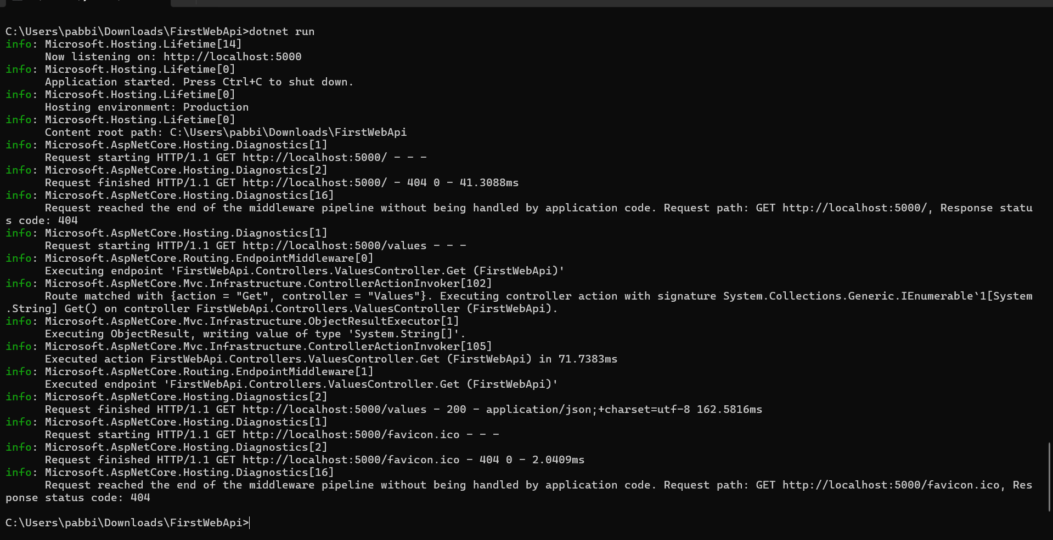

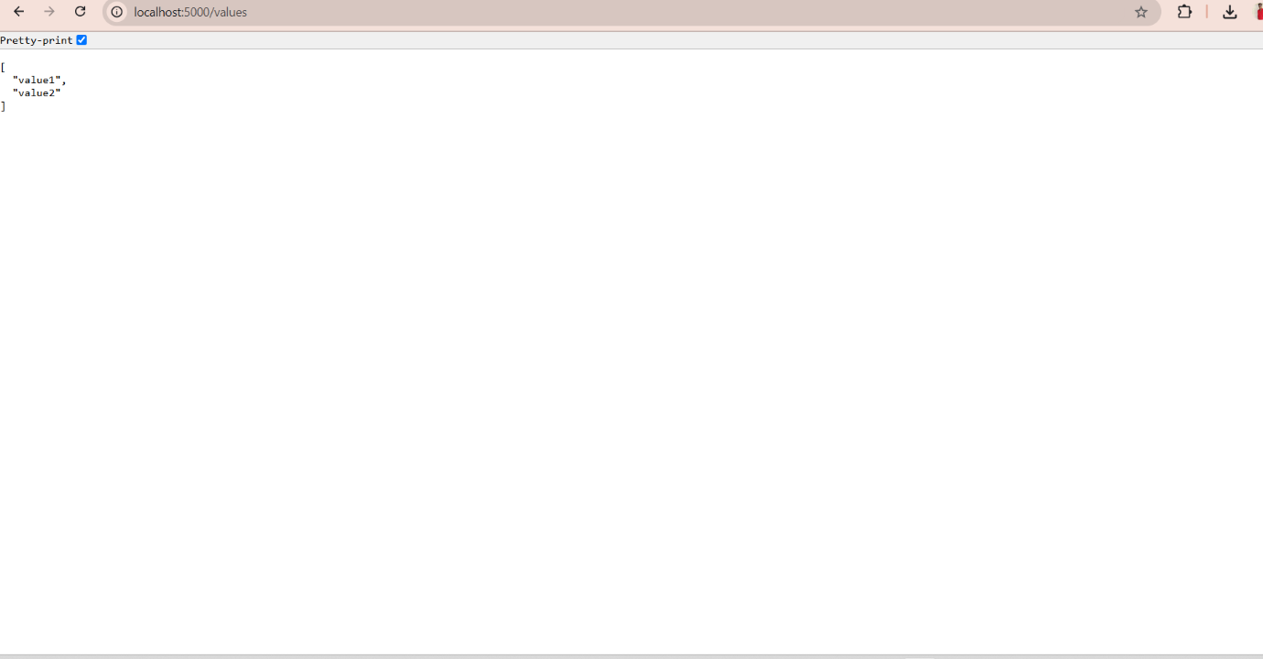

**Task2: Web Api using .Net core with Swagger**

**Source code**

**EmployeeController.cs**

using Microsoft.AspNetCore.Mvc;

using System.Collections.Generic;

namespace SwaggerDemo.Controllers

{

    [Route("api/Emp")]

    [ApiController]

    public class EmployeeController : ControllerBase

    {

        public class Employee

{

    public int Id { get; set; }

    public string? Name { get; set; }        // Add the '?' here

    public string? Department { get; set; }  // And here

}

        [HttpGet]

        public ActionResult<List<Employee>> Get()

        {

            var employees = new List<Employee>

            {

                new Employee { Id = 1, Name = "Alice", Department = "HR" },

                new Employee { Id = 2, Name = "Bob", Department = "IT" },

                new Employee { Id = 3, Name = "Charlie", Department = "Finance" }

            };

            return Ok(employees);

        }

    }

}

**Program.cs**

using Microsoft.AspNetCore.Builder;

using Microsoft.Extensions.DependencyInjection;

using Microsoft.Extensions.Hosting;

using Microsoft.OpenApi.Models;

var builder = WebApplication.CreateBuilder(args);

// Add services to the container.

builder.Services.AddControllers();

builder.Services.AddEndpointsApiExplorer();

builder.Services.AddSwaggerGen(c =>

{

    c.SwaggerDoc("v1", new OpenApiInfo

    {

        Title = "Swagger Demo",

        Version = "v1",

        Description = "TBD",

        TermsOfService = new Uri("https://example.com/terms"),

        Contact = new OpenApiContact

        {

            Name = "John Doe",

            Email = "john@xyzmail.com",

            Url = new Uri("https://www.example.com")

        },

        License = new OpenApiLicense

        {

            Name = "License Terms",

            Url = new Uri("https://www.example.com")

        }

    });

});

var app = builder.Build();

if (app.Environment.IsDevelopment())

{

    app.UseDeveloperExceptionPage();

}

app.UseSwagger();

app.UseSwaggerUI(c =>

{

    c.SwaggerEndpoint("/swagger/v1/swagger.json", "Swagger Demo");

    c.RoutePrefix = string.Empty;  // serve swagger at root

});

app.UseRouting();

app.UseAuthorization();

app.MapControllers();

app.Run();

**Swaggardemo.csproj**

<Project Sdk="Microsoft.NET.Sdk.Web">

  <PropertyGroup>

    <TargetFramework>net9.0</TargetFramework>

    <Nullable>enable</Nullable>

    <ImplicitUsings>enable</ImplicitUsings>

  </PropertyGroup>

  <ItemGroup>

    <PackageReference Include="Swashbuckle.AspNetCore" Version="6.5.0" />

  </ItemGroup>

</Project>

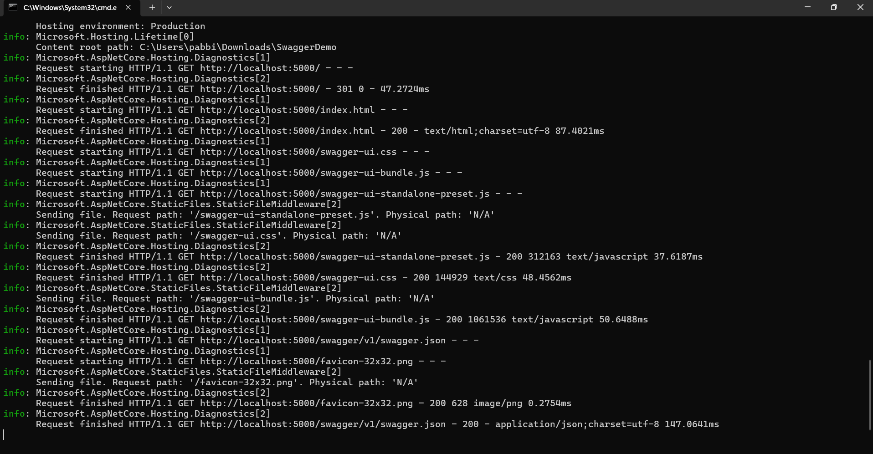

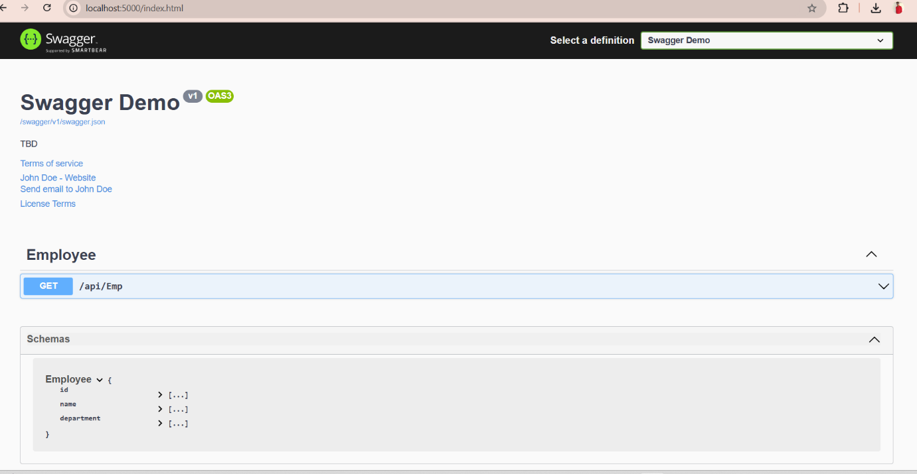

**Task** 3: **Web Api using custom model class**

**Create a Custom action filter for Authorization.**

**Custom Exception filter**

**Source code**

**Employeecontroller.cs**

namespace EmployeeApiDemo.Models

{

    public class Department

    {

        public int Id { get; set; }

        public string? Name { get; set; }  // nullable string

    }

}

**Program.cs**

using EmployeeApiDemo.Filters;   // Your custom filters namespace

using Microsoft.OpenApi.Models;

var builder = WebApplication.CreateBuilder(args);

// Register MVC controllers with filters

builder.Services.AddControllers(options =>

{

    options.Filters.Add<CustomExceptionFilter>();  // your exception filter

});

// Register Swagger generator

builder.Services.AddEndpointsApiExplorer();

builder.Services.AddSwaggerGen(c =>

{

    c.SwaggerDoc("v1", new OpenApiInfo { Title = "Employee API", Version = "v1" });

});

var app = builder.Build();

// Enable Swagger in Development or all environments if you want

app.UseSwagger();

app.UseSwaggerUI(c =>

{

    c.SwaggerEndpoint("/swagger/v1/swagger.json", "Employee API V1");

});

app.UseAuthorization();

app.MapControllers();  // This maps the controller endpoints

app.Run();

**EmployeeDemoApi.csproj**

<Project Sdk="Microsoft.NET.Sdk.Web">

  <PropertyGroup>

    <TargetFramework>net9.0</TargetFramework>

    <Nullable>enable</Nullable>

    <ImplicitUsings>enable</ImplicitUsings>

  </PropertyGroup>

  <ItemGroup>

    <PackageReference Include="Swashbuckle.AspNetCore" Version="9.0.3" />

  </ItemGroup>

</Project>

