**WEEK 6 TASKS ON REACT**

* **Task 1 : Set up a react environment**
* **Use create-react-app**

**Source code**

**Public Folder**

**Index.html**

<!DOCTYPE html>

<html lang="en">

  <head>

    <meta charset="utf-8" />

    <meta name="viewport" content="width=device-width, initial-scale=1" />

    <title>My First React App</title>

  </head>

  <body>

    <div id="root"></div>

  </body>

</html>

**SRC Folder**

**App.js**

import React from 'react';

function App() {

  return (

    <div>

      <h1>Welcome to the first session of React</h1>

    </div>

  );

}

export default App;

**Index.css**

body {

  margin: 0;

  font-family: Arial, Helvetica, sans-serif;

  text-align: center;

  padding-top: 50px;

}

**Index.js**

import React from 'react';

import ReactDOM from 'react-dom/client';

import './index.css';

import App from './App';

const root = ReactDOM.createRoot(document.getElementById('root'));

root.render(

  <React.StrictMode>

    <App />

  </React.StrictMode>

);

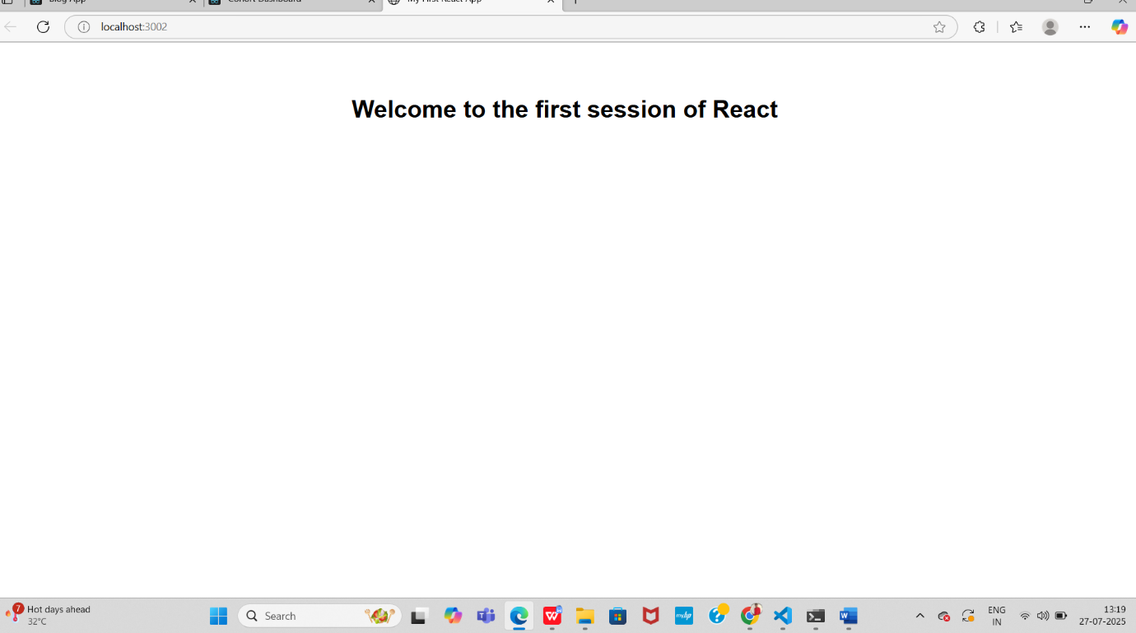

**Task2 : Student app**

**Source code**

**Public folder**

**Index.html**

<!DOCTYPE html>

<html lang="en">

  <head>

    <meta charset="utf-8" />

    <link rel="icon" href="%PUBLIC_URL%/favicon.ico" />

    <meta name="viewport" content="width=device-width, initial-scale=1" />

    <meta name="theme-color" content="#000000" />

    <meta

      name="description"

      content="Web site created using create-react-app"

    />

    <link rel="apple-touch-icon" href="%PUBLIC_URL%/logo192.png" />

    <link rel="manifest" href="%PUBLIC_URL%/manifest.json" />

    <title>React App</title>

  </head>

  <body>

    <noscript>You need to enable JavaScript to run this app.</noscript>

    <div id="root"></div>

  </body>

</html>

**SRC FOLDER**

**App.css**

.App {

  text-align: center;

}

.App-logo {

  height: 40vmin;

  pointer-events: none;

}

@media (prefers-reduced-motion: no-preference) {

  .App-logo {

    animation: App-logo-spin infinite 20s linear;

  }

}

.App-header {

  background-color: #282c34;

  min-height: 100vh;

  display: flex;

  flex-direction: column;

  align-items: center;

  justify-content: center;

  font-size: calc(10px + 2vmin);

  color: white;

}

.App-link {

  color: #61dafb;

}

@keyframes App-logo-spin {

  from {

    transform: rotate(0deg);

  }

  to {

    transform: rotate(360deg);

  }

}

**APP.js**

import logo from './logo.svg';

import './App.css';

function App() {

  return (

    <div className="App">

      <header className="App-header">

        <img src={logo} className="App-logo" alt="logo" />

        <p>

          Edit <code>src/App.js</code> and save to reload.

        </p>

        <a

          className="App-link"

          href="https://reactjs.org"

          target="_blank"

          rel="noopener noreferrer"

        >

          Learn React

        </a>

      </header>

    </div>

  );

}

export default App;

**App test.js**

import { render, screen } from '@testing-library/react';

import App from './App';

test('renders learn react link', () => {

  render(<App />);

  const linkElement = screen.getByText(/learn react/i);

  expect(linkElement).toBeInTheDocument();

});

**Index.css**

body {

  margin: 0;

  font-family: -apple-system, BlinkMacSystemFont, 'Segoe UI', 'Roboto', 'Oxygen',

    'Ubuntu', 'Cantarell', 'Fira Sans', 'Droid Sans', 'Helvetica Neue',

    sans-serif;

  -webkit-font-smoothing: antialiased;

  -moz-osx-font-smoothing: grayscale;

}

code {

  font-family: source-code-pro, Menlo, Monaco, Consolas, 'Courier New',

    monospace;

}

**Index.js**

import React from 'react';

import ReactDOM from 'react-dom/client';

import './index.css';

import App from './App';

import reportWebVitals from './reportWebVitals';

const root = ReactDOM.createRoot(document.getElementById('root'));

root.render(

  <React.StrictMode>

    <App />

  </React.StrictMode>

);

// If you want to start measuring performance in your app, pass a function

// to log results (for example: reportWebVitals(console.log))

// or send to an analytics endpoint. Learn more: https://bit.ly/CRA-vitals

reportWebVitals();

**Component folder**

**About.js**

import React from 'react';

function About() {

  return (

    <div>

      <h1>About Us</h1>

      <p>This is the About Page of StudentApp.</p>

    </div>

  );

}

export default About;

**Contact.js**

import React from 'react';

function Contact() {

  return (

    <div>

      <h1>Contact Us</h1>

      <p>Email: studentapp@example.com</p>

    </div>

  );

}

export default Contact;

**Home.js**

import React from 'react';

function Home() {

  return (

    <div>

      <h1>Welcome to StudentApp</h1>

      <p>This is the Home Page.</p>

    </div>

  );

}

export default Home;

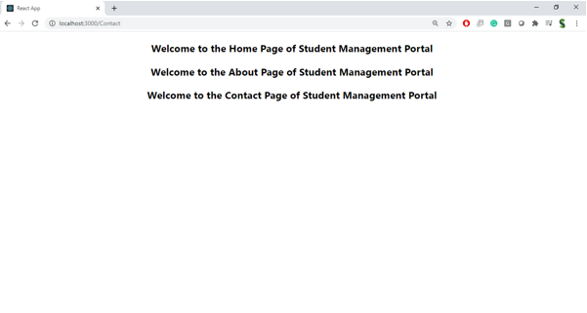

**Task 3 Create a function component**

**Apply style to components**

**Render a component**

**Souce code**

**Public folder**

**Index.html**

<!DOCTYPE html>

<html lang="en">

  <head>

    <meta charset="utf-8" />

    <link rel="icon" href="%PUBLIC_URL%/favicon.ico" />

    <meta name="viewport" content="width=device-width, initial-scale=1" />

    <meta name="theme-color" content="#000000" />

    <title>Score Calculator App</title>

  </head>

  <body>

    <noscript>You need to enable JavaScript to run this app.</noscript>

    <div id="root"></div>

  </body>

</html>

**SRC**

**COMPONENT FOLDER**

**Calculatescore.js**

import React, { useState } from 'react';

import '../Stylesheets/mystyle.css';

function CalculateScore() {

  const [score, setScore] = useState(0);

  const [input, setInput] = useState("");

  const handleAdd = () => {

    setScore(score + Number(input));

    setInput("");

  };

  const handleReset = () => {

    setScore(0);

  };

  return (

    <div className="score-container">

      <h2>Your Score: {score}</h2>

      <input

        type="number"

        value={input}

        onChange={(e) => setInput(e.target.value)}

        placeholder="Enter score"

      />

      <button onClick={handleAdd}>Add Score</button>

      <button onClick={handleReset}>Reset</button>

    </div>

  );

}

export default CalculateScore;

**Stylesheet folder**

**App.js**

import React from 'react';

import './Stylesheets/mystyle.css';

import CalculateScore from './Components/CalculateScore';

function App() {

  return (

    <div className="App">

      <h1>Score Calculator App</h1>

      <CalculateScore />

    </div>

  );

}

export default App;

**Index.css**

body {

  margin: 0;

  padding: 0;

}

**Index.js**

import React from 'react';

import ReactDOM from 'react-dom/client';

import './index.css';

import App from './App';

const root = ReactDOM.createRoot(document.getElementById('root'));

root.render(

  <React.StrictMode>

    <App />

  </React.StrictMode>

);

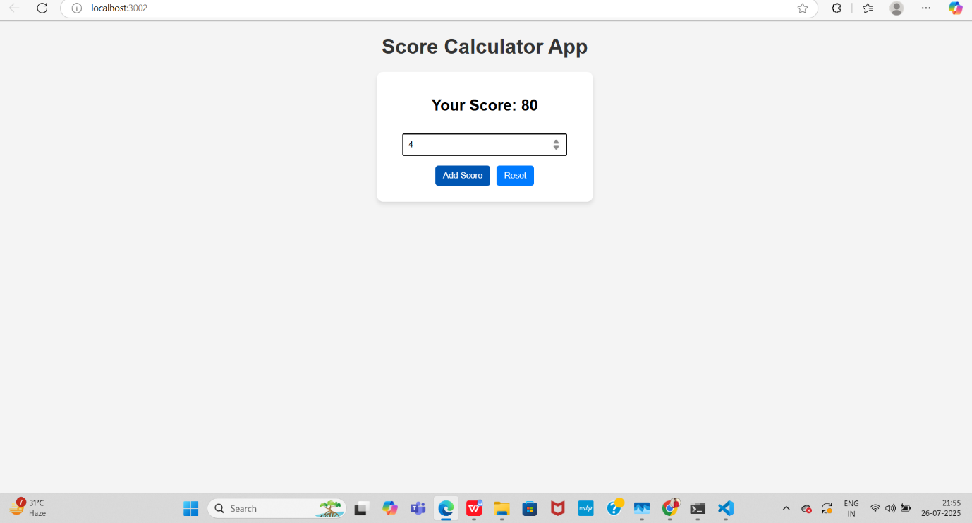

**Task 4 : Implement componentDidMount() hook**

**Implementing componentDidCatch() life cycle hook.**

**Source code**

**Public folder**

**Index.html**

<!DOCTYPE html>

<html lang="en">

<head>

  <meta charset="utf-8" />

  <link rel="icon" href="%PUBLIC_URL%/favicon.ico" />

  <meta name="viewport" content="width=device-width, initial-scale=1" />

  <title>Blog App</title>

</head>

<body>

  <div id="root"></div>

</body>

</html>

**SRC**

**App.css**

.App { max-width: 800px; margin: auto; background: #fff; padding: 20px; box-shadow: 0 0 10px #ccc; }

**App.js**

import React from 'react';

import './App.css';

import Posts from './Posts';

function App() {

  return (

    <div className="App">

      <Posts />

    </div>

  );

}

export default App;

**Index.css**

body { font-family: Arial, sans-serif; background: #f4f4f4; margin: 0; padding: 20px; }

**Index.js**

import React from 'react';

import ReactDOM from 'react-dom/client';

import './index.css';

import App from './App';

const root = ReactDOM.createRoot(document.getElementById('root'));

root.render(

  <React.StrictMode>

    <App />

  </React.StrictMode>

);

**Post.js**

import React, { Component } from 'react';

class Post extends Component {

  render() {

    return (

      <div style={{border: "1px solid #ccc", margin: "10px", padding: "10px"}}>

        <h3>{this.props.title}</h3>

        <p>{this.props.body}</p>

      </div>

    );

  }

}

export default Post;

**Posts.js**

import React, { Component } from 'react';

import Post from './Post';

class Posts extends Component {

  constructor(props) {

    super(props);

    this.state = {

      posts: [],

      hasError: false

    };

  }

  loadPosts = () => {

    fetch('https://jsonplaceholder.typicode.com/posts')

      .then(response => response.json())

      .then(data => {

        this.setState({ posts: data });

      })

      .catch(error => {

        console.error("Error fetching posts:", error);

        alert("Error fetching posts!");

      });

  };

  componentDidMount() {

    this.loadPosts();

  }

  componentDidCatch(error, info) {

    console.error("Error caught in componentDidCatch:", error, info);

    this.setState({ hasError: true });

    alert("Something went wrong in the Posts component!");

  }

  render() {

    if (this.state.hasError) {

      return <h2 style={{color:"red"}}>Error occurred while loading posts.</h2>;

    }

    return (

      <div>

        <h1>Blog Posts</h1>

        {this.state.posts.map(post => (

          <Post key={post.id} title={post.title} body={post.body} />

        ))}

      </div>

    );

  }

}

export default Posts;

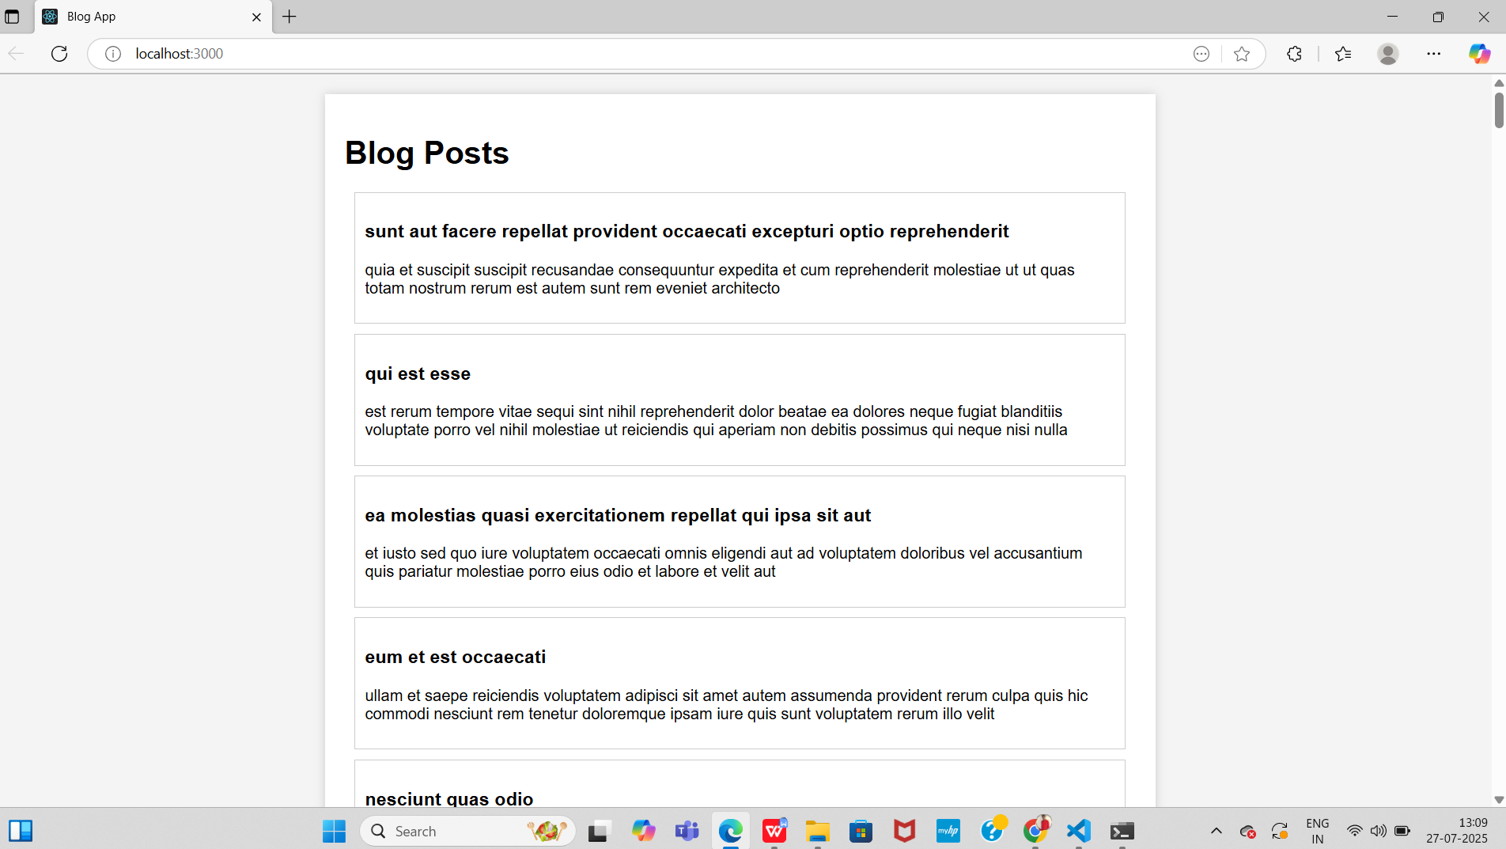

**Task 5 : Style a react component**

**Define styles using the CSS Module**

**Apply styles to components using className and style properties**

**Source code**

**Public folder**

**Index.html**

<!DOCTYPE html>

<html lang="en">

  <head>

    <meta charset="utf-8" />

    <meta name="viewport" content="width=device-width, initial-scale=1" />

    <title>Cohort Dashboard</title>

  </head>

  <body>

    <div id="root"></div>

  </body>

</html>

**SRC**

**App.js**

import React from 'react';

import CohortDetails from './CohortDetails';

function App() {

  const cohorts = [

    { name: "React Bootcamp", status: "ongoing", startDate: "2025-07-01", endDate: "2025-09-01" },

    { name: "Node.js Workshop", status: "completed", startDate: "2025-05-01", endDate: "2025-06-15" }

  ];

  return (

    <div>

      <h2>Cohort Dashboard</h2>

      {cohorts.map((cohort, index) => (

        <CohortDetails key={index} cohort={cohort} />

      ))}

    </div>

  );

}

export default App;

**CohortDetails.js**

import React from 'react';

import styles from './CohortDetails.module.css';

function CohortDetails({ cohort }) {

  const { name, status, startDate, endDate } = cohort;

  const headingStyle = {

    color: status === "ongoing" ? "green" : "blue",

  };

  return (

    <div className={styles.box}>

      <h3 style={headingStyle}>{name}</h3>

      <dl>

        <dt>Status:</dt>

        <dd>{status}</dd>

        <dt>Start Date:</dt>

        <dd>{startDate}</dd>

        <dt>End Date:</dt>

        <dd>{endDate}</dd>

      </dl>

    </div>

  );

}

export default CohortDetails;

**CohortDetails.css**

.box {

  width: 300px;

  display: inline-block;

  margin: 10px;

  padding: 10px 20px;

  border: 1px solid black;

  border-radius: 10px;

}

dt {

  font-weight: 500;

}

**Index.css**

body {

  font-family: Arial, sans-serif;

  padding: 20px;

}

**Index.js**

import React from 'react';

import ReactDOM from 'react-dom/client';

import './index.css';

import App from './App';

const root = ReactDOM.createRoot(document.getElementById('root'));

root.render(

  <React.StrictMode>

    <App />

  </React.StrictMode>

);

