**WEEK 7 TASKS ON REACT**

**Task 1:** Create a React Application named “cricketapp” with the following components:

1. ListofPlayers

* Declare an array with 11 players and store details of their names and scores using the map feature of ES6

**Source code**

**src**

**App.cs**

import React from 'react';

import ListOfPlayers from './components/ListOfPlayers';

import IndianPlayers from './components/IndianPlayers';

const App = () => {

  const flag = true; // Toggle to false to show IndianPlayers

  return (

    <div className="App">

      <h1>Welcome to Cricket App</h1>

      {flag ? <ListOfPlayers /> : <IndianPlayers />}

    </div>

  );

};

export default App;

**Index.js**

import React from 'react';

import ReactDOM from 'react-dom/client';

import App from './App';

const root = ReactDOM.createRoot(document.getElementById('root'));

root.render(

  <React.StrictMode>

    <App />

  </React.StrictMode>

);

**Component**

**IndianPlayer.js**

import React from 'react';

const IndianPlayers = () => {

  const team = ['Virat', 'Rohit', 'Dhawan', 'Iyer', 'Pant', 'Hardik'];

  const [p1, p2, p3, p4, p5, p6] = team;

  const oddPlayers = [p1, p3, p5];

  const evenPlayers = [p2, p4, p6];

  const T20Players = ['Gill', 'Surya', 'Kishan'];

  const RanjiTrophyPlayers = ['Pujara', 'Rahane'];

  const allPlayers = [...T20Players, ...RanjiTrophyPlayers]; // Merge with spread operator

  return (

    <div>

      <h2>Odd Team Players (Destructuring):</h2>

      <ul>{oddPlayers.map((p, i) => <li key={i}>{p}</li>)}</ul>

      <h2>Even Team Players (Destructuring):</h2>

      <ul>{evenPlayers.map((p, i) => <li key={i}>{p}</li>)}</ul>

      <h2>All Players (Merged T20 + Ranji):</h2>

      <ul>{allPlayers.map((p, i) => <li key={i}>{p}</li>)}</ul>

    </div>

  );

};

export default IndianPlayers;

**ListOfPlayers.js**

import React from 'react';

const ListOfPlayers = () => {

  const players = [

    { name: "Virat", score: 95 },

    { name: "Rohit", score: 88 },

    { name: "Dhawan", score: 60 },

    { name: "Iyer", score: 45 },

    { name: "Pant", score: 71 },

    { name: "Hardik", score: 66 },

    { name: "Jadeja", score: 74 },

    { name: "Shami", score: 32 },

    { name: "Bumrah", score: 20 },

    { name: "Ashwin", score: 59 },

    { name: "Kohli", score: 100 }

  ];

  const lowScorers = players.filter(player => player.score < 70);

  return (

    <div>

      <h2>All Players (with map):</h2>

      <ul>

        {players.map((player, index) => (

          <li key={index}>{player.name} - {player.score}</li>

        ))}

      </ul>

      <h2>Players Scored Below 70 (with arrow functions):</h2>

      <ul>

        {lowScorers.map((player, index) => (

          <li key={index}>{player.name} - {player.score}</li>

        ))}

      </ul>

    </div>

  );

};

export default ListOfPlayers;

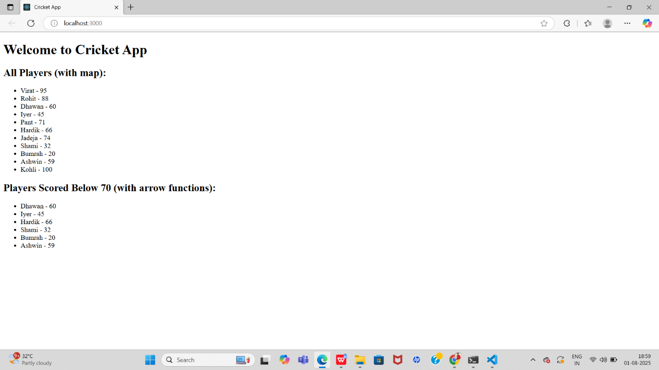

**Task 2 :** Create a React Application named “officespacerentalapp” which uses React JSX to create elements, attributes and renders DOM to display the page.

**Source code**

**Src**

App.js

import React from 'react';

import officeImage from './office.jpg';

const officeList = [

  {

    name: "ABC Corporate",

    rent: 45000,

    address: "Bangalore, Karnataka"

  },

  {

    name: "XYZ Ventures",

    rent: 65000,

    address: "Chennai, Tamil Nadu"

  },

  {

    name: "Startup Hub",

    rent: 58000,

    address: "Pune, Maharashtra"

  }

];

function App() {

  return (

    <div style={{ padding: '20px', fontFamily: 'Arial' }}>

      <h1>Office Space Rental App</h1>

      <img src={officeImage} alt="Office" style={{ width: '400px', height: 'auto', marginBottom: '20px' }} />

      {officeList.map((office, index) => (

        <div key={index} style={{ marginBottom: '15px', border: '1px solid #ccc', padding: '10px' }}>

          <h2>{office.name}</h2>

          <p style={{ color: office.rent > 60000 ? 'green' : 'red' }}>

            Rent: ₹{office.rent}

          </p>

          <p>Address: {office.address}</p>

        </div>

      ))}

    </div>

  );

}

export default App;

**Index.js**

import React from 'react';

import ReactDOM from 'react-dom/client';

import App from './App';

const root = ReactDOM.createRoot(document.getElementById('root'));

root.render(<App />);

**Index**

**Index.html**

<!DOCTYPE html>

<html lang="en">

  <head>

    <meta charset="UTF-8" />

    <meta name="viewport" content="width=device-width, initial-scale=1.0" />

    <title>Office Space Rental App</title>

  </head>

  <body>

    <div id="root"></div>

  </body>

</html>

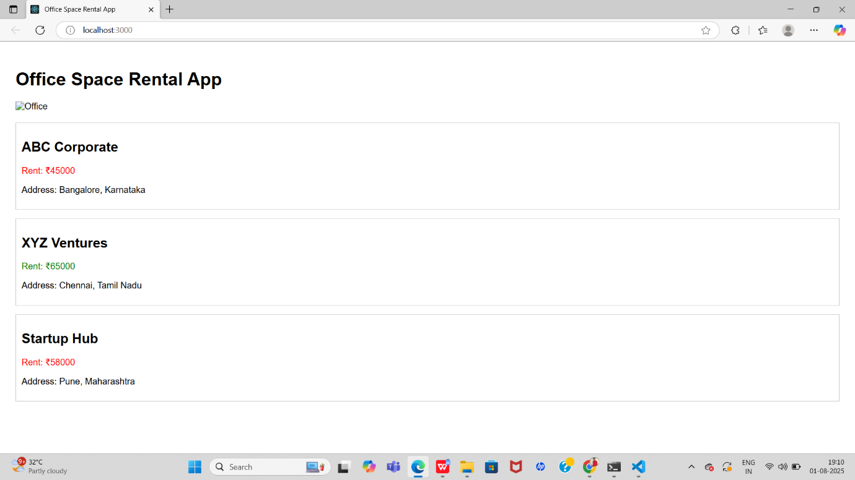

**Task 3**: Create a React Application “eventexamplesapp” to handle various events of the form elements in HTML.

1. Create “Increment” button to increase the value of the counter and “Decrement” button to decrease the value of the counter. The “Increase” button should invoke multiple methods.
   1. To increment the value
   2. Say Hello followed by a static message.

**Souce code**

**Src**

**App.js**

import React, { Component } from 'react';

import CurrencyConvertor from './CurrencyConvertor';

class App extends Component {

  constructor(props) {

    super(props);

    this.state = {

      counter: 0

    };

  }

  incrementCounter = () => {

    this.setState({ counter: this.state.counter + 1 });

  };

  sayHello = () => {

    console.log("Hello! This is a static message.");

  };

  handleIncrement = () => {

    this.incrementCounter();

    this.sayHello();

  };

  decrementCounter = () => {

    this.setState({ counter: this.state.counter - 1 });

  };

  sayWelcome = (msg) => {

    alert(msg);

  };

  handleSyntheticEvent = (e) => {

    e.preventDefault();

    alert("I was clicked");

  };

  render() {

    return (

      <div style={{ padding: '20px', fontFamily: 'Arial' }}>

        <h1>React Event Examples</h1>

        <h2>Counter: {this.state.counter}</h2>

        <button onClick={this.handleIncrement}>Increment</button>

        <button onClick={this.decrementCounter}>Decrement</button>

        <hr />

        <button onClick={() => this.sayWelcome("Welcome!")}>Say Welcome</button>

        <hr />

        <button onClick={this.handleSyntheticEvent}>OnPress</button>

        <hr />

        <CurrencyConvertor />

      </div>

    );

  }

}

export default App;

**CurrencyConverter.js**

import React, { useState } from 'react';

const CurrencyConvertor = () => {

  const [rupees, setRupees] = useState('');

  const [euro, setEuro] = useState('');

  const handleChange = (e) => {

    setRupees(e.target.value);

  };

  const handleSubmit = (e) => {

    e.preventDefault();

    const converted = parseFloat(rupees) / 90;

    setEuro(converted.toFixed(2));

  };

  return (

    <div>

      <h2>Currency Converter (INR → Euro)</h2>

      <form onSubmit={handleSubmit}>

        <input

          type="number"

          placeholder="Enter amount in INR"

          value={rupees}

          onChange={handleChange}

        />

        <button type="submit">Convert</button>

      </form>

      {euro && <p>Amount in Euro: €{euro}</p>}

    </div>

  );

};

export default CurrencyConvertor;

**Index.js**

import React from 'react';

import ReactDOM from 'react-dom';

import App from './App';

ReactDOM.render(<App />, document.getElementById('root'));

**Public**

**Index.html**

<!DOCTYPE html>

<html lang="en">

  <head>

    <meta charset="UTF-8" />

    <title>Event Examples App</title>

  </head>

  <body>

    <div id="root"></div>

  </body>

</html>

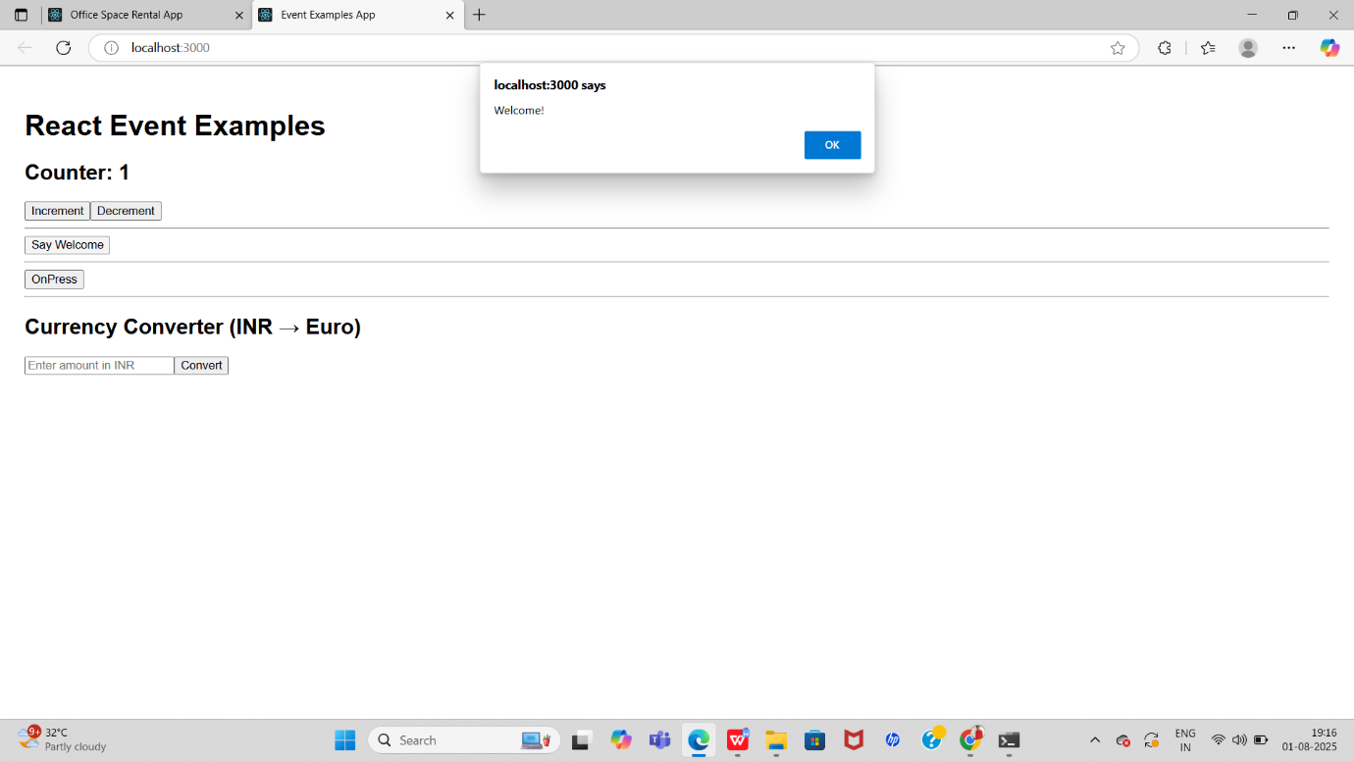

**Task4 :** Create a React Application named “ticketbookingapp” where the guest user can browse the page where the flight details are displayed whereas the logged in user only can book tickets.

The Login and Logout buttons should accordingly display different pages. Once the user is logged in the User page should be displayed. When the user clicks on Logout, the Guest page should be displayed.

**Source code**

**Src**

**App.js**

// App.js

import React, { useState } from 'react';

import GuestPage from './components/GuestPage';

import UserPage from './components/UserPage';

import FlightDetails from './components/FlightDetails';

function App() {

const [isLoggedIn, setIsLoggedIn] = useState(false);

let page;

if (isLoggedIn) {

page = <UserPage />;

} else {

page = <GuestPage />;

}

return (

<div className="App">

<h1>Ticket Booking Application</h1>

<FlightDetails />

<div style={{ marginTop: '20px' }}>

{isLoggedIn ? (

<button onClick={() => setIsLoggedIn(false)}>Logout</button>

) : (

<button onClick={() => setIsLoggedIn(true)}>Login</button>

)}

</div>

<hr />

{page}

</div>

);

}

export default App;

**Component**

**FlightDetails.js**

// components/FlightDetails.js

import React from 'react';

export default function FlightDetails() {

  return (

    <div>

      <h3>Flight Details</h3>

      <ul>

        <li>Flight: AI202</li>

        <li>From: Delhi</li>

        <li>To: Mumbai</li>

        <li>Time: 10:00 AM</li>

      </ul>

    </div>

  );

}

**GuestPage.js**

// components/GuestPage.js

import React from 'react';

export default function GuestPage() {

  return (

    <div>

      <h2>Welcome, Guest!</h2>

      <p>Please log in to book tickets.</p>

    </div>

  );

}

**UserPage.js**

// components/UserPage.js

import React from 'react';

export default function UserPage() {

  return (

    <div>

      <h2>Welcome, User!</h2>

      <p>You can now book your flight tickets.</p>

    </div>

  );

}

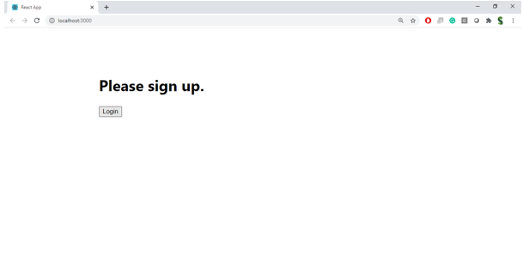

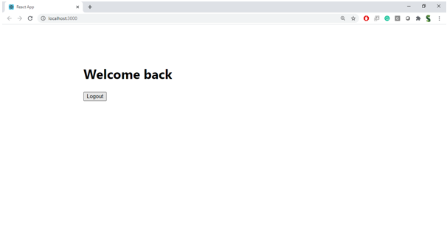

**Task 5:** **Create a React App named “bloggerapp” in with 3 components.**

1. **Book Details**
2. **Blog Details**
3. **Course Details**

**Source code**

**Src**

**App.js**

import React, { useState } from "react";

import BookDetails from "./components/BookDetails";

import BlogDetails from "./components/BlogDetails";

import CourseDetails from "./components/CourseDetails";

function App() {

  const [activeComponent, setActiveComponent] = useState("book");

  const [isCourseVisible, setIsCourseVisible] = useState(false);

  // Conditional rendering using variable assignment

  let displayedComponent = null;

  switch (activeComponent) {

    case "book":

      displayedComponent = <BookDetails />;

      break;

    case "blog":

      displayedComponent = <BlogDetails />;

      break;

    default:

      displayedComponent = <p>No component selected</p>;

  }

  return (

    <div style={{ padding: "20px", fontFamily: "Arial, sans-serif" }}>

      <h1 style={{ color: "#2c3e50" }}>📚 BloggerApp</h1>

      <div style={{ marginBottom: "20px" }}>

        <button onClick={() => setActiveComponent("book")} style={{ marginRight: "10px" }}>

          Show Book

        </button>

        <button onClick={() => setActiveComponent("blog")} style={{ marginRight: "10px" }}>

          Show Blog

        </button>

        <button onClick={() => setIsCourseVisible((prev) => !prev)}>

          Toggle Course Details

        </button>

      </div>

      <hr />

      {/* Main content area */}

      <div>{displayedComponent}</div>

      {/* Conditional rendering using && */}

      {isCourseVisible && <CourseDetails show={true} />}

      {/* Conditional rendering using ternary */}

      <p style={{ marginTop: "20px", fontStyle: "italic" }}>

        {isCourseVisible

          ? "✅ Course Details are visible."

          : "ℹ️ Click the toggle button to view Course Details."}

      </p>

    </div>

  );

}

export default App;

**Component**

**BlogDetails.js**

const BlogDetails = () => {

  const blogs = [

    { id: 1, title: "React Basics", author: "Jane" },

    { id: 2, title: "Advanced Hooks", author: "John" },

  ];

  return (

    <div>

      <h2>Blog Details</h2>

      <ul>

        {blogs.map(blog => (

          <li key={blog.id}>

            <strong>{blog.title}</strong> by {blog.author}

          </li>

        ))}

      </ul>

    </div>

  );

};

export default BlogDetails;

**BookDetails.js**

const BookDetails = () => {

  return (

    <div>

      <h2>Book Details</h2>

      <ul>

        <li>Title: React in Action</li>

        <li>Author: Mark T.</li>

        <li>Pages: 350</li>

      </ul>

    </div>

  );

};

export default BookDetails;

**CourseDetails.js**

const CourseDetails = ({ show }) => {

  if (!show) return null;

  return (

    <div>

      <h2>Course Details</h2>

      <p>Course: Full Stack Development</p>

      <p>Instructor: Alex</p>

      <p>Duration: 3 Months</p>

    </div>

  );

};

export default CourseDetails;

