James Yang

DATA 558

Hw4

1. Giving g(x) = e^x, we can give plot a graph of each.
   1. ĝ(x) = 0

* 1. ĝ(x) =

= 2.256

* 1. ĝ(x) = ax+b

After running lm(y ~ x), we get the coefficients to be:

(Intercept) x

2.194379 3.105231

* 1. ĝ(x) =

After running a lm with y ~ x + x^2, the equation is:   
1.58870890*x^2 + 2.5476450*x + 0.08390203

Using this code:

1. We will plot it out after calculating x = [-2,6]:

|  |  |
| --- | --- |
| X | Y |
| -2 | 2 |
| -1 | 2 |
| 0 | 5 |
| 1 | -1 |
| 2 | -4 |
| 3 | -6 |
| 4 | -10 |
| 5 | 2 |
| 6 | 2 |

Using this code:

It appears that the curve is constant from -2 and -1 where y = 2. From 0 to 1, y is linear with y = -6x + 5. From 1 to 2, it is linear with y = -3x + 2. From 2 to 3 it is linear with y = -2x. From 3 to 4 it is linear with y = -4x + 6. From 4 to 5 it is linear with y = 12x – 58. From 5 to 6 it is constant with y = 2.

1. The MSEs will be labeled at the bottom of the problem.
   1. After splitting data in 2800 training and 200 testing, polynomial function ended up being:

Y = -0.05321429*x^2 + 5.31585967*x -10.87610589

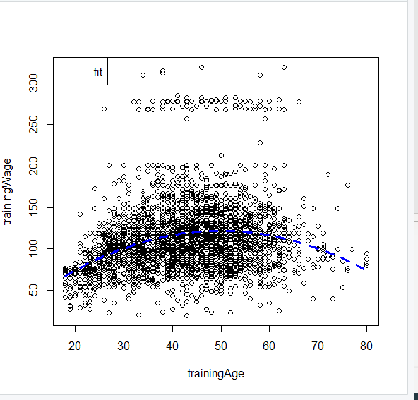

Producing a graph like this with the blue dashed line being the fitted values.

After analyzing all of the errors:

MSE 4a: 1609.01

MSE 4b: 1731.71

MSE 4c: 1532.32

MSE 4d: 1590.30

The best approach for this problem according to MSE was the piecewise polynomial. This is interesting but it could be because the dataset is fitting the curvature of step function in a polynomial manner. However, after reevaluating the MSE values, they do fluctuate a bit but keep a consistent lowest value for 4c.

* 1. When fitting a regression tree without pruning, we get these results. **Its accuracy predicts 85.4%**

When pruning with a best of 4, we get a slightly higher accuracy of 89.58%

When pruning with a best of 4, it gives a higher accuracy rating than when we simply created a tree regression. This means the pruning process has produced a more interpretable tree, but also has slightly improved classification accuracy. This makes sense because as the value of best increases, we obtain a larger pruned tree that can give us lower classification accuracy but higher interpretability.

After calculating the MSE, 

We get that the MSE is about **20.31**, meaning the model does not fit the data very well with regression trees.

* 1. Using this code:



We get that the MSE is about **17.64** which means the bagging did improve the model accuracy a bit. The tuning parameters used were the number of bags = 150 and that the coob = TRUE.

* 1. When fitting a random forest model:

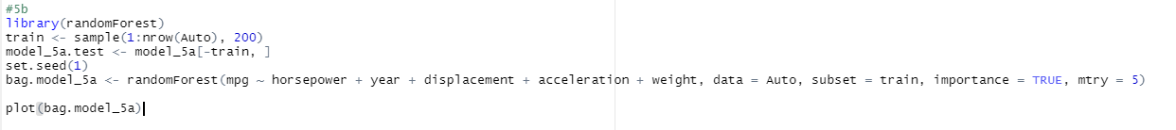

With an mtry of 5:

**Mtry = 5**

Obviously as the ntrees progress, we see that the error decreases. When the trees increase though, it makes the model less interpretable which kind of defeats the purpose of having a regression tree.

When calculating the MSE, we get **8.425** with an mtry of 5.

* 1. Using this code:

|  |  |
| --- | --- |
|  |  |
|  |  |
|  |  |
|  |  |
|  |  |



After calculating the MSE on the GAM model, we find that the MSE is **7.504** which is less than the regression tree, random forest, and bagging. So it is the best model so far. Also, when doing summary(gam.model_5a), we get that the p-values were less than 0.05 which indicates that they are signficant in estimating mpg.

* 1. Considering both accuracy and interpretability of the fitted models, I prefer the random forest model. Even though it didn’t produce the best MSE, the error to tree graph made the most sense as it became clear when the optimal point of number trees would arise with the greatest reduction of error. With regression trees in this model, it becomes highly complex and increasingly less interpretable and its important to find when that sweet spot occurs which is what the bagged regression tree model tells us. The GAM model was the best model for accuracy, but I don’t think it was as interpretable as the random forests model.

There is an article written by Arrieta, Rodriguez, Ser about the concepts, taxonomies, opportunities and challenges of AI for interpretability.

They have assembled this idea that as the models go down the list, they become more difficult to interpret to a human. Decision trees and regression trees are some of the easiest models for humans to interpret, and the trade off that the GAM model had in this exercise did not seem worth it. They divide the ideas into simulatability, decomposability, and algorithmic transparency. GAM algorithmic transparency drives at an exponential slope when it comes to interpretability for humans, therefore making it less interpretable and more difficult as more predictors come into play. The same goes for regression trees, but they are way more interpretable at the beginning states of tree nodes (especially when pruning). That’s why I believe random forests are somewhat in the middle of interpretability and they fit this problem quite well.