James Yang

DATA 558

Spring 2022

Homework #5

1. .
2. Left side of data is just the mean value of kmeans$withinss = 1.219

Right side of data is the average distance between point and centroid squared = 1.219

This iteration created an equal value which indeed supports the idea in the textbook that it holds equivalent.

1. .
   1. Producing the observations with different means so they can get spread out.

* 1. Performing PCA, I get the following plot with the following code. Since it is dimension reduction, we only want the $x values from the output.

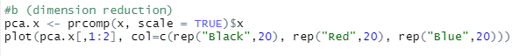

* 1. After doing K-means clustering = 3, we get all perfect labels.

* 1. After doing K = 2, we still get a perfect classification.

* 1. After doing K = 4, it appears the 3rd column gets a split classification between 3 and 4.

* 1. After doing K = 3 with the PCA, it appears to perfectly classify.

* 1. After doing the scale(x), it appears to also perfectly classify. The results appear to be the exact same as the ones found in part c except the classification flipped with column 2 and 3 finding 3 and 1 respectively. This could be due to randomization but standardizing the values because of their mean may alter their classification, but it does it on each set of values so they might just classify differently but still as a cluster.

1. .
   1. The following code creates a training set of 800 observations in OJ.

* 1. After calling svm, we get the following results.

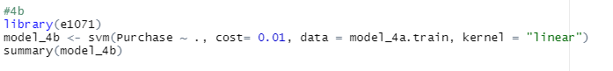

It appears there were over 424 support vectors being plotted to classify this binary svm. 212 in one and 212 in the other. The reason it’s binary is because the number of classes being shown appears to be 2. It appears to be a linear kernel used with cost of 0.01.

* 1. Testing error appears to be 17.4%.

Training error appears to be 15.5%

With this code:

* 1. 398