Problem Chosen  A | 2026  MCM/ICM  Summary Sheet | Team Control Number  2600064
Your Paper's Title
Summary

Keywords: keyword1; keyword2; keyword3; keyword4

Contents
1 Introduction 3
1.1 Problem Background 3
1.2 Restatement of the Problem 3
1.3 Literature Review 4
1.4 Our Work 4
2 Assumptions and Justifications 5
3 Notations and data source 6
4 Continuous-time model for battery state of charge 7
4.1 Modle1: The Establishment of Second-Order Thevenin ECM + Thermal Model (Continuous-Time ODE) 7
4.1.1 Basic Differential Equation Derivation 8
4.1.2 Total Power Consumption Model 8
4.2 2.2 放电截止电压 V_cut 的设定（你要求写清楚） 12
4.3 The Solution of Model 1 12
5 The name of model 2 13
6 The name of model 3 13
7 Sensitivity Analysis 13
8 Model Evaluation and Further Discussion 13
8.1 Strengths 14
8.2 Weaknesses 14
8.3 Further Discussion 14
9 Conclusion 14
References 15

Introduction

Problem Background
With the widespread adoption of mobile smart devices, smartphones have evolved from simple communication tools into miniature computing hubs that integrate office functions, entertainment, social networking, and geolocation services. However, this functional diversity poses significant challenges for energy management, Battery endurance has become a bottleneck that constrains the user experience.
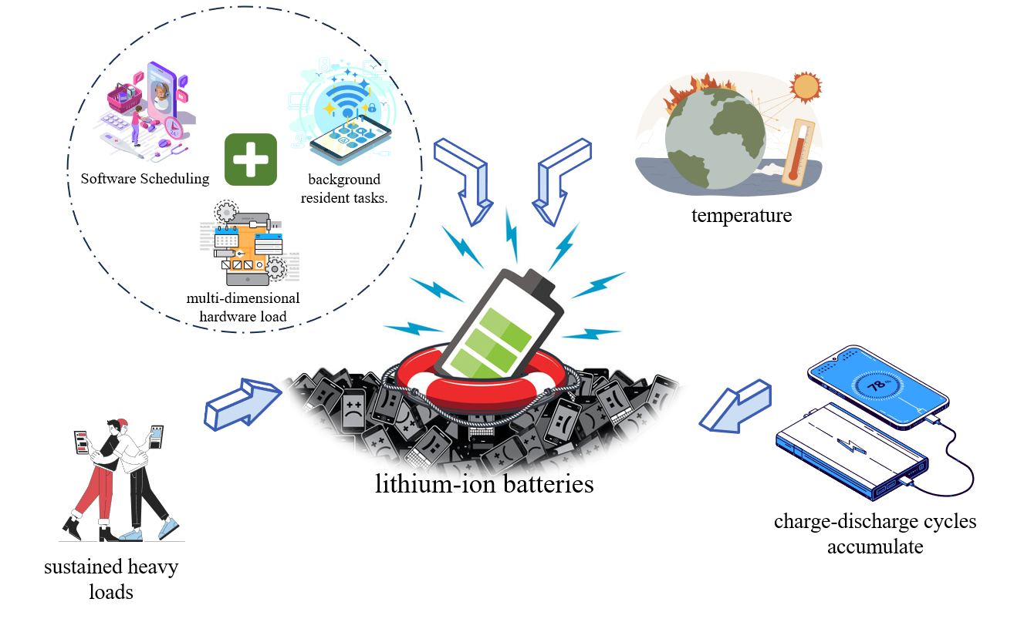
          - Phone battery level
The consumption of mobile phone battery power is a dynamic process involving multiple intertwined factors. In practical use, the battery discharge rate is not constant; it is influenced by the phone's internal multi-dimensional hardware load, software scheduling, and background resident tasks. Additionally, mobile phones commonly use lithium-ion batteries, which are extremely sensitive to. In low-temperature environments, increased internal resistance reduces the battery's usable capacity. Conversely, under high temperatures or sustained heavy loads, the battery may trigger frequency-limiting protection due to overheating. Furthermore, as charge-discharge cycles accumulate, irreversible degradation occurs within the battery's internal materials, gradually diminishing its maximum capacity. This aging characteristic makes predicting "remaining battery life" increasingly challenging.

Restatement of the Problem
Under the above background, in order to help users better understand and utilize their phone's battery power, our team will explore battery consumption patterns and usage habits, completing the following tasks:
- Task 1: Develop a continuous-time model to precisely describe the dynamic evolution of the State of Charge (SOC) over time. This model start from fundamental loss mechanisms and progressively incorporate key variables such as screen usage, processor load, network connectivity, GPS, and background tasks into the system of equations.
- Task2: Predict Time-to-Empty across different initial charge levels and usage scenarios using the model, then compare these with actual behavior. Quantify prediction uncertainty and identify areas where the model performs well or poorly.
  - Explain differences in these outcomes and identify the specific drivers of rapid battery drain in each case.
  - Use the model to explain the main causes of range variations across different scenarios and identify core drivers of rapid battery depletion. Analyze which activities contribute most significantly to reduced range and which factors have less impact than intuitively expected.
- Task 3: Examine how modeling assumptions, parameter values, and usage pattern variations cause fluctuations in prediction results, thereby evaluating the model's robustness.
- Task 4: Translate model conclusions into practical energy-saving recommendations for users and provide insights for operating system power-saving strategies.

Literature Review

Literature Review：文献综述就是把关于当前问题的现有研究成果做个概述。首先需要阅读大量解决该问题的论文，其次得用自己的话总结出来。
除非想冲O奖，否则别写这部分。一来竞赛时间有限，不可能去阅读大量论文；二来能力有限，不一定能写好总结。
小技巧：去搜相关论文，一般发表的论文都会有文献综述部分，照着别人的综述用自己的话描述一遍即可。

Our Work
Our Work：这个小部分主要介绍论文的分析思路和建模的框架， 有点像国赛论文中的问题分析部分，可以画个思维导图（可用软件亿图图示），大家可以学习。
例1：
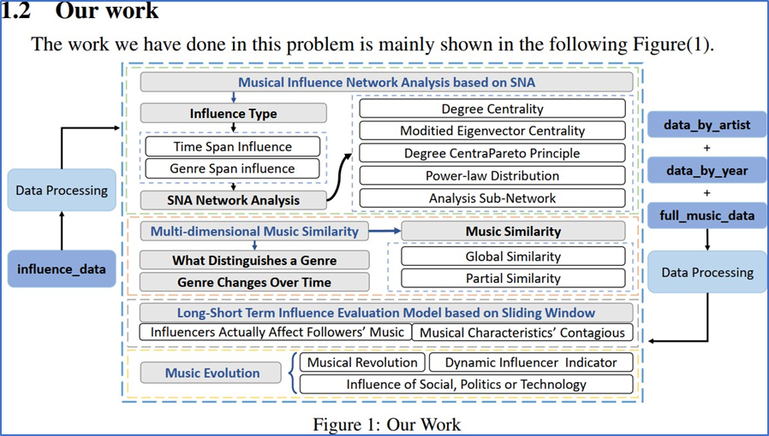
          - Our Work

Assumptions and Justifications
In order to simplify the problem and improve the model's tractability and computational
efficiency, we make the following assumptions
- Assumption 1: Assuming the use of lithium-ion batteries.
Justifications 1: Lithium-ion batteries represent the mainstream power solution in the smartphone sector, offering significant advantages in high energy density and long cycle life. Establishing a unified chemical framework facilitates standardized modeling using known electrochemical parameters.
- Assumption 2: Assumes the battery state changes continuously over time.
Justifications 2: Battery charging and discharging constitute a macroscopic electrochemical reaction process without abrupt jumps. Based on this assumption, we can employ Ordinary Differential Equations (ODEs) to precisely describe the trajectory of the battery state's dynamic evolution over time.
- Assumption 3: Battery capacity gradually degrades with increasing charge-discharge cycles.
Justifications 3: This inherent physical characteristic of lithium-ion batteries enables the model to reflect not only short-term capacity changes but also assess long-term device health.
- Assumption 4: Transitions between high and low operating states are calculated as infinitesimally small time intervals.
Justifications 4: Although microsecond-level physical delays exist in hardware circuit voltage and current stabilization, these transition times are negligible relative to the battery's discharge cycles spanning several hours, allowing for simplified model analysis.
假设1：假设使用锂离子电池，
解释1：锂离子电池是目前智能手机领域的主流电源方案，具备高能量密度和长循环寿命的显著优势。设定统一的化学背景有助于我们利用已知的电化学参数进行标准化建模。
假设2：假设电池的状态随时间呈连续变化
解释2：电池的充放电是一个宏观的电化学反应过程，不具备突发性跳转。基于此假设，我们可以运用微分方程（Ordinary Differential Equations）来精确描述电池状态随时间动态演变的轨迹。
假设3：假设电池容量随充放电循环次数的增加而逐渐衰减
解释3：这是锂离子电池固有的物理特性，这样使模型不仅能反映“短期使用”的电量变化，还能评估设备的“长期健康度”
假设4：高工作和低工作状态之间的转化按时间无限小计算
解释4：虽然硬件电路的电压、电流稳定存在微秒级的物理延迟，但相对于电池数小时的放电周期而言，这些过渡时间可以忽略不计，可以简化模型研究。

Notations and data source
Notations是对模型中使用的重要变量进行说明，表格形式三线表，表头分别是Symbol（符号）、Description （含义）、Unit（单位）（可不写），一般排版时尽量放到一页中。
The key mathematical notations used in this paper are listed in Table 1.
        - Notations used in this paper
Symbol | Description | Unit

注意：
- 只需写主要模型用到的重点变量、全篇通用的变量
- 求解计算等过程中的局部变量不要写
- 符号要以公式的形式写；如果是物理量，可在描述里写单位
- 每个符号的描述要简短，控制在一行内

Continuous-time model for battery state of charge

Modle1: The Establishment of Second-Order Thevenin ECM + Thermal Model (Continuous-Time ODE)
Based on a physical abstraction of smartphone power supply systems, this study treats smartphones as multi-field coupled open thermodynamic systems to overcome the limitation of traditional discrete fitting models—which cannot account for "unpredictable power depletion." We first assume constant power consumption to derive the simplest linear model...
。。。。。。。。。。

Thus, we consider constructing a multi-model framework. We develop a Hybrid Dynamical System (HDS) that deeply couples the battery's electrochemical reactions and thermodynamic evolution with discrete events from the upper system layer (user behavior, component state machines). Unlike traditional power consumption superposition models, this approach precisely captures the "synergistic effects" and "unpredictability" during battery depletion by integrating continuous-time differential equations
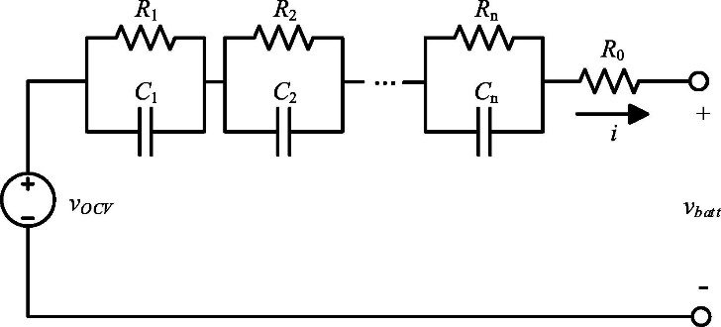
          - Second-Order Thevenin ECM + Thermal Model

Basic Differential Equation Derivation
First, we define the battery State of Charge (SOC) as the percentage of the current remaining charge relative to the rated capacity:
$$SOC\left(t\right)=\frac{Q\left(t\right)}{Q_{\text{eff}}\left(t\right)}×100\%$$
Where:
- Q(t) is the remaining charge at time t(unit: mAh).
- $Q_{\text{eff}}\left(t\right)$is the total battery capacity (unit: mAh).
- At SOC = 1, the battery is fully charged; at SOC = 0, the system considers the battery "depleted".
At the same time, lithium-ion batteries have an inherent characteristic: their capacity gradually degrades with increasing number of charge cycles. Therefore, when designing the battery model, we also factor in this characteristic.
$$C_{t}h \frac{dT}{dt}=I{\left(t\right)}^{2}R0\left(SOC,T,SOH\right)+α_{c}hip P_{c}hip\left(t\right)-hA\left(T-T_{a}mb\left(t\right)\right)$$
$$V_{term}\left(t\right)=OCV\left(SOC，T\right)-I·R0\left(SOC,T,SOH\right)-U1-U2$$
We define the effective available capacity of the battery$Q_{\text{eff}}\left(t\right)$ as a function of state of charge, expressed as follows:
$$Q_{\text{eff}}\left(t\right)=Q_{0}⋅f_{T}\left(T\left(t\right)\right)⋅f_{C}\left(I\left(t\right)\right)⋅f_{A}\left(A\right)$$

As shown, the effective capacity is highly dependent on the nominal capacity of a new battery under standard conditions, the temperature correction function , the battery or cell temperature , the discharge rate/current impact function , the aging (SOH) impact function , and aging indicators such as cycle count .
Substituting the definition of SOC into the above equation yields the rate of change of SOC:
$$\frac{d\left(SOC\left(t\right)\right)}{dt}=\frac{1}{Q_{\text{eff}}\left(t\right)}×\frac{dQ\left(t\right)}{dt}×100\%=-\frac{I\left(t\right)}{Q_{\text{eff}}\left(t\right)}×100\%$$

$$I(t)=\frac{P_{\text{sys}}(t)}{η(t) V_{\text{bat}}(t)}$$To simplify the model, using mAh/h as the power consumption unit allows $I\left(t\right)$ to be converted into the power P we wish to study. Therefore, the final fundamental differential equation is:
$$\frac{dSOC}{dt}=-\frac{P}{Q_{\text{eff}}\left(t\right)}×100\%$$
This equation describes the relationship between the rate of SOC change over time and power consumption: as power consumption increases, the SOC decline accelerates; as battery capacity increases, the SOC decline slows down.

Total Power Consumption Model
The total power consumption is composed of multiple components, each related to its respective usage state. Existing literature often idealizes these components as independent individuals that do not interfere with one another. However, in reality, the usage states of various smartphone components interact with each other. Although the electrochemical reactions within the battery and the thermal accumulation within the device body are continuous physical processes occurring at all times, user interactions—such as turning on the screen, enabling 5G, or launching a high-load app—are discrete sequences of events. Therefore, we have optimized the model as follows:
$P_{sys}\left(t\right)=\frac{1}{η}\left[\underset{\text{Base Noise}}{\underbrace{P_{sys_base}}}+\underset{\text{Screen (Size+Brightness)}}{\underbrace{k_{screen}⋅A_{size}⋅B\left(t\right)}}+\underset{\text{Processor (Big}\text{/}\text{Small cores)}}{\underbrace{P_{cpu}\left(u\left(t\right)\right)}}+\underset{\text{Network (Traffic)}}{\underbrace{P_{net}\left(D\left(t\right)\right)}}+\underset{\text{GPS Switch}}{\underbrace{P_{gps}⋅δ_{gps}\left(t\right)}}+\underset{\text{Background Tasks}}{\underbrace{P_{bg_apps}\left(t\right)}}+\right]；η\left(t\right)∈\left(0,1\right]${图}

The advantage of this analytical approach lies in its ability to deconstruct and reconstruct the complex total power consumption $P_{sys}\left(t\right)$. By aggregating intervals for specific labels—such as network type —we can similarly calculate the energy contribution of different modules to the overall runtime.
$E_{net}^{Wi\text{-}Fi}=\sum_{k:m=Wi\text{-}Fi}{E_{net,k}} E_{net,k}=\int_{t_{k}}^{t_{k+1}}{P_{net}\left(t\right)dt} E_{screen,k}=\int{P_{screen}\left(t\right)dt}${图}
This Hybrid Analysis approach endows our mechanism model with both the physical "skeleton" at its foundation and the "soul" to comprehend complex user behavior.
From the above, we derive the overall equation for power consumption SOC driven by user/system behavior:
$$\frac{dSOC\left(t\right)}{dt}=-\frac{P_{sys}\left(t\right)}{η\left(t\right)⋅V_{bat}\left(t\right)⋅Q_{eff}\left(t\right)}$$
Where $V_{bat}\left(t\right)$ is the current battery terminal voltage. The integral solution for SOC is:
$$SOC\left(t\right)=SOC\left(0\right)-\int_{0}^{t}{\frac{P_{sys}\left(τ\right)}{η\left(τ\right)⋅V_{bat}\left(τ\right)⋅Q_{eff}\left(τ\right)}}dτ$$
This enables us to obtain the solution method for estimating remaining battery life:
$$\int_{t_{0}}^{t_{0}+T_{remain}}{\frac{P_{sys}\left(t\right)}{η\left(τ\right)⋅V_{bat}\left(τ\right)⋅Q_{eff}\left(τ\right)}}dt=SOC\left(t_{0}\right)$$

Modle2 :Battery Depletion Time Prediction Model
Based on the above model, we will establish a time-based discharge prediction model for mobile phone usage.

Discharge cut-off voltage setting
First, considering that in reality, the cut-off voltage of lithium-ion batteries significantly impacts factors such as "available capacity" and "lifespan/safety margin," this paper assumes a conservative strategy aligned with smartphone systems (avoiding deep discharge to prevent lifespan degradation and shutdown uncertainty): $Vcut=3.3$
Simultaneously, sensitivity analysis will perturb $Vcut$ as a key parameter (e.g., 3.2–3.4 V) to evaluate its impact on TTE and undervoltage probability, thereby explicitly revealing the trade-off between "cut-off voltage selection—endurance—lifespan."
In real-world smartphone usage, prolonged operation can lead to overheating and rapid battery drain, while low outdoor temperatures may also cause accelerated power loss. While a battery's energy storage capacity is fixed, its "available energy" is dynamically constrained by environmental factors and its own thermal state.
For instance, in high-temperature scenarios (such as running demanding games), intense heat generated by the SoC chip is conducted through the device body to the battery, causing its temperature $R_{0}$ to rise. While this short-term heating slightly reduces the internal resistance $R_{0}$, the overall internal resistance still increases, generating more heat. Consequently, the power $P_{sys}$required to maintain the same functionality is forced to rise. Conversely, in low-temperature environments (e.g., cold outdoor conditions), $R_{0}$ increases exponentially. To maintain the same output power under energy conservation, the battery must deliver a significantly higher current $I$. This substantial current not only accelerates SOC depletion but also causes the terminal voltage $V_{term}$ to prematurely reach the critical $V_{cut}$ threshold due to the sharp increase in the voltage drop $I⋅R_{0}$. This results in the so-called "sudden power drop" phenomenon.
To unify these complex physical variables within an energy balance framework, we establish the following battery-side current solution model:
We define the battery's effective open-circuit voltage $V_{oc}$. This is not simply the open-circuit voltage $OCV$, but rather the result after subtracting the voltage drops $U_{1}$ and$U_{2}$ caused by polarization effects. This reflects the battery's "fatigue effect"—after operating at high current for a period, the usable voltage temporarily decreases. Terminal voltage $V_{term}$: This is the voltage actually sensed by the phone's circuitry. When this value drops to your set cutoff voltage$V_{cut}$ (3.3V), the system will force a shutdown.
Phone components (screen, CPU, 5G module, etc.) require power to operate.
$$V_{oc}=OCV\left(SOC,T\right)-U1-U2，V_{term}=V_{oc}-I·R_{0}$$
$$P_{sys}=V_{term}·I=V_{oc}I-R_{0}{ I}^{2}$$

- The $R₀I²$term represents internal resistance thermal losses.
- $R_{0}=R_{0}\left(SOC\left(t\right),T\left(t\right),SOH\right)$ This is a variable related to SOH.
This means that a portion of the electrical energy output by the battery is directly converted into heat within the battery itself, rather than being supplied to the phone. This explains why the battery itself heats up significantly under heavy loads.
To determine whether the battery has reached its limit, we set $Δ\left(t\right)$ to assess its power consumption state.
$$Δ\left(t\right)=V_{oc}^{2}-4R_{0}P_{sys}$$
When:
- $Δ\left(t\right)>0$ :The battery can meet the load power demand by adjusting its output current, ensuring normal system operation.
- $Δ\left(t\right)=0$ :The system has reached its maximum power transfer point. At this point, any slight increase in load or voltage fluctuation will cause current to become uncontrollable.
- $Δ\left(t\right)<0$ : A physical "voltage collapse" occurs. This typically happens when the battery is extremely low on charge or in extremely cold environments, where excessive internal resistance prevents the battery from maintaining the minimum system operating voltage.
In the algorithm, once $Δ\left(t\right)<0$ the model immediately triggers the TTE termination signal, indicating a forced shutdown.

Time to First Termination. (non-regression)
This model defines endurance time not as a linear regression based on historical data, but as a first-time-to-reach (TTE) problem within the state space of a dynamic system. We deconstruct shutdown behavior as a physical-level "boundary game": When terminal voltage touches the protection threshold$V_{cut}$, chemical energy SOC is depleted, or load demand exceeds the battery's power output limit ($Δ\left(t\right)<0$), the system equilibrium breaks, triggering a termination signal. This modeling approach enables us to precisely capture nonlinear power-down behavior under extreme conditions, providing a scientifically grounded physical explanation for 'unpredictable depletion'.
Regarding the shutdown phenomenon, we have categorized it into three distinct triggering causes.
- Voltage threshold trigger: $V_{term}\left(t\right)≤V_{cut}$ ：
This is the most common cause of shutdown. To protect lithium batteries from over-discharge
- Energy depletion trigger: $SOC\left(t\right)≤SOC_{min}$ ：
This represents ideal state depletion.
- Power unfeasibility trigger (voltage collapse): $Δ\left(t\right)<0$ ：
This represents ideal state depletion.
This is the core explanation for "unexpected shutdowns." During extreme cold (where internal resistance $R_{0}$ surges) or intensive gaming (where power $P_{sys}$ peaks), the discriminant suddenly drops below zero. At this point, the battery can no longer deliver sufficient current to sustain the load—both mathematically and physically—resulting in a "voltage collapse." This is the model's key to explaining "why the screen suddenly blacks out with 10% battery remaining."

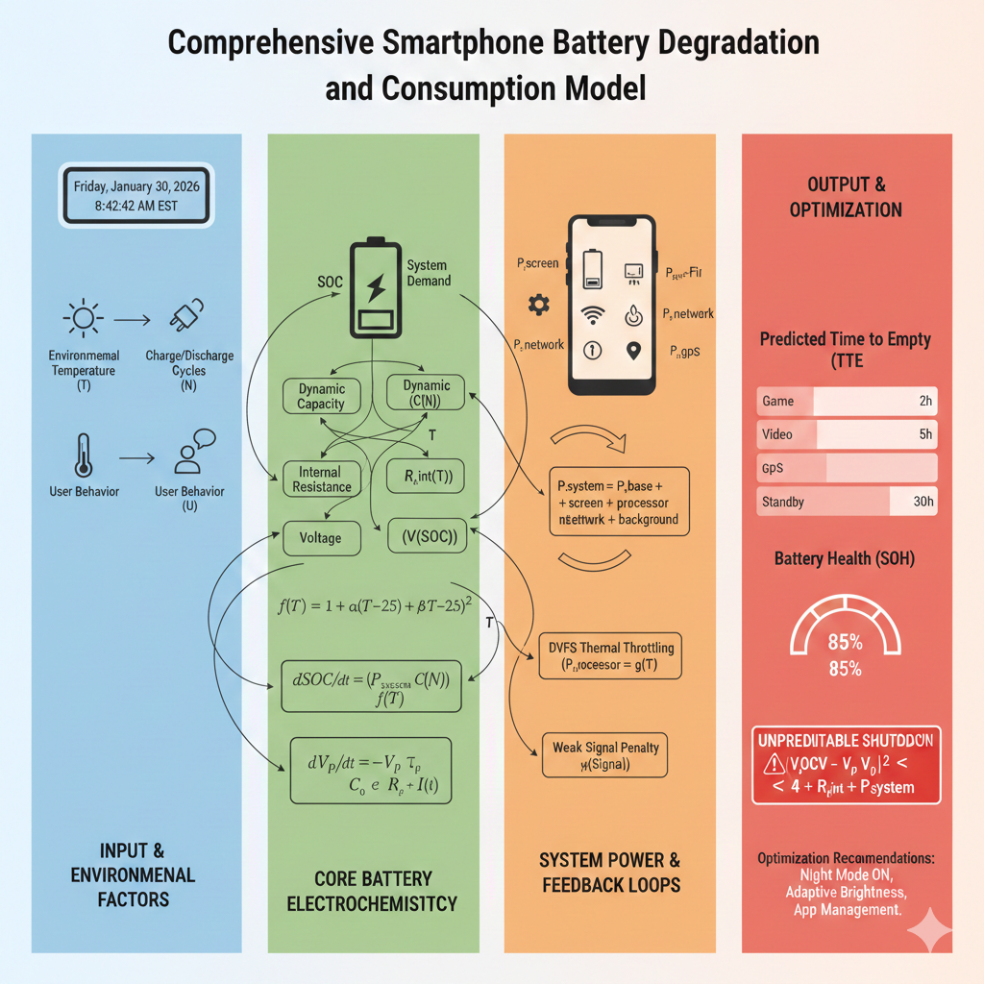
          - Continuous-time model for battery state of charge

The Solution of Model 1
这里可以写第一个模型的求解，把实际问题归结为一定的数学模型后，就要利用数学模型求解所提出的实际问题了。一般需要借助计算机软件进行求解，例如常用的软件有Matlab, Spss, Lingo, Excel, Stata, Python等。求解完成后，得到的求解结果应该规范准确并且醒目，若求解结果过长，最好编入附录里。（注意：如果使用智能优化算法或者数值计算方法求解的话，需要简要阐明算法的计算步骤）
同样的，很少有论文直接用“模型求解”作为这部分的标题，大家可以根据得到的结论来合理设计这里的标题。
另外，很多美赛论文对于模型的建立和求解没有区分开，这里沿用的是类似于国赛的形式，这样可以让论文框架清晰点。

这里插入公式 | ()

这里插入公式 | ()

The name of model 2
和上一个部分类似的写法。

The name of model 3
和上一个部分类似的写法。

注意：大多数美赛优秀论文都是对每个问题或者每个模型作为一个一级标题，就像我们上面的这种布局；也有一部分论文建立一个大的一级标题，取名为“Models and Solutions”，然后在这个大的标题下设计每个问题或者模型对应的二级标题，这一种排版布局在国赛中用的更多。

Sensitivity Analysis
模型的分析 ：在建模比赛中模型分析主要有两种，一个是灵敏度(性)分析，另一个是误差分析。灵敏度分析是研究与分析一个系统（或模型）的状态或输出变化对系统参数或周围条件变化的敏感程度的方法。其通用的步骤是：控制其他参数不变的情况下，改变模型中某个重要参数的值，然后观察模型的结果的变化情况。误差分析是指分析模型中的误差来源，或者估算模型中存在的误差，一般用于预测问题或者数值计算类问题。
模型的检验：模型检验可以分为两种，一种是使用模型之前应该进行的检验，例如层次分析法中一致性检验，灰色预测中的准指数规律的检验，这部分内容应该放在模型的建立部分；另一种是使用了模型后对模型的结果进行检验，数模中最常见的是稳定性检验，实际上这里的稳定性检验和前面的灵敏度分析非常类似，等会大家看到例子就明白了。
在美赛的写作中，写的最多的就是灵敏度分析（Sensitivity Analysis），因此这里我们的标题就直接取得是灵敏度分析；如果你既要写灵敏度分析，又要写误差分析（Error Analysis），那么你可以把标题改成： Sensitivity Analysis and Error Analysis

Model Evaluation and Further Discussion
注：本部分的标题需要根据你的内容进行调整，例如：如果你没有写进一步讨论的话，就直接把标题写成模型的评价。（优缺点一定要写）

Strengths
这里写论文或者模型的优点

Weaknesses
这里写缺点：缺点写的个数一般要比优点少

Further Discussion
进行进一步的讨论，这里可以写模型的改进和拓展：
模型的改进：主要是针对模型中缺点有哪些可以改进的地方；
模型的拓展：将原题的要求进行扩展，进一步讨论模型的实用性和可行性。

Conclusion
结论部分，这个部分在国赛论文很少见到，但在美赛中出现的频率很高。
这个部分可以是论文中心思想的重申、研究结果或主要观点的归纳，也可以是某些启示性的解释或考虑。

References
参考文献至少五六篇，引用中文文献记得翻译成英文。
            - 在正文对应部分也设置序号
引用格式一定要正确，建议从检索网站直接导出，下图以知网为例
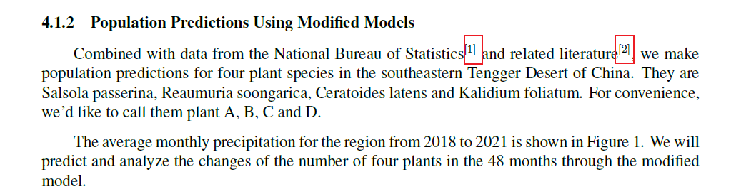
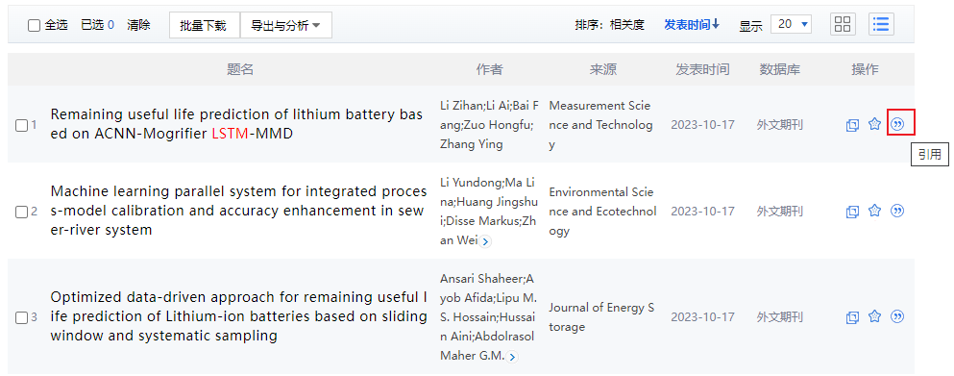


        - 123

