Screenshots:

**Home Activity:**

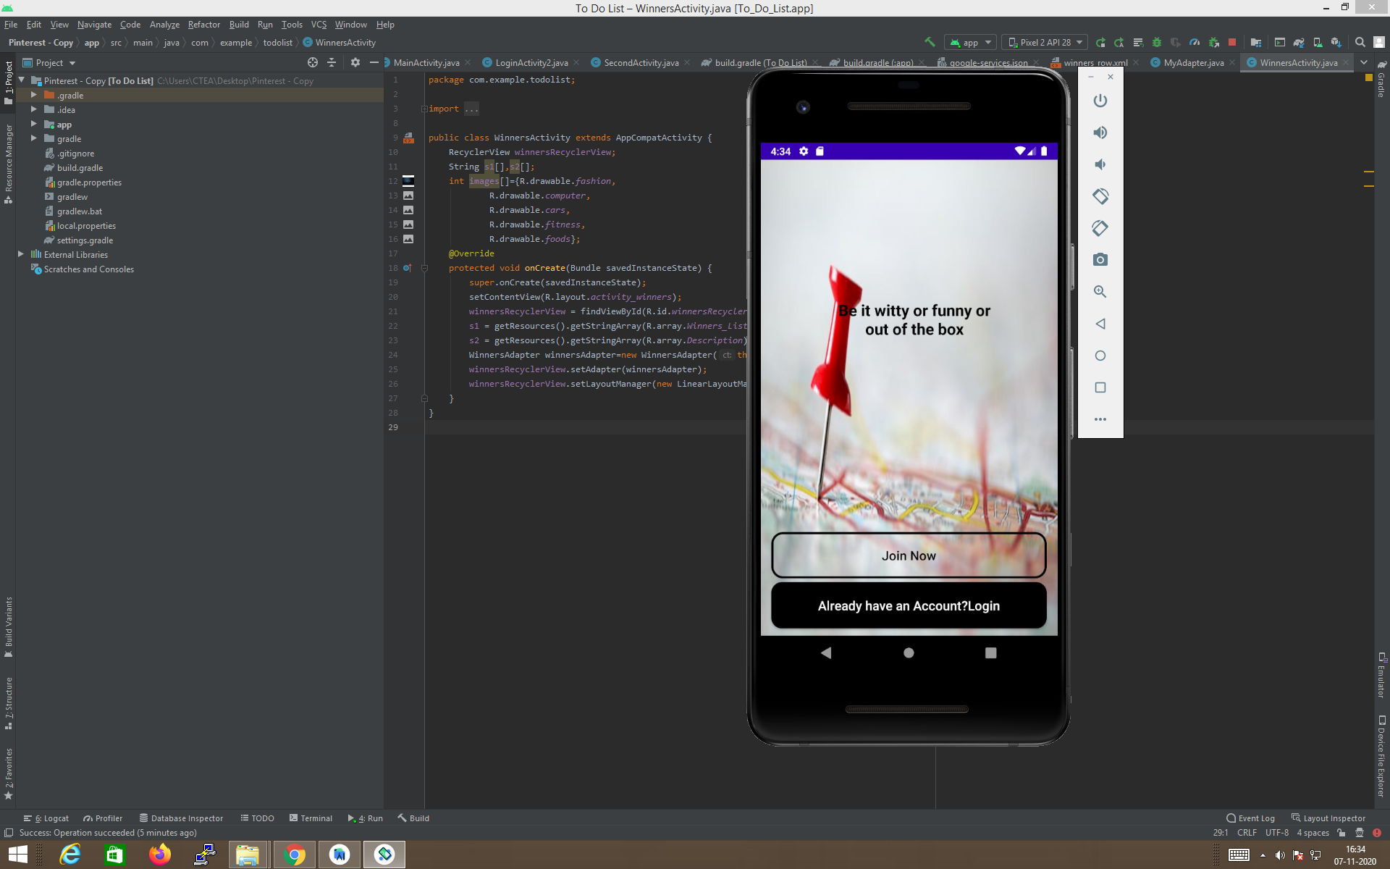

**Register Activity:**

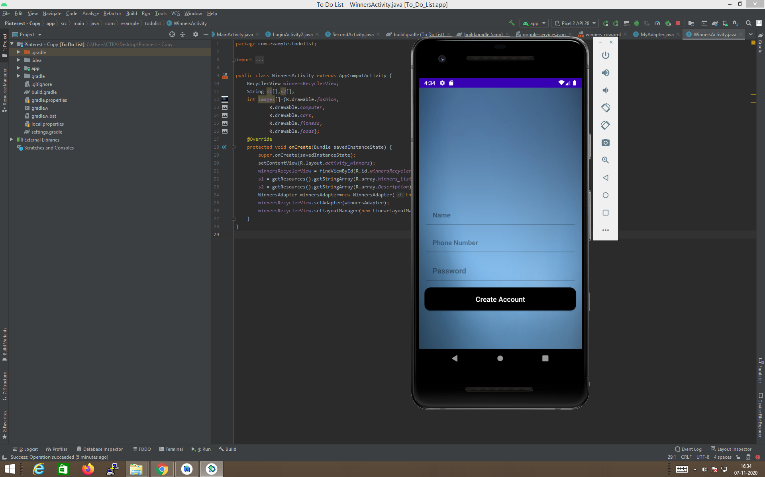

**Login Activity:**

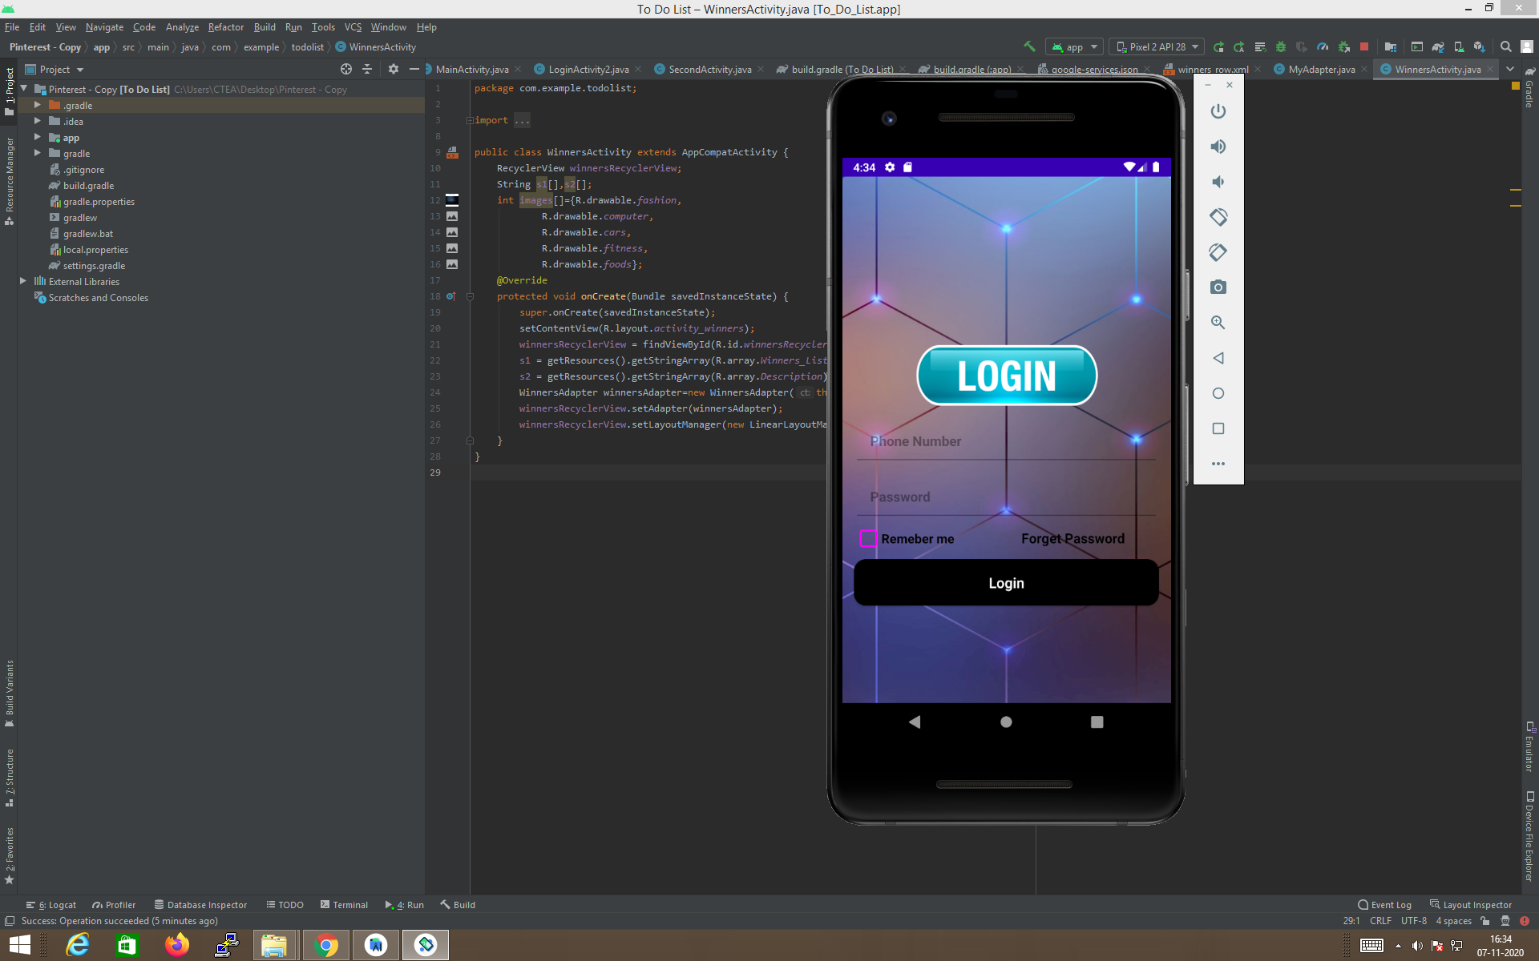

**Recycler View:**

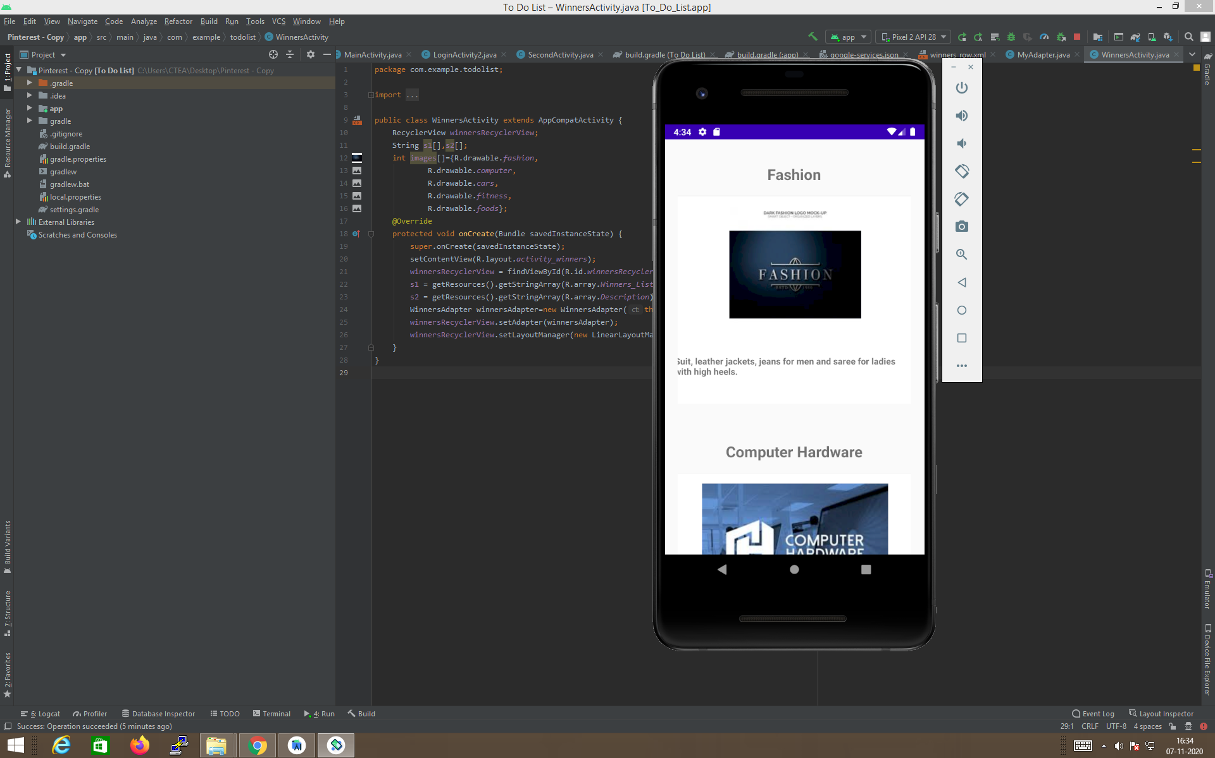

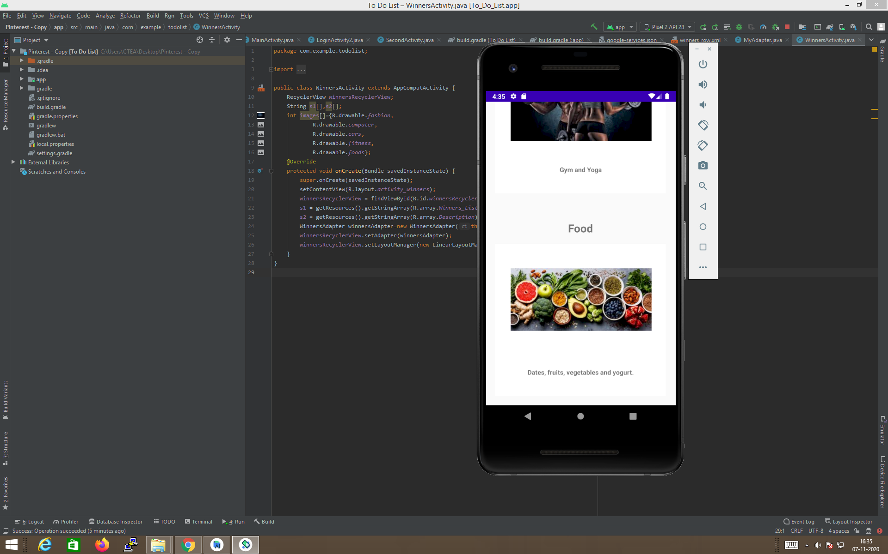

**It’ s taking both the language:**

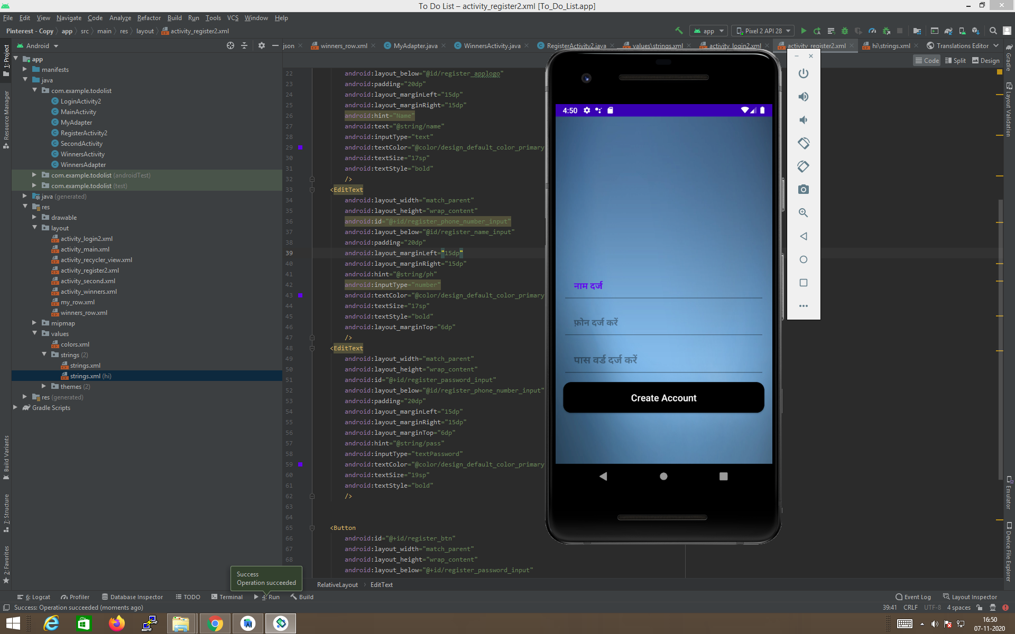

**Git Hub Link:**

<https://github.com/99002441/Androidassesement>

Aptizer.io link:

<https://appetize.io/app/774vc3f5m26jkzde8kfun4v2u0>