|  |  |  |  |  |  |
| --- | --- | --- | --- | --- | --- |
| **Ver. Rel. No** | **Release Date** | **Mod.By Mod. Dt** | **Rev. By**  **Relevant**  **Stakeholders Rev. Dt.** | **Auth By Auth Dt.** | **Remarks/**  **Revision details** |
| 1.0 | 17-Dec-2020 | Bindu K R | Raghavendra C S |  |  |
| Harshith H K | Jagadeesh B |  |
| Hasika Chelladurah |  |  |  |
| Devineni Sai Kiran |  |  |  |
| 1.1 | 17-Dec-2020 | Bindu K R | Raghavendra C S |  |  |
| Harshith H K | Jagadeesh B |  |
|  |  | Hasika Chelladurah |  |  |  |
|  |  | Devineni Sai Kiran |  |  |  |

2.0

**Camera Annotations**

Ver

sion

–

1.0

**DOCUMENT HISTORY**



**Table of contents**

1.1 Purpose of this project 3

1.2 Key success Factors 3

1.3 Stakeholders Reference 3

1.4 References 3

2.1 Product / Project Overview 4

2.2 User - Block Diagram 4

2.3 Scope of the Project 5

2.4 Not in the scope of the Project 5

2.6 Annual quantity/ prototype quantity 5

2.8 System Environment 6

2.10 Assumptions and Dependencies 6

3.1 Business Context 6

3.3 User Profiles 6

3.4 Cost 7

4.1 Strategy / Process adopted for Requirements Gathering and Elicitation 7

5.1 System Requirements 7

5.2 Software Requirements 7

5.3 Hardware Requirements 14

5.4 Non-Functional Requirements 14

5.8 Availability Requirements – (AVR) 14

5.9 Usability Requirements (UR) 14

7.1 Deliverables and Acceptance Criteria 15

|  |  |
| --- | --- |
| **1.0** | **Introduction** |

# 1.1 Purpose of this project

To create a mobile application using Android Studio to allow users to do annotations over a live camera stream. User should be able to record annotations along with video for future reference ans can also capture the screenshot whenever required.

# 1.2 Key success Factors

* Users should be able to use camera annotations over a live camera as and when it’s streamed.
* Users should be able to take notes over the stream with Text or pen live.
* Users should also be able to erase all widgets to clear all annotations taken in a shot.
* Additionally, users should also be able to use normal text field to take notes.

# 1.3 Stakeholders Reference

* Raghavendra CS: raghavendra.cs@ltts.com
* Jagadeesh B: jagadeesh.b@ltts.com
* Ayaz Uddin: ayaz.uddin@ltts.com

# 1.4 References

* + Shadow Project Document. - CES_SW_Shadow Project Proposal ver 1.0_Camera Annotations
  + Annotaions[**:**https://developer.android.com/reference/android/hardware/camera2/packa ge-summary](https://developer.android.com/reference/android/hardware/camera2/package-summary)
  + Camerax API[**:**](https://developer.android.com/jetpack/androidx/releases/annotation) <https://developer.android.com/training/camerax>
  + <https://developers.google.com/ar/develop/java/quickstart>

|  |  |
| --- | --- |
| **2.0** | **Project Descriptions** |

# 2.1 Product / Project Overview

• To develop an Android Application that will allow the users to take notes on the go with the live stream video record using Camera annotations with help of via a Pen (Black Color Optional) or via Text as and when the live video session is happening and save the annotations and points for later references with the use of screen recorder.

# 2.2 User - Block Diagram

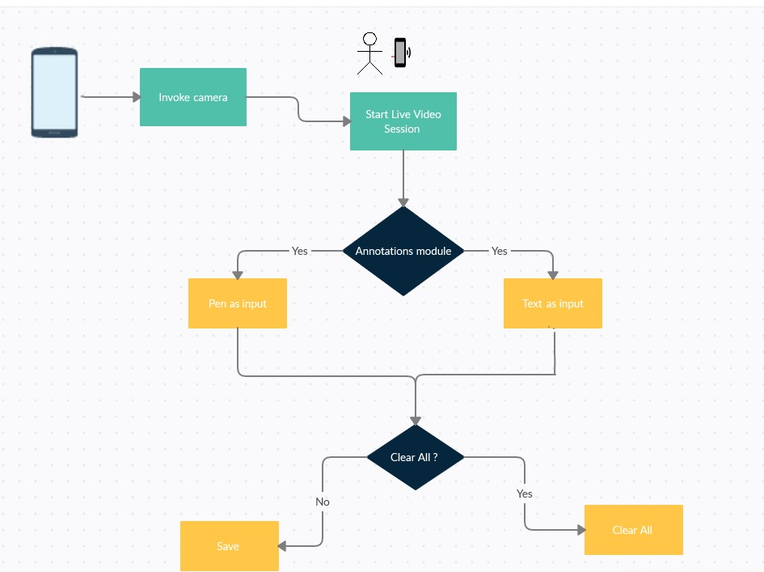

# 2.3 Scope of the Project

* Application should be able to run the video recording with the default camera.
* Application should be able record the whole screen including annotation and free handwriting.
* Application should be able to render the widget tools in the video frame itself.
* Application should be able to take Text also as input Notes.
* Architecture of the application should be designed in such a way that the Android OS upgrades should have no or minimum impact on the application.
* Application should be able to record the live camera with the widgets on screen on both static field and Dynamic field in the background.
* Application should have a button to clear all widgets and texts in one tap.
* Application should be able to capture the screen(screenshot), whenever required

# 2.4 Not in the scope of the Project

NA

**2.5 Product Functions / General Descriptions**

* Camera API
* Widgets
* Annotations
* Camera annotation application should be able to take videos with camera annotations

# 2.6 Annual quantity/ prototype quantity

* Its one-time delivery no maintenance required
* Application to be generic so that customer can maintain themselves

**2.7 Expected product life**

* Application to be generic so that customer can maintain themselves

# 2.8 System Environment

* L&T provided laptops and desktops with standard configuration.
* Android Studio for Development.
* Physical Android Smartphone.

**2.9 Design and Implementation Constraints**

NA

# 2.10 Assumptions and Dependencies

.

• Every mobile using this application should contain hardware camera

|  |  |
| --- | --- |
| **3.0** | **Application Environment** |

# 3.1 Business Context

**3.1.1 Environment**

* Android 5.0 and above.

**3.1.2 Functions**

* Real time video live stream and handling annotations.

**3.1.3 Problems / Risks to be watched for**

* While implementing video annotations we should take care that annotations are static are dynamic
* Making sure the application serves its purpose and its usage and doesn’t crash or malfunction.

**3.2 Operational Concepts & Scenarios:**

NA

# 3.3 User Profiles

Role : User

Functional Area : Camera Application

Needs/Expectations from the system : Pre-defined widgets should work in real time simulation.

# 3.4 Cost

Application to be completed and delivered on 17th Dec 2020

|  |  |
| --- | --- |
| **4.0** | **Details of requirements gathering process** |

# 4.1 Strategy / Process adopted for Requirements Gathering and Elicitation

• Project Proposal Document provided by BU team from those documents created required functionalities of application.

|  |  |
| --- | --- |
| **5.0** | **Requirements Specifications** |

The Requirements Specifications have been divided into five categories

1. System Requirements
2. Software Requirements
3. Hardware Requirements
4. Functional
5. Non-Functional Requirements

# 5.1 System Requirements

* Microsoft® Windows® 7/8/10 (64-bit).
* 4 GB RAM minimum, 8 GB RAM recommended.
* 2 GB of available disk space minimum,

4 GB Recommended (500 MB for IDE + 1.5 GB for Android SDK and emulator system image).

* 1280 x 800 minimum screen resolution.

# 5.2 Software Requirements

|  |  |
| --- | --- |
| **Requirement Id.** | SWR_01 |
| **Reference** | 1. CES_SW_Shadow Project Proposal ver 1.0_Camera Annotations |
| **Description** | Launching camera application foreground |
| **Criticality** | Critical |
| **Technical issues** | NA |
| **Risks** | NA |
| **Dependencies with other requirements** | Mobile which uses these applications should contain hardware camera |
| **Expected Results with acceptability limits, Wherever applicable** | Application should launch in the foreground. It should launch when user wants to open application by clicking on application |
| **Method of Verification** | Manual verification |
| **Method of Validation** | NA |

|  |  |
| --- | --- |
| **Requirement Id.** | SWR_02 |
| **Reference** | 1. CES_SW_Shadow Project Proposal ver 1.0_Camera Annotations |
| **Description** | Uninstall and reinstall the application |
| **Criticality** | Critical |
| **Technical issues** | NA |
| **Risks** | NA |
| **Dependencies with other requirements** | SWR_01 |
| **Expected Results with acceptability limits, Wherever applicable** | Uninstalling the application should remove all the context and data belongs To the camera application except the (Image/Video data) |
| **Method of Verification** | Manual verification |
| **Method of Validation** | NA |

|  |  |
| --- | --- |
| **Requirement Id.** | SWR_03 |
| **Reference** | 1. CES_SW_Shadow Project Proposal ver 1.0_Camera Annotations |
| **Description** | Application should be able to capture screenshot |
| **Criticality** | Critical |
| **Technical issues** | NA |
| **Risks** | NA |
| **Dependencies with other requirements** | SWR_02 |
| **Expected Results with acceptability limits, Wherever applicable** | Camera annotation Application should be able to capture the screenshot |
| **Method of Verification** | Manual verification |
| **Method of Validation** | NA |

|  |  |
| --- | --- |
| **Requirement Id.** | SWR_04 |
| **Reference** | 1. CES_SW_Shadow Project Proposal ver 1.0_Camera Annotations |
| **Description** | User should be able to add annotations on photos and videos according to user requirements |
| **Criticality** | Critical |
| **Technical issues** | NA |
| **Risks** | NA |
| **Dependencies with other requirements** | SWR_03 |
| **Expected Results with acceptability limits, Wherever applicable** | User should be able to preview the annotations before saving the picture/video |
| **Method of Verification** | Manual verification |
| **Method of Validation** | NA |

|  |  |
| --- | --- |
| **Requirement Id.** | SWR_05 |
| **Reference** | 1. CES_SW_Shadow Project Proposal ver 1.0_Camera Annotations |
| **Description** | User should be able to Annotate over the camera stream via Text or Pen with black color. Color selection widget is optional. |
| **Criticality** | Critical |
| **Technical issues** | NA |
| **Risks** | NA |
| **Dependencies with other requirements** | SWR_04 |
| **Expected Results with acceptability limits, Wherever applicable** | User can add text to picture or video using different colours |
| **Method of Verification** | Manual verification |
| **Method of Validation** | NA |

|  |  |
| --- | --- |
| **Requirement Id.** | SWR_06 |
| **Reference** | 1. CES_SW_Shadow Project Proposal ver 1.0_Camera Annotations |
| **Description** | User should be able to erase particular annotations or entire annotations |
| **Criticality** | Critical |
| **Technical issues** | NA |
| **Risks** | NA |
| **Dependencies with other requirements** | SWR_05 |
| **Expected Results with acceptability limits, Wherever applicable** | User can be able to erase the annotations |
| **Method of Verification** | Manual verification required for each command |
| **Method of Validation** | NA |

|  |  |
| --- | --- |
| **Requirement Id.** | SWR_07 |
| **Reference** | 1. CES_SW_Shadow Project Proposal ver 1.0_Camera Annotations |
| **Description** | Annotation widget shall allow free hand drawing on the screen via Pen option |
| **Criticality** | Critical |
| **Technical issues** | NA |
| **Risks** | NA |
| **Dependencies with other requirements** | SWR_04 |
| **Expected Results with acceptability limits, Wherever applicable** | User can have free hand drawing on the screen via Pen option |
| **Method of Verification** | Manual verification required for each command with proper parameters |
| **Method of Validation** | NA |

|  |  |
| --- | --- |
| **Requirement Id.** | SWR_08 |
| **Reference** | 1. CES_SW_Shadow Project Proposal ver 1.0_Camera Annotations |
| **Description** | Annotation widget shall also allow to do text input on the screen. |
| **Criticality** | Critical |
| **Technical issues** | NA |
| **Risks** | NA |
| **Dependencies with other requirements** | **SWR_04** |
| **Expected Results with acceptability limits, Wherever applicable** | User can be able to add notes using keypad |
| **Method of Verification** | Manual verification |
| **Method of Validation** | NA |

|  |  |
| --- | --- |
| **Requirement Id.** | SWR_9 |
| **Reference** | 1. CES_SW_Shadow Project Proposal ver 1.0_Camera Annotations |
| **Description** | User should be able to Tap and write over the camera preview screen. |
| **Criticality** | Critical |
| **Technical issues** | NA |
| **Risks** | NA |
| **Dependencies with other requirements** | **SWR_04** |
| **Expected Results with acceptability limits, Wherever applicable** | User can be able to Tap and write over the camera preview screen. |
| **Method of Verification** | Manual verification |
| **Method of Validation** | NA |

|  |  |
| --- | --- |
| **Requirement Id.** | SWR_10 |
| **Reference** | 1. CES_SW_Shadow Project Proposal ver 1.0_Camera Annotations |
| **Description** | User should be able to save the video in required storage location. |
| **Criticality** | Critical |
| **Technical issues** | NA |
| **Risks** | NA |
| **Dependencies with other requirements** | NA |
| **Expected Results with acceptability limits, Wherever applicable** | User can be accessing the saved picture later. |
| **Method of Verification** | Manual verification |
| **Method of Validation** | NA |

|  |  |
| --- | --- |
| **Requirement Id.** | SWR_11 |
| **Reference** | 1. CES_SW_Shadow Project Proposal ver 1.0_Camera Annotations |
| **Description** | User should be able to record the whole screen including annotation and text part for future reference. |
| **Criticality** | Critical |
| **Technical issues** | NA |
| **Risks** | NA |
| **Dependencies with other requirements** | NA |
| **Expected Results with acceptability limits, Wherever applicable** | User can be able to view the annoted video for referance |
| **Method of Verification** | Manual verification |
| **Method of Validation** | NA |

# 5.3 Hardware Requirements

* Android Mobile
* Laptop/Desktop with Windows 10. RAM – 8 GB min (16 GB recommended

# 5.4 Non-Functional Requirements

* Application should not crash at all times.
* Multiple users should be able to access the app and use the widgets.
* Users should be able to save multiple instance of the notes at one shot.

* 1. **Operational Requirements (OPR)**

NA

* 1. **Security Requirements (SCR)**

NA

* 1. **Reliability Requirements- (RLR)**

NA

# 5.8 Availability Requirements – (AVR)

• Application should be available for all Android users in play store once the official release is done after beta testing.

# 5.9 Usability Requirements (UR)

• The user Interface(UI) should be user friendly - anyone with a simple android knowledge and application skills should be able to understand and use the app.

|  |  |
| --- | --- |
| **6.0** | **Implicit Requirements** |
|  | • Camera Quality – Should be at least bare more than 2 Mega Pixel for good viewing and watching. |
| **7.0** | **Non-Technical Requirements** |

# 7.1 Deliverables and Acceptance Criteria

|  |  |  |  |  |  |
| --- | --- | --- | --- | --- | --- |
| **Deliverables agreed**  **(Both Intermediate & Final**) | **Date of**  **Delivery,**  **Only if committed to the customer** | **Deliverable format** | **Acceptance Criteria** | | **Remarks** |
| **Task** | **Responsibility** |
| Camera annotations Application to be delivered to BU team | 17-Dec-2020 | Android application |  |  |  |

**Other aspects agreed upon:**

a) Periodic Reviews should be given: Weekly

|  |  |
| --- | --- |
| **8.0** | **Special Requirement** |
|  | NA |
| **9.0** | **Test Strategy** |
| • | Application code should follow coding standards and all APIs should be modularized |
| • | Application should accommodate any further changes done from the modem perspective. The code should be generic enough so that it can be easily ported. |
| • | Application should accommodate any new APIs |
| **10.0** | **Glossary** |

NA