./

Learning Report –

Voice Controlled DC Motor

Course Code: <CODE>



|  |  |  |  |  |  |
| --- | --- | --- | --- | --- | --- |
| **Ver. Rel. No.** | **Release Date** | **Prepared. By** | **Reviewed By** | **Approved By** | **Remarks/Revision Details** |
|  |  |  |  |  |  |
|  |  |  |  |  |  |
|  |  |  |  |  |  |
|  |  |  |  |  |  |
|  |  |  |  |  |  |

**Document History**

Contents

Checklist 2

Activity 1– System/Software Development 4

**Section1: Requirements** 4

Research: 4

SWOT Analysis 6

Detailed Requirements: 7

**Section 2: Design** 8

Low Level Design 8

High Level Design 11

**Section 3: Test Plan** 14

Activity 2 –CI Workflow for C Programming 16

16

Activity 3 – Agile Aspects 18

Appendix 18

Activity and Tasks

# Activity 1– System/Software Development

## **Section1: Requirements**

### Introduction:

It is really difficult to work in hazardous environment in many of the industries. Humans can handle only certain amount of temperature, pressure and other climatic conditions. To work in an environment with such severe conditions among machines will cause threat to human life. To overcome this difficulty, voice controlled systems is being developed so that machines can be operated remotely.

### Research:

###### Ageing

A brief timeline of important events that led to current voice recognition technology:

20th Century

* Voice recognition technology was first developed by Bell Labs in 1952.
* In 1960s, came IBM’s Shoebox machine which could understand 16 words spoken only in English by a designated speaker.
* In the early 1980’s came the Hidden Markov Model (HMM). In this, speech recognition went from using templates to understanding words to a statistical method that measured the probability of unknown sounds being words.
* In 1993, Speakable items, the first built-in speech recognition and voice enabled control software for Apple computers.

21st Century

* In 2002, Microsoft integrates speech recognition into office products.
* In 2008, Google launches the Voice Search app for the iPhone, bringing speech recognition technology to mobile devices which paved the way for future of Voice recognition technology.
* From 2012 onwards research had been carried out to integrate heavy machineries with voice recognition.

###### Gradation

|  |  |  |  |  |
| --- | --- | --- | --- | --- |
| Motor Type | Controller | Wireless Module | Key features related to this project. | Approx Cost (in rupees) |
| DC Motor of 12 V | Arduino Uno | Bluetooth | * 8 bit Atmega 328 processor. * Operating DC current:40mV * Clk speed: 16Mhz | 500 |
| Wifi | 650 |
| ESP32S | Inlcuded Bluetooth module | * 32-bit LX6 microprocessor * Operating DC current:50mV * Clk speed: 160 or 240Mhz. * Bluetooth 4.0 included | 800 |
| External wifi module | 900 |
| DC Motor of 50V | ESP32S | Inlcuded Bluetooth module | * 32-bit LX6 microprocessor * Operating DC current:50mV * Clk speed: 160 or 240Mhz. * Bluetooth 4.0 included | 800 |
| External wifi module | 900 |
|  |  |  |  |
| DC Motor> 100V | Customized Circuitary | Cloud based operation | * Long range Communication * Remote operation. * High Bandwidth requirement * Relay logic required | 2000 |

### SWOT Analysis

### Detailed Requirements:

|  |  |
| --- | --- |
| ID | Description |
| H_01 | Speed and Direction control of 12 V DC motor |
| H_02_L_01 | Microcontroller minimum Input Voltage- 7v |
| H_02_L_02 | Microcontroller minimum Output voltage-12V |
| H_02_L_03 | Microcontroller minimum clk freq- 15 Mhz. |
| H_03_L_01 | Motor driver minimum i/p voltage-5V |
| H_03_L_02 | Motor driver minimum Output voltage-12V |
| H_03_L_03 | Transition time-200ns |
| H_03_L_04 | Automatic Thermal shutdown, speed and direction controllable. |
| H_04 | Intermediate mobile application to act between microcontroller and human voice. |
| H_04_L_01 | Take the user voice and convert into Bluetooth/wifi module readable signals. |
| H_04_L_02 | Easy Integration with wireless modules. |
| H_04_L_03 | User friendly GUI. |
| H_04_L_04 | Precise Voice recognition. |
| H_05_L_01 | Wireless Device Range>=25m |
| H_05_L_02 | Easy Integration with other modules. |
| H_05_L_03 | Wireless Device must be robust in nature |
| H_05_L_04 | IOT integratable. |
| H_06_L_01 | Melting point of the enclosure of circuitry setup must be higher than 100C |
| H_06_L_02 | Max allowed dimension of enclosure: 10x10cm |
| H_06_L_03 | Enclosure must be robust in nature. |

## 

## **Section 2: Design**

### Low Level Design

##### Behavioral Diagrams

###### Activity Diagram

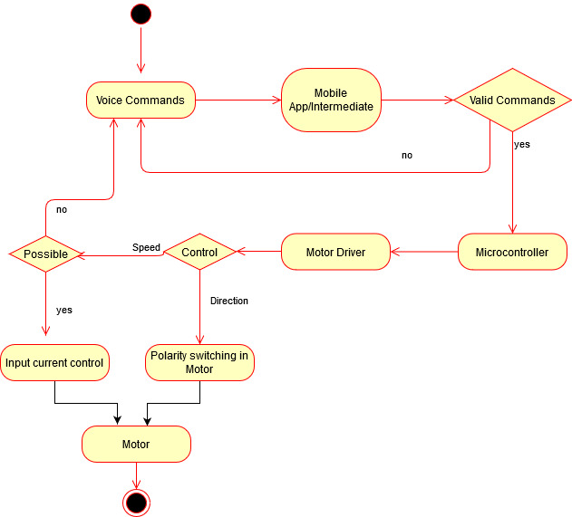

###### Use Case Diagram

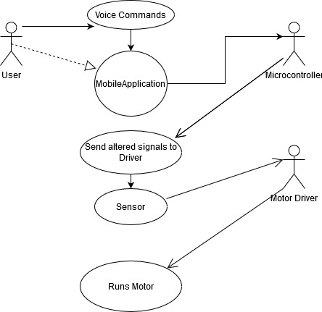

##### Structural Diagrams

###### Class Diagram

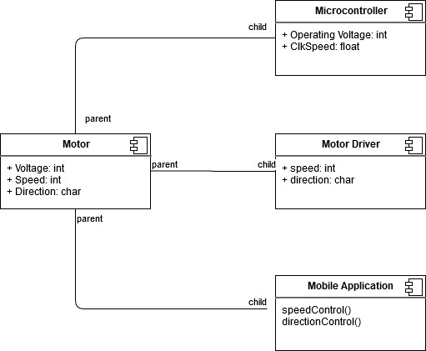

###### Object Diagram

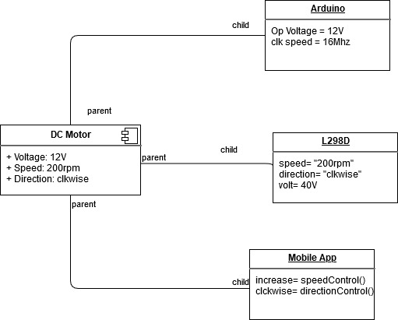

### High Level Design

##### Behavioral Diagrams

###### Activity Diagram

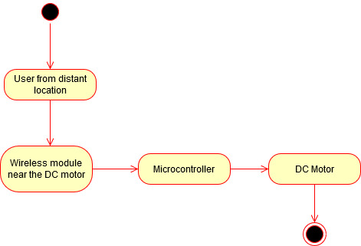

###### User Case Diagram

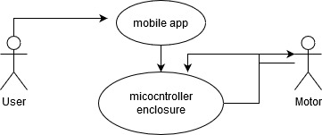

##### Structural Diagrams

###### Class diagram

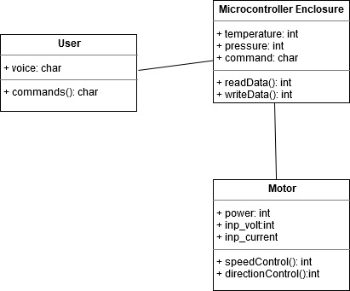

###### Object diagram

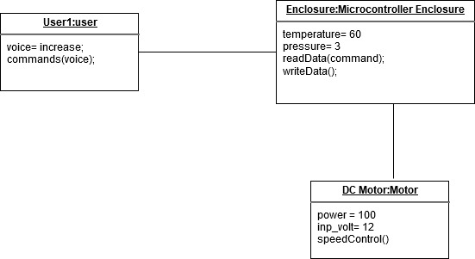

## **Section 3: Test Plan**

|  |  |  |  |  |  |
| --- | --- | --- | --- | --- | --- |
| ID | Description | Precondition | Expected I/p | Expected O/p | Actual o/p |
| H_01_L_01 | Recognizable voice commands on speed. | Commands are already setup. | set 200 rpm | Motor runs at 200rpm | 200rpm |
| H_01_L_02 | Recognizable voice commands on direction. | Commands are already setup. | change direction | Motor starts to rotate clockwise if initially it was anti clockwise and vice versa. | Motor starts to rotate clockwise if initially it was anti clockwise and vice versa. |
| H_02 | Full day operation | Module Setup | Power on | Power on throughout | Power on throughout |
| H_03_L_01 | Operating voltage of microcontroller should be 12V. | 0V | 12V | Works perfectly | Works perfectly at 12V |
| H_03_L_02 | Maximum power i/p of microcontroller should be 100W | 0W | 100W | Works perfectly | Works perfectly |
| H_03_L_03 | Microcontroller minimum clk freq- 15 Mhz. |  | 15Mhz | Speed is 15Mhz | Speed is 15Mhz |
| H_03_L_04 | Motor driver minimum voltages | 0V | 5V | 12V to run the motor | Approx. 12V |
| H_04 | Converting user input voice to input signals to wireless module | Mic on | Take user voice command | Interpret and send to wireless module | Interpret and send to wireless module |
| H_05_L_01 | Minimum range of wireless operation 25m. | Power Off | Incoming signals from mobile app starting from 25m away | Perfect reception | Almost perfect reception till 100m before it loses connectivity. |
| H_05_L_02 | Accuracy of wireless reception | Power off | Incoming signals from mobile app | Appropriate signals changes to microcontroller | Almost correct interpretation with slight errors. |
| H_06_L_01 | Melting point of the enclosure of circuitry setup must be atleast 100C | Room temperature | Increasing Temperature of the environment | No deformations spotted even after 100C | It starts to show signs of melting after 100C |
| H_06_L_02 | Robust in the working environment. | No defects | Stress from falls and heat | No defects | No defects |
| H_07_L_01 | If speed and direction command is given simultaneously, direction is given preference. | Normal functioning | Both commands simultaneously given | Direction gets preceded | Direction gets preceded |
| H_07_L_02 | If voltage levels increase beyond the limit, microcontroller module is disconnected. | Normal functioning | voltage levels are increased beyond the limit | microcontroller module is disconnected | microcontroller module is disconnected |
| H_07_L_03 | If wireless is not detected or gets disconnected, notification pops up in mobile app | Normal functioning | Wireless is disconnected | notification pops up in mobile app | notification pops up in mobile app |

# Activity 2 –Agile Aspects

|  |  |  |  |
| --- | --- | --- | --- |
| Theme  Operate a Dc Motor with User voice | | | |
| Epic1  Wireless Module | | Epic 2  Motor driver | |
| User Story-1  I want to control a DC motor using my voice commands via a mobile app to interface.  Time required: 2 weeks | User Story-2  I need to control the motor so a microcontroller might be needed to include the changes.  Time required: 1 week | User Story-3  I want to change and control speed as well as direction of the motor so an H-bridge should be used for the same.  Time required: 1 week | User Story-4  I might need an extra amplifier can be included to increase the output so that motor of higher ratings can also be operated.  Time required: 3 days |

# Activity-3: CI Workflow

## Operations on Shapes

### Introduction:

This project is a multifile program GitHub to perform multiple mathematical operations on different shapes.

### Reqirements:

|  |  |
| --- | --- |
| ID | Description |
| H_01 | Selecting the shape from available options. |
| H_02 | Dimensions of the shape. |
| H_02_L_01 | Calculating area of the shape |
| H_02_L_02 | Calculating perimeter of the shape |
| H_03 | Operations on the area and perimeter of shapes. |
| H_03_L_01 | Arithmetic operations: addition, subtraction, multiplication, division, modulus. |
| H_03_L_02 | Checking if the input is odd or even |
| H_03_L_03 | Checking if input is prime or composite |
| H_03_L_04 | Checking if the number is positive, negative or zero |
| H_03_L_05 | Finding factorial of the number |
| H_03_L_06 | Finding reverse of the number |
| H_03_L_07 | Finding sum of digits |
| H_03_L_08 | Checking if the input is a magic number |

### Design:

##### Activity Diagram

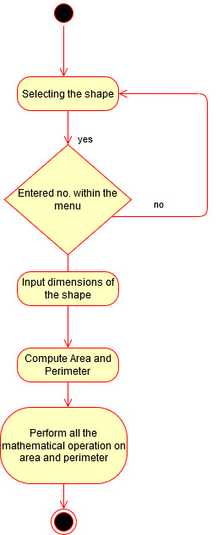

### Test Plan:

|  |  |  |  |  |  |
| --- | --- | --- | --- | --- | --- |
| ID | Description | Precondition | Expected I/p | Expected O/p | Actual o/p |
| H_01 | Selecting from available options on shapes. | Menu containing available options | Serial no. corresponding to shape | Takes the correct shape as input | Takes the correct shape as input |
| H_02 | In taking dimensions of the shape. | Shape selected | Depending on the shape, providing the dimensions | Takes the correct dimensions as input | Takes the correct dimensions as input. |
| H_02_L_01 | Calculating area of the shape | Dimensions given | Dimensions of the shape | Area of the shape | Area of the shape |
| H_02_L_02 | Calculating perimeter of the shape | Dimensions given | Dimensions of the shape | Perimeter of the shape | Perimeter of the shape |
| H_03 | Operations on the area and perimeter of shapes. | Calculated area and perimeter of shape | area and perimeter of shape | Corresponding functional value or Boolean value to the mathematical operation | Corresponding functional value or Boolean value to the mathematical operation |
| H_03_L_01 | Arithmetic operations: addition, subtraction, multiplication, division, modulus. | Calculated area and perimeter of shape | area and perimeter of shape | Corresponding mathematical operation value | Corresponding mathematical operation value |
| H_03_L_01_01 | Addition | Calculated area and perimeter of shape | Eg:  Area=20, perimeter=9 | 29 | 29 |
| H_03_L_02 | Checking if the input is odd or even | Calculated area and perimeter of shape | Eg: Area=40,perimeter=13 | 1,0 | 1,0 |
| H_03_L_03 | Checking if input is prime or composite | Calculated area and perimeter of shape | Eg: Area=40,perimeter=13 | 0,1 | 0,1 |
| H_03_L_04 | Checking if the number is positive, negative or zero | Calculated area and perimeter of shape | Eg: Area=40,perimeter=13 | 1,1 | 1,1 |
| H_03_L_05 | Finding reverse of the number | Calculated area and perimeter of shape | Eg: Area=298,perimeter=148 | 892,841 | 892,841 |
| H_03_L_06 | Finding factorial of the number | Calculated area and perimeter of shape | Eg: Area=10,perimeter=7 | 3,628,800, 5,040 | 3,628,800, 5,040 |
| H_03_L_07 | Finding sum of digits | Calculated area and perimeter of shape | Eg: Area=200,perimeter=120 | 2,3 | 2,3 |
| H_03_L_08 | Checking if the input is a magic number | Calculated area and perimeter of shape | Eg: Area=240,perimeter=100 | 0,1 | 0,1 |

# Appendix

### GitHub Activity

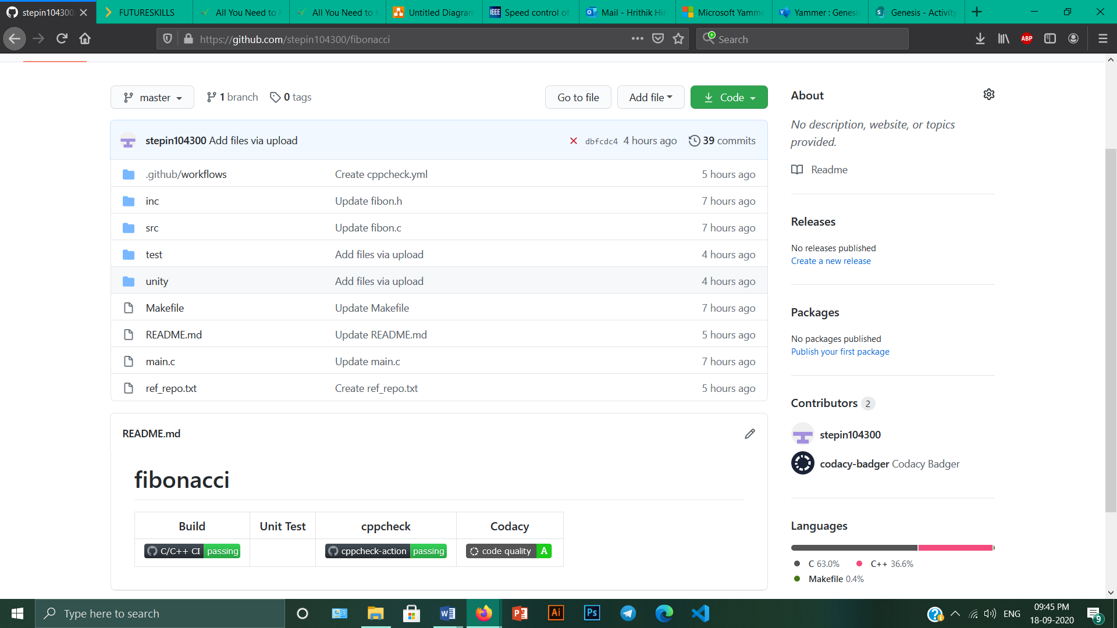

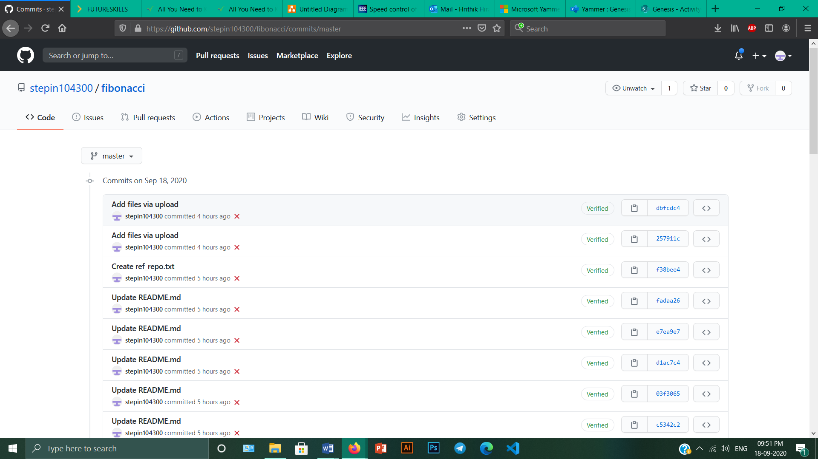

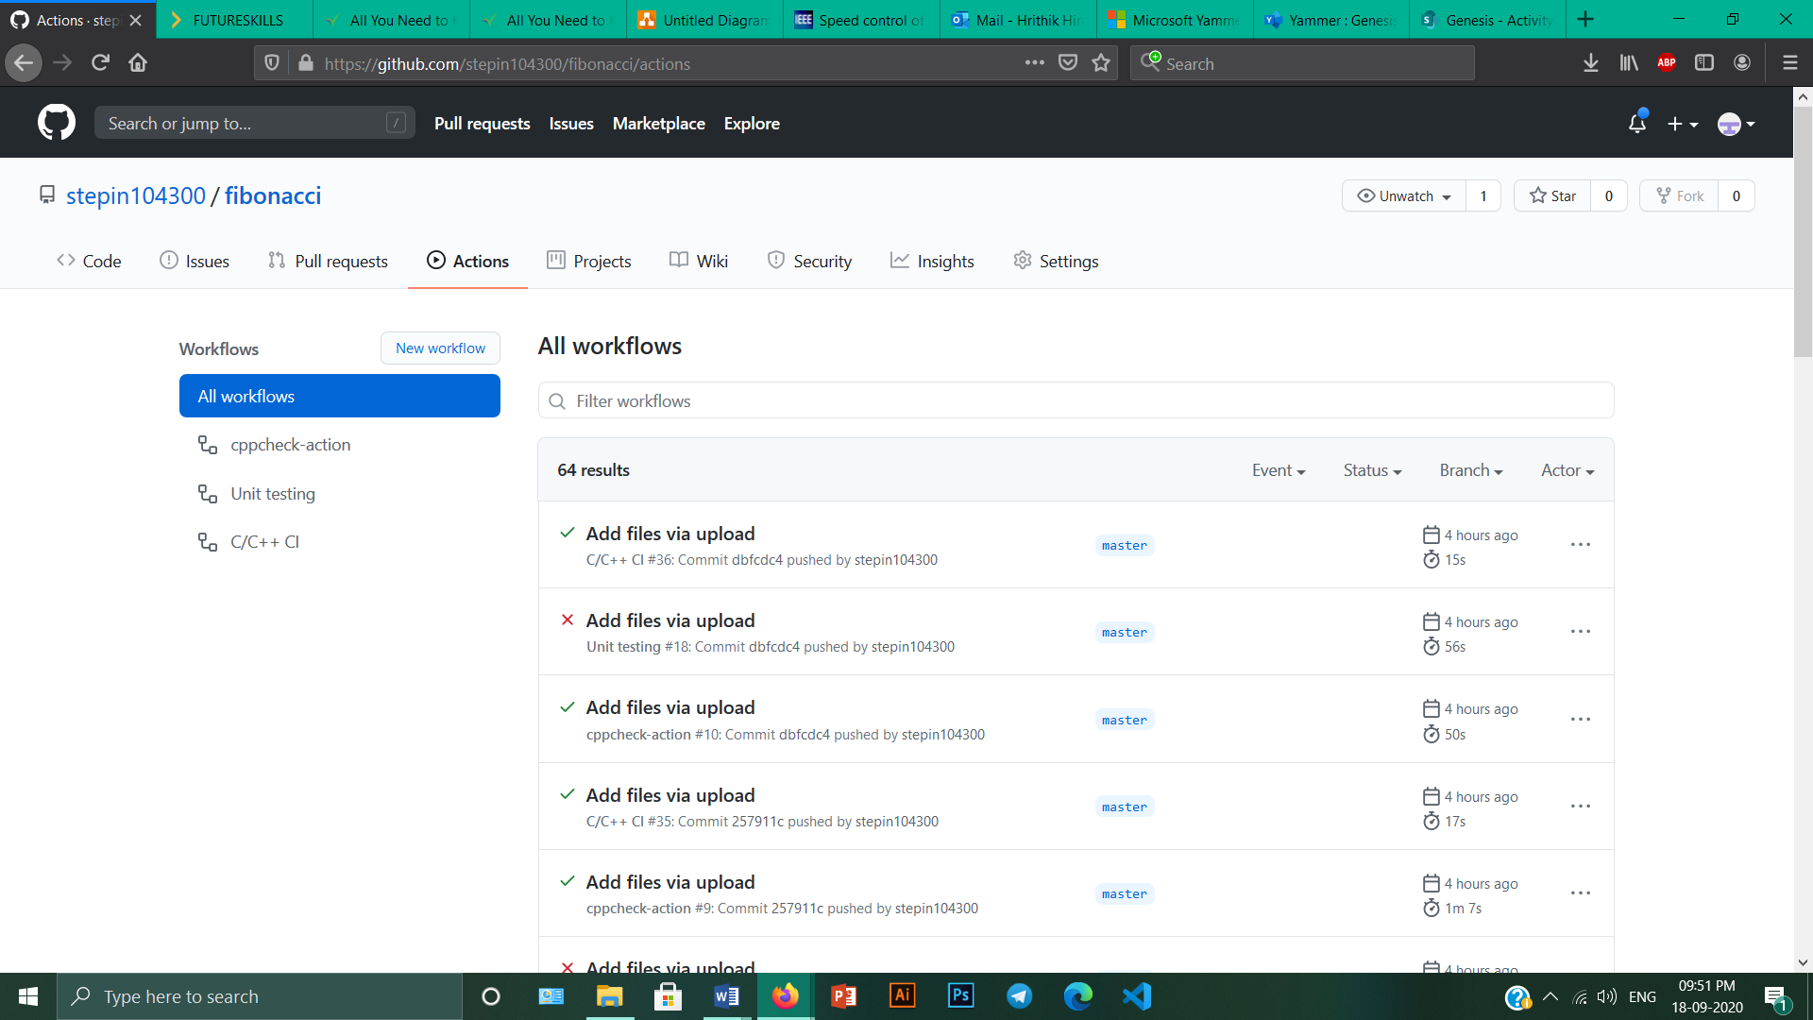

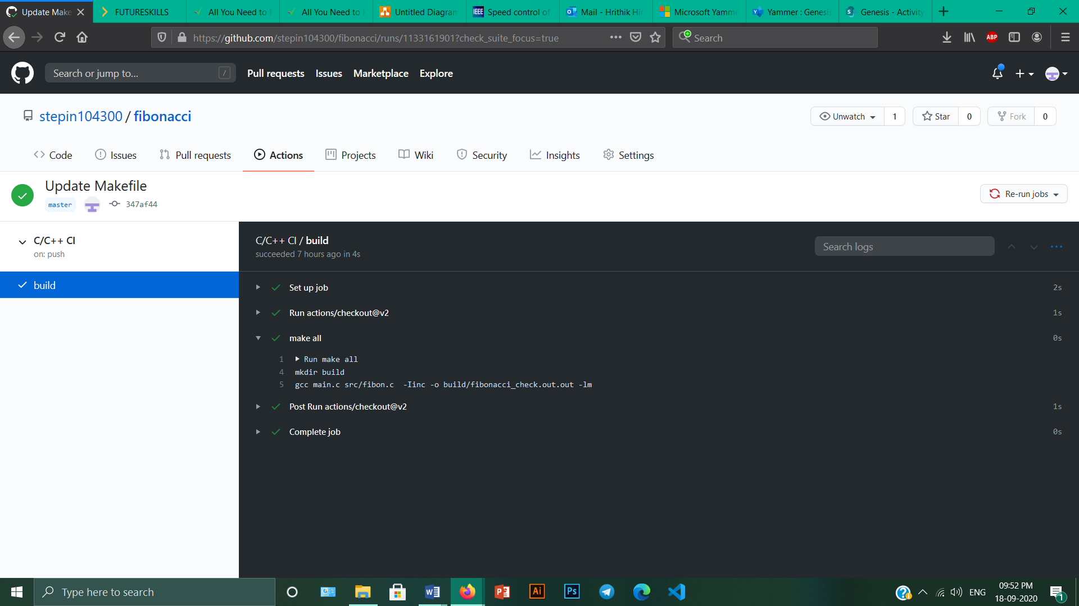

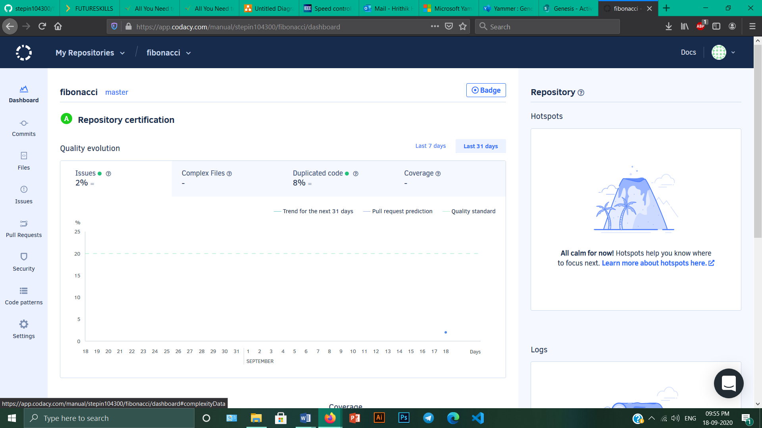

Link to the GitHub repository:

<https://github.com/stepin10400/fibonacci.git>

# References

1.

2.

3.