./

Learning Report –

Embedded C

Course Code: <CODE>



Genesis

|  |  |  |  |  |  |
| --- | --- | --- | --- | --- | --- |
| **Ver. Rel. No.** | **Release Date** | **Prepared. By** | **Reviewed By** | **To be Approved By** | **Remarks/Revision Details** |
| 1. | 30.09.20 | Hrithik Hiran |  |  | Linker scripts, Semi Hosting, SPI, Debugging Techniques |
|  |  |  |  |  |  |
|  |  |  |  |  |  |
|  |  |  |  |  |  |
|  |  |  |  |  |  |

**Document History**

# Activity-1: Linker Script

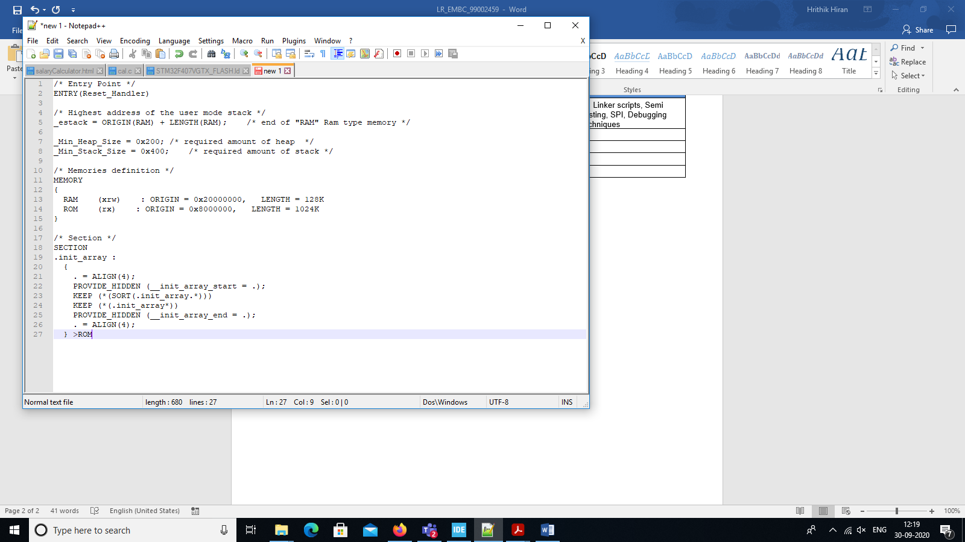

# Activity-2: Semi Hosting

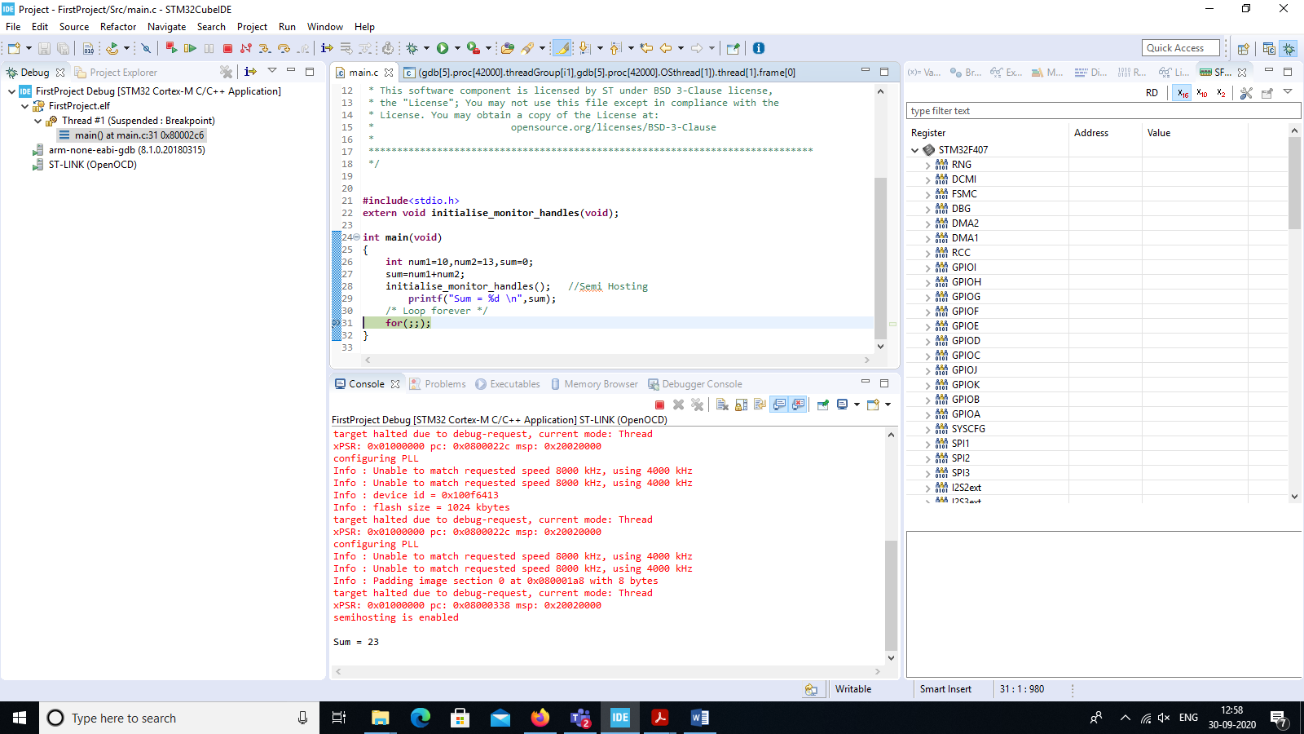

# Activity-3: SPI

