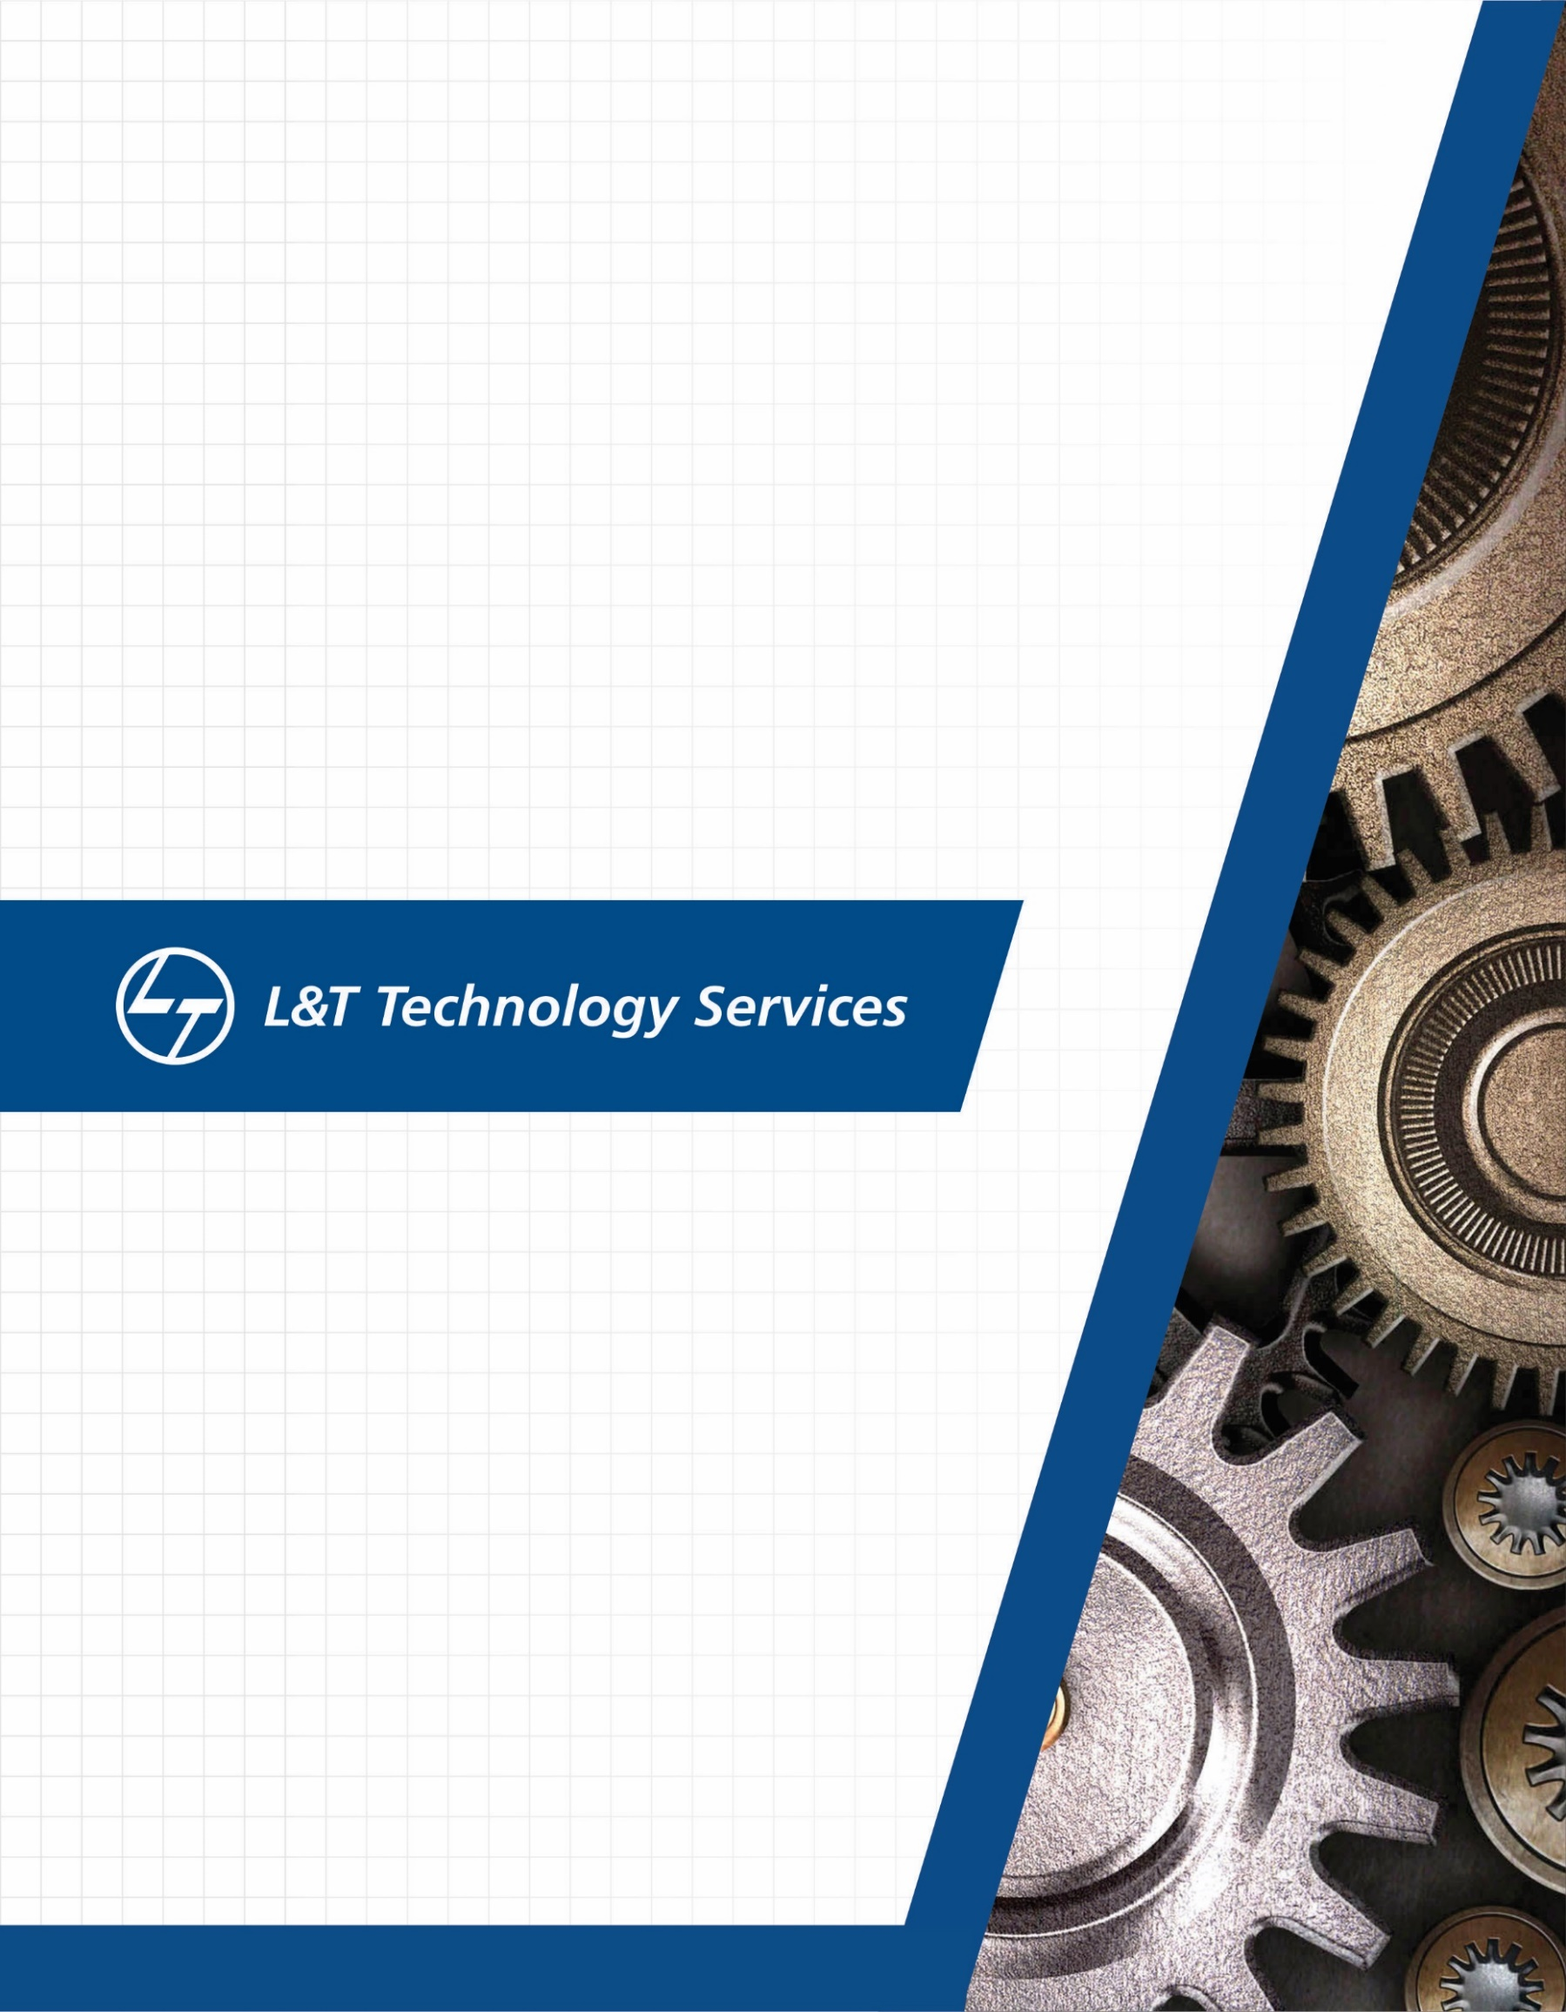

**VOICE ASSISTANCE TO DUMB PEOPLE BASED ON HAND GESTURES**



**CONTENTS**

|  |  |
| --- | --- |
| Introduction | 3 |
| **Activity 1:** Requirements   * Research * Ageing * Cost gradation * SWOT Analysis * Requirement Mapping | 3-5  3  3  3-4  4  5 |
| **1.2** Design | 7-9 |
| **1.3** Test Plan | 10 |
|  |  |
| **Activity 2:** Agile model Aspects | 11 |

**Voice Assistance to Dumb People based on Hand Gestures**

**Introduction**

The objective of this product is to build Voice Assistance to dumb people in multiple languages which makes easier for the common people who don’t know the particular language. The actions or the gestures made by dumb people are saved in the system. First, the language of communication is established between the dumb people and common people making it easier to communicate in the emergency or whenever the communication is required.

**Activity 1: Requirements – The System/ Software**

* **Research**

|  |  |
| --- | --- |
| Year | System Technology |
| 2014 | Sign to speech conversion |
| 2015 | Image processing using 2D Technology |
| 2016 | Image processing using 3D Technology |
| 2016 | Optical flow method |
| 2016 | Tangible glove interface |
| 2017 | Neural networks |
| 2018 | Convolutional neural networks |
| 2019 | Neural networks and machine learning |

* **Ageing**

1. In 2014, sign to speech the flex sensors were used.
2. In 2015, the system uses image processing which is a software.
3. In 2016, the system uses 3-D Image processing same as 2D image processing but more efficient.
4. In 2017 and later neural networks came into existence and different types of neural networks took over the technology

* **Cost Gradation**

1. In early 2000s the idea for this system was evolved which costed around 50 rupees.
2. In 2014 the system used sensors and voice output which made it cost around 500-1000.
3. In 2016, the cost of the system increased by 15-20% as the technology changed. System cost was around 2000-2005.

**SWOT ANALYSIS**

* **STRENGTH**

1. Efficient Sign to speech conversion.
2. Usage of sensors.
3. Evolution of technologies and performance of latest technology.

* **WEAKNESS**

1. Cost of neural network and other sensors for recognizing hand gestures.
2. Language communication constraints limited to only particular language.
3. Number of messages storage constraint.

* **OPPORTUNITIES**

1. To build a Multilingual System which won’t have an language constraint
2. To store or deliver as many as voice messages.
3. To make or utilize a processor more precisely.

* **THREATS**

1. Speed of processor converting sign to speech.
2. Accuracy of the sensors or neural networks.

**GENERAL REQUIREMENTS**

1. **HIGH LEVEL REQUIREMENTS**
2. Speed and accuracy of the processor should be good.
3. Accuracy and lifetime of sensor should be more.
4. Compact in nature and cost effectiveness.
5. Stability in different temperatures.
6. **LOW LEVEL REQUIREMENTS**
7. The processor needs to act as an ADC and a sign to speech interpreter.
8. The sensors should be able to measure the angle of hand gestures accurately.
9. The voice needs to be produced through speaker in different languages with the help of Google Translator.

**REQUIREMENTS FOR MY PRODUCT**

* The product requires a processor which has great speed and precision.
* It needs stabilized and accurate sensors.
* Neural networks technology.
* Amplified voice version output.

**REQUIREMENT MAPPING**

|  |  |  |
| --- | --- | --- |
| **Product ID** | **Product Name** | **Description** |
| H_01 | Processor | Processor needs to have more speed |
| H_02 | Sensor | Sensor should have high accuracy and precision |
| H_03 | System | System should be cost effective |
| L_01 | microcontroller as ADC | Processor should work as an Analog to digital converter |
| L_02 | Flex Sensor | Sensor should detect the gesture and produce a corresponding analog value to the processor |
| L_03 | Speaker | Speaker to produce voice output |

**1.2 DESIGN**

**HIGH LEVEL DESIGN**

* **BEHAVIOURAL UML DIAGRAM**

1. **USE CASE DIAGRAM**

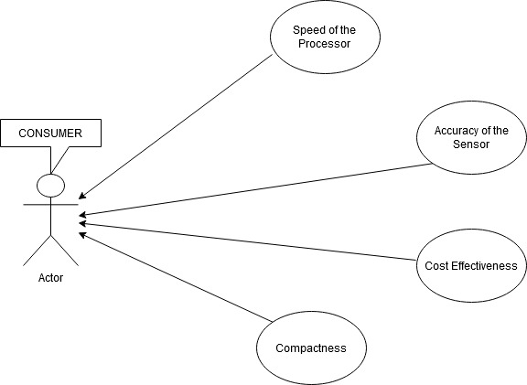

**STRUCTURAL DIAGRAM**

* 1. **Package Diagram**

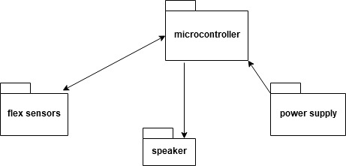

* 1. **Class Diagram**

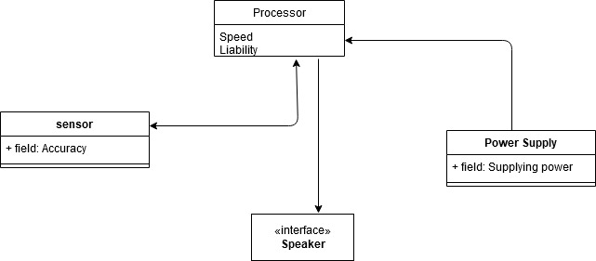

**LOW LEVEL DESIGN**

* **STRUCTURAL UML DIAGRAM**

1. **PACKAGE DIAGRAM**

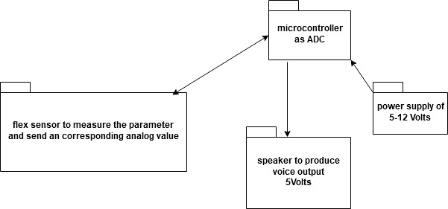

1. **CLASS DIAGRAM**

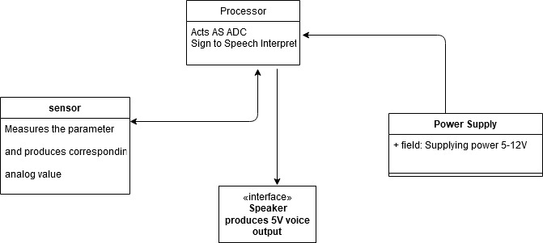

**BEHAVIOURAL DIAGRAM**

1. **USE CASE DIAGRAM**

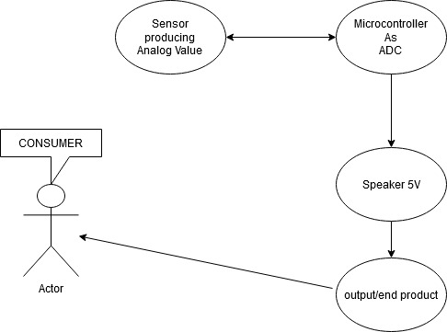

1. **ACTIVITY DIAGRAM**

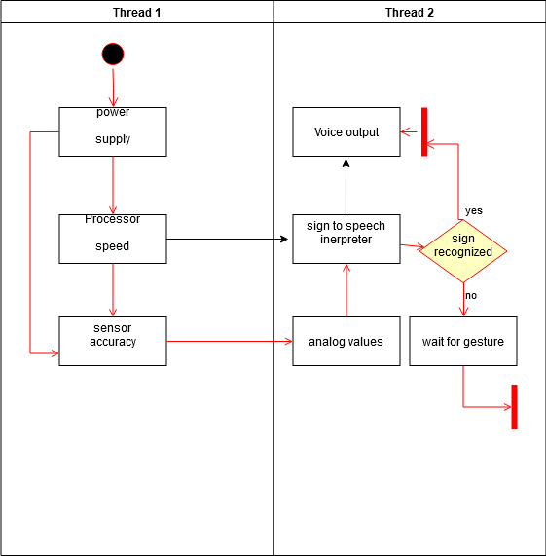

**1.3 TEST PLAN**

**TEST MAPPPING**

|  |  |  |  |  |  |
| --- | --- | --- | --- | --- | --- |
| **Product ID** | **Description** | **Pre-Condition** | **Expected Input** | **Expected Output** | **Actual Output** |
| H_01 | Processor needs to have more speed | Processor ON | Data | Display of data within nana seconds | Delay in display of data |
| H_02 | Sensor should have high accuracy and precision | Sensor is in ON-State | Hand Gesture | Gestured detected | Gestured detected |
| H_03 | System should be cost effective |  |  |  |  |
| H_01_L_01 | Processor should work as an Analog to digital converter | Processor is on and as data as input | Analog value | Digital Value | Digital value |
| H_02_L_02 | Sensor should detect the gesture and produce a corresponding analog value to the processor | Sensor is on and gesture detected | gesture | Analog value | Analog value |
| L_03 | Speaker to produce voice output | ON state | signal | Voice output | Voice output |

**SCENARIO TESTING PLAN**

1. When the hands are shivering and unable to make proper gesture.
2. When the gesture angle is not met.
3. What if a person knows that particular language?

**BOUNDARY TESTING PLAN**

1. During temperature changes operating voltage of system varies or not.
2. Will he sensor work with hand sweat what is the effect of sweat on the sensor.

**REQUIREMENTS BASED TESTING**

1. When person is unable to speak the requirement comes into picture.
2. When a person is unable to communicate.
3. When he doesn’t know any particular language.

**Activity 3: Agile Model Aspects**

***User stories***

* What is a user story?

The user story describes the type of user, what they want and why, a user story helps to create a simplified description of a requirement.

**User Story of My product**

**Story 1**

As a processor handler

I want a make sure whether my processor operates at all standard conditions. The processor need to be made to work as an Analog to digital convertor taking an input from a sensor converting the value to digital. It needs to perform as a sign to speech interpreter and produce he output signal to the speaker.

So that my main and important component of my product will be ready

Expected completion time of this story – **5 Days**

**Story 2**

As a sensor department manager

I want to make sure whether all my sensors are in healthy condition and it produces an expected value for the various parameters. It should also take the input from the gesture and produces an output as an analog value.

So that sensors won’t create a problem to the system development

Expected completion time of this story – **3 Days**

**Story 3**

As an Entire System Manager

I want to make sure whether all the departments are doing their jobs properly and encounter the issues faced by them. I need to integrate and co-ordinate with all my departments.

So that my system or an end product is ready and efficient.

Expected completion time – **1 Week**

**Activity 3: Task CI**

**Project name: - Smart Calculator**

**Description: -** The smart calculator is different from the normal calculator it has inbuilt arithmetic as well as math functions. It also tells u the area perimeter of different shapes based on your input

**Requirement Analysis**

* **High Level Requirements**
  + Any calculator needs to have the highest speed and accuracy.
  + The system should be multifunctional.
  + The System should be user friendly and compact.
  + The smart calculator’s battery lifetime should be more.
  + The precision value should be high.
* **Low Level Requirements**
* The speed of the calculator, it should give output within picoseconds.
* The system functions need to be specified and work properly.
* The precision of the calculator should be 10 power -15.
* The functions taking take input and process the output within nanoseconds.

**Requirement Mapping**

|  |  |
| --- | --- |
| **Product ID** | **Description** |
| H_01 | Speed and accuracy should be more |
| H_02 | The processor should be multifunctional |
| H_03 | System should be compact |
| H_04 | Battery lifetime should be more |
| H_05 | Precision should be high |
| H_01_L_01 | Speed should be in picoseconds |
| H_02_L_02 | The functions should be selected and should produce correct output. |
| H-03_L_03 | Precision value should be 10power -15 |
| L_04 | Process time should be less than nanoseconds |

**DESIGN**

**UML Diagrams**

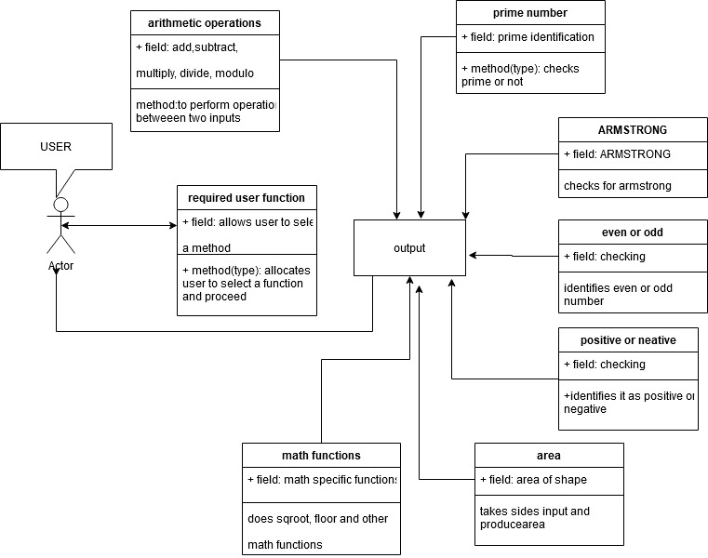

**TEST PLAN**

|  |  |  |  |  |  |
| --- | --- | --- | --- | --- | --- |
| **Product ID** | **Description** | **Pre-condition** | **Expected**  **Input** | **Expected**  **output** | **Actual**  **output** |
| H_01 | Speed and accuracy should be more | ON state | User data | In nanoseconds | In seconds |
| H_02 | The processor should be multifunctional | Functional | Different data | Produce corresponding output | Met the expected output |
| H_04 | Battery lifetime should be more | ON state | Power | 2years lifetime | 1 year lifetime |
| H_05 | Precision should be high | User data is fed | data | 10power -15 | Met the expected output |
| L_01 | Square root function | Function call has been made | User inputs  (16) | Square root of user input number (4) | Same as expected output  (4) |
| L_02 | Area of different shapes function | System in ON state and function selected | User inputs of specified shape sides | Area of specified shape | Same as expected output but delay in time |
| L_03 | Prime function | Prime function selected | User number (8) input | Is not a prime number | Is not a prime number |
| L_04 | Even or odd function | Even or odd function selected | User input (2) | Is an even number | Is an even number |
| L_05 | Arithmetic functions | Select any arithmetic functions | Add  2 and 3 | 5 | 5 |

Test Mapping

**GIT**

* Created an account with the PS number
* Added a repository.

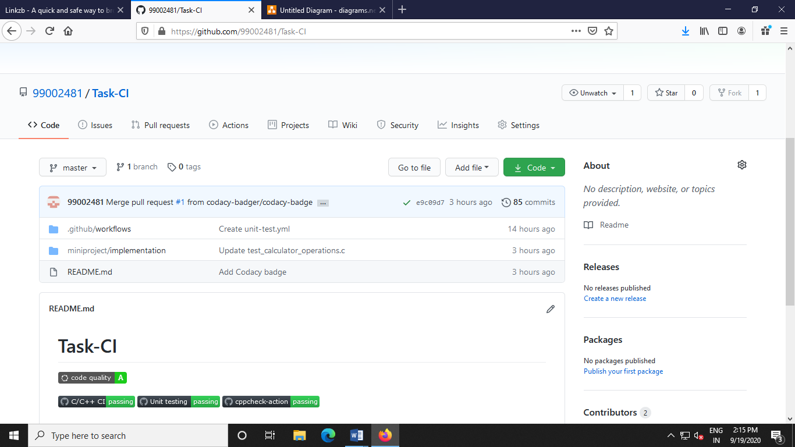

Fig: Snapshot of my repository and badges

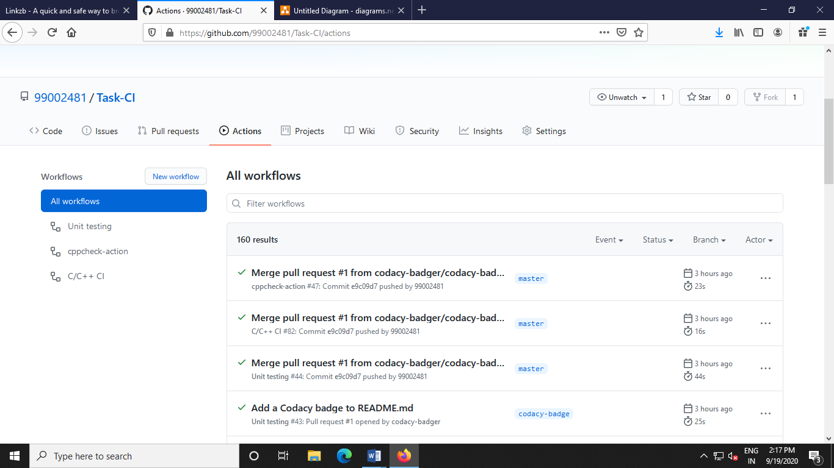

Fig: snapshot of my CI workflows

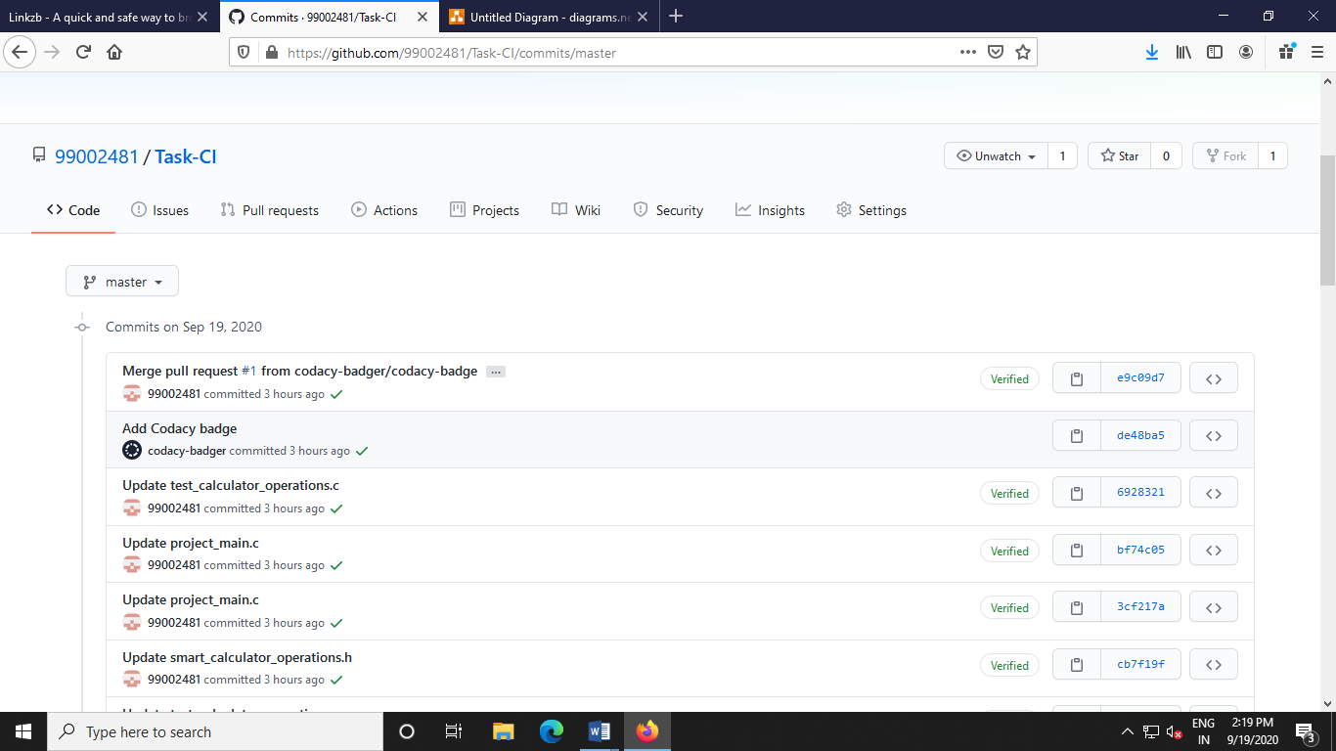

Fig: Snapshot of my commits

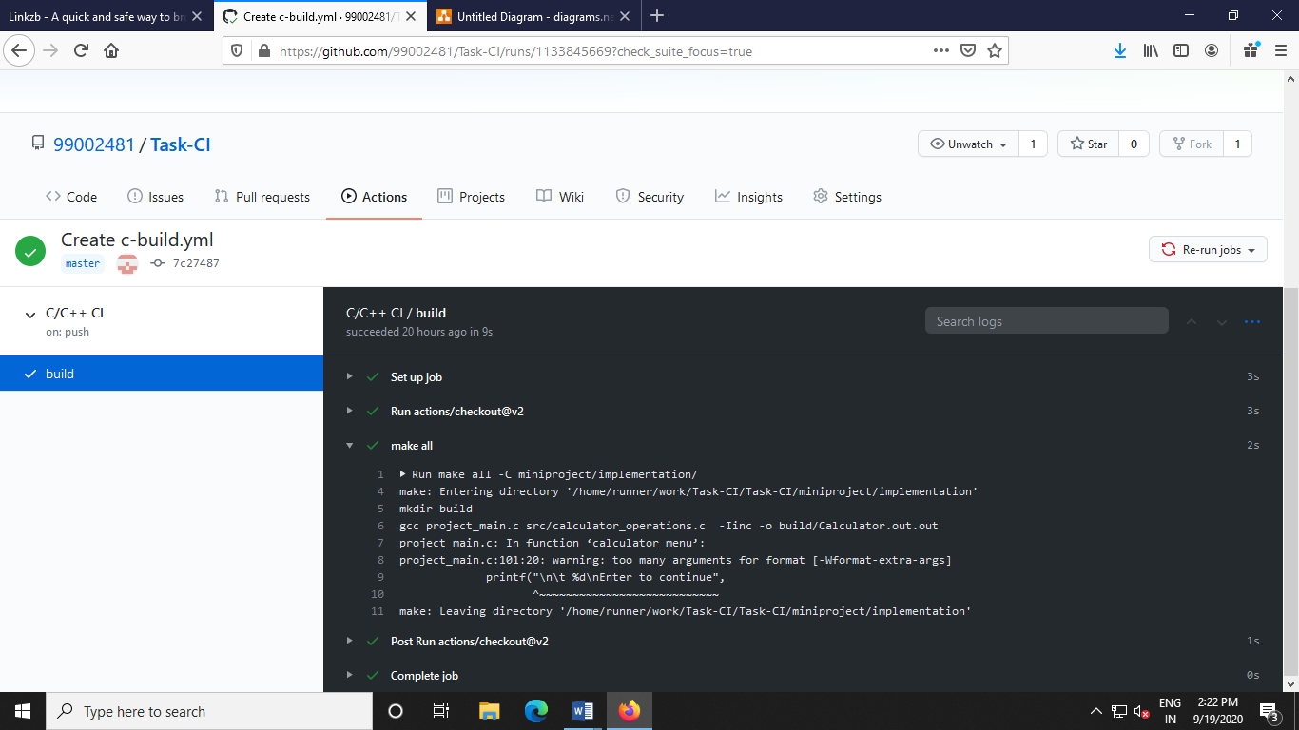

Fig: snapshot Build and make all

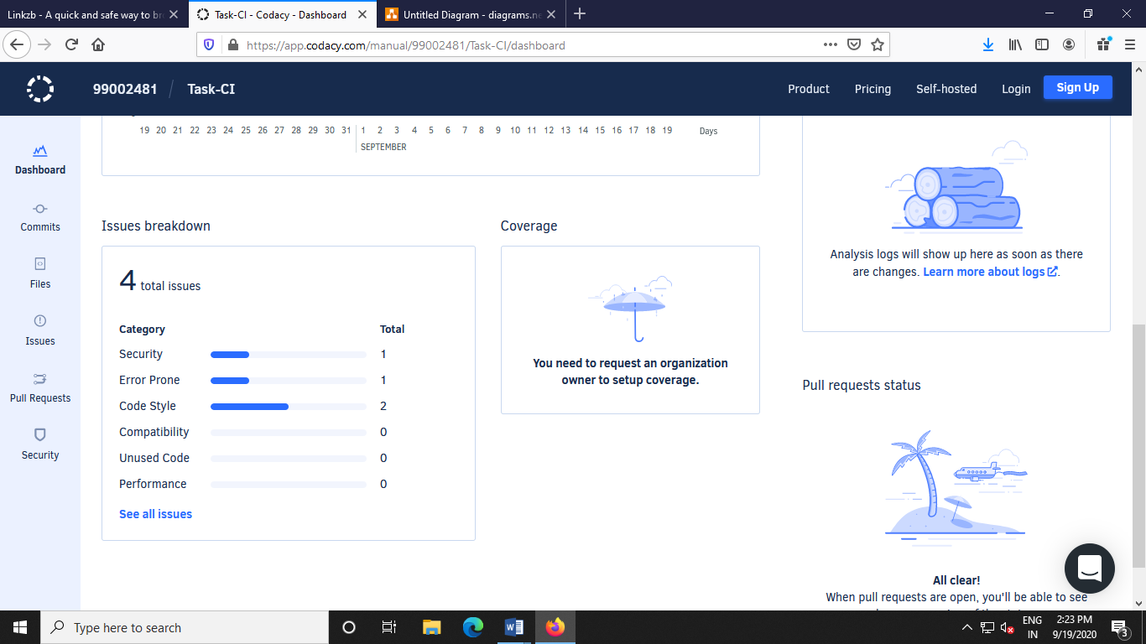

Fig: snapshot of codacy

**https://github.com/99002481/Task-CI**

**Appendix**