# LENGTH AND WEIGHT CONVERTOR

## Design

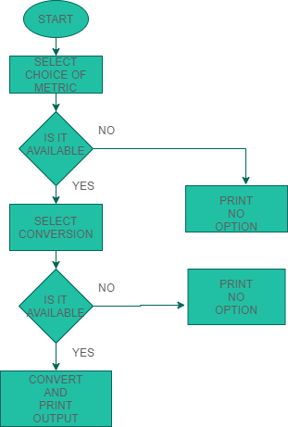

**Figure 1 Length and Weight Convertor**