./

GENESIS - Learning Outcome & Mini-project Summary Report



**Details**

|  |  |  |  |  |  |
| --- | --- | --- | --- | --- | --- |
| **Ver. Rel. No.** | **Release Date** | **Prepared. By** | **Reviewed By** | **Approved By** | **Remarks/Revision Details** |
| 1 | 11/8/2020 | Pavan S L |  |  | Design Implementation. |
|  |  |  |  |  |  |
|  |  |  |  |  |  |
|  |  |  |  |  |  |
|  |  |  |  |  |  |
|  |  |  |  |  |  |

Contents

Design: 4

Structural diagram: 4

Behavioral: 5

Table of Figures:

Figure 1:Structural class diagram 4

Figure 2:Behavioral flowchart 5

# Design:

## Structural diagram:

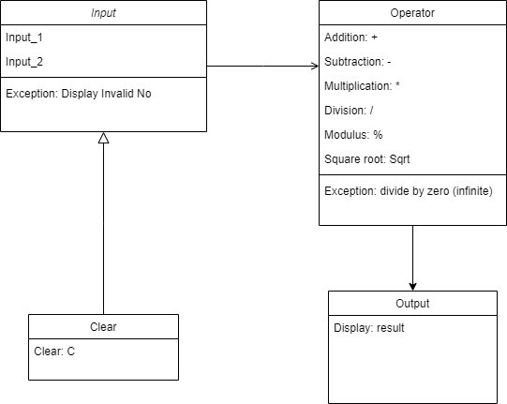

Figure 1:Structural class diagram

## Behavioral:

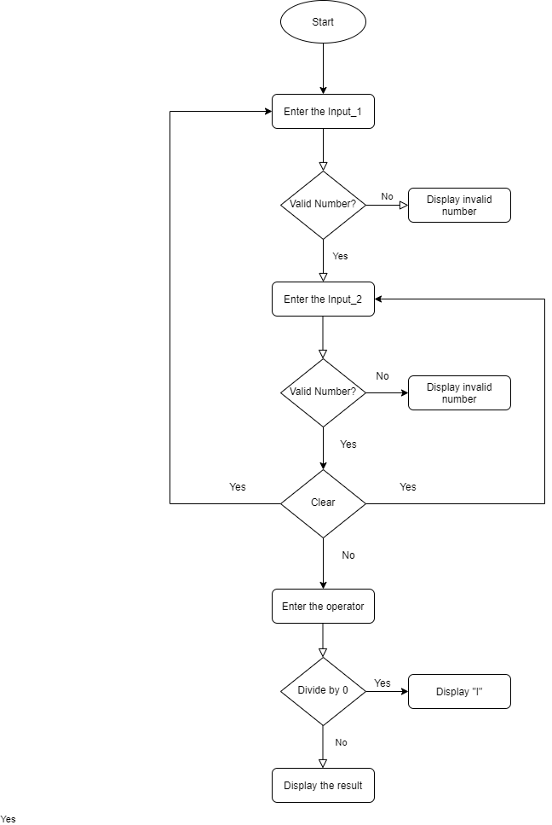

Figure 2:Behavioral flowchart