# **Requirements**

|  |  |
| --- | --- |
| **Id** | **Requirements** |
| 1. | A customer must be able to make a cash withdrawl from any suitable account linked to the card. Approval must be obtained from the bank before cash is dispensed. |
| 2. | A customer must be able to make a transfer of money between any two accounts linked to the card. |
| 3. | A customer must be able to make a balance inquiry of any account linked to the card. |
| 4. | The login time and logout time along with the user’s pin no and account number is registered in the bank’s database. |
| 5. | The login time and logout time along with the user’s pin no and account number is registered in the bank’s database. |
| 6. | Various changes in the user’s account after the transactions, if any, are reported in the database. |
| 7. | If it is a valid cash card and a valid password but there are problems with the account the bank will send a message to the ATM that there are problem. |
| 8. | Each bank has a limit k for each account about the amount of money that is available via cash card each day. |

Refigerator

1. Requirements

* L**ook for the energy star.**
* **Consider a Refrigerator with a Top-Mounted Freezer.**
* **Less power consumption .**
* **More space for items in compact size.**
* **Advance options.**

1. Ageing

**Past :-** Food preservation has been an issue people have dealt with for all of time. From the moment begins to harvest, it starts to break down, therefore some kind of refrigeration is necessary in order to slow down this chemical process. Before refrigerators, people used ice, snow and underground storage to provide lower temperatures to their food. The first widely used refrigeration system was introduced by General Electric in 1927. The low temperature of the refrigerator slows the growth of microorganisms already in the food. Perishable food will go bad over time, even in lower temperatures because of microorganisms, enzymes, and oxidation.

**Present:-** The kitchen that we all know today is both a functional and technical space as well as a social gathering space in the home. Weekly grocery shopping trips are part of the normal routine for most. Certain foods – such as milk, meat and leftovers – need to be kept colder to extend their shelf life..The potential wasted items have become more in the spotlight as people’s environmental awareness has grown and the understanding of composting and importance of recycling are on the forefront of people’s minds. In the kitchen especially, people want efficiency and insight into their pantry stock. New technologies, such as smart fridges and touch-activated faucets, have begun to make less waste more possible.

**Future:-** The future kitchen will not only provide insight into wasted foods but promotes healthy nutrition. This is done by technologies, such as the Siemens’ New Camera Fridge. This system incorporates two cameras that take pictures of the fridge’s contents – one when door opens and the second when door closes – and then send images to your phone. When you are at the grocery store and realize you left your grocery list at home, you can access the app and see what is running low or missing (or moldy) and easily remember what you need to buy. This app will also share recipes for healthy options based on your current items and provide items you will need to pick up.

1. Costing

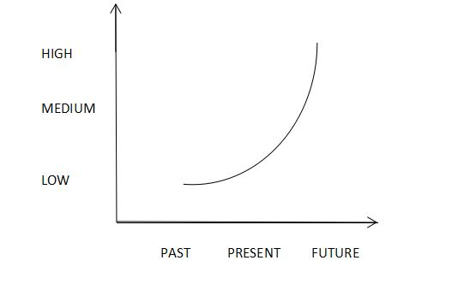

1. SWOT Analysis

|  |  |
| --- | --- |
| STRENGTHSBRAND EQUITY  * FINANCIAL STRENGH   MANUFACTURING FLEXIBILITY and CONTRACT CHANNEL LEADER   * HIGH PRODUCT RATINGS BY CONSUMER REPORTS * STRONGEST BRAND PORTFOLIO | WEAKNESS   * LOWER PRODUCT RATINGS FROM CONSUMER REPORTS * Expensive products * OLD PRODUCT PLATFORM |
| OPPORTUNITIES  * E COMMERCE MARKETING. * Emerging markets. * IMPROVED GLOBAL LEVERAGE | **THREATS**   * Heavy competition. * Volatile market. |

1. High level requirements

* Power.
* Cooling effect.

1. Low level requirements

* Spaces for items.
* Fast cooling.
* Voltage.
* Temperature.

1. Design

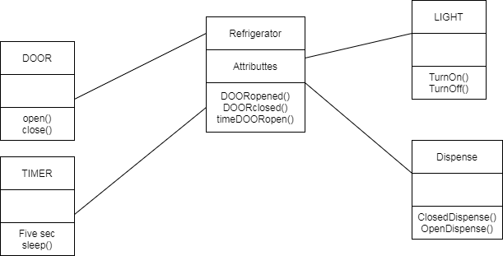

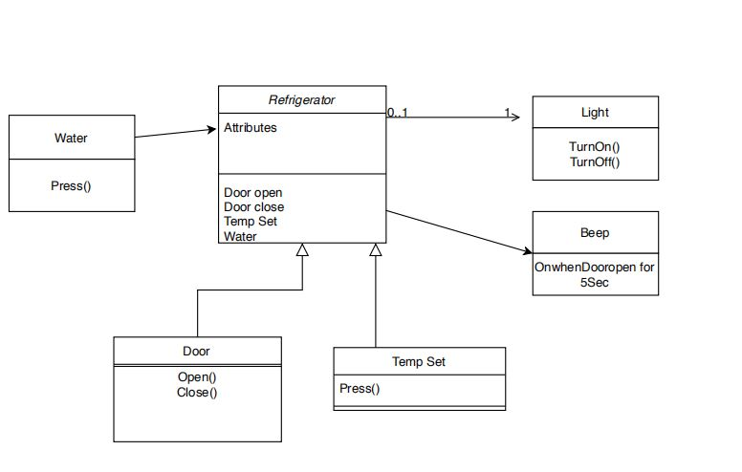

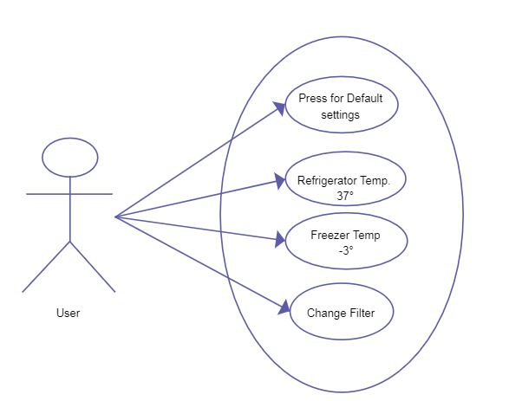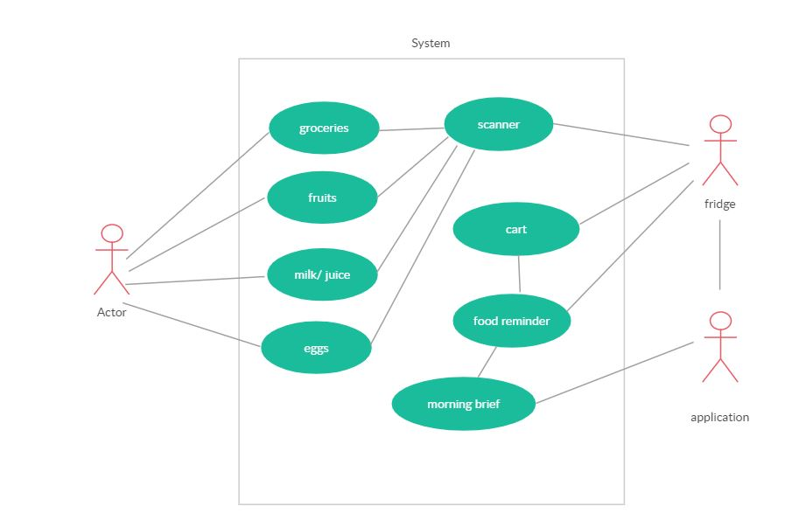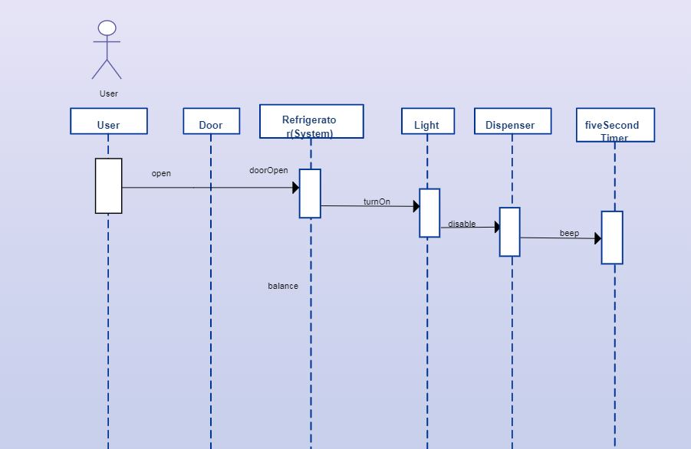

Refrences

1. <https://kitchenofthefuture.wordpress.com/>