## **Design:**

This work was centred on design and implementation of simple scientific calculator. This work mainly focused principally on numbers and arithmetic operation. Interestingly, the end result of simple calculator

System was its ability to process number and operators and provides a useful result.

### High level design:

Activity Diagram:

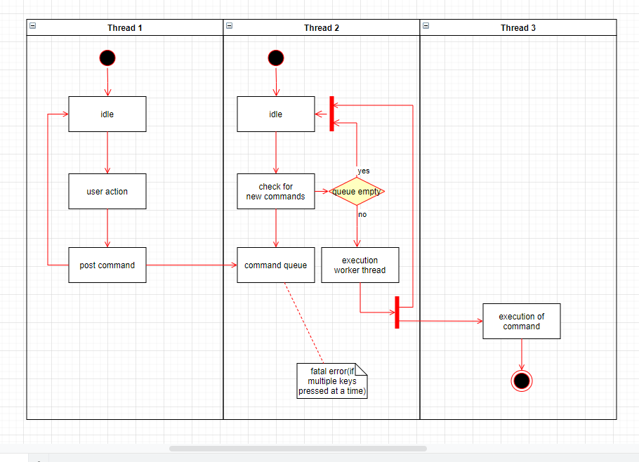

Class Diagram:

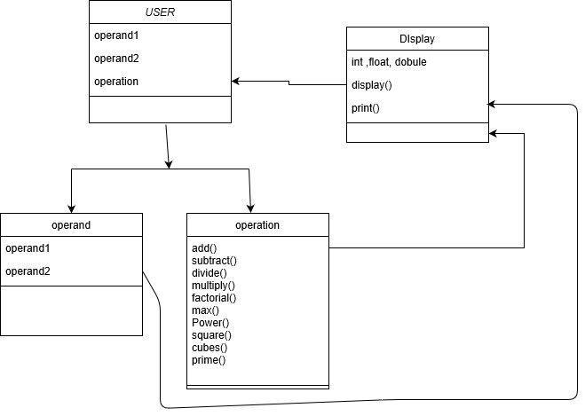

### Low level design:

Sequence Diagram:

