**Design: UML diagrams**

## **Structural diagram:**

**1. Class diagram**

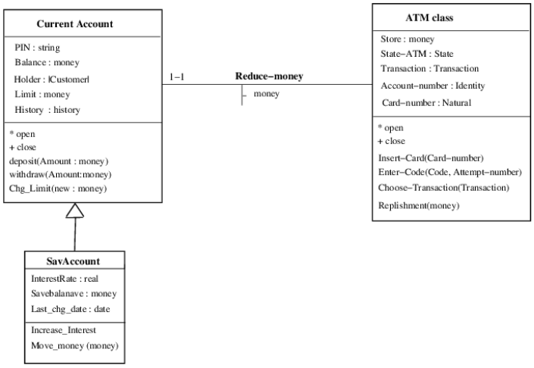

Figure 1: class diagram

2. Component diagram

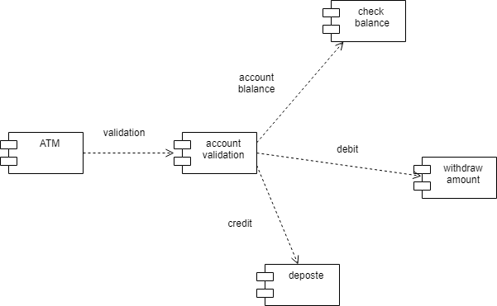

Figure 2:component diagram

## **Behavioral diagram**

1.Usecase diagram:

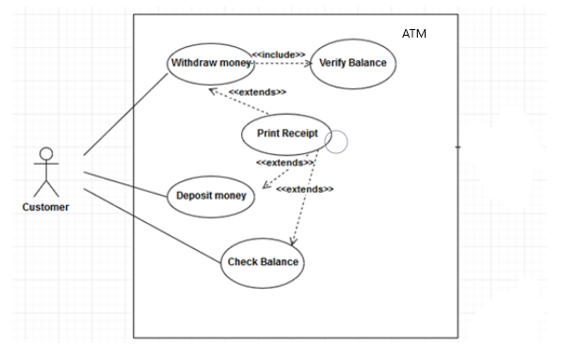

Figure 3: use case diagram

2. Activity Diagram

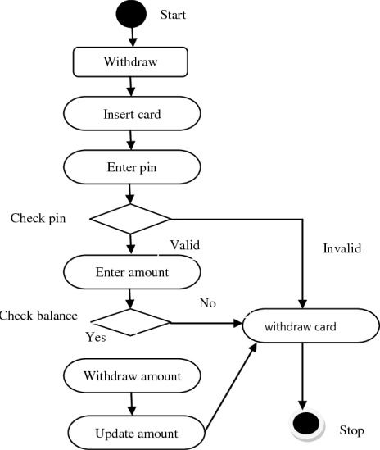

Figure 4:Activity diagram

3. Sequence diagram:

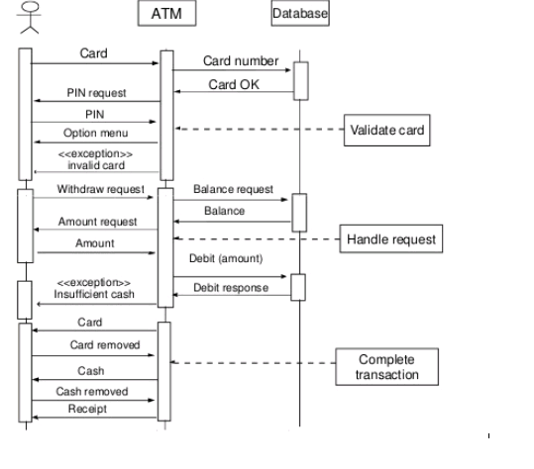

Figure 5:Sequence diagram