Name: Sreelakshmi Orakkan

PS No.:99002581

**CALCULATOR**

|  |  |  |
| --- | --- | --- |
| SL No. | Description | Page No. |
| 1. | Requirements | 1 |
| 2. | UML diagrams | 2 |
| 3. | Test Plans | 3 |
| 4. | CI | 4 |
| 5. | References | 4 |

1. Requirements

|  |  |
| --- | --- |
| ID | Description |
| C01 | Take two digits |
| C02 | Select the operation |
| C03 | Add the digits |
| C04 | Subtract the digits |
| C05 | Multiply the digits |
| C06 | Divide the digits |
| C07 | Find modulus of the digits |
| C08 | Find the power of a digit |
| C09 | Find the factorial of a digit |
| C10 | Get the correct output |
| C11 | Display the output |

2. UML Diagrams

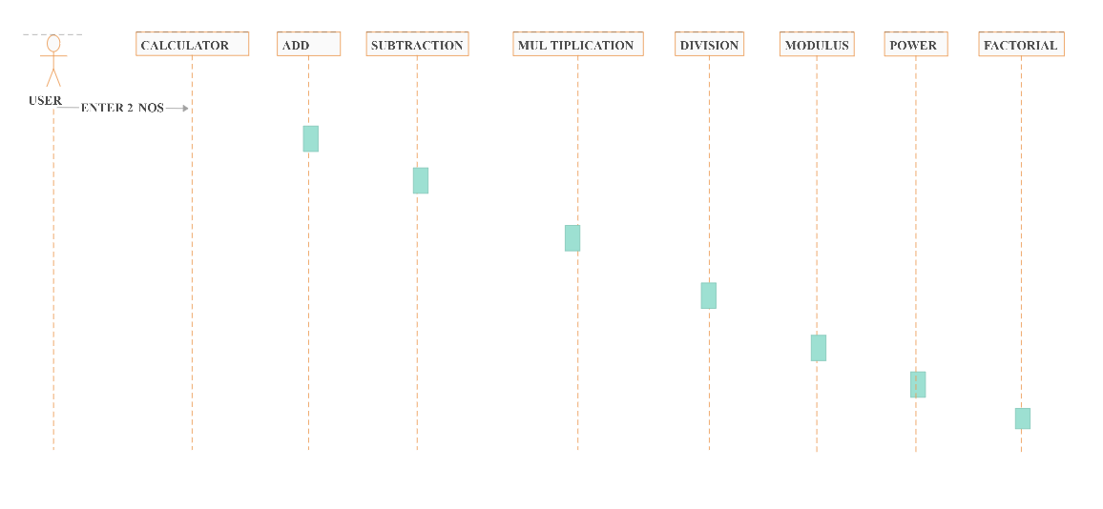

Figure 1. Sequential Diagram

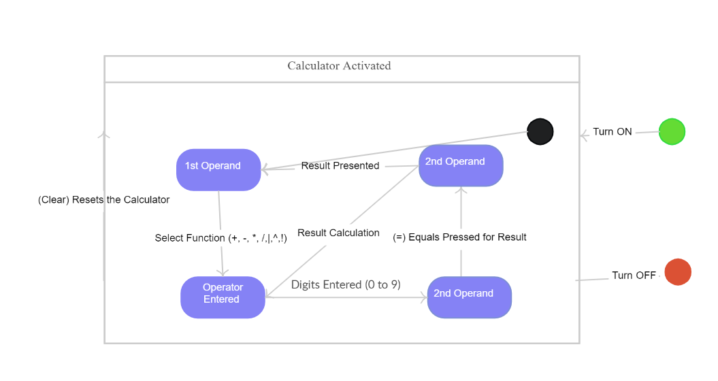

Figure 2. State machine Diagram

3. Test Plan

|  |  |  |  |  |  |
| --- | --- | --- | --- | --- | --- |
| ID | Description | Pre-condition | Expected input | Expected output | Actual output |
| CT01 | Check if two digits are given as input to the calculator | Switch on Calculator | Two digits | Digit1 and Digit2 should get input | Digit1 and Digit2 gets input |
| CT02 | Check the digits gets the correct output for addition | Switch on Calculator | Two digits and the addition operator | Digit1 and Digit2 should add and give the correct answer | Digit1 and Digit2 gives the correct answer |
| CT03 | Check the digits gets the correct output for subtraction | Switch on Calculator | Two digits and the subtraction operator | Digit1 and Digit2 subtract add and give the correct answer | Digit1 and Digit2 gives the correct answer |
| CT04 | Check the digits gets the correct output for multiplication | Switch on Calculator | Two digits and the multiplication operator | Digit1 and Digit2 should multiply and give the correct answer | Digit1 and Digit2 gives the correct answer |
| CT05 | Check the digits gets the correct output for division | Switch on Calculator | Two digits and the division operator | Digit1 and Digit2 should divide and give the correct answer | Digit1 and Digit2 gives the correct answer |
| CT06 | Check the digits gets the correct output for modulus | Switch on Calculator | Two digits and the modulus operator | Digit1 and Digit2 should find modulus and give the correct answer | Digit1 and Digit2 gives the correct answer |
| CT07 | Check the power of a digit gives the output | Switch on Calculator | Digit and power | The power of a digit should give the correct answer | The power of a digit gives the correct answer |
| CT08 | Check the factorial of a digit is correct | Switch on Calculator | Digit | The factorial of the digit should give the correct answer | The factorial of a digit gives the correct answer |
| CT09 | Check the addition of two long integers | Switch on Calculator | Two digits and the addition operator | The long integers entered should give the sum of the numbers | The output gives a wrong answer since the calculator takes in only 16bit value |
| CT10 | Check the difference of two long integers | Switch on Calculator | Two digits and the subtraction operator | The long integers entered should give the difference of the numbers | The output gives a wrong answer since the calculator takes in only 16bit value |
| CT11 | Check the product of two long integers | Switch on Calculator | Two digits and the multiplication operator | The long integers entered should give the product of the numbers | The output gives a wrong answer since the calculator takes in only 16bit value |
| CT12 | Check a digit divided by 0 | Switch on Calculator | Input a digit and 0 | When a digit is divided by zero it should display invalid | The output doesn’t generate. |
| CT13 | Check the factorial of a negative number | Switch on Calculator | Input a digit to find factorial | When the factorial is negative it should display “Factorial cannot be found” | The output doesn’t generate |

4. CI

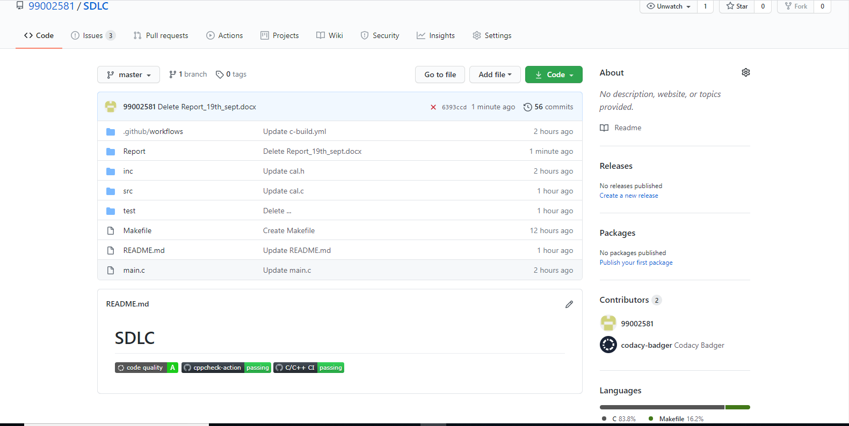

<https://github.com/99002581/SDLC>

5. References

1. <https://creately.com/diagram/example/ilmhym1b3/CALCULATOR%20SEQUENCE%20DIAGRAM>
2. <https://fresh2refresh.com/c-programming/c-programs/c-code-for-calculator-application/>