# DESIGN:

## **Behavioral Diagrams:**

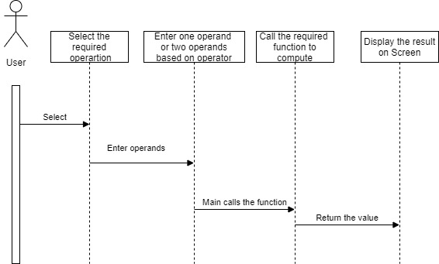

Figure 1 Sequence diagram of User interaction with calculator

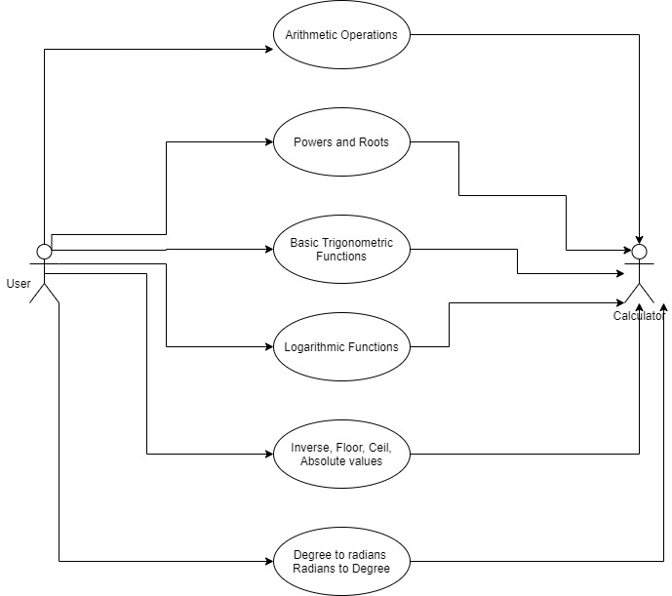

Figure 2 Use case diagram of Calculator

## 

## **Structural Diagrams**

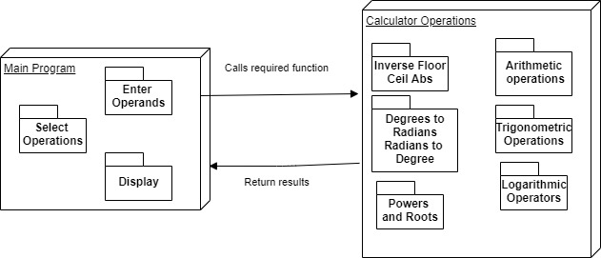

Figure 3 Deployment diagram of Calculator

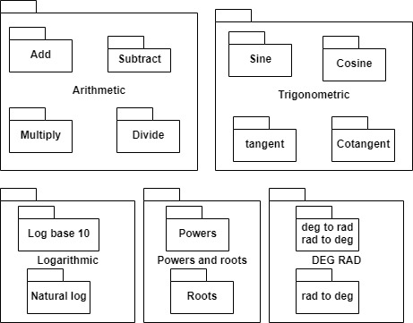

Figure 4 Package diagram