## **Design:**

**Flowchart**

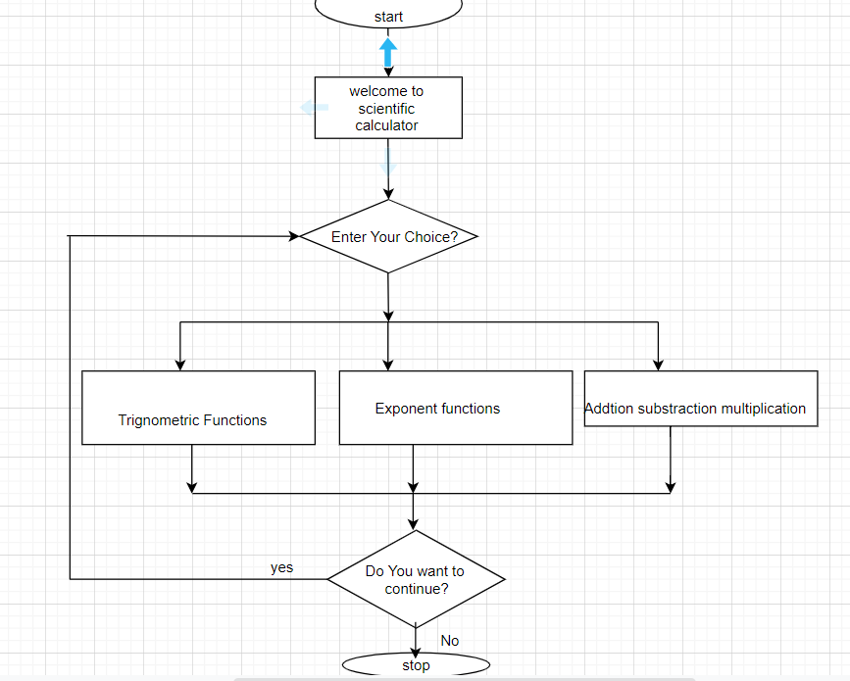

**Fig5: flowchart diagram for scientific calculator**

**Use case diagram**

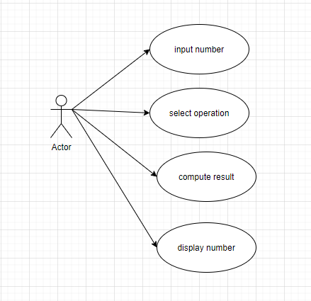

FIG6: usecasediagram for scientific calculator

**CLASS DIAGRAM FOR SCIENTIFIC CALCULATOR**

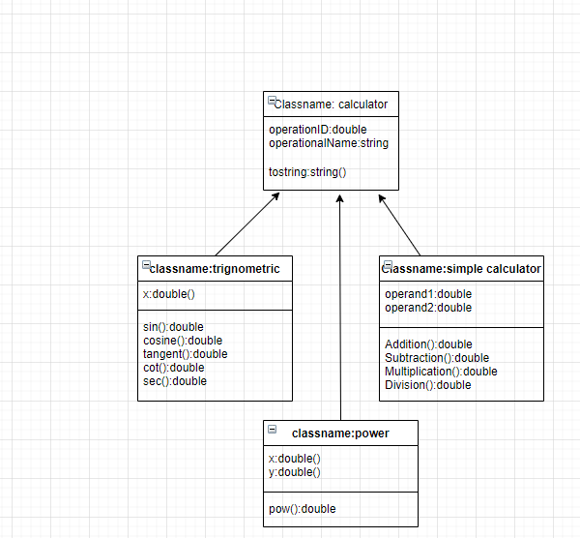

Fig7:classdiagram for simple scientific calculator