Multilevel Inverter

Contents

Research: 1

Ageing: 2

Requirements: 2

High level Requirements: 2

Low level requirements: 2

SWOT Analysis: 2

UML diagrams: 3

Structural diagram 3

Behavioural Diagram 3

Structural diagram 4

Behavioural diagram 5

Test plan: 5

Requirements based: 5

Scenario based: 5

Boundary conditions: 5

Requirements table: 6

High level: 6

Low level 6

Test planning: 7

User stories: 7

GIT Activities: 7

Theme: 9

Requirements: 9

Test Planning: 9

UML Diagram: 11

GIT activities: 11

Issues raised and solved: 12

# 

# Research:

Multilevel inverters (MLI) have played a significant role in high power converter applications. In power electronic applications, multilevel inverters are getting well known and popular, having a good capacity to fulfil the demand of higher power rating and power quality. There are three main types of multi-level inverters: diode-clamped (neutral-point clamped), capacitor-clamped (flying capacitors) and cascaded H-bridge inverters.

Diodes are used in diode-clamped topology, and provide multiple voltage levels to the series-connected capacitor bank arrangement through the different stages. Hence, the stress on the other loads is reduced by the diode that transfers a restricted amount of

voltage. So, the maximum output voltage becomes half of the input DC voltage. This is the main drawback of the diode clamped multilevel inverter.

In capacitor-clamped multi inverter series connected capacitor clamped switches are used. Like the diodes, the capacitors also transfer the limited amount of voltage to electrical loads. In this inverter, switching states are similar as in the diode clamped inverter topology, hence in this topology also the output becomes half of the input DC voltage. This is a drawback of the flying capacitors multi-level inverter as well. In the cascaded h-bridge multilevel inverter as the number of levels of outputs increases, the complexity of the circuit increases so as to increase the number of gate pulses to generate. This is one of the drawback of cascaded h-bridge multilevel inverter.

# Ageing:

2000’s: The multilevel inverter was executed with only two levels of output

2010’s: The multilevel inverter was carried by cascaded multilevel inverter

2015’s: The multilevel inverter was carried by diode and capacitor clamped multilevel inverter

2020’s: The multilevel inverter is being carried out by reducing the elements

# Requirements:

## High level Requirements:

* MOSFET’s
* Arduino IDE
* DC Power sources

## Low level requirements:

* CRO
* Capacitors
* PCB

# SWOT Analysis:

# UML diagrams:

## Structural diagram

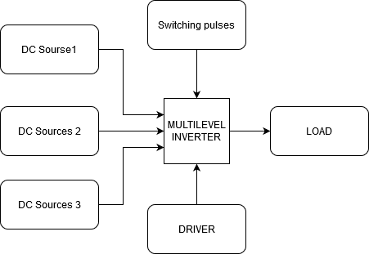

## Behavioural Diagram

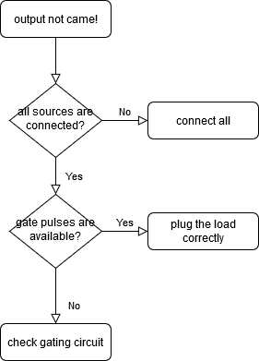

## Structural diagram

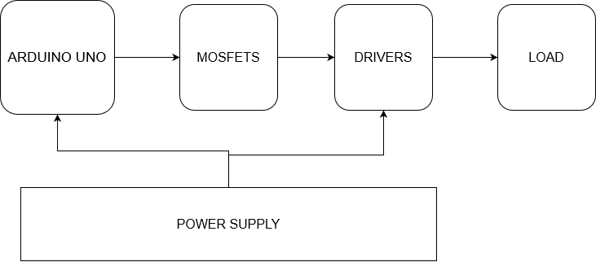

## Behavioural diagram

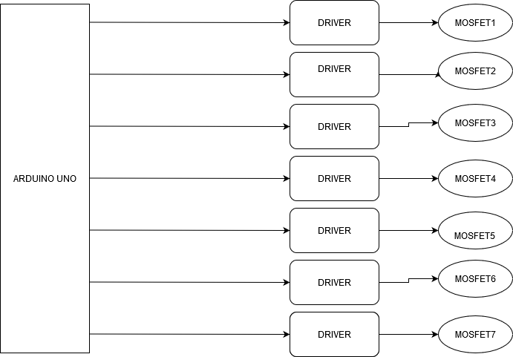

# Test plan:

## Requirements based:

* What is the output voltage If input voltages are at the exact values?
* What is the output voltage when my load is half of full load?

## Scenario based:

* If any one of the source is inactive
* If any two of the sources are inactive
* If all the three sources are inactive
* If the overloading happens
* What if driver fails
* What if gate pulses are not coming
* What if MOOSFET’s burns
* What if load is disconnected

## Boundary conditions:

* If system input voltages all are zero, what’s the output voltage?
* If input voltages all are greater than their values, what’s the output voltage

# Requirements table:

## High level:

|  |  |
| --- | --- |
| ID | Description |
| HL_01 | Constant input voltages of 4v,8v,12v |
| HL_02 | Constant gating pulses for the switches |
| HL_03 | Constant supply voltage for the Arduino-UNO board (between 7 to 12) |

|  |  |
| --- | --- |
| ID | Description |
| LL_01 | All hardware connections should be connected correctly |
| LL_02 | Code to generate gating pulses |
| LL_03 | Specific MOSFET’s for operation |

## Low level

|  |  |  |  |  |  |
| --- | --- | --- | --- | --- | --- |
| ID | Description | Precondition | Expected input | Expected output | Actual output |
| HL_01 | Constant input voltages of 4v,8v,12v | All the batteries or power sources should be charged or in good condition | The batteries should be charged | The output from batteries should be 4,8,16v | The output were 4,7.6,15v |
| HL_02 | Constant gating pulses for the switches | Arduino should be in working condition and code should be written | Coding should be done well | Should produce an well suited waveform of gating pulses | Gating pulses were generated |
| HL_03 | Constant supply voltage for the Arduino-UNO board (between 7 to 12) | There should be an AC source of 230v, from this we can give it to an Arduino cable that converts it to required input voltage | AC input of 230v | Output of 7v-12v DC | The input for Arduino was in the range of 7v-12v |
| LL_01 | All hardware connections should be connected correctly | All components must be organised well | - | - | - |
| LL_02 | Code to generate gating pulses | Requires software tool | Coding | Expected waveforms of gating pulses | Expected gating pulses were generated |
| LL_03 | Specific MOSFET’s for operation | Should be available in the market | Contacting to the shopkeeper | - | - |

# Test planning:

## User stories:

* All the batteries should be charged fully so that to provide an output voltage of 4v,8v,16v for the input of the system. If power sources are used, then make sure that the output voltages of those are adjusted to give the referred voltages as 4,8,16v.
* Arduino should be connected to the power source of 7-12v and also make sure that the gating pulses are available as per the design.

# GIT Activities:







GIT link: <https://github.com/vishwadasar3/calci>

Theme: Developing code for array operations

# Requirements:

|  |  |
| --- | --- |
| ID | Description |
| HL_01, LL01 | Needs to sort the elements in array passed by the test case standard input values |
| HL_02, LL02 | Need to find the minimum and maximum number that are present in the array |
| HL_03, LL03 | Needs to find the element in the array that need to be find out |
| HL_04, LL04 | Needs to arrange the elements in descending order from the given standard array |
| HL_05, LL05 | Needs to insert the element specified at an specified location of the index of the array |

# Test Planning:

|  |  |  |  |  |  |
| --- | --- | --- | --- | --- | --- |
| ID | Description | Precondition | Expected input | Expected output | Actual output |
| HL_01 | Needs to sort the elements in array passed by the test case standard input values | Neds to provide the standard array elements to sort | 1 2 3 4 5 | 1 2 3 4 5 | 1 2 3 4 5 |
| HL_01 | Needs to sort the elements in array passed by the test case standard input values | Neds to provide the standard array elements to sort | 2 5 8 10 | 2 5 8 10 | 2 5 8 10 |
| HL_02 | Need to find the minimum and maximum number that are present in the array | Need to provide the array filled with elements to search min & max. | 1 3 2 10 | 1 10 | 1 10 |
| HL_02 | Need to find the minimum and maximum number that are present in the array | Need to provide the array filled with elements to search min & max. | 0 2 4 5 | 0 5 | 0 5 |
| HL_03 | Needs to find the element in the array that need to be find out | Need to provide the array filled with elements to search an element | (1 2 3 4 5 6),(5) | 5 | 5 |
| HL_03 | Needs to find the element in the array that need to be find out | Need to provide the array filled with elements to search an element | (1 2 3 4 5 6),(5) | 5 | 5 |
| HL_04 | Needs to arrange the elements in descending order from the given standard array | Need to provide the array filled with elements to sort | 1 2 3 4 5 6 | 6 5 4 3 2 1 | 6 5 4 3 2 1 |
| HL_04 | Needs to arrange the elements in descending order from the given standard array | Need to provide the array filled with elements to sort | 7 8 6 9 | 9 8 7 6 | 9 8 7 6 |
| HL_05 | Needs to insert the element specified at an specified location of the index of the array | Need to provide the array, index, element to place in the array | (1 2 3 4 5 6),(2),(15) | 1 15 2 3 4 5 6 | 1 15 2 3 4 5 6 |
| HL_05 | Needs to insert the element specified at an specified location of the index of the array | Need to provide the array, index, element to place in the array | (4 2 1 6 9),(4),(0) | 4 2 1 0 6 9 | 4 2 1 0 6 9 |

# UML Diagram:

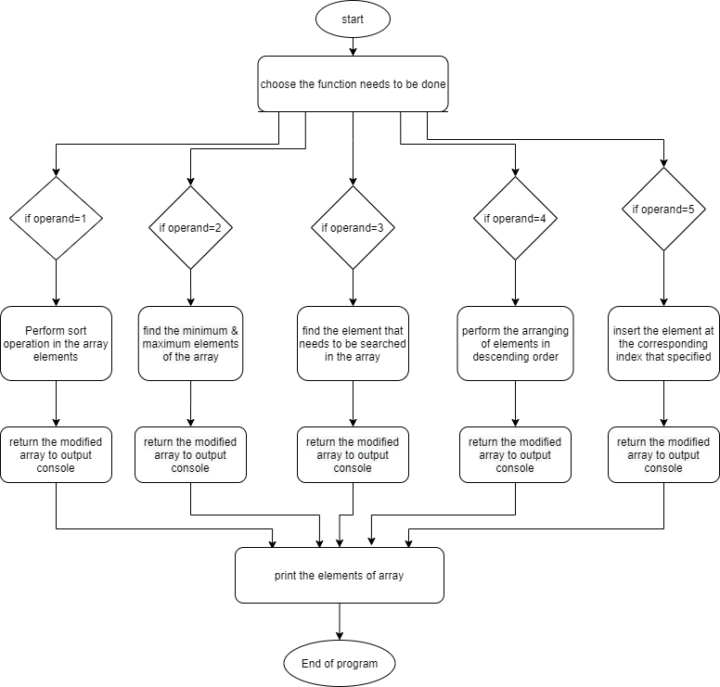

# 

# GIT activities:

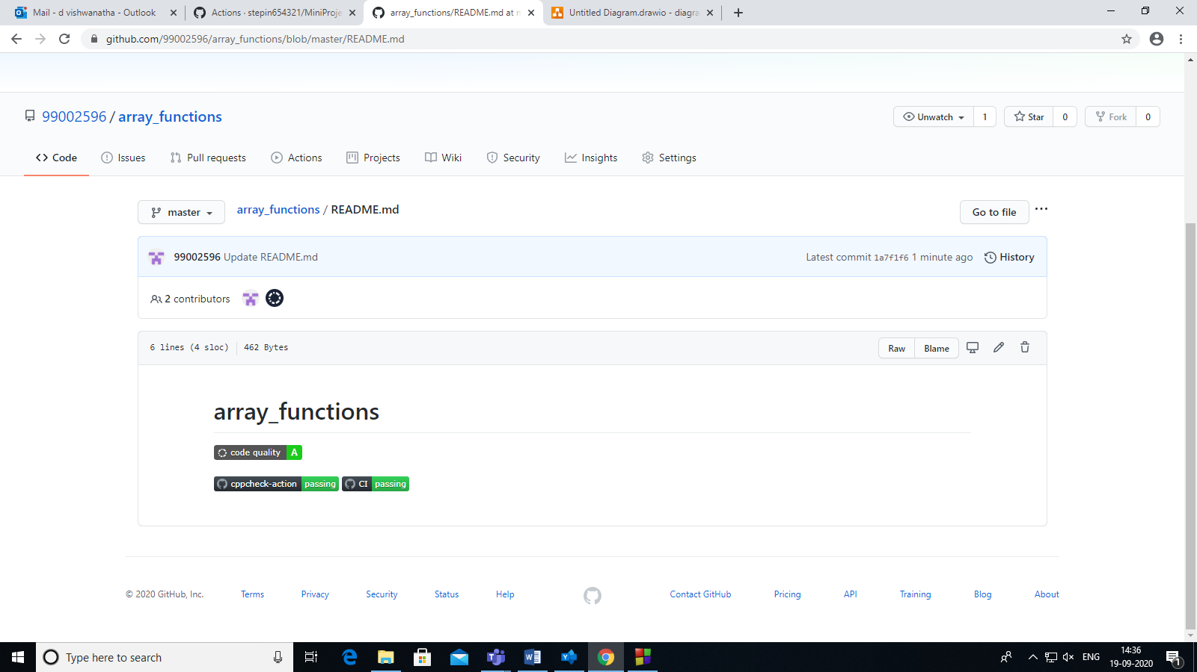



## Issues raised and solved:





GIThub link: <https://github.com/99002596/array_functions>