**Github link-** <https://github.com/99002599/AndroidProject>

**Appetize Link-**

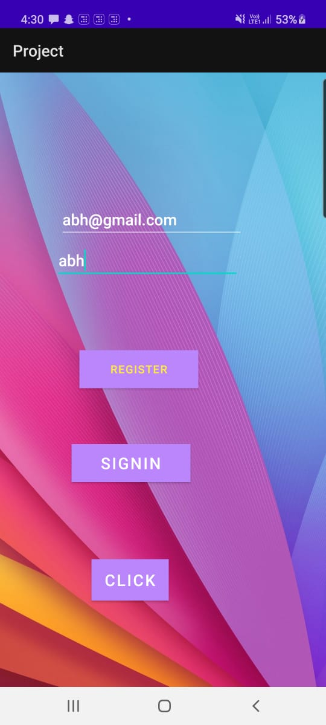

[https://appetize.io/app/g82qvd8c018wtgnvc4htfqxn5m](https://appetize.io/app/g82qvd8c018wtgnvc4htfqxn5m  )

