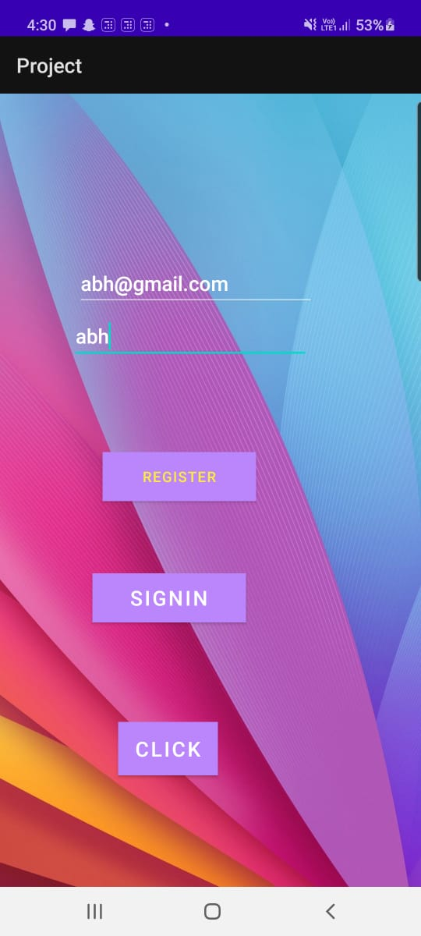

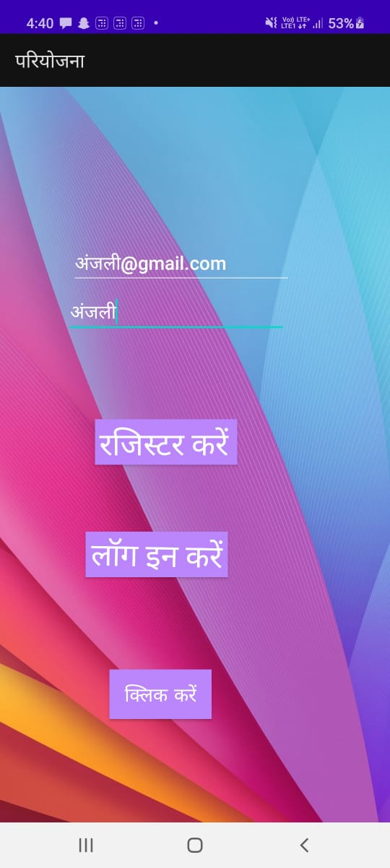

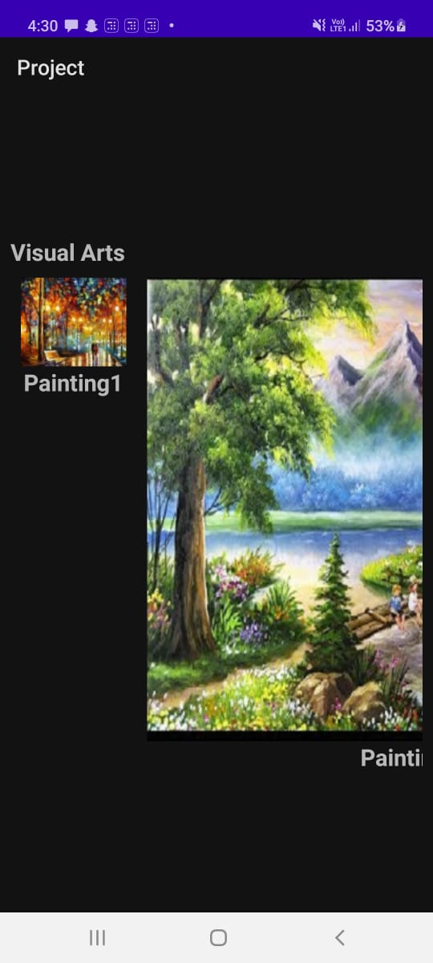

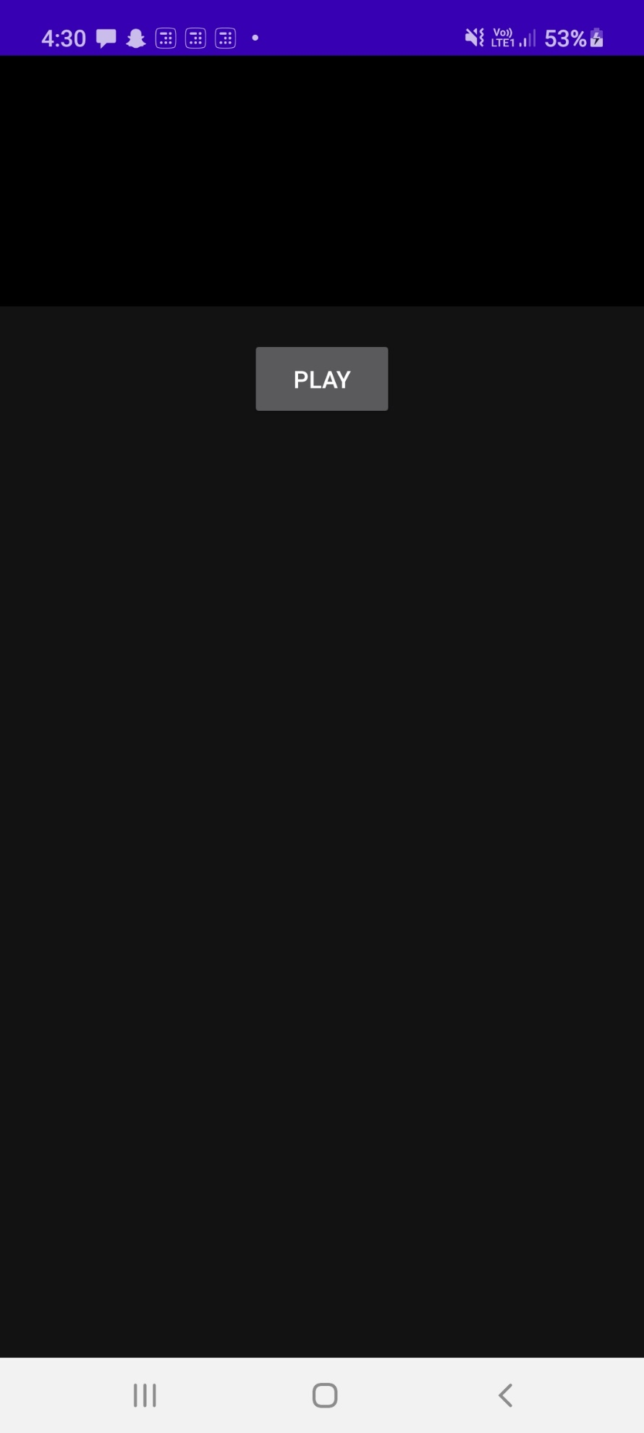

Appetize link:

<https://appetize.io/app/g82qvd8c018wtgnvc4htfqxn5m?device=nexus5&scale=75&orientation=portrait&osVersion=8.1>

Github Link: <https://github.com/99002599/AndroidProject>