./

Learning Report – Smart Helmet

Course Code: <CODE>



|  |  |  |  |  |  |
| --- | --- | --- | --- | --- | --- |
| **Ver. Rel. No.** | **Release Date** | **Prepared. By** | **Reviewed By** | **Approved By** | **Remarks/Revision Details** |
|  |  |  |  |  |  |
|  |  |  |  |  |  |
|  |  |  |  |  |  |
|  |  |  |  |  |  |
|  |  |  |  |  |  |

**Document History**

# 

Contents

Checklist 4

Activity and Tasks 4

**Activity 1**– System/Software Development 4

**Activity 2** –CI Workflow for C Programming 4

**Activity 3** – Agile Aspects 4

Activity 1– System/Software Development 5

Requirements 5

Ageing 5

1. Cost gradation 5

SWOT analysis 6

Detailed requirements 7

High level 7

Low level requirements. 9

Design 10

High level design 10

Low level design 13

Test Plan 14

Activity 2 –CI Workflow for C Programming 15

Activity 3 – Agile Aspects 17

User stories 17

# Checklist

* Installation of SW on Phone and Desktop
* Additional Aspects …

# Activity and Tasks

## **Activity 1**– System/Software Development

* Sub Tasks
* Complete and Evolve

## **Activity 2** –CI Workflow for C Programming

* Sub Tasks
* Complete and Evolve

## **Activity 3** – Agile Aspects

* User stories

# Activity 1– System/Software Development

## Requirements

The conventional helmet has two protective components, one would be a thin, hard

outer shell made from polycarbonate plastic, fiberglass or Kevlar

and a soft liner usually made of expanded polystyrene or polypropylene foam.

For the manufacturing it requires helmet injection making manufacturing machine

## Ageing

Conventional helmet never had a visor in front as the technology evolved there had

been evolution in the helmet produced down the years. Now in the 21st century the

helmet of this century is Bluetooth enabled, have a inbuilt microphone, have

indicator blinker installed in them, camera, rear light, side notification display, GPS enabled, upgraded air vents, good aerodynamic shape and what not.

As the technology evolves their research on installing a solar sticker, micro-turbines for powering the electronic components used in the helmet.

1. Cost gradation: in the market there are helmets which are ranging from few hundred rupees to few thousand rupees they are different because the material used for the manufacturing of the helmets would be of high quality material and the technology used for their procurement would be different from different helmets. The features of the costly helmet do not only to prevent the fatality of the helmet but also some other features would prevent drink and drive etc.

## SWOT analysis

Strengths: positive attributes of the product and uniqueness of the product there would no helmet which would by renewable energy source and would have features of the latest technology leveraged to it.

Weakness:

1. this would require big capital for the manufacturing
2. if the product is from company which is in budding stage it would face a problem of lack of reputation
3. finding investors for the experimenting project would be difficult
4. convincing customers to buy the project

Opportunities

Any upcoming regulation that would impact the product positively

Threats:

1. Competition from the other brands
2. Market trends
3. Technology development that would impact the product

## Detailed requirements

### High level

The Bike-Mounted module shall be mounted onto the back of the motorcycles, in between

the seat and brake lights.

●The Bike-Mounted module shall be able to interpret motorcycle signals

●The Bike-Mounted module shall be able to detect when the turning signal is

activated on the motorcycle

●The Bike-Mounted module shall be able to interface with the Rear-Mounted

module’s proximity sensors to receive ranging data

●The Bike-Mounted module shall be able to wirelessly communicate with the

helmet module to send proximity and awareness data

●The Bike-Mounted module shall be able to wirelessly communicate to up to 50 feet away

●The Bike-Mounted module shall draw power from the motorcycle

|  |  |
| --- | --- |
| ID | Description |
| HL_01 | The Bike-Mounted Motorcycle Interface module will be mounted directly onto the back of the motorcycle. |
| HL_02 | It will read rider’s inputs (turn signal, etc.), listen for proximity information from the Rear-Mounted proximity detection module, and send uniform information wirelessly to the Helmet Heads-up Display (HUD) module |
| HL_03 | Wireless range is planned to extend to at least fifty feet, in between the two endpoints. |
| HL_04 | A low wireless range is meant to preserve battery life, but is still long enough to easily and properly connect with the helmet Heads-Up Display (HUD) module easily |
| HL_05 | The Bike-mounted motorcycle interface module will be powered using the motorcycle’s existing battery to ensure the longest battery life possible. |

### Low level requirements.

The Bike-Mounted module shall include functions to activate proximity sensors

and receive ranging data

●The Bike-Mounted module shall be able to consolidate ranging data from

all sensors to provide an accurate distance reading

●The Bike-Mounted module shall implement processes to structure and send

data over wireless communication

●The Bike-Mounted module shall be able to convert ranging data into the

appropriate units of measurement

|  |  |
| --- | --- |
| ID | Description |
| LL_01 | It has proximity sensors to gauge the wide field |
| LL_02 | Proximity sensor have little delay in reading to ensure up-to-date reading for user |
| LL_03 | Smart Helmet team needs is just a simple, quick arithmetic conversion that is handled by the Arduino with high level programming language on the front-facing module |

## Design

### High level design

Component diagram (structural)

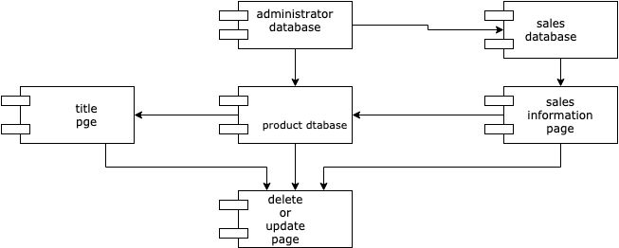

Sequential diagram (behavioural)

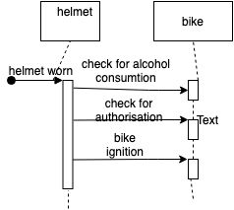

class diagram(structural)

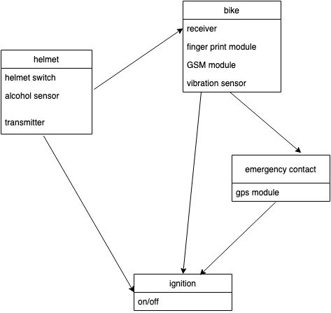

communication diagram (behavioral)

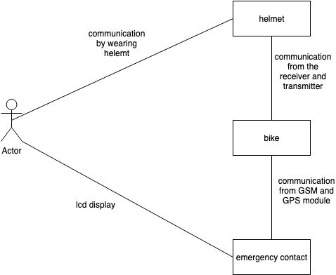

### Low level design

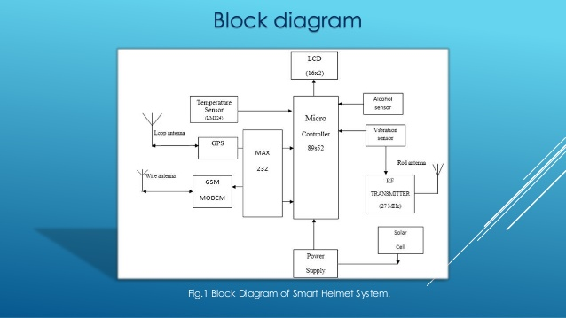

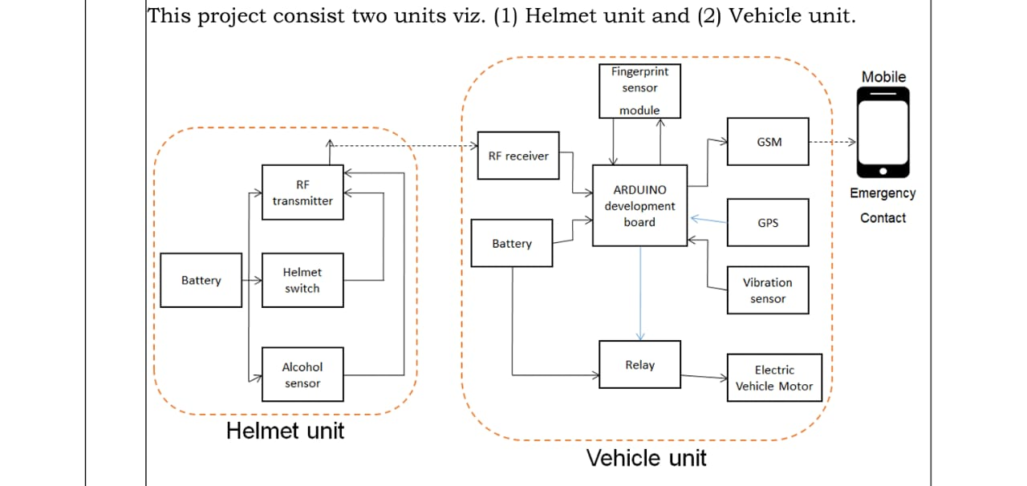

## Test Plan

Required based test plan:

1. Impact test
2. Position stability or Roll-off test.

Scenario based test plan:

1. Connectivity or the communication test between the vehicle and the helmet
2. Finger print authorization test

Boundary based test plans

1. Helmet witch disabling

|  |  |  |  |  |  |
| --- | --- | --- | --- | --- | --- |
| ID | Description | Pre- condition | Expected input | Expected output | Actual output |
| HL_01 | Hemet switch detection | Switch open | Wearing the helmet (helmet switch close) | Check for alcohol consumption | Check for alcohol consumption |
| HL_02 | Alcohol detection | Value(digital zero) | Alcohol fumes | Bike ignition off | Bike ignition off |
| HL_03 | Piezoelectric sensor | Zero | Pressure(eternal) | bike ignition off sending message and geographical co-ordinates to contact | bike ignition off sending message and geographical co-ordinates to contact |

Every high level requirement is executed with the help of low level requirement which has Arduino Uno for the operation of the components in High level requirement

# Activity 2 –CI Workflow for C Programming

GIT

badges

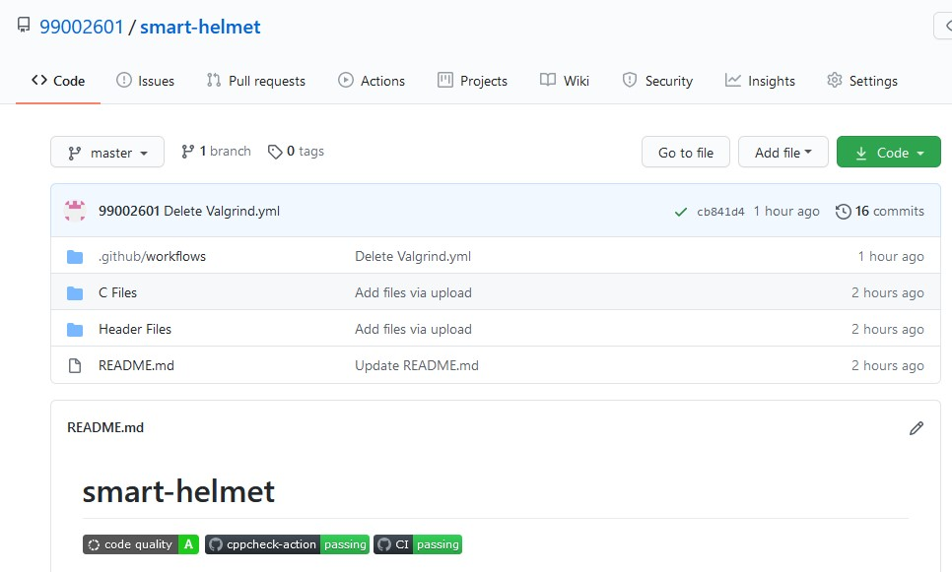

Workflow

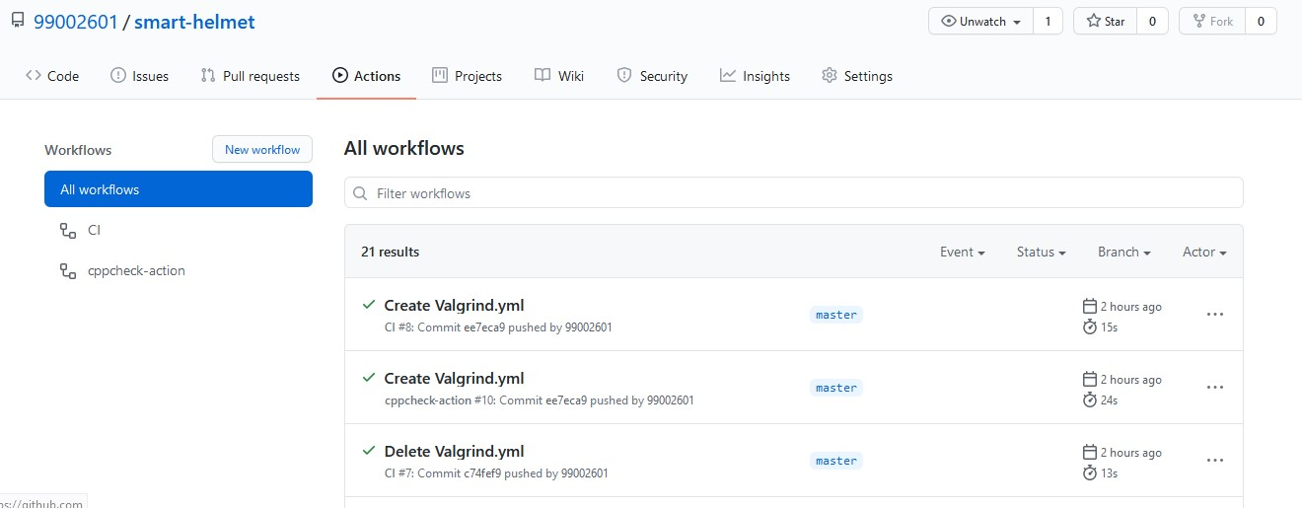

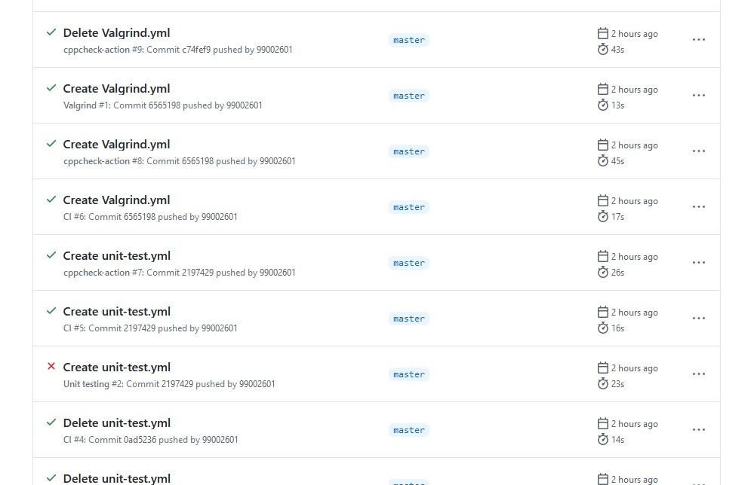

Commits

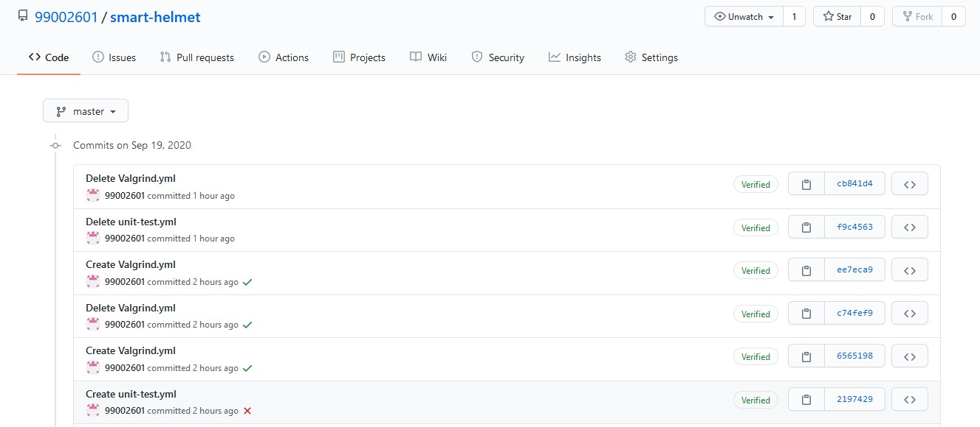

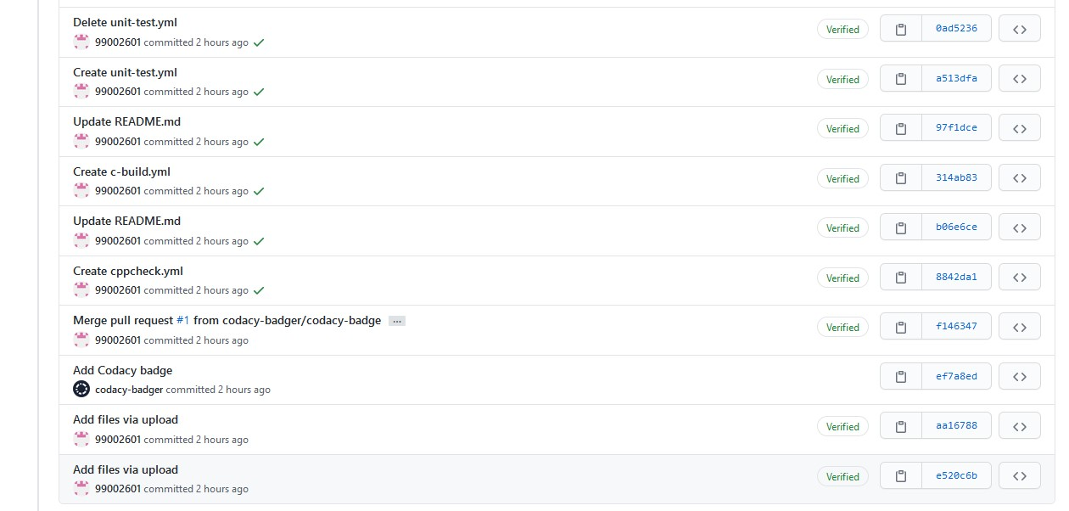

Code quality

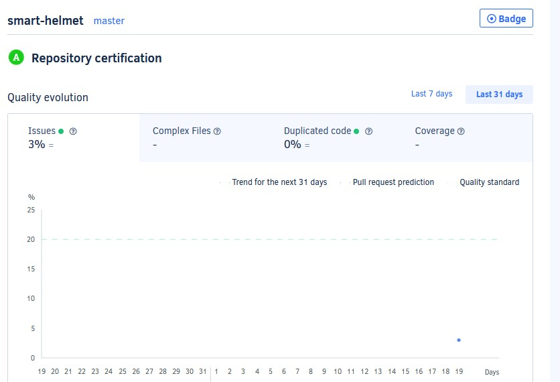

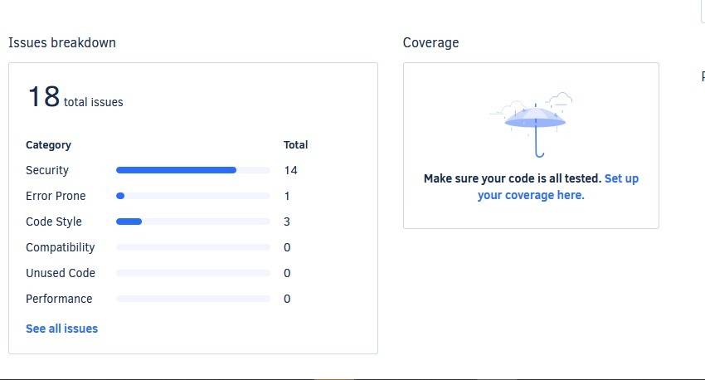

# Activity 3 – Agile Aspects

Theme: Smart Helmet

Epic: Battery, Communication components.

## User stories

The product developed is useful for the whole mankind to urge everyone to wear helmet and avoid the fatality by providing immediate medical assistance to the victim who met with an accident.

As an professional rider,

I want to have a helmet which is light

so that it would not have any problem in riding like neck pain etc.

Acceptance criteria

1. The user cannot have their helmet which is heavy
2. The helmet with the light weight will be compact and user friendly
3. Protection against any other issues
4. Letting them have to safe ride

As an analyst

I want to power the helmet with renewable sources

So that it would be economical

Acceptance criteria

1. Making it economical and make it available for everyone
2. It would reduce the replacing of batteries
3. Disposal of batteries is not require making environment friendly

As product manger

I want inextensible relation between the two units used

So that there would be continuous operation of the product

Acceptance criteria

1. Proper operation of the product helps in continuous operation
2. No discrepancies in the product
3. Making it user friendly technology if there is any technical issues the user himself should be able to correct.

APPENDIX

https://github.com/99002601/smart-helmet