Problem statement: 1
Requirements: 1
Import the data 1
Create output variable 1
Allocate imported array to column variable names 1
Clear temporary variables 1
Daily_usage_time 2
Daily_water_usage 2
Create a table with all the original data and results 2
Plotting the total consumption on each day in a single graph 2
% Workbook: Weekly_Water_Consumption.csv
% Worksheet: in

Problem statement:
Given a set of data in "Weekly_Water_Consumption.csv" about the consumption of water in a house on seven days of a week on average, design an algorithm to: 1. Calculate the total usage of water (in litres) and the total time used (in minutes) on each day. 2. Plot the total consumption on each day in a single graph

Requirements:
Input - Flow rates of different equipments (in Litre/minutes) Output - Time consumed by each equipment (in minutes) Equation - Litres consumed = Flow rate*time of use

Import the data
[raw0_0] = xlsread('Weekly_Water_Consumption.csv','B2:G8');
[raw0_1] = xlsread('Weekly_Water_Consumption.csv','B12:B18');
raw = [raw0_0,raw0_1];

Create output variable
data = raw;

Allocate imported array to column variable names
Flowrate = data(:,6);

Clear temporary variables
clearvars raw raw0_0 raw0_1 R;

Daily_usage_time
Calculates total time water was consumed by all equipments in a day
for i=1:7
Total_time(i,1)=0;
for j=1:5
Total_time(i,1) = addTime(Total_time(i,1),data(i,j)); %addTime() is a custom function to add two inputs
end
end

Daily_water_usage
Calculates total water consumption by all equipments in a day
for i=1:7
Total_usage(i,1)=0;
for j=1:5
Total_usage(i,1)=addTime(Total_usage(i,1),(produ(data(i,j),Flowrate(j,1)))); %produ() is a custom function to multiply two inputs
end
end

Create a table with all the original data and results
finaltable=table
finaltable.Day=(1:7)';
finaltable.WashBasin=data(:,1);
finaltable.BathroomShower=data(:,2);
finaltable.HealthFaucet=data(:,3);
finaltable.BathroomTap=data(:,4);
finaltable.ToiletFlush=data(:,5);
finaltable.TotalTimeofUse_in_minutes=Total_time(:);
finaltable.TotalUsage_in_litres=Total_usage(:);
finaltable =
empty 0-by-0 table

Plotting the total consumption on each day in a single graph
scatter(finaltable.Day,finaltable.TotalUsage_in_litres);
title('Total usage vs Days of the week');
xlabel('Days of the week (Sunday-Saturday)');
ylabel('Total usage (in Litres)');
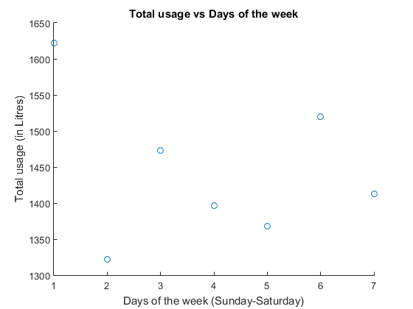
Published with MATLAB® R2015a

