./

Learning Report – Scientific calculator

Course Code: <CODE>



|  |  |  |  |  |  |
| --- | --- | --- | --- | --- | --- |
| **Ver. Rel. No.** | **Release Date** | **Prepared. By** | **Reviewed By** | **Approved By** | **Remarks/Revision Details** |
|  |  |  |  |  |  |
|  |  |  |  |  |  |
|  |  |  |  |  |  |
|  |  |  |  |  |  |
|  |  |  |  |  |  |

**Document History**

# 

Contents

Checklist 3

Activity and Tasks 4

**Activity 1**– System/Software Development 4

**Activity 3** – Agile Aspects 4

**Activity 3** – CI Workflow for C Programming 6

# Checklist

* Installation of SW on Phone and Desktop
* Additional Aspects …

# Activity and Tasks

## **Activity 1**– System/Software Development

## **Requirements**: The calculator must have the following keys

* Number from 0 to 9.
* Symbols like +, -, *, /.
* Trigonometric functions like sine, cos, hyperbolic sine, hyperbolic cos.
* Other functions like exponential, logarithm and factorial.
* **Aging**: The first scientific calculator that included all of the basic ideas above was the programmable Hewlett-Packard HP-9100A released in 1968.

The HP-35, introduced on February 1, 1972, was Hewlett-Packard's first pocket calculator and the world's first handheld scientific calculator.

Texas Instruments (TI), after the introduction of several units with scientific notation, came out with a handheld scientific calculator on January 15, 1974, in the form of the SR-50.

Casio is a major player in the graphing calculator market, and was the first company to produce one ([Casio fx-7000G](https://en.wikipedia.org/wiki/Casio_fx-7000G)).

* **Gradation in terms of cost**

|  |  |  |
| --- | --- | --- |
| **Year** | **Model** | **Cost** |
| 1972 | Tl-2500 | $149.95 |
| 1985 | fx-7000G | $75 |
| 1988 | Tl-68 | $55 |
| 1992 | Tl-85 | $130 |
| 2020 | Tl-30XS | $18.13 |

## **SWOT Analysis**

|  |  |
| --- | --- |
| **Strengths**   * Products driven by innovation. * Strong technology expertise driving new business. * Broad variety of products across consumer segments. | **Weakness**   * Slow to launch products as per fast changing consumer needs. |
| **Opportunities**   * Adapting to new technology and creating new business. * Expand growth in timepiece and educational scientific calculator business. | **Threats**   * Large competitors for products. * Fluctuations in economy can highly influence sales. |

## **High level requirements**

|  |  |
| --- | --- |
| ID | Description |
| HL_01 | Include trigonometric functions like sine, cos, hyperbolic sine and hyperbolic cos in the calculator. |
| HL_02 | Include the exponential, logarithm and factorial functions in the calculator |
| HL_03 | Include symbols like +, -, *, / to perform simple mathematical operations. |

* **Low level requirements**

|  |  |
| --- | --- |
| ID | Description |
| LL_01 | Include numbers from 0 to 9. |
| LL_02 | Calculator must provide with ON, Off, Memory options. |

## **Test plan**

|  |  |  |  |  |  |
| --- | --- | --- | --- | --- | --- |
| **ID** | **Description** | **Pre-condition** | **Expected I/P** | **Expected O/P** | **Actual O/P** |
| HL_01 | Calculate the sine function | Calculator is in degree mode. | Enter an integer | If integer is 0 to 180, then return sine function value, if integer is 180 to 270, if integer is -360, -180 and 360, return 0. | If integer is 0 to 180, then return sine function value, if integer is 180 to 270, if integer is -360, -180 and 360, return 0. |
| HL_02 | Calculate the cos function | Calculator is in degree mode | Enter an integer | If integer is 0 to 90, return cos function. If integer is 90 to 180, return –cos. For 180 to 270, return –cos function and for 270 to 360, return cos function. | If integer is 0 to 90, return cos function. If integer is 90 to 180, return –cos. For 180 to 270, return –cos function and for 270 to 360, return cos function. |
| HL_03 | Calculate the factorial of a number | Calculator is in degree mode | Enter a number to be factorized | If a given number is 0 and 1 then return 0. For number other than 0 and 1, calculate the factorial of the number | If a given number is 0 and 1 then return 0. For number other than 0 and 1, calculate the factorial of the number. |

* **Design**
  + **UML diagram**

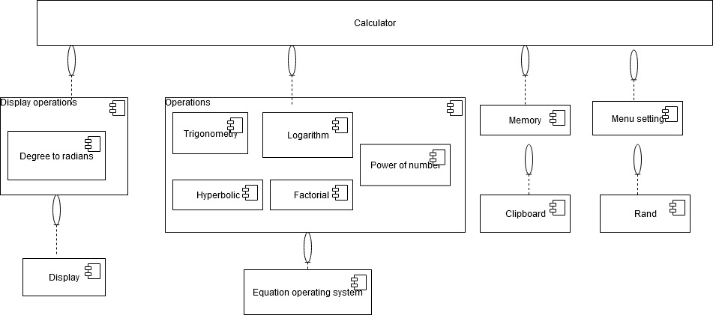

## **Activity 2** – Agile Aspects

* Theme : Scientific Calculator
* Epic : Trigonometric and factorial operation
* User stories:

Description - As a user.

I want to do trigonometric operation.

I want calculate sine function.

Test case - An integer is entered.

If integer is 0 to 180, then return sine function value, if integer is 180 to 270, if integer entered is -360, -180 and 360, return 0.

Description - As a user.

I want to do trigonometric operation.

I want calculate Cos function.

Test case - An integer is entered.

If integer is 0 to 90, return cos function. If integer is 90 to 180, return –cos. For 180 to 270, return –cos function and for 270 to 360, return cos function.

Description - As a user.

I want to calculate factorial of a number.

Test - An integer entered.

If a given number is 0 and 1 then return 0. For number other than 0 and 1, calculate the factorial of the number.

* **References**

<https://en.m.wikipedia.org/wiki/Calculator>

<https://www.swotandpestle.com/casio/>

## **Activity 3** – CI Workflow for C pr0graming

## 

## 

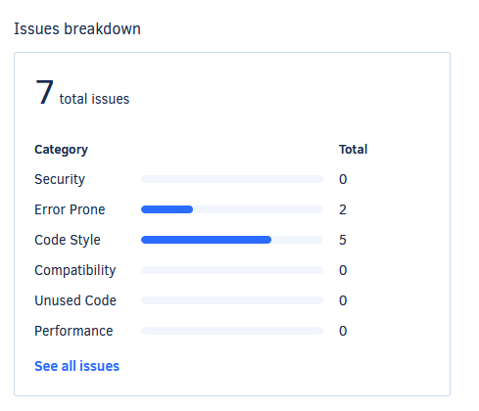

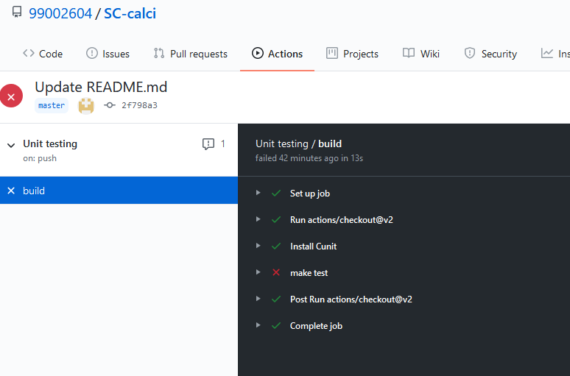

* **Appendix**

<https://github.com/stepin104926/calculator>