./

Learning Report – Applied System Development Life Cycle and Software Testing



|  |  |  |  |  |  |
| --- | --- | --- | --- | --- | --- |
| **Ver. Rel. No.** | **Release Date** | **Prepared. By** | **Reviewed By** | **To be approved By** | **Remarks/Revision Details** |
| 1 |  | Name/PS No | Name/PS No | Module Owner Name | Comments |
| 2 |  |  |  |  |  |
| 3 |  |  |  |  |  |
|  |  |  |  |  |  |
|  |  |  |  |  |  |

**Document History**

Table of Contents

[Table of Figures 3](#_Toc53129062)

[Table of Tables 4](#_Toc53129063)

[ACTIVITY 1: SYSTEM/ SOFTWARE DEVELOPMENT 4](#_Toc53129064)

**[INTRODUCTION](#_Toc53129065)** [4](#_Toc53129065)

**[MY PRODUCT: “Name ”](#_Toc53129066)** [6](#_Toc53129066)

**[SWOT ANALYSIS](#_Toc53129067)** [7](#_Toc53129067)

**[REQUIREMENTS](#_Toc53129068)** [7](#_Toc53129068)

**[DESIGN](#_Toc53129069)** [8](#_Toc53129069)

[HIGH LEVEL DESIGN 8](#_Toc53129070)

[LOW LEVEL DESIGN 11](#_Toc53129071)

**[TEST PLANS](#_Toc53129072)** [13](#_Toc53129072)

**[REFERENCES](#_Toc53129073)** [15](#_Toc53129073)

[ACTIVITY 2: AGILE METHODOLOGY 15](#_Toc53129074)

**[THEME](#_Toc53129075)** [15](#_Toc53129075)

**[EPIC](#_Toc53129076)** [15](#_Toc53129076)

**[USER STORY](#_Toc53129077)** [16](#_Toc53129077)

**[REFERENCES](#_Toc53129078)** [17](#_Toc53129078)

[APPENDIX: 17](#_Toc53129079)

## Table of Figures

[Figure 1 CLASS DIAGRAM(HIGH LEVEL) 10](#_Toc52177314)

[Figure 2 USE CASE DIAGRAM (HIGH LEVEL) 11](#_Toc52177315)

[Figure 3 ACTIVITY DIAGRAM (HIGH LEVEL) 12](#_Toc52177316)

[Figure 4 USE CASE DIAGRAM (LOW LEVEL) 12](#_Toc52177317)

[Figure 5 ACTVITY DIAGRAM (LOW LEVEL) 13](#_Toc52177318)

[Figure 6 BLOCK DIAGRAM 13](#_Toc52177319)

[Figure 7 COMPONENT DIAGRAM (HIGH LEVEL) 22](#_Toc52177320)

[Figure 8 ACTIVITY DIAGRAM (high level) 23](#_Toc52177321)

[Figure 9 ACTIVITY DIAGRAM (LOW LEVEL) 24](https://lnttsgroup.sharepoint.com/sites/GEA/Global%20Engineering%20Academy/GEA%20Insights/Genesis/Shared%20Documents/Submission/MYSORE/2009MYSEMB/Foundation/Applied%20SDLC%20with%20Software%20Testing/99002439/FINAL.docx" \l "_Toc52177322)

[Figure 10- ACTIVITY DIAGRAM (LOW LEVEL) 24](#_Toc52177323)

[Figure 11 TEST PLAN 25](#_Toc52177324)

[Figure 12 GIT 27](#_Toc52177325)

[Figure 13 GIT ISSUES 28](#_Toc52177326)

[Figure 14 GIT COMMITS 1 28](#_Toc52177327)

[Figure 15 GIT COMMIT 2 29](#_Toc52177328)

[Figure 16 GIT 30](#_Toc52177329)

[Figure 17 GIT MAKE 31](#_Toc52177330)

[Figure 18 GIT MAKE 2 31](#_Toc52177331)

[Figure 19 GIT BUILD 32](#_Toc52177332)

[Figure 20 GIT CODE QUALITY 32](#_Toc52177333)

## Table of Tables

[Table 1 AGING 6](#_Toc52177304)

[Table 2 GRADING COST 6](#_Toc52177305)

[Table 3 REQUIREMENTS 8](#_Toc52177306)

[Table 4 HIGH LEVEL TEST PLAN 15](#_Toc52177307)

[Table 5 LOW LEVEL TEST PLAN 16](#_Toc52177308)

[Table 6 USER STORIES 17](#_Toc52177309)

[Table 7 AGING 19](#_Toc52177310)

[Table 8 GRADING COST 19](#_Toc52177311)

[Table 9 REQUIREMENTS 21](#_Toc52177312)

[Table 10 USER STORIES 27](#_Toc52177313)

## ACTIVITY -1

**Product Selected -** Try On Augmented Reality Watch

### Ageing -

* Augmented reality technology was invented in 1968, with Ivan Sutherland’s development of the first head-mounted display system. However, the term ‘augmented reality’ wasn’t coined until 1990 by Boeing researcher Tim Caudell.
* A view of the physical real-world environment with superimposed

Computer-generated images, thus changing the perception of reality, is the AR.

* According to Apple CEO Tim Cooke, Augmented Reality is the core technology and will be big technological step forward, which is similar to the release of smartphones.

### Costing of Products-

* Earlier due to shortage of skills a basic augmented application cost around $100 - $200.
* After invention of software like Unity and Spark Augmented and Virtual Reality become quite easy to make.
* In present augmented reality is used almost every platform like e commerce, medical, and etc.
* It is one of the largest employment sector in the world right now.

**SWOT Analysis-**

Strength-

* Application creates the virtual objects.
* Virtual object well defines the original object.

Weakness-

* The application is virtual so can’t be filled or touched.
* The application only runs android platform

Opportunities-

* It gives customer a detail look of the product
* With new updates the product can generate a lot of revenue.

Threats-

* Security concerns are one of major issues.
* Application needs mobile battery power to work on

### 

### Requirements -

#### High Level Requirements -

* Android Smartphone
* Minimum Android Version- 8.0
* Minimum Storage Space of 45 MB
* In build Camera
* Image Target
* Virtual Object Formation

#### 

#### Low Level Requirements -

* Creating Core Functionality -
  + Create 3 different Watch Models
  + Occlusion Of hand
* Creating User Interface -
  + Create UI slide in Frame
  + Create Color switch buttons for watches
* Create a Exit Button

### DESIGN

### High Level Design -

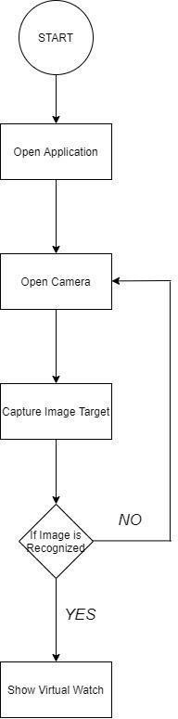

Structural Diagram -

**Fig 1: flow chart diagram**

Behavioral Diagram

- State Chart Diagram

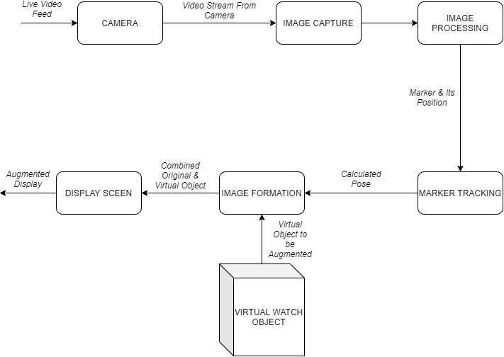

Fig2: State Chart Diagram

### Low Level Design-

Structural Diagram -

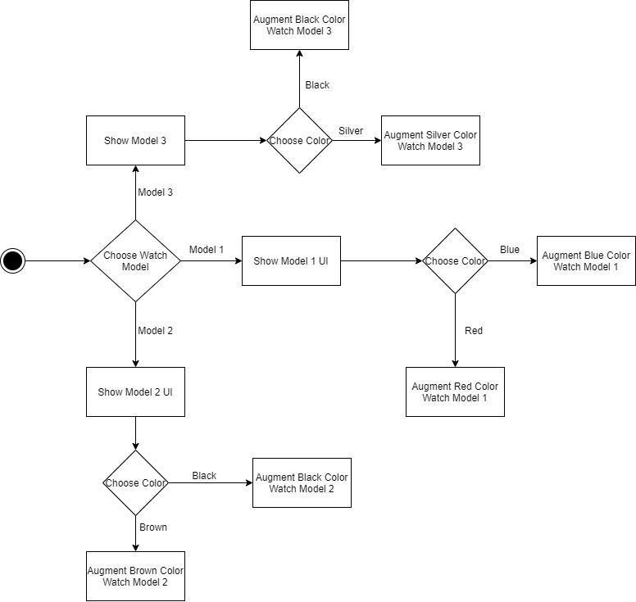

Fig 3: Flow Chart Diagram

Behavioral Diagram -

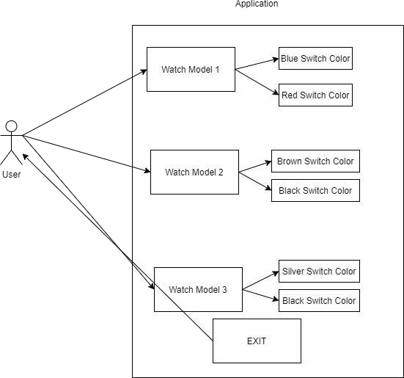

**Fig 4: Use Case Diagram**

### Testing -

|  |  |  |  |  |
| --- | --- | --- | --- | --- |
| **TEST ID** | **DESCRIPTION** | **EXPECTED INPUT** | **EXPECTED OUTPUT** | **ACTUAL OUTPUT** |
| T001 | Animation of Watch window 1 | Tap on Window 1 UI | Watch window 1 slides into the frame | Watch window  1 slides into the frame |
| T002 | Animation of Watch window 2 | Tap on Window 2 UI | Watch window 2 slides into the frame | Watch window 2 slides into the frame |
| T003 | Animation of Watch window 2 | Tap on Window 3 UI | Watch window 3 slides into the frame | Watch window 3 slides into the frame |
| T004 | Exit Button of Watch window 1 | Tap on Exit Button of Watch window 1 | Watch window 1 slides back from the frame | Watch window  1 slides back from the frame |
| T005 | Exit Button of Watch window 2 | Tap on Exit Button of Watch window 2 | Watch window 2 slides back from the frame | Watch window  2 slides back from the frame |
| T006 | Exit Button of Watch window 3 | Tap on Exit Button of Watch window 3 | Watch window 3 slides back from the frame | Watch window  3 slides back from the frame |
| T007 | Color Switch Buttons of Watch window 1 | Tap on the Red color switch buttons | Color of Watch Changes to Red | Color of the Watch Changes to Red |
| T008 | Color Switch Buttons of Watch window 1 | Tap on the Blue color switch buttons | Color of Watch Changes to Blue | Color of Watch Changes to Blue |
| T009 | Color Switch Buttons of Watch window 2 | Tap on the Black color switch buttons | Color of Watch Changes to Black | Color of Watch Changes to Black |
| T010 | Color Switch Buttons of Watch window 2 | Tap on the Brown color switch buttons | Color of Watch Changes to Brown | Color of Watch Changes to Brown |
| T011 | Color Switch Buttons of Watch window 3 | Tap on the Black color switch buttons | Color of Watch Changes to Black | Color of Watch Changes to Black |
| T012 | Color Switch Buttons of Watch window 3 | Tap on the Silver color switch buttons | Color of Watch Changes to Silver | Color of Watch Changes to Silver |

**GitHub Screeshots and Links-**

**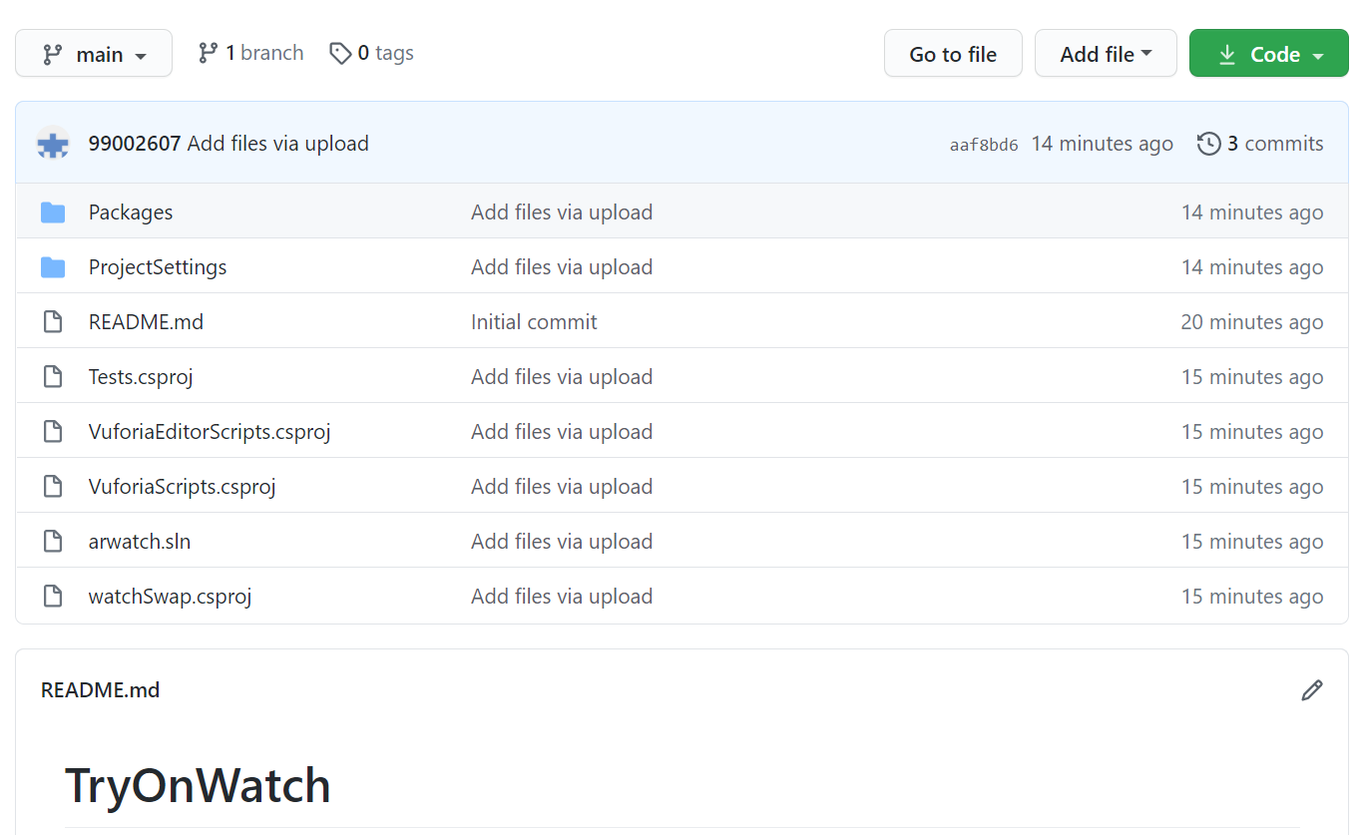**

**Fig 5: GitHub Screenshots**

Git Repository - <https://github.com/99002607/TryOnWatch>

#### **ACTIVITY -2**

#### **CALCULATOR**

**Introduction**

#### A calculator is a machine which allows people to do [math](https://simple.wikipedia.org/wiki/Mathematics) operations more easily. For example, most calculators will [add](https://simple.wikipedia.org/wiki/Addition), [subtract](https://simple.wikipedia.org/wiki/Subtraction), [multiply](https://simple.wikipedia.org/wiki/Multiplication), and [divide](https://simple.wikipedia.org/wiki/Division_(mathematics)). Some also do [square roots](https://simple.wikipedia.org/wiki/Square_root), and more complex calculators can help with [calculus](https://simple.wikipedia.org/wiki/Calculus) and draw function graphs. Calculators are found everywhere. A [smartphone](https://simple.wikipedia.org/wiki/Smartphone) or other [computer](https://simple.wikipedia.org/wiki/Computer) can also act as a calculator.

Some calculators, like the [abacus](https://simple.wikipedia.org/wiki/Abacus), will work without [batteries](https://simple.wikipedia.org/wiki/Battery). Others, like the electronic calculator, require batteries. There are two types of electronic calculators: simple calculators, which can only [add](https://simple.wikipedia.org/wiki/Addition), [subtract](https://simple.wikipedia.org/wiki/Subtraction), [multiply](https://simple.wikipedia.org/wiki/Multiplication) and [divide](https://simple.wikipedia.org/wiki/Division_(mathematics)), and sometimes take [square roots](https://simple.wikipedia.org/wiki/Square_roots); and scientific calculators, which can do many other things, such as calculate [factorials](https://simple.wikipedia.org/wiki/Factorial) and [trigonometry](https://simple.wikipedia.org/wiki/Trigonometry) functions.

**Requirements**

**High Level Requirement**

* Performance - The performance of the calculator should be high.
* Speed -The speed of operations performed should be fast.
* It should perform all the arithmetic operations.
* It should find the area of square.
* It should perform conversion operations.
* It should find the factorial of number.
* It should check for prime number.

**Low level requirements**

* It should take operands as input and give the result of addition, subtraction, multiplication and division of the operands accordingly.
* It should take two operands as input and give the area of square.
* It should take an operand as input and make conversion from kilometer to meter, centimeter and millimeter.
* It should take the operand as input and give its factorial as output.
* It should take an operand as input check if it is prime number.

1. **Requirement Mapping**

|  |  |
| --- | --- |
| ID | Description |
| H\_01 | Performance  The performance of the calculator should be high. |
| H\_02 | Speed  The speed of operations performed should be fast. |
| H-03\_L\_01 | It should perform all the arithmetic operations.  It should take operands as input and give the result of addition, subtraction, multiplication and division of the operands accordingly. |
| H-04\_L\_02 | It should find the area of square  It should take two operands as input and give the area of square. |
| H-05\_L\_03 | It should perform conversion operations.  It should take a operand as input and make conversion from kilometer to meter, centimeter and millimeter. |
| H-06\_L\_04 | It should find the factorial of number.  It should take the operand as input and give its factorial as output. |
| H-07\_L\_05 | It should check for prime number.  It should take a operand as input check if it is prime number. |

**Test plan mapping**

|  |  |  |  |  |  |
| --- | --- | --- | --- | --- | --- |
| ID | Description | Precondition | Expected input | Expected output | Actual Output |
| H\_01 | Performance | Should be 90% and above | - | High performance | - |
| H\_02 | speed | <20ms | - | Speed< 20ms | <20ms |
| H\_03 | addition | Two operands  as input | 2 and 3 | 5 | 5 |
| H\_04 | subtraction | Two operands  as input | 3 and 2 | 1 | 1 |
| H\_05 | multiplication | Two operands  as input | 2\*3 | 6 | 6 |
| H\_06 | division | Two operands  as input | 4/2 | 2 | 2 |
| H\_07 | factorial | One operand | 3 | 6 | 6 |
| H\_08 | Conversion from kilometer to  meter | One operand | 100km | 100000m | 100000m |
| H\_09 | Area of square | Two operands  as input | 2 and 2 | 4 | 4 |