./

Learning Report – Smart Bag for Women Safety

Course Code: <CODE>

|  |  |  |  |  |  |
| --- | --- | --- | --- | --- | --- |
| **Ver.Rel. No.** | **Release Date** | **Prepared. By** | **Reviewed By** | **Approved By** | **Remarks/Revision Details** |
| 1 | 17/09/2020 | Ananthula Kavya |  |  | Made changes to the requirements table |
| 2 | 18/09/2020 | Ananthula Kavya |  |  | Added mapping to the requirements table |
| 3 | 19/09/2020 | Ananthula Kavya |  |  | Added Learning report for new application |
|  |  |  |  |  |  |
|  |  |  |  |  |  |

**Document History**

# 

Contents

LIST OF FIGURES 3

LIST OF TABLES 3

ACTIVITY 1 4

SYSTEM/SOFTWARE DEVELOPMENT 4

IDENTIFY PRODUCT 4

RESEARCH 4

SWOT ANALAYSIS 5

REQUIREMENTS 5

ACTIVITY 2 13

CI WORKFLOW FOR C PROGRAMMING 13

ACTIVITY 3 16

AGILE ASPECTS 16

V Model 17

ACTIVITY-CI 18

DOCUMENTATION 18

# LIST OF FIGURES

Figure 1-Block Diagram 8

Figure 2-Use case Diagram 9

Figure 3-Activity Diagram 10

Figure 4-Flow Chart 11

# LIST OF TABLES

Table 1-High and Low level Requirements 7

Table 2-Test plans 13

# ACTIVITY 1

## **SYSTEM/SOFTWARE DEVELOPMENT**

**Consumer product – Smart bag for women**

**IDENTIFY PRODUCT -**Smart Bag for Women Safety

**RESEARCH-**

**PROBLEM STATEMENT**

The problem statement requires us to create a proposed smart bag that adds in a feature to offer security to women through an emergency button in the bag. When this button is pressed, the victim’s location will be traced using GPS of mobile and a SMS will be sent to the victim’s

contacts.

**COSTING**

* **PAST**- costs within the range of 3000-4000 because in the past raspberry pi. Raspberry pi is costly
* **PRESENT**-costs within the range of 500-1000 because now Arduino is used.The programming language C is used. It costs less compared to raspberry pi.
* **FUTURE**-In the future, the microprocessor is even costs low. If the size of the microprocessor is small then the cost will be low. It will be eco-friendly.

**AGING**

* **PAST**- The microprocessor is very big and it is expensive
* **PRESENT**- The microprocessor is in the normal size and it costs in the normal range
* **FUTURE**-The microprocessor will be in the small size and it will be in cost and easy to handle.

**FEATURES**

* Going to be Lightweight
* Takes less space
* Has separate button in emergency situations
* Eco friendly
* Provided in a customized manner.
* Mobile even get charged.
* We just have batteries for the changing purpose.

**SWOT ANALAYSIS –**

**STRENGTH** –

* + Consumes less power
  + Provides very accurate data via GPS system
  + Facilitates simple asset recovery and tracking
  + Culprits can be easily found and can be punished
  + High manufacturing quality

**WEAKNESS**-

* + In some places due to poor signals, messages cannot be send.
  + The only thing that is clear about constitutional protections for location-based service information is the lack of clarity.

**OPPORTUNITIES-**

* + - Our product becomes a necessity (must have) in city & surrounding areas.
    - Expand our commercial market with other retail stores.
    - More promotion of brand in different channels.

**THREATS-**

* + - Cheaper mass production from competitors.
    - Increasing of online shopping.

**REQUIREMENTS –**

**DETAILED REQUIREMENTS**

**ARDUINO**

Arduino is an open-source electronics platform based on easy-to-use hardware and software. Arduino

boards are able to read inputs - light on a sensor, a finger on a button, or a Twitter message - and turn it

into an output - activating a motor, turning on an LED, publishing something online. You can tell your

board what to do by sending a set of instructions to the microcontroller on the board. It is simple

and accessible user experience, Arduino has been used in thousands of different projects and

applications. The Arduino software is easy-to-use for beginners, yet flexible enough for advanced users.

It runs on Mac, Windows, and Linux. Teachers and students use it to build low cost scientific instruments,

to prove chemistry and physics principles, or to get started with programming and robotics. Arduino

also simplifies the process of working with microcontrollers, but it offers some advantage for

teachers, students, and interested amateurs over other systems:

* Inexpensive
* Cross-platform
* Simple, clear programming environment
* Open source and extensible software
* Open source and extensible hardware

**GPS TRACKER**

A GPS tracking unit or geo-tracking unit is a navigation device normally carried by a moving vehicle or

person or animal that uses the Global Positioning System(GPS) to track the device's movements

and determine its geographic position. The recorded location data can either be stored within the

tracking unit or transmitted to an Internet-connected device using SMS, radio or satellite modem

embedded in the unit. This allows the location to be displayed against a map backdrop either in real

time or when analysing the track later, using GPS tracking software. Data tracking software is available

for smartphones with GPS capability.

**GSM MODULE**

GSM Modules are one of the commonly used communication modules in embedded systems. A GSM

Module is used to enable communication between a microcontroller (or a microprocessor) and the

GSM Network. Here, GSM stands for Global System for Mobile Communication. GSM module is a

messaging module after tracking the location for sending the location messages.For catching the

signals to our device,we use GSM module.

**MEMORY CARD MODULE**

A memory card is an electronic data storage device used for storing digital information, typically using

flash memory. These are commonly used in portable electronic devices, such as digital cameras,

mobile phones, computers, tablets, PDAs, portable media players, video game consoles,

synthesizers, electronic keyboards and digital pianos.

**LINUX ENVIRONMENT**

Linux is a family of open source Unix-like Operating Systems based on the Linux Kernel Linux is

typically packaged in a Linux Distribution.Linux was originally developed for personal computers

based on the Intel X86 architecture, but has since been ported to more platforms than any other

operating system. Because of the dominance of Android on smartphones, Linux also has the largest

installed base of all general-purpose operating systems.

**HIGH LEVEL REQUIEMENTS**

* Arduino
* GPS Tracker
* GSM Module
* Memory card module
* Button
* Bag

**LOW LEVEL REQUIEMENTS**

* Connecting wires
* Programming Language-C
* Linux Environment
* Zipper
* LCD

|  |  |
| --- | --- |
| **ID** | **DESCRIPTION** |
| HL_01 | Arduino is an open source electronics platform easy to use software and hardware |
| HL_01_LL_01 | Linux Environment is a family of open source Unix-like Operating Systems |
| HL_01_LL_02 | The programming language used in Arduino is C |
| HL_02 | GPS Tracker is a navigation device normally carried by a moving vehicle or person to locate the geographic position. |
| HL_03 | GSM module is used to establish communication between a computer and a GSM-G\PRS system |
| HL_04 | In case of emergency situations ,the victim presses the button |
| HL_04_LL_01 | Liquid Crystal Display screen is associated in nursing electronic display module. |
| HL_05 | A memory card is an electronic data storage device used for storing digital information, typically using flash memory. |
| HL_06 | Batteries are used so that it will be charged. It will be in low cost. |
| HL_07 | Smart bag is an application-specific design that can be useful for almost everyone in the society |

Table -High and Low level Requirements

**5. UML DESIGN**

**BLOCK DIAGRAM**

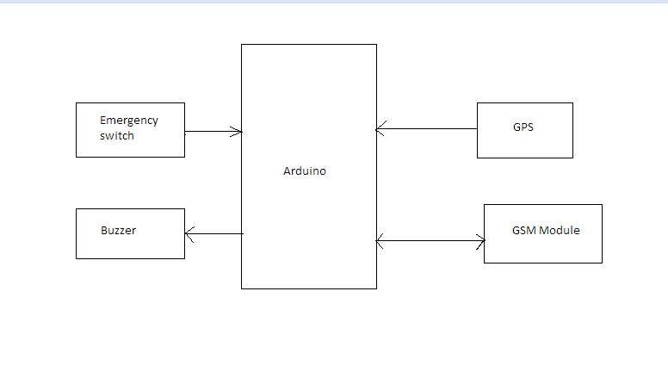

Figure -Block Diagram

**BEHAVIORAL DIAGRAMS**

**USECASE DIAGRAM**

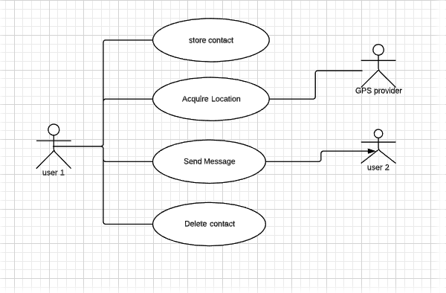

Figure -Use case Diagram

**ACTIVITY DIAGRAM**

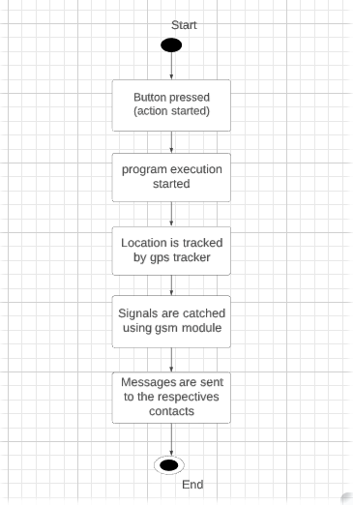

Figure -Activity Diagram

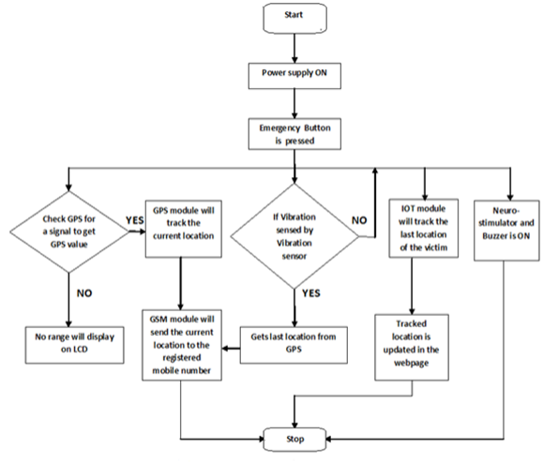

Figure -Flow Chart

**6. TEST PLAN**

**Requirement based**

* Smart bag is an application-specific design that can be useful for almost everyone in the society.

**Scenario based**

* Due to poor signals - In some places due to poor signals.

**Boundary conditions**

* Windproof – If you reside in an area that faces typhoons, its best to consider the best GPS tracker.
* The only thing that is clear about constitutional protections for location based service information is the lack of clarity.

|  |  |  |  |  |  |
| --- | --- | --- | --- | --- | --- |
| **ID** | **DESCRIPTION** | **PRECONDITION** | **EXPECTED INPUT** | **EXPECTED OUTPUT** | **ACTUAL OUTPUT** |
| HL_02 | In case of wind proof | If you reside in an area that faces typhoons. | Its best to consider the best GPS tracker | If the GPS tracker is better, we can approximately locate the place | We can locate the place. |
| HL_03 | While storing the emergency contacts ,if the contact’s number is stored incorrect | Make sure you store the correct contact’s numbers | Establish the verification process while storing the contacts. | By the verification process, the admin can maintain the correct emergency contacts. |  |
| HL-02-LL_1 | The only thing that is clear about constitutional protections for location based service information is the lack of clarity | It is impossible to locate the victim’s location accurately | Make sure you on the GPS. | By GPS tracker, we can accurately find the location. |  |
| HL_01 | Arduino is an open source electronics platform easy to use software and hardware | The Arduino should work properly. | It is a microprocessor opensource platform. | We use C language in Arduino. | It should work on C properly. |
| HL_07 | Smart bag is an application-specific design that can be useful for almost everyone in the society | Make sure the smart bag is easy to handle. | Make sure the emergency contacts are stored properly. | By this we can be alert and take the action of pressing the button | Can be alert and take the action of pressing button |
| HL_06 | Make sure the battery is working properly. | Check before the battery is charged. | Make sure the battery is charged. | Messages can be send immediately | Messages can be send immediately |

Table -Test plans

7. **REFERENCES**

* https://www.sciencedirect.com/topics/computer-science/structure-diagram
* <https://www.arduino.cc/en/guide/introduction>
* <https://www.electronicshub.org/gsm-gprs-module/#:~:text=A%20GSM%20GPRS%20Module%20is,for%20General%20Packet%20Radio%20Service>.
* <https://app.diagrams.net/>

# ACTIVITY 2

## **CI WORKFLOW FOR C PROGRAMMING**

1. **Git**

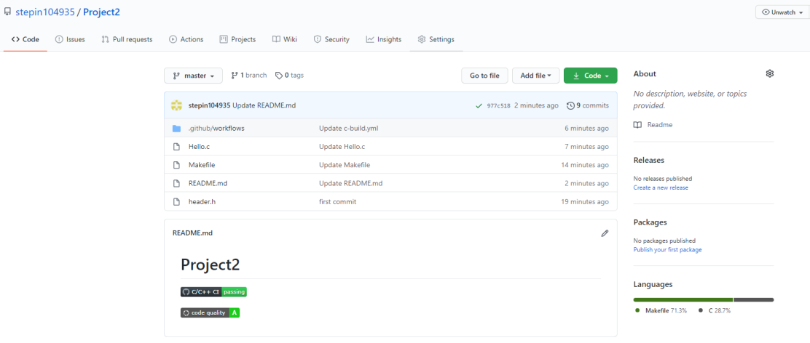

1. **Make File**

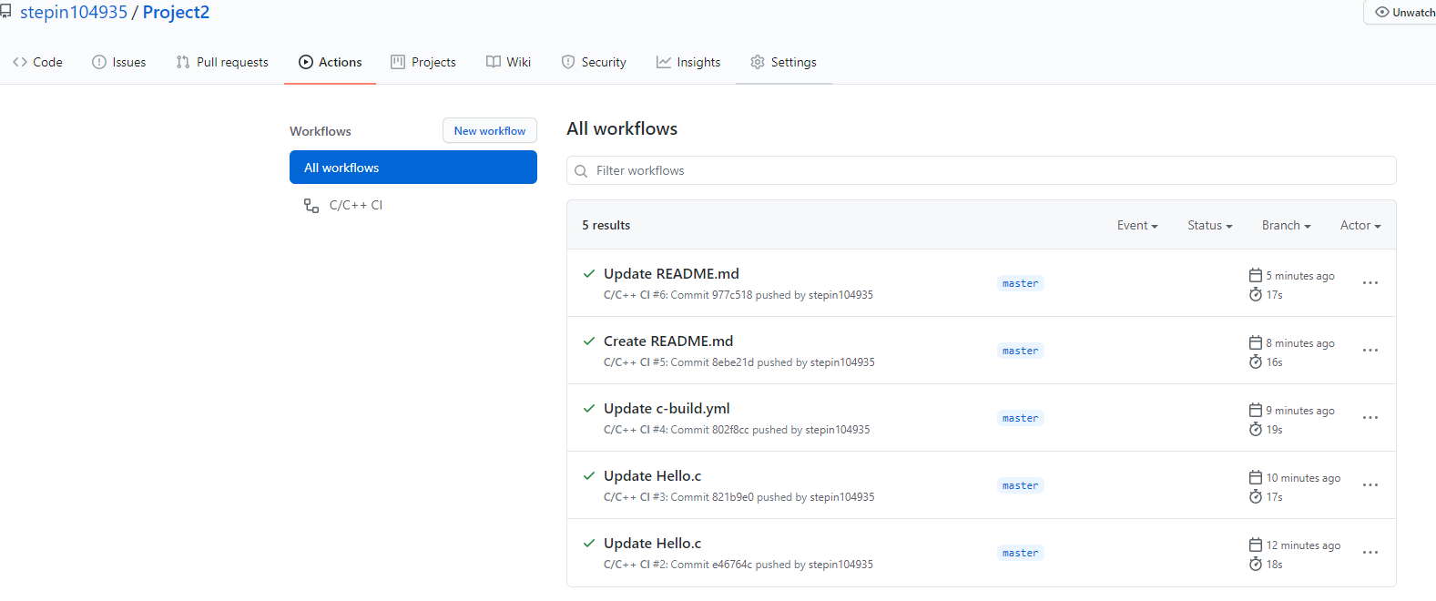

1. **Build**

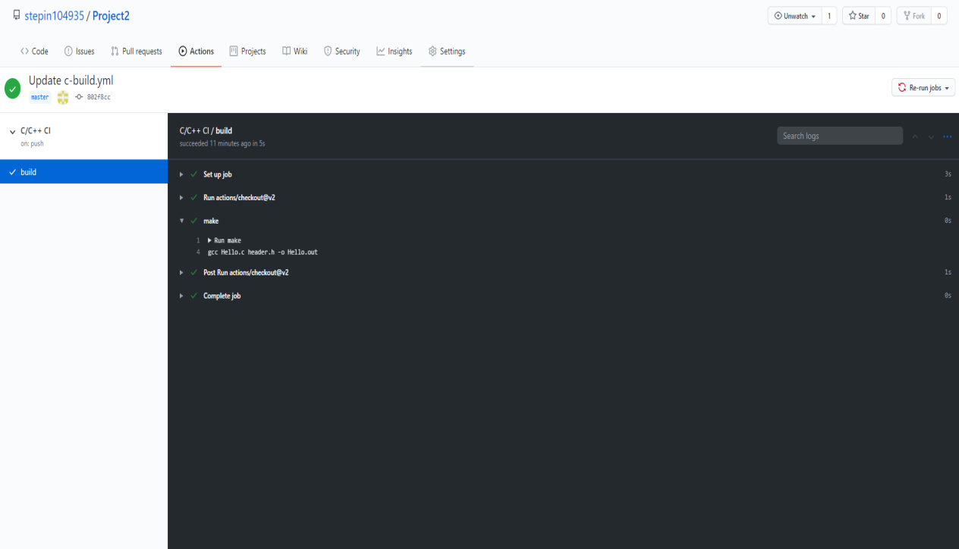

1. **Code Quality**

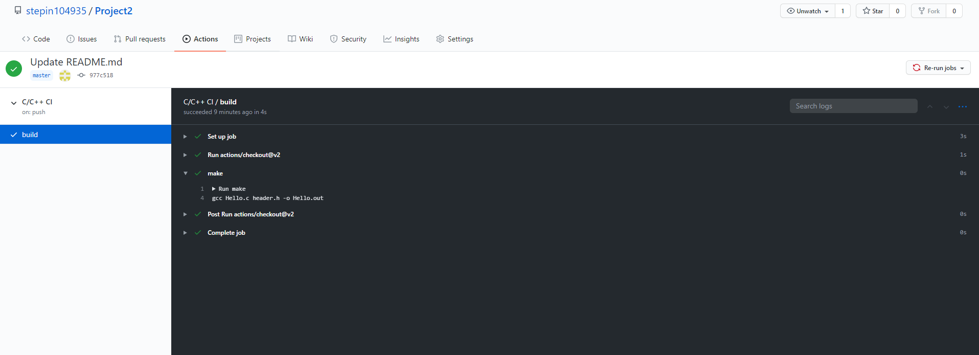

GIT LINK: <https://github.com/stepin104935/Project2>

# ACTIVITY 3

## **AGILE ASPECTS**

1. **Agile methodology**

Agile practices for software development aim to offer a lightweight, product-oriented solution in a

fast changing environment. Agile practices have as high-level philosophy simplicity and

speed,concentrating only on the functions needed, delivering them fast, collecting feedback and

reacting rapidly to business and technology changes.

* Customer satisfaction by early and continuous delivery of valuable software.
* Welcome changing requirements, even in late development.
* Deliver working software frequently (weeks rather than months)
* Close, daily cooperation between business people and developers
* Projects are built around motivated individuals, who should be trusted
* Face-to-face conversation is the best form of communication (co-location)
* Working software is the primary measure of progress
* Sustainable development, able to maintain a constant pace
* Continuous attention to technical excellence and good design
* Simplicity—the art of maximizing the amount of work not done—is essential
* Best architectures, requirements, and designs emerge from self-organizing teams
* Regularly, the team reflects on how to become more effective, and adjusts accordingly

Many industrial giants which are the top and important players in their respective fields, adopt to the

Agile methodology. This is used to continuously monitor and report progress on the system development

to their respective clients.

1. **Epic and User stories**

An Epic can be defined as a big chunk of work that has one common objective

User stories are short, simple descriptions of a feature told from the perspective of the person who desires the new capability, usually a user or customer of the system.

**2.1 Epic for Smart bag for Women safety**

**User story 1:**

 As a customer, I want to buy a smart bag product so that I can use the product.

The THEME at large in this story is to design a system which meets the expectations of improvements

to the current technologies related to that field.

**User story 2:**

As a regular customer, I want to buy a smart bag with low cost so that it is going to be affordable for everyone.

The THEME at large in this story is to design a system which meets the expectations of improvements

to the current technologies related to that field.

**User story 3:**

As a traveler, I want all features like light weight, easy to use that should be included in one piece

rather than going for different types of bags so that it will be very useful for travelers and also for

others as well.

The THEME at large in this story is to design a system which meets the expectations of improvements

to the current technologies related to that field.

## **V Model**

**Requirement analysis:**

High level requirements are bag and emergency button where the emergency button is built in bag with well-defined features where acceptance test design which discovers the performance defects in the user environment which goes parallelly with the requirement analysis.

**System design:**

With the input of requirements documents feasibility study is conducted on bag and emergency button like how feasible bag and emergency button works and what are all the specialities. System design is parallelly done where the whole system functionality is tested.

**Architecture Design:**

At this stage analysis of system design document is done and generate high level design as different components are ready to build the product. And in Integration testing the internal modules like all the parts of bag and emergency button.

**Module Design:**

As above 3 steps act as input for this stage, an individual module that is bag and emergency button is designed and generates low-level design. In Unit testing each individual module functions are tested.

**Coding:**

As it is not the software product, but it consists of coding in the Arduino. The programming language used in Arduino is C.

# ACTIVITY-CI

## **DOCUMENTATION**

**MULTIPURPOSE CALCULATOR**

**Requirements Mapping:**

|  |  |
| --- | --- |
| **Name** | **Description** |
| H_01 | Operand1 |
| H_02 | Operand 2 |
| H_03 | Basic Arithmetic Ops (add, sub, mul, div) |
| H_01_L_01 | Find out if number is Prime |
| H_01_L_02 | Find out if number is positive |
| H_01_L_03 | Find out if number is negative |
| H_01_L_04 | Find out if number is equal to zero |
| H_01_L_05 | Find out if the Modulo of two numbers |
| H_01_L_06 | Find out if a number is even |
| H_01_L_07 | Find out if a number is odd |
| H_01_L_08 | Find out the percentage of the number |
| H_01_L_09 | Find out the factorial of given number |
| H_01_L_09 | Find out area of a parallelogram |

**UML DIAGRAM**

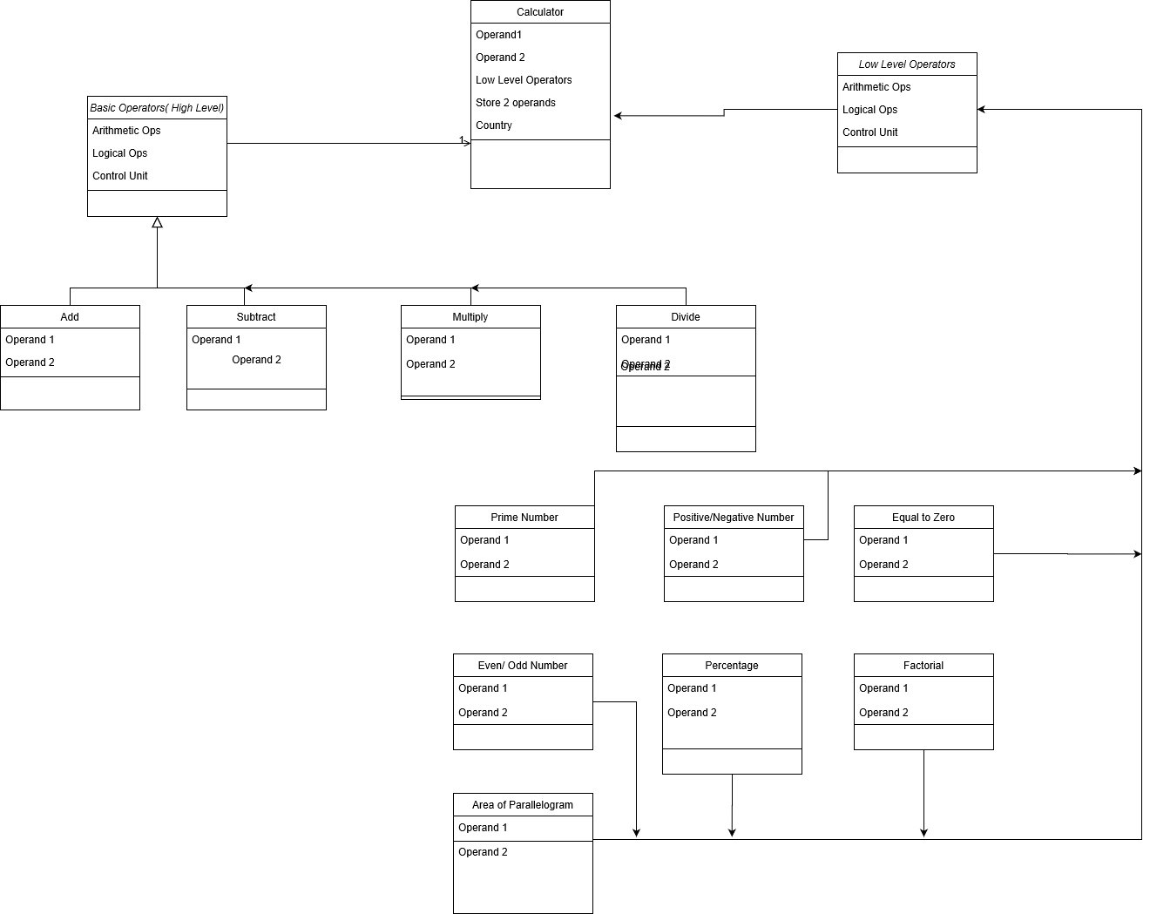

**TEST PLANS**

|  |  |  |  |  |  |
| --- | --- | --- | --- | --- | --- |
| **Product ID** | **Description** | **Precondition** | **Expected Input** | **Expected Output** | **Actual Output** |
| H_01 | Operand 1 | Uninitiated | Initiate | Initiated | Initiated |
| H_02 | Operand 2 | Uninitiated | Initiate | Initiated | Initiated |
| H_03 | Arithmetic Operators | Undefined | Define basic operators | Defined basic operators | Defined Basic Operators |
| H_01_L_01 | Prime number | Not verified | Any integer number | Verify if prime number or not | Verify if prime number or not |
| H_01_L_02 | Positive Number | Not verified | Any integer number | Verify if positive number or not | Verify if positive number or not |
| H_01_L_03 | Negative Number | Not verified | Any integer number | Verify if negative number or not | Verify if negative number or not |
| H_01_L_04 | Zero | Not verified | Any integer number | Verify if number is 0 or not | Verify if number is 0 or not |
| H_01_L_05 | Even number | Not verified | Any integer number | Verify if even number or not | Verify if even number or not |
| H_01_L_06 | Odd number | Not verified | Any integer number | Verify if odd number or not | Verify if odd number or not |
| H_01_L_07 | Percentage | Not calculated | 2 integer numbers | Calculate percentage of a number | Calculate percentage of a number |
| H_01_L_08 | Factorial | Not calculated | Any integer number | Calculate the factorial of a number | Calculate the factorial of a number |
| H_01_L_08 | Area | Not calculated | Two float nums | Calculate the area of a parallelogram | Calculate the area of a parallelogram |

**GITHUB REPOSITORY**

<https://github.com/99002608/Calculator-Operations>

**SCREENSHOTS**

