./

Learning Report – HYBRID ELECTRIC VEHICLES

Course Code: <CODE>



|  |  |  |  |  |  |
| --- | --- | --- | --- | --- | --- |
| **Ver. Rel. No.** | **Release Date** | **Prepared. By** | **Reviewed By** | **Approved By** | **Remarks/Revision Details** |
|  |  |  |  |  |  |
|  |  |  |  |  |  |
|  |  |  |  |  |  |
|  |  |  |  |  |  |
|  |  |  |  |  |  |

**Document History**

# 

Contents

ACTIVITY AND TASKS 3

**Activity 1**– System/Software Development 3

DEFINE TOPIC: 3

RESEARCH 4

SWOT analysis 5

Detailed Requirements for this projects: 6

DESIGN: 9

TEST PLAN: 12

**Activity 2** –CI Workflow for C Programming 14

• BADGES GAINED: 14

• COMMMITS: 14

• ALL WORKFLOWS: 15

• CODACY: 17

**Activity 3** – Agile Aspects 19

• THEMES: 19

• EPIC: 19

• USER STORIES: 19

# 

# ACTIVITY AND TASKS

## **Activity 1**– System/Software Development

### DEFINE TOPIC:

Today's **HYBRID ELECTRIC VEHICLES (HEV)** are powered by an internal combustion engine in combination with one or more electric motors that use energy stored in batteries. HEVs combine the benefits of high fuel economy and low tailpipe emissions with the power and range of conventional vehicles.

A wide variety of HEV models are currently available. Although HEVs are often more expensive than similar conventional vehicles, some cost may be recovered through fuel savings or state incentives. Compare HEV and non-hybrid models side by side using the "Can a Hybrid Save Me Money?" tool on FuelEconomy.gov. The tool compares the costs of a selected HEV with a comparably equipped non-hybrid model from the same manufacturer and provides fuel cost savings associated with the HEV option.

### RESEARCH

#### Cost gradation

A variety of propulsion concepts including hybrids (HEV), plug-in hybrids (PHEVs), extended range electric vehicles (EREVs) battery electric vehicles (BEVs) and fuel cell electric vehicles (FCEVs) are available. Hybrids and plug-in hybrid derived from them and can come in many combinations of powertrain configurations and a mix of electric and internal combustion engine power. In this paper plug-in versions of HEVs with two levels of electric drive power – PHEVs (grid-connected HEVs) and EREVs – are examined. By combining all-electric driving capability at limited top speeds for limited distances with unrestricted range (like ICEs), plug-in hybrid electric vehicles offer a very promising alternative to conventional drivetrains. In addition, the EREV, a vehicle capable of electric driving at all speeds, also using an ICE to increase range and power is examined. The higher initial purchase price and lower running cost of vehicles using electric drivetrains require a life cycle perspective when comparing them to conventional vehicles and to one another. Previous total cost of ownership (TCO) analyses usually exclude maintenance and repair cost (M&R) as well as the resale value of a car. Since the resale value of an average car accounts for over a third of its initial purchase price, this approach might lead to incorrect conclusions. The objective of this paper is therefore a holistic cost assessment of numerous options for use of electric drive, with a special focus on PHEVs.

#### Ageing

The extensive use of batteries in hybrid electric vehicles (HEVs) today requires establishing an accurate model of battery aging and life. During a battery's lifetime, its performance slowly deteriorates because of the degradation of its electrochemical constituents. Battery manufacturers usually provide aging data that will show this degradation. However, the data they provide result from standard aging tests, in which the battery is discharged and charged thousands of times with identical current profiles (or cycles). Using these data many aging models have been developed that relate the maximum number of battery cycles to the depth of discharge (DOD) of the current profile used. In this work, we focus on the development of an aging model suitable for applications in which the battery is used with no pre-defined cycles, as in the case of hybrid-electric vehicles. Laboratory experiments and concepts borrowed from fatigue analysis are applied to the relationship between battery aging and the most important operational conditions that affect its life, i.e. its operating temperature and current history.

### SWOT analysis

#### Strengths:

1. Eco friendly
2. Silent
3. Low cost of ownership
4. Cheaper to run
5. Energy savings achievable from regenerative braking system
6. Simpler mechanism

#### Weakness:

1. Needs time to recharge
2. Lack of recharging infrastructure
3. Batteries change is expensive

#### Opportunities:

1. Governments subsidy for ownership
2. No congestion charge
3. Lower taxes
4. Increasing fossil fuel costs

#### Threats:

1. Compensation in form of electric hybrids, alternative fuel, hydrogen powered cars
2. Rise in cost of electricity

### Detailed Requirements for this projects:

In this section discuss the major requirements. The electric powertrain basically required to develop sufficient power to meet the demands of vehicle performance, carry sufficient energy on-board to support vehicle driving in the given range, high efficiency, and emit less environmental pollutants. The HEV consists of two power sources; one is primary power source and another one is secondary power source. For the purpose of recapturing part of the breaking energy, HEV has at least one bi-directional energy source, typically chemical battery (LIB) or SC.

#### HIGH LEVEL REQUIREMENTS

1. Very high instant power and a high power density.
2. High torque at low speeds for starting and climbing, as well as a high power at high speed for cruising.
3. Very wide speed range, including constant-torque and constant-power regions.
4. Fast torque response.
5. High efficiency over the wide speed and torque ranges.
6. High efficiency for regenerative braking.
7. High reliability and robustness for various vehicle operating conditions, and
8. Reasonable cost

|  |  |
| --- | --- |
| **ID** | **DESCRIPTION** |
| HL_01 | Very high instant power and a high power density. |
| HL_02 | High torque at low speeds for starting and climbing, as well as a high power at high speed for cruising. |
| HL_03 | Very wide speed range, including constant-torque and constant-power regions. |
| HL_04 | Fast torque response. |
| HL_05 | High efficiency over the wide speed and torque ranges. |
| HL_06 | High efficiency for regenerative braking. |
| HL_07 | High reliability and robustness for various vehicle operating conditions and reasonable cost. |

#### LOW LEVEL REQUIREMENTS:

1. Start

When the vehicle is started the fuel cell warms up, if necessary the electric motor acts as a generator, converting energy from the engine into electricity and store in the battery.

1. Cruising

The fuel cell powers the vehicle at cruising speeds and, if needed, provides power to the battery for later use.

1. Passing

During heavy accelerating or when additional power is needed, the fuel cell and electric motor are both used to propel the vehicle. Additional power from the battery is used to power the electric motor as needed.

1. Regenerative Breaking

Regenerative braking converters otherwise wasted energy from braking into electricity and stores it in the battery. In regenerative braking, the electric motor is reversed so that, instead of using electricity to turn the wheels, the rotating wheels turn the motor and create electricity. Using energy from the wheels to turn the motor slows the vehicle down. If additional stopping power is needed, conventional friction brakes are also applied automatically.

1. Stopped

The vehicle is stopped, such the fuel cell and electric motor shut off automatically so that energy is not wasted in idling.

1. Electric Motor Drive

The electric motor provides additional power to assist the engine in accelerating and passing or hill climbing. This allows a smaller; more efficient motor to be used in some vehicles, the motor alone provides power for low speed driving conditions.

1. Automatic Start and Stop

Automatically shuts off the motor when the vehicle comes to a stop and restarts it when the accelerator is pressed. This prevents wasted energy from idling

|  |  |
| --- | --- |
| **ID** | **DESCRIPTION** |
| LLR_01_ | When the vehicle is started the fuel cell warms up, if necessary the electric motor acts as a generator, converting energy from the engine into electricity and store in the battery. |
| LLR_02 | The fuel cell powers the vehicle at cruising speeds and, if needed, provides power to the battery for later use. |
| LLR_03 | During heavy accelerating or when additional power is needed, the fuel cell and electric motor are both used to propel the vehicle. Additional power from the battery is used to power the electric motor as needed. |
| LLR_04 | Regenerative braking converters otherwise wasted energy from braking into electricity and stores it in the battery. In regenerative braking, the electric motor is reversed so that, instead of using electricity to turn the wheels, the rotating wheels turn the motor and create electricity. Using energy from the wheels to turn the motor slows the vehicle down. If additional stopping power is needed, conventional friction brakes are also applied automatically. |
| LLR_05 | The vehicle is stopped, such the fuel cell and electric motor shut off automatically so that energy is not wasted in idling |
| LLR_06 | The electric motor provides additional power to assist the engine in accelerating and passing or hill climbing. This allows a smaller; more efficient motor to be used in some vehicles, the motor alone provides power for low speed driving conditions |
| LLR_07 | Automatically shuts off the motor when the vehicle comes to a stop and restarts it when the accelerator is pressed. This prevents wasted energy from idling. |

### DESIGN:

#### BEHAVIOURAL DIAGRAMS FOR HIGH LEVEL:

1. 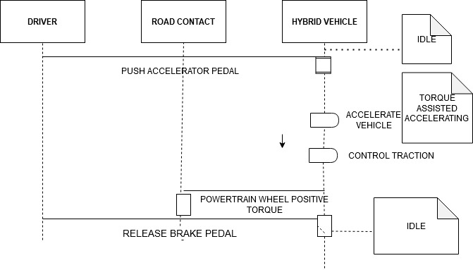SEQUENCE DIAGRAM:

SEQUENCE DIAGRAM

1. 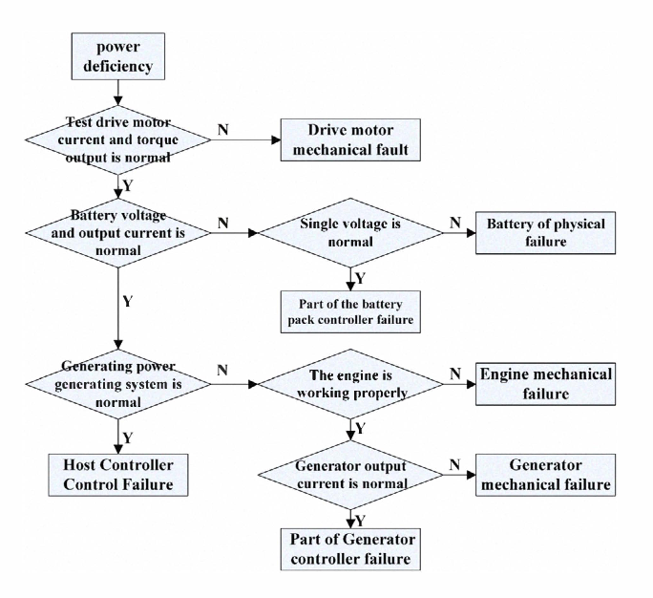ACTIVITY DIAGRAM

#### STRUCTURE DIAGRAM FOR HIGH LEVEL:

1. 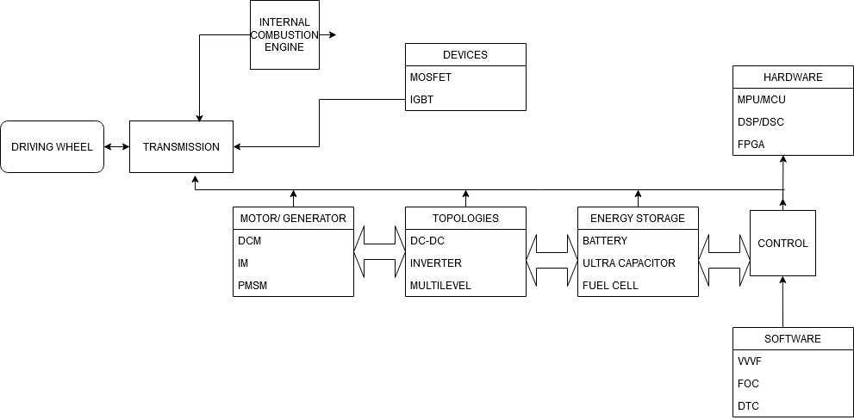COMPONENT DIAGRAM:

COMPONENT DIAGRAM

1. CLASS DIAGRAM: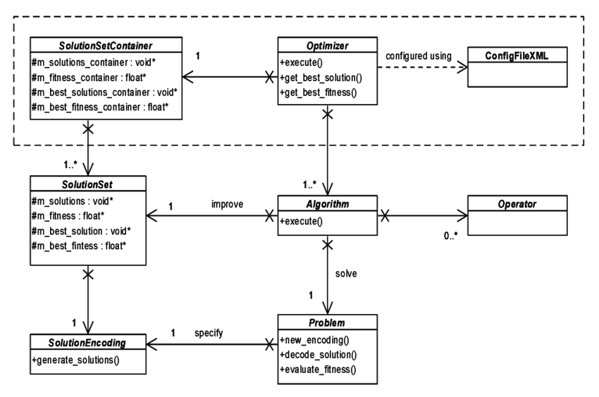

CLASS DIAGRAM

#### BEHVIOURAL DIAGRAM FOR LOW LEVEL:

#### STRUCTURE DIAGRAM FOR LOW LEVEL:

### TEST PLAN:

Plug-in Hybrid Electric Vehicle Acceleration, Grade ability, and Deceleration Test

|  |  |  |  |  |  |
| --- | --- | --- | --- | --- | --- |
| **ID** | **DESCRIPTION** | **PRE_CONDITION** | **EXPECTED INPUT** | **EXPECTED OUTOUT** | **ACTUAL OUTPUT** |
| HL_01 | Battery charger plays an important role in the development of HEV’S | There is a lack of charging infrastructure. | An integrated bidirectional converter is proposed to function as AC/DC battery charger and to transfer energy between battery pack and motor drive of the traction system. | According to input/output-voltage-current conditions, the controller chooses the control schemes and proper operating modes. | The integrated converter reduces system cost, increases power density, and may lead to improved efficiency. |
| HL_02 | 1) to meet the power demand of the driver, 2) to operate each component of the vehicle with optimal efficiency, 3) to recover braking energy as much as possible, | Braking energy is not used up to the mark. And optimal efficiency of the parts of the vehicle are not reached. | The distributed system control with the CAN open protocol on a CAN bus permits the control of the electrical drives systems in safe conditions and with improved dynamic performances. | High torque at low speeds for starting and climbing can obtained from this requirements. | High power for speeding the vehicle can be achieved easily. |
| HL_06 | **regenerative braking** (also called **regen**) is the conversion of the **vehicle's** kinetic energy into chemical energy stored in the battery, where it can be used later to drive the **vehicle**. | The chemical energy stored in the battery after the braking is not used to drive the vehicle in the latter case. | In this concept regen the conversion of vehicles kinetic energy into chemical energy is done. | the driver being one of the most important ones. It's estimated that a system's ability to capture **energy** can range from about 16 to 70 per cent, and that's all in how the vehicle is being driven. | This helps in increase efficiency with respect to the regenerative braking. |

## **Activity 2** –CI Workflow for C Programming

### BADGES GAINED:

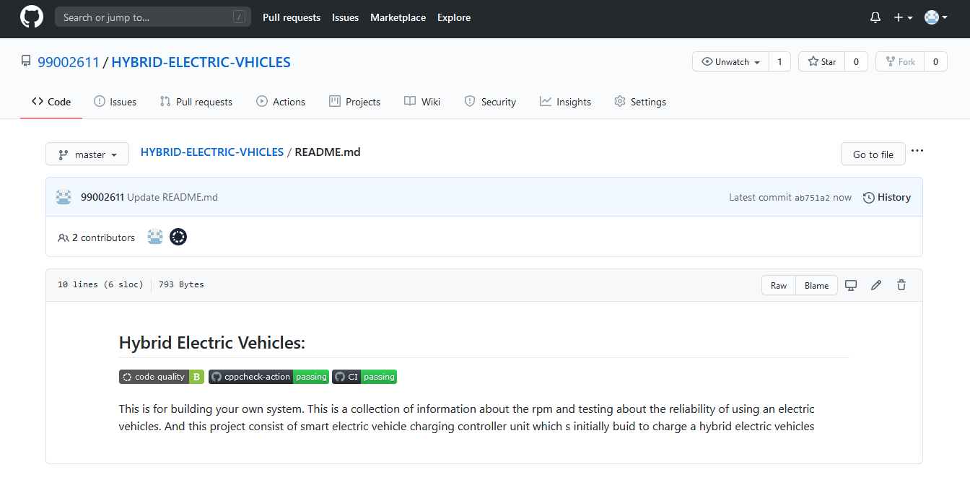

### COMMMITS:



### ALL WORKFLOWS:



### CODACY:

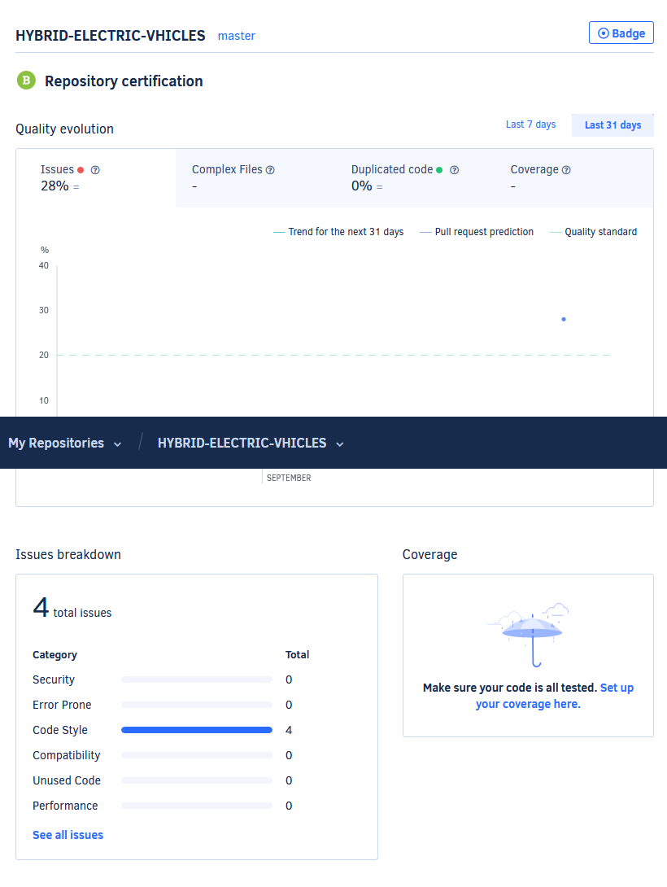

## **Activity 3** – Agile Aspects

### THEMES:

HYBRID ELECTRIC VEHICLES

### EPIC:

TORQUE AND SPEED MANAGEMENT, FAST TORQUE RESPONSE, HIGH EFFICIENCY OVER THE WIDE SPEED AND TORQUE RANGES, HIGH EFFICIENCY FOR REGENERATIVE BRAKING.

### USER STORIES:

* As a process manager,

I make sure that the vehicles all components are working in a correct sequence and also give outputs to the other departments for their valuable work.

Expected completion time of the story is around 5 days.

* As a power and torque analyst,

I make sure that the vehicle delivers the proper power to reach the desired speed. and also checks for the wide range of speeds. And other configurations such as braking and torque and mileage of the vehicle.

Expected completion time of the story is around 30 days.

* As a customer,

As a customer I expect the vehicle needs to be maintenance free and should be highly reliable on long time. The should have a long life and should work on all conditions.

Expected completion time of the story is around 1 year.