./

Learning Report – Scientific calculator

Course Code: <CODE>



|  |  |  |  |  |  |
| --- | --- | --- | --- | --- | --- |
| **Ver. Rel. No.** | **Release Date** | **Prepared. By** | **Reviewed By** | **Approved By** | **Remarks/Revision Details** |
|  |  |  |  |  |  |
|  |  |  |  |  |  |
|  |  |  |  |  |  |
|  |  |  |  |  |  |
|  |  |  |  |  |  |

**Document History**

# 

Contents

Checklist 3

Activity and Tasks 4

**Activity 1**– System/Software Development 4

• Design 6

**Activity 2** –CI Workflow for C Programming 6

**Activity 3** – Agile Aspects 6

# Checklist

* Installation of SW on Phone and Desktop
* Additional Aspects …

# Activity and Tasks

## **Activity 1**– System/Software Development

* Requirements : The calculator must have the following keys
* Number from 0-9
* Symbols - /, +, *, -
* Trigonometric functions – sine, cosine, sine hyperbolic, cosine hyperbolic
* Other functions like exponential, factorial etc.
* Aging
* The first scientific calculator that included all of the basic ideas above was the programmable Hewlett-Packard [HP-9100A](https://en.wikipedia.org/wiki/Hewlett-Packard_9100A) released in 1968
* The [HP-35](https://en.wikipedia.org/wiki/HP-35), introduced on February 1, 1972, was Hewlett-Packard's first [pocket calculator](https://en.wikipedia.org/wiki/Pocket_calculator) and the world's first handheld scientific calculator
* Handheld scientific calculator on January 15, 1974, in the form of the [SR-50](https://en.wikipedia.org/wiki/TI_SR-50)
* First graphics calculator developed in 1990 Tl-81 for math education that adds a new visual dimension to mathematics instruction
* Cost gradation

|  |  |  |
| --- | --- | --- |
| Year | Model | Cost |
| 1972 | Tl-2500 | $149.95 |
| 1985 | fx-7000G | $75 |
| 1988 | Tl-68 | $55 |
| 1992 | Tl-85 | $130 |
| 2020 | Tl-30XS | $18.13 |

* SWOT Analysis

1. Strengths

* Products driven by innovation
* Strong technology expertise driving new business
* Board variety of products across consumer segments
* Efficient marketing team and major sponsorships

1. Weakness

* Brand image stereotyped
* Slow to launch products as per fast changing consumer needs

1. Opportunities

* Youth centric approach in launching new products
* Marketing and brand promotion
* Adapting to new technology and creating new businesses
* Expand growth in timepiece and educational scientific calculator business

1. Threats

* Large competitors
* Fluctuations in economy can highly influence sales
* Low level requirements

|  |  |
| --- | --- |
| ID | requirements |
| LL_01 | Include buttons with number 0-9 |
| LL_02 | Calculator must provide with ON, Off, Memory options. |

* High level requirements

|  |  |
| --- | --- |
| ID | requirements |
| HL_01 | Trigonometric functions like sine, cos, hyperbolic sine and hyperbolic cos must include in the calculator. |
| HL_02 | Exponential, logarithm and factorial functions must include in the calculator |
| HL_03 | Symbols like +, -, *, / must include to perform simple mathematical operations. |

* Test plan

|  |  |  |  |  |  |
| --- | --- | --- | --- | --- | --- |
| **ID** | **Description** | **Pre-condition** | **Expected I/P** | **Expected O/P** | **Actual O/P** |
| HL_01 | Calculate the sine function | Calculator is in degree mode. | Enter an integer | If integer is 0 to 180, then return sine function value, if integer is 180 to 270, if integer is -360, -180 and 360, return 0. | If integer is 0 to 180, then return sine function value, if integer is 180 to 270, if integer is -360, -180 and 360, return 0. |
| HL_02 | Calculate the cos function | Calculator is in degree mode | Enter an integer | If integer is 0 to 90, return cos function. If integer is 90 to 180, return –cos. For 180 to 270, return –cos function and for 270 to 360, return cos function. | If integer is 0 to 90, return cos function. If integer is 90 to 180, return –cos. For 180 to 270, return –cos function and for 270 to 360, return cos function. |
| HL_03 | Calculate the factorial of a number | Calculator is in degree mode | Enter a number to be factorized | If a given number is 0 and 1 then return 0. For number other than 0 and 1, calculate the factorial of the number | If a given number is 0 and 1 then return 0. For number other than 0 and 1, calculate the factorial of the number. |

## Design

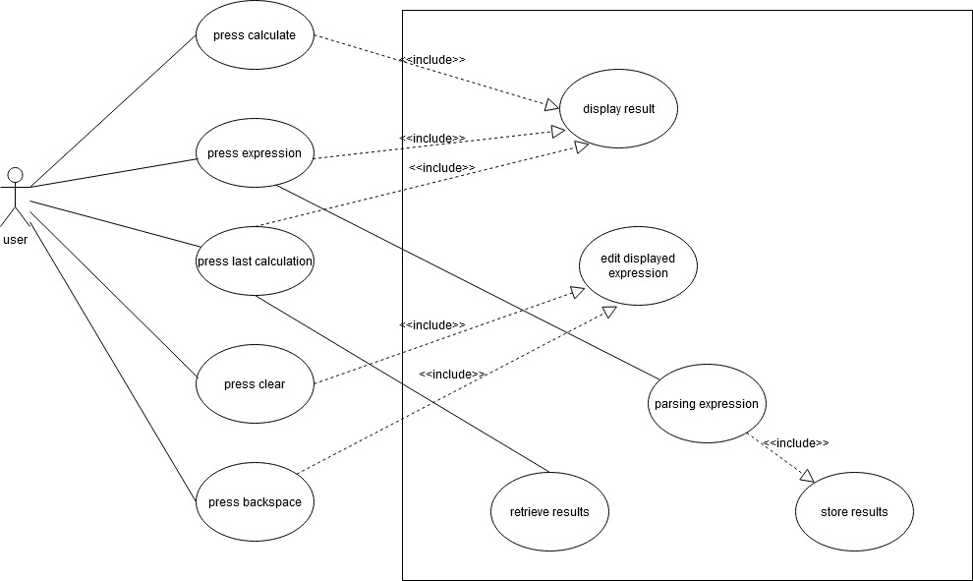

Use case Diagram

## **Activity 2** – Agile Aspects

* Theme : Scientific calculator
* Epic : trigonometric and factorial operation
* User stories :

Description - As a user

I need to perform trigonometric operation.

I need to calculate sine function

Test case - an integer is entered

If integer is 0 to 180, then return sine function value, if integer is 180 to 270, if integer is -360, -180 and 360, return 0

Description - As a user

I need to perform trigonometric operation.

I need to calculate cosine function

Test case - an integer is entered

If integer is 0 to 90, return cosine function. If integer is 90 to 180, return –cosine. For 180 to 270, return –cosine function and for 270 to 360, return cosine function.

Description - As a user

I need to calculate factorial of a number

Test case - an integer is entered

If a given number is 0 and 1 then return 0. For number other than 0 and 1, calculate the factorial of the number

## **Activity 3** –CI Workflow for C Programming

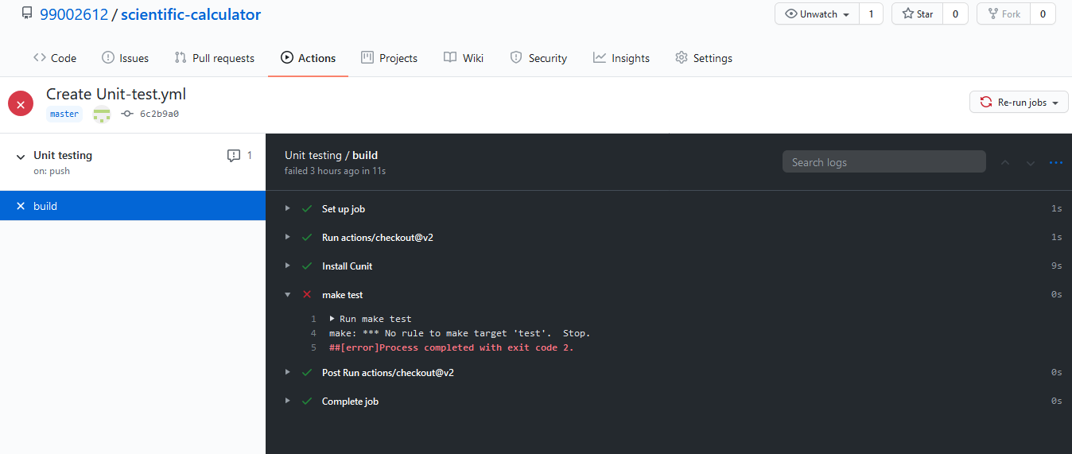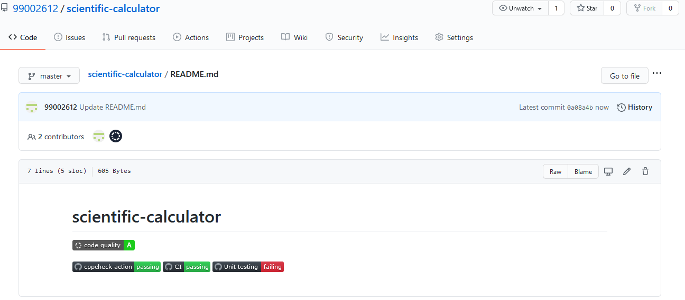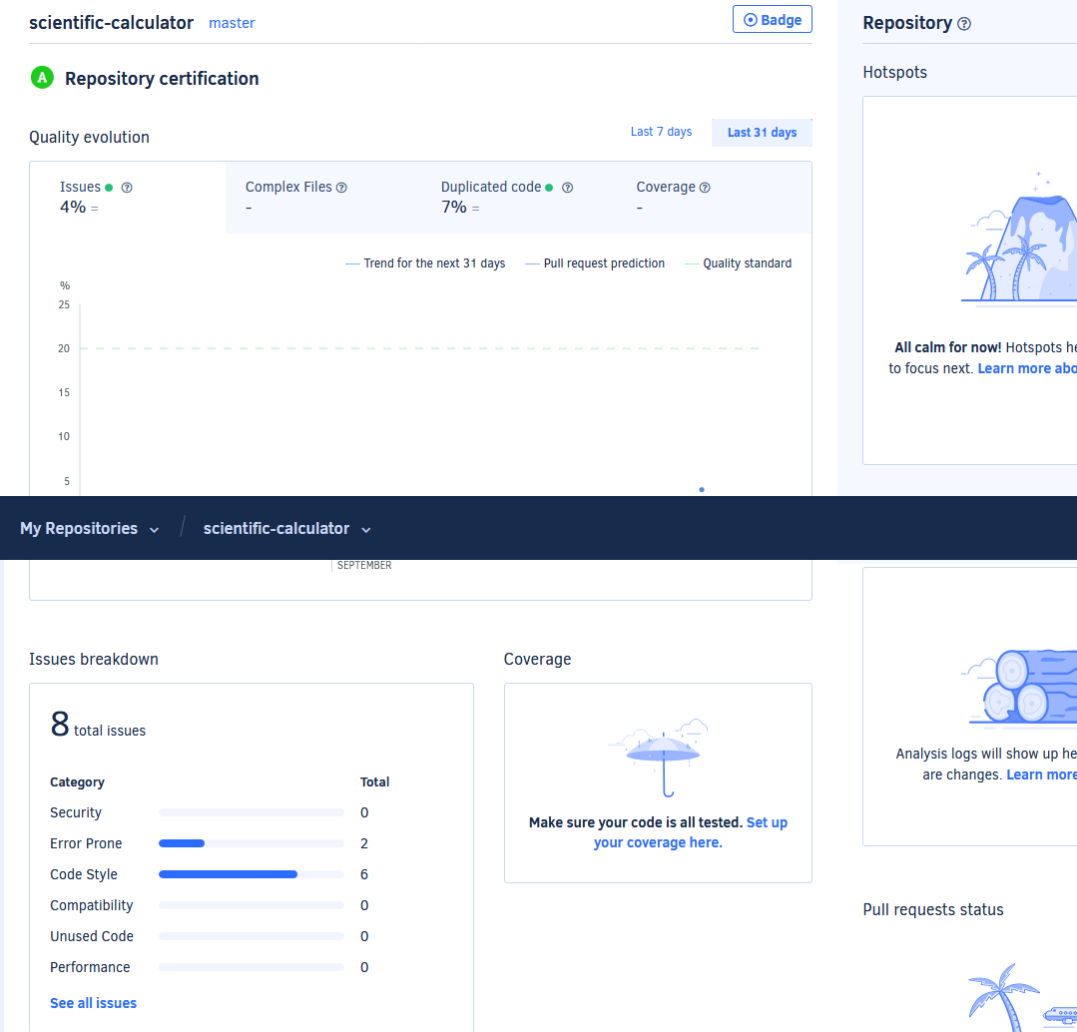

**Reference**

[https://en.wikipedia.org/wiki/Scientific_calculator#History](https://en.wikipedia.org/wiki/Scientific_calculator%23History)

<https://www.swotandpestle.com/casio/>

**Appendix**

<https://github.com/stepin104947/calc>