**DOCUMENTATION FOR TS GOT TALENT APP**

**Name : NITHYA P**

**PS No : 99002626**

1. SCREENSHOTS

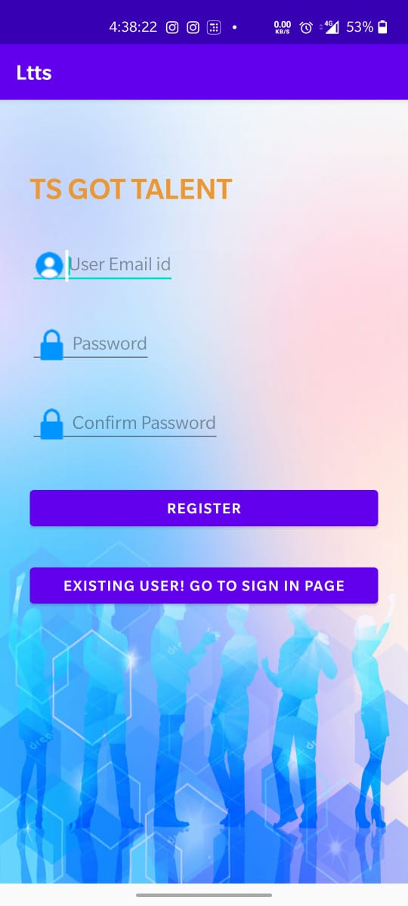 

Fig 1: Resistration Activity Fig 2: Login Activity

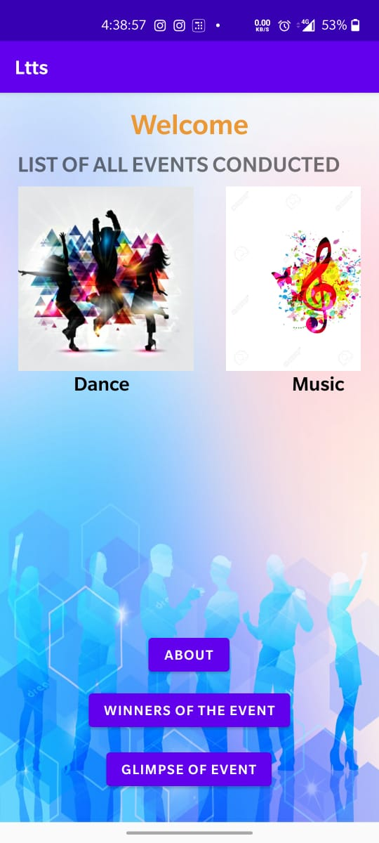 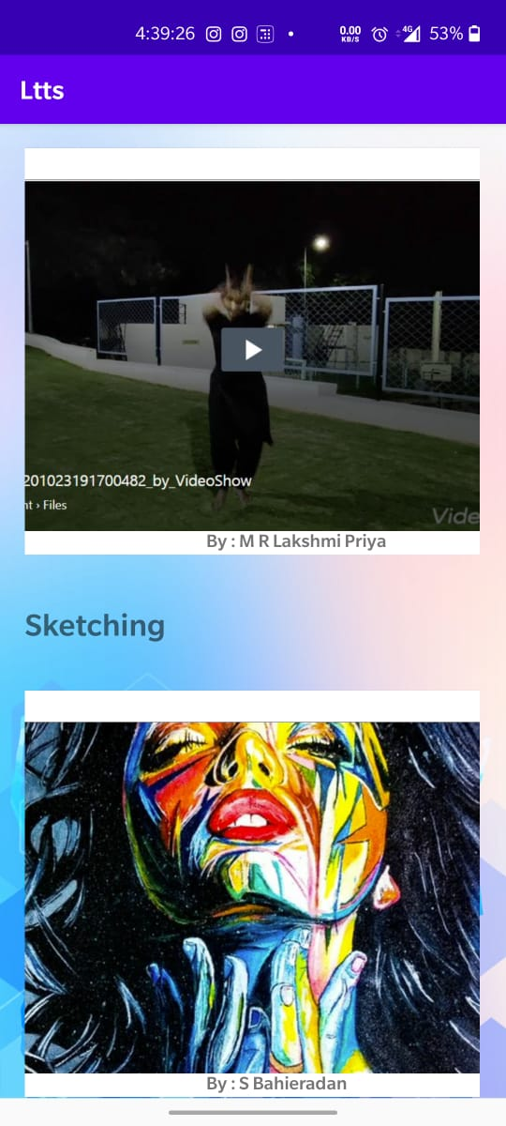

Fig 3: Welcome Activity Fig 4: Winners Activity

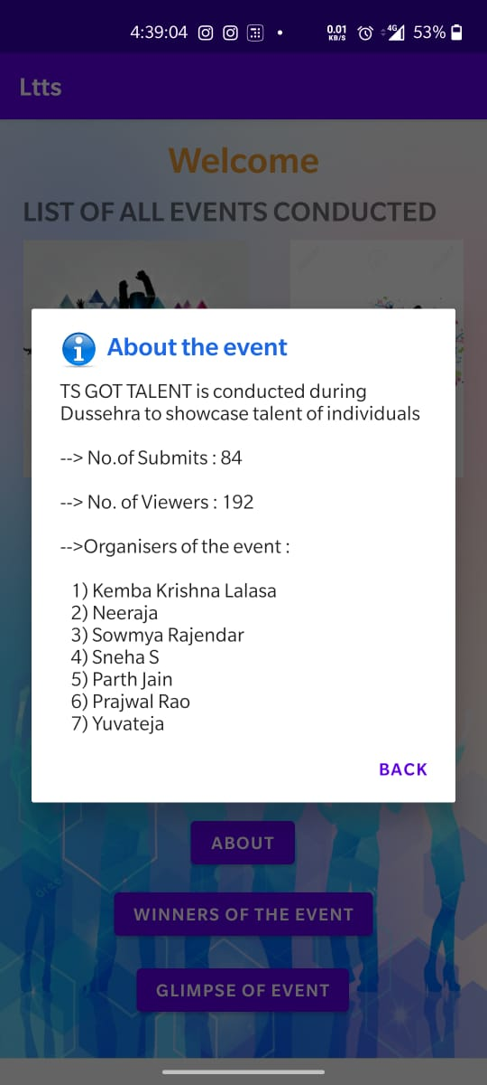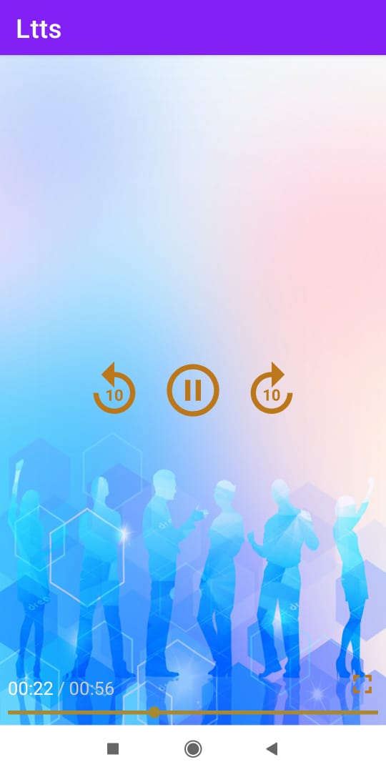

Fig 5: About the Event Fig 6: Exo Player

1. Link to APK : <https://appetize.io/app/vebgfudbv7jfbxuzj03wwda06c>
2. Link to GitHub : https://github.com/99002626/androidAssessment