Cyber security And Cyber Safety

Cyber security | Cyber safety
- means protecting data and information networks.  - Cybersecurity protects school technology infrastructure, such as networks, computers, cloud applications, and data from cyber-attacks. | - means protecting users from harmful online content.  - Cyber safety uses technology to help protect the data.

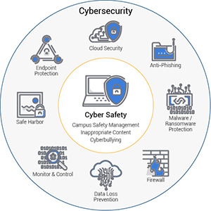

Measures
1) Establish strong passwords: using a combination of capital and lower-case letters, numbers, and symbols.

2) Set up a firewall: Gatekeepers between your computer and the internet, and one of the major barriers to prevent the spread of cyber threats such as viruses and malware.

Make sure that you set up your firewall devices properly and check them regularly to ensure they have the latest software/firmware updates installed, or they may not be fully effective.

3) Think of antivirus protection: Antivirus and anti-malware are indispensable to protecting your Data. They are designed to prevent, search for, detect and remove viruses but also adware, worms, trojans, and so on.

4) Updating is important: Computer must be properly patched and updated. Recent updates allow your Data to be more secured.

5) Encryption: A simple solution is to encrypt them. In doing so, without the right password, your computer’s Data is unreadable.

6) Schedule backups: You can schedule backups to external hard drives or in the cloud to keep your data stored safely.

7) Latest software in market: Data, Software, technologies, everything is moving so fast. Keep track of them, keep in touch with news to see what is new on the market.

8) Be smart with emails and surfing the web: Downloading apps or files, opening emails, and clicking on links can infect your computer and your network.

9) Educate your employees about Data Security: Prevention is the best way to keep your Data safe. Warned employees will always be more attentive.

10) Use Two-Factor Authentication: This method provides two layers of security measures so if a hacker can accurately guess your password, there is still an additional security measure in place to ensure that your account is not breached.

