./

Learning Report – Emotion Detection and Banking System

Course Code: <CODE>



|  |  |  |  |  |  |
| --- | --- | --- | --- | --- | --- |
| **Ver. Rel. No.** | **Release Date** | **Prepared. By** | **Reviewed By** | **Approved By** | **Remarks/Revision Details** |
| 1 | 17/09/2020 | Shabana R P |  |  |  |
| 2 | 18/09/2020 | Shabana R P |  |  |  |
| 3 | 19/09/2020 | Shabana R P |  |  |  |
|  |  |  |  |  |  |
|  |  |  |  |  |  |

**Document History**

# 

Contents

Checklist Error! Bookmark not defined.

Activity and Tasks 4

Activity 1– System/Software Development 5

Activity 2– Agile Aspects 19

Activity 3 –CI Activity 21

Activity4-CI Workflow……………………………………………………………………………………………………………………………………26

Appendix 30

# 

# Activity and Tasks

## **Activity 1**– System/Software Development

* Sub Tasks
* Complete and Evolve

## **Activity 2** – Agile Aspects

* Theme
* Epic
* User stories

## **Activity 3**–CI Activity for C Programming

* Sub Tasks
* Complete and Evolve

## **Activity 3**–CI Workflow for C Programming

* Sub Tasks
* Complete and Evolve

**Appendix**

Task 1: Software Development analysis

**Requirement Gathering**

Research: aging and costing in terms of performance and accuracy

|  |  |  |
| --- | --- | --- |
| Years | Performance | Cost value(accuracy) |
| 2002 | 2.5 million emotions tweets covering 7 emotion categories for automatic emotion detection | 60.4% |
| 2012 | Unigram method, Lemmatized unigram, Naïve Bayes lexical model | 65.57% |
| 2014 | LDA and SVM | 70% |

**Past:**

**Keyword-based:**

In Existing solution method detection of emotions is limited to some short documents. They detect emotions by classifying it into positive , negative and neutral.

**Limitations:**

Ambiguity in Keyword Definitions

Incapability of Recognizing Sentences without Keywords

Lack of Linguistic Information

**Present:**

**Sentiment Analysis (SA) or Opinion Mining (OM)** is the computational study of people’s opinions, attitudes and emotions toward an entity. The entity can represent individuals, events or topics. These topics are most likely to be covered by reviews. The two expressions SA or OM are interchangeable.

In [1], the authors explore the field of sentiment analysis. According to them domain-specific corpus gives better results than working on the domain independent corpus. There is still lack of research in the field of domain-specific SA which is sometimes called context-based SA. This is because building the domain-specific corpus is more complicated than using the domain-independent one

**Future:**

Above project can be fine-tuned by implementing it with POS tagger and word2vec tool by making it domain independent

**Added features:**

POS Tagger

Word2vec tool

Comparing accuracy of keyword based and POS Tagging based methods

**SWOT Analysis:**

4 . High level and low level Requirement(traditional):

High level requirement

1. Data Pre processing
2. Identify basic emotions
3. Extend dataset

Low Requirement:

1. Data Preprocessing

* Tokenization
* Lemmatization
* Stemming
* Stopword removal

1. Identify basic emotions

* Classify emotions by implementing algorithms

1. Pos tagging
2. Classification
3. Extend Dataset

* Implement Word2vec tool

4 . High level and low level Requirement(agile):

High Level Requirement:

|  |  |
| --- | --- |
| ID | Description |
| 1 | 1. Data Pre-processing |
| 2 | 1. Identify basic emotions |
| 3 | 1. Extend dataset |

Low Requirement:

|  |  |
| --- | --- |
| ID | Description |
| 1 | Tokenization: Tokenization is a key (and mandatory) aspect of working with text data |
| 2 | Lemmatization:  takes into consideration the morphological analysis of the words. To do so, it is necessary to have detailed dictionaries which the algorithm can look through to link the form back to its lemma. |
| 3 | Stemming: algorithms work by cutting off the end or the beginning of the word, taking into account a list of common prefixes and suffixes that can be found in an inflected word. |
| 4 | Stop word removal:  A stop word is a commonly used word (such as “the”, “a”, “an”, “in”) that a search engine has been programmed to ignore |
| 5 | Classify emotions by implementing algorithms :Classify them into basic emotion classes |
| 6 | Pos tagging:is the process of assigning a **part-of-speech** like noun, verb, pronoun, preposition, adverb, adjective or other lexical class marker to each word in a sentence. The **POS tagger** assigns to each token in the input one of **POS tags**. |
| 7 | Implement Word2vec tool: To extend database implement word2vec |

Design:

1. High-level design
   * + 1. Structural Diagrams:

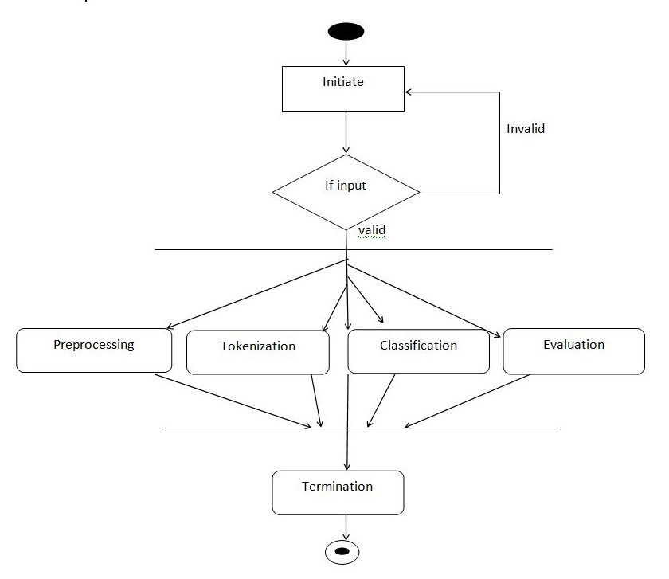

Fig(1).Emotion Classifier

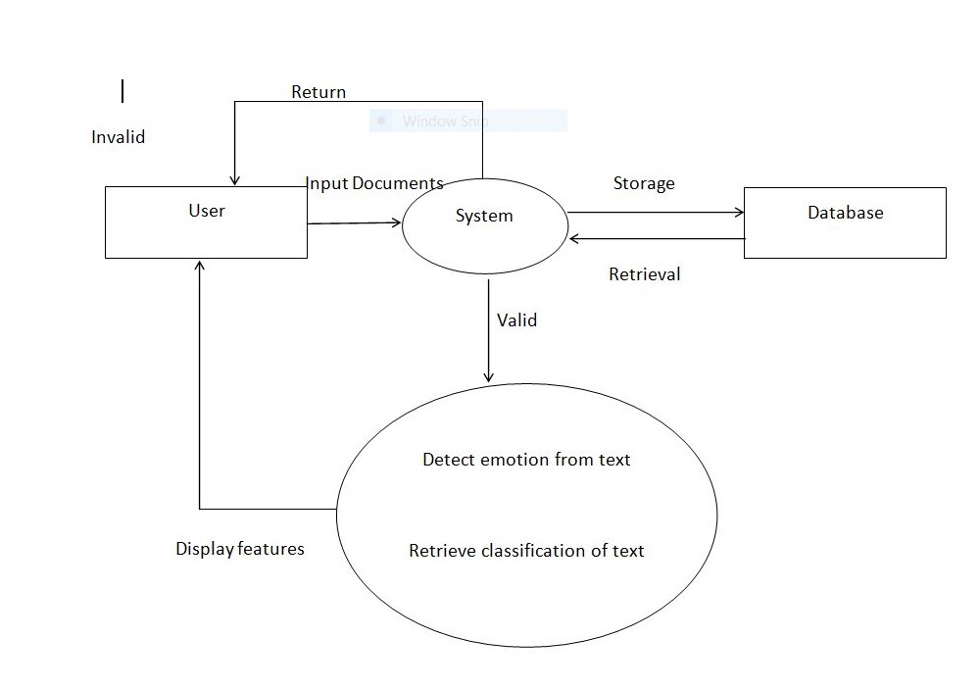

Fig(2)Information Retrival

Behavioral diagrams

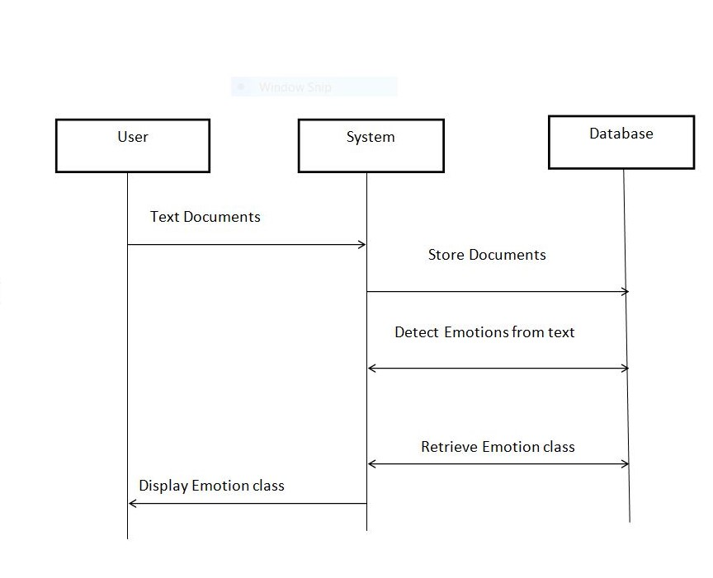

Fig (3) Sequence Diagram for classifying emotions

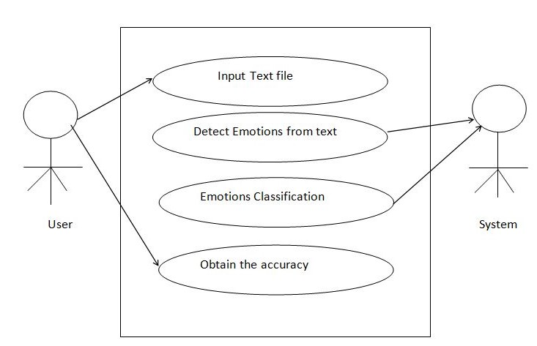

Fig(4)Use Case Diagram for obtaining accuracy

1. Low-level design
   * + 1. Structural Diagrams:

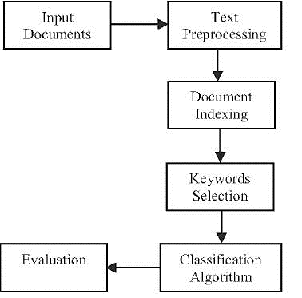

Fig(5) Feature Selection



Fig(6) Pre processing

English Text

Sentence segmentation

Sentence

Tokenization

Fig(7) Tokenization

English Text

Parts of speech recognizing

Sentence segmentation

Sentence

POS Tagging

Tokenization

**Test Plans (agile method):**

**Requirement Based Test cases:** To classify sentences into basic emotions

|  |  |  |  |  |  |
| --- | --- | --- | --- | --- | --- |
| ID | Description | Pre condition | Expected  input | Expected output | Actual  output |
| 1 | Classify the sentence into fear class | It should identify fear keyword with word much | I am having so much fear about my life | Emotion Detected:  Fear |  |
| 2 | Classify the sentence into joy class | It should identify happy, good keyword with word very | I am very happy and good | Emotion Detected:  Joy |  |
| 3 | Classify the sentence into sad class | It should take intensity of sadness | I was sad by hearing that news | Emotion Detected:  Sad |  |
| 4 | Classify the sentence into Anger class | It should take intensity of sadness | The sport riot caused too much anger in players and fans | Emotion Detected: Anger |  |
| 5 | Classify the sentence into disgust class | It should take intensity of sadness | It was a disgusting move by the government | Emotion detected:  disgust |  |

**2. Scenario Based Test cases:**

|  |  |  |  |  |  |
| --- | --- | --- | --- | --- | --- |
| ID | Description | Pre-condition | Expected  input | Expected output | Actual  output |
| 1 | Keyword based approach: | If not is used before the emotion word or within some specified window it should be considered and sentence should be classified according to their classes | I am not  happy | Sad |  |
| 2 | POS Tagging method: | If there are more tags with more emotional words in the sentence then adjective and adverb tagged words should be prioritized | I am not angry | Neutral |  |

**3. Boundary Based Test cases:**

|  |  |  |  |  |  |
| --- | --- | --- | --- | --- | --- |
| ID | Description | Pre-condition | Expected  input | Expected output | Actual  output |
| 1 | Positive or above neutral | : If different adjectives or adverbs are given before the emotional word it should detect the degree of intensity | I am very happy today | Happy  It should consider adverb (very in this case) along with emotional word ie happy to depict the emotion and consider its intensity |  |
| 2 | Neutral  (nullifying) | If different adjectives or adverbs are given before the emotional word it should detect the degree of intensity | I am neither happy nor sad | Neutral  It should nullify this statement to neutral as it contains Both positive and negative emotion |  |
| 3 | Neutral | It should consider this sentence neutral as there is no emotional words in it. | Delhi is the Capital of India | Neutral |  |
| 4 | Negative or below Neutral | If different adjectives or adverbs are given before the emotional word it should detect the degree of intensity | I found it very disgusting and I am angry | It should consider adverb (very in this case) along with negative emotional words i.e. disgusting and angry to depict the emotion and consider its degree of intensity.  if we assign weights, we will have more weightage to disgusting than angry |  |

**2) Agile Aspects**

**Theme**: Emotion detection from Text

* This project is aimed to design a prototype which classifies 5 different levels of emotions from smaller to larger text documents using NLP.
* To classify text as emotional or non-emotional text.
* To compare Natural Language processing.
* To develop a prototype to provide overall accuracy for 5 different emotions.
* To find out Parts of speech for tokenized word.
* To compare Accuracy of both POS and Keyword based Emotion detection methods.

**Epics:**

1**.** Data Pre processing

* Tokenization
* Stop word removal
* Case folding
* Stemming
* Classifying Emotions
* Detect and Classify Emotions into 5 different Categories.
* Accuracy

2. Identify basic emotions

* Classify emotional and non-emotional keywords and then apply algorithms on emotional text to detect correct emotions

3. Extend dataset

* To include new keywords data set should be extended using word2vec-tool

**User stories**:

**Pre-Processing (epic 1)**

**Tokenization** In this process, divide the user query input into small tokens. that is divide the text or sentence into words.

EX. I am not happy today, I am feeling very sad

Tokens: [I] [am] [not] [happy] [today] Next is **Stop word removal**, In this process remove the stop word from the text or sentence, like a, an, the, after, before etc. EX: I am not happy today, I am feeling very sad In the above example after removing stop words the text should be like ANS: happy today feeling very sad, after removing stop words next step is **Case folding** In this process, convert the all words into lowercase for easy comparison. EX: happy today feeling very sad Last step is **Stemming**, In this process, convert the all words into root words. EX: feeling ANS: feel

**Identifying Emotions(epic 2)**

The system should be able to detect emotions from different sized documents. Emotions are divided into 5 different types based on the Paul Ekman Theory. Happy, Sad, Angry, Fear, Disgust, when an input is given it should apply the above discussed preprocessing techniques to extract features then it should apply 2 methods on it i.e. keyword-based approach and POS Tagger approach and then Identify keywords that are the useful to the classifier from the input dataset. Then finally classify extracted features to their respective classes of emotion then Find and compare accuracy of the Emotions for both the methods.

**Extend dataset(epic 3)**

We have an emotion based Keyword dataset and Phrase dataset. Key word dataset has key words which can be used for training the system by classifying keywords into different files according to their emotions. Phrase dataset has phrases which can be used for testing the system by classifying Phrases into different files according to their emotions or keep it as 1 big fat file These dataset may be not sufficient at high level, hence extend the these dataset u sing a tool called word2vec tool.

1. **CI Activity:**
2. **Project title: Online banking system**

**High Level Requirements:**

|  |  |
| --- | --- |
| ID | Description |
| 1 | Create a user account |
| 2 | View the account details |
| 3 | Credit Money |
| 4 | Debit money |
| 5 | Transfer Money between accounts |
| 6 | Mobile number change: If user enters old mobile number it should display a message |

**Low Level Requirements:**

|  |  |
| --- | --- |
| ID | Description |
| 1 | If a user is below 18 year old, he should not be permitted to create account |
| 2 | It should take password from user and match it with the user database |
| 3 | If user credits money which exceeds daily transaction time it should notify user, on successful credit it should display a confirmation mail |
| 4 | If user tries to debit money from the empty /low balance account  It should pop up an error |
| 5 | It should check whether both accounts are valid |

**Design:**

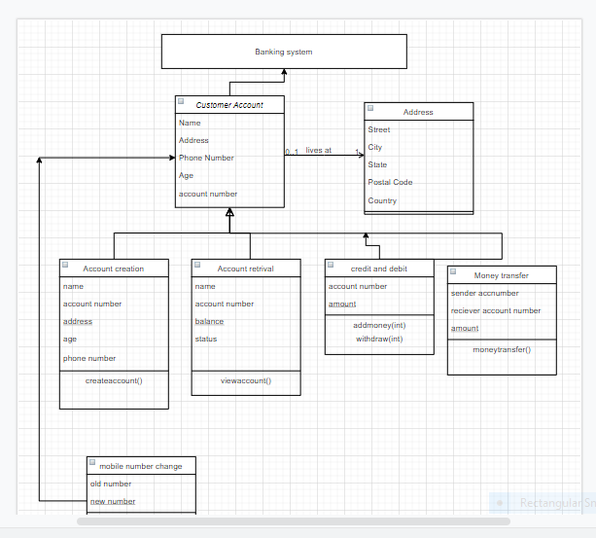

Fig(1) class diagram for Online Banking system

**Test cases:**

|  |  |  |  |  |  |
| --- | --- | --- | --- | --- | --- |
| ID | Description | Pre condition | Expected  input | Expected output | Actual  output |
| 1 | Create a user account | If a user is below 18 year old, he should not be permitted to create account | User below 18 year old  Ex age < 18 | Account cannot be created | Account cannot be created |
| 2 | View the account details | It should take password from user and match it with the user database | User enters password with allowed inputs | If password matches: display the details  If password does not matches: display the error | If password matches: display the details  If password does not matches: display the error |
| 3 | Credit Money | If user credits money which exceeds daily transaction time it should notify user ,on successful credit it should display a confirmation mail | User enters credit amount based on pre condition | On valid transaction: successfully credit  On invalid transaction: display error message | On valid transaction: successfully credit  On invalid transaction: display error message |
| 4 | Debit money | If user tries to debit money from the empty /low balance account  It should pop up an error | The sport riot caused too much anger in players and fans | On valid transaction: successfully debited  On invalid transaction:  Invalid transaction | On valid transaction: successfully debited  On invalid transaction:  Invalid transaction |
| 5 | Transfer Money between accounts | It should check whether both accounts are valid | User enters 2 account numbers and the amount to be transferred | On valid transaction: successfully transferred  On invalid transaction:  In valid Transfer | On valid transaction: successfully transferred  On invalid transaction:  Invalid Transfer |
| 6 | Mobile number change | If user enters old mobile number it should display a message | User enters new mobile number | On valid input: Mobile number changed  On invalid in valid: this is the old number | On valid input: Mobile number changed  On invalid in valid: this is the old number |

**Activity 3**

**CI Workflow:**

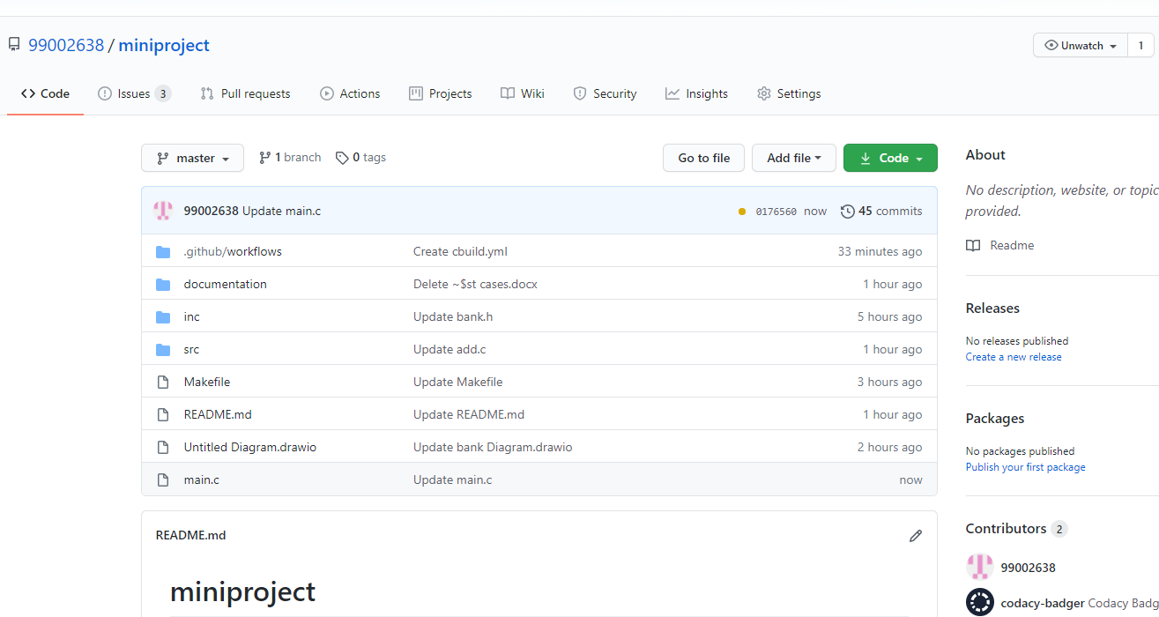

**Fig(1) git commits**

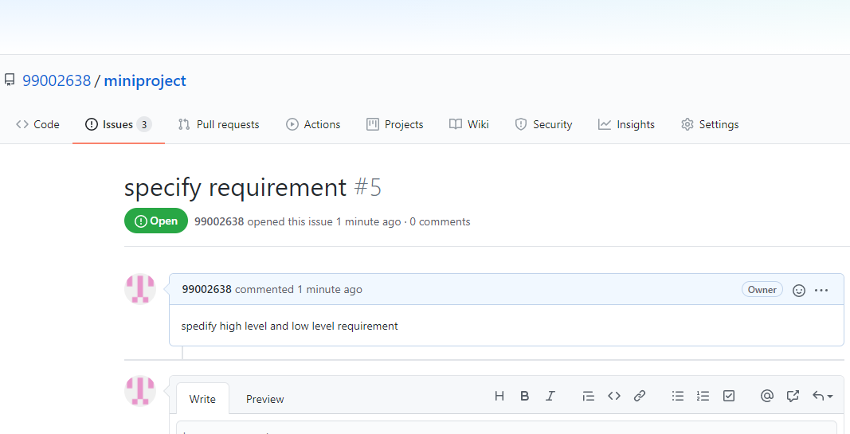

**Fig(2) Issue created**

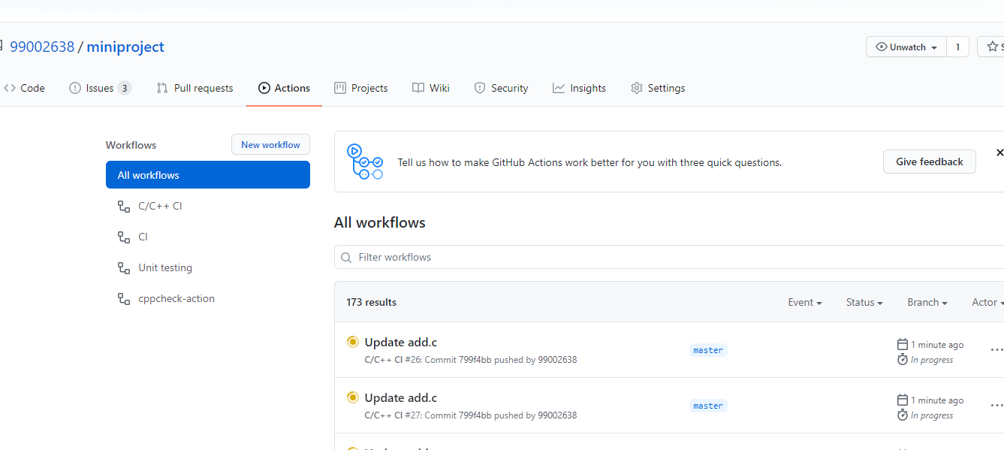

**Fig(3) Git Workflow**

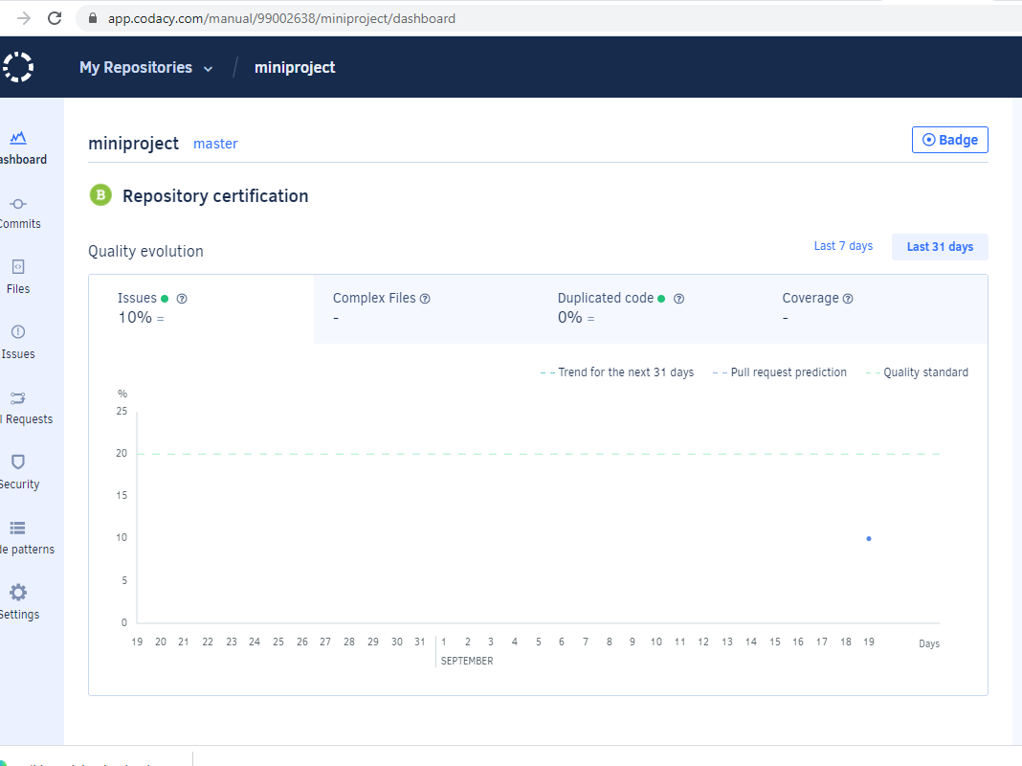

**Fig(4) Code Quality**

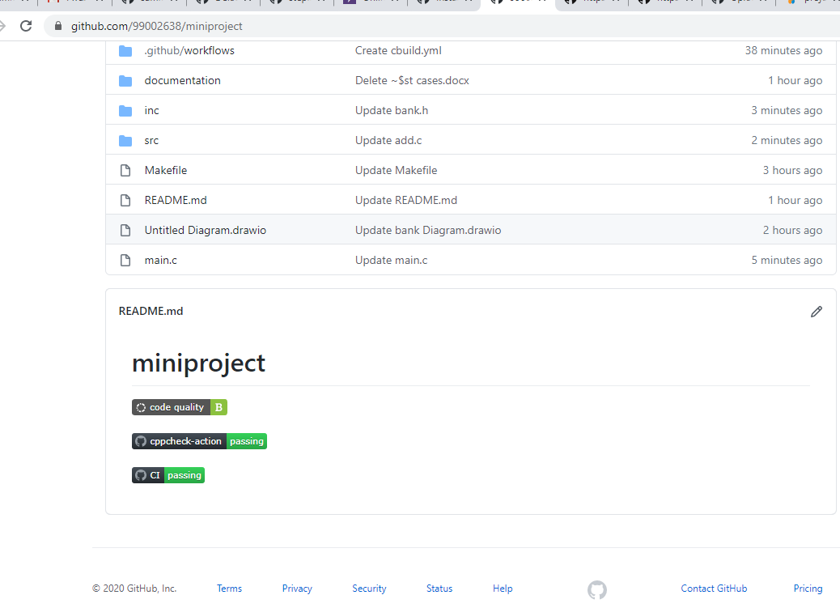

**Fig(4) Badges**

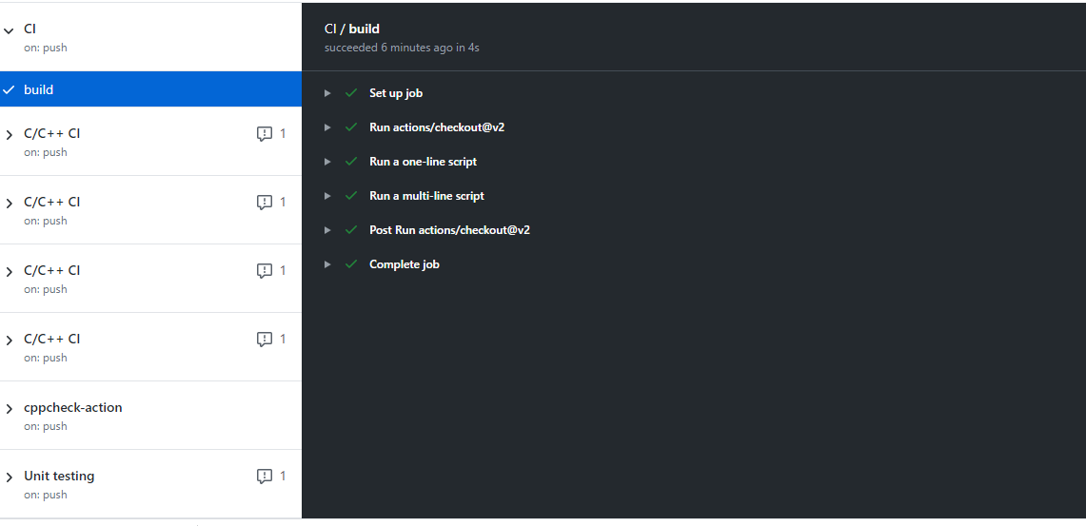

**Fig(5) Build**

**Link To github Repository**: <https://github.com/99002638/miniproject>

**Appendix**

**Completion of 5 basic github courses**

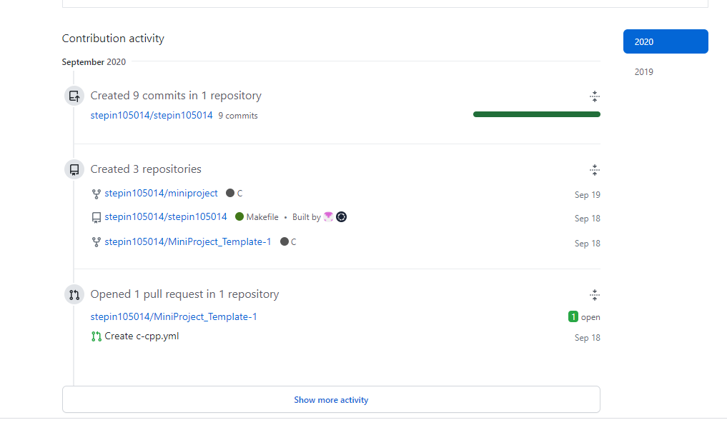

**Fig(1) Github basics**

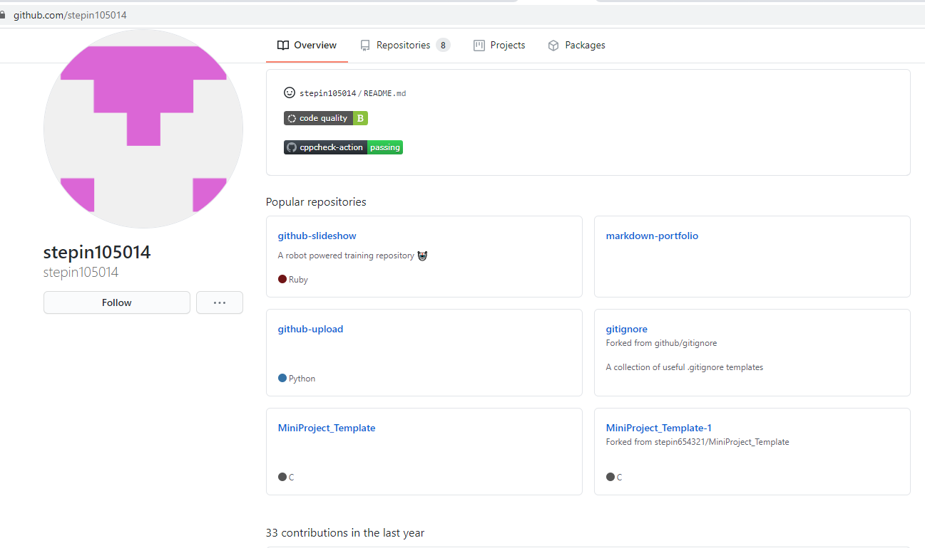

**Fig(2) Repositories(after completing those tasks)**

**Link to the Stepin_Repository:** <https://github.com/stepin105014>

**References:**

[1]. Medhat, Walaa, Ahmed Hassan, and Hoda Korashy. "Sentiment analysis algorithms and applications: A survey." Ain Shams Engineering Journal (2014).

[2] <https://www.researchgate.net/publication/225045375_Emotion_Detection_from_Text>

[3]<https://www.tutorialspoint.com/uml/uml_activity_diagram.htm>

[4]<https://en.m.wikipedia.org/wiki/Use_case_diagram>

[5] <https://en.m.wikipedia.org/wiki/Data-flow_diagram>

[6] <https://en.m.wikipedia.org/wiki/Sequence_diagram>

[7] https://www.javatpoint.com/online-banking-project