Requirements Specifications: Asha & Unmesh

# Analog:

## Transducer:

Tolerance: ±0.06%

Accuracy: ±0.2%

Supply Voltage: 3V to 6V

Power Consumption: 250mW max

Resolution: correct up to 2 decimal figures

Minimum Environmental Conditions: IP65

Operating Temperature: -50°C to 200°C

EMI/EMC compliant

Minimum Response Time: 1000ms

Minimum Linearity: ±0.04

JTAG (female) Connector

## Signal Attenuator & Conditioning:

Attenuation Factor: 100dB?

Max Accuracy: 0.3%

Drift: 60ppm/°C

Supply Voltage: 3V to 6V

Max Offset: 120 µV

Frequency Range: 1Hz to 200000Hz

Power Handling: 300mW max

Type: Surface Mount

Input Impedance: 5GΩ

Output Impedance: 50Ω

Minimum Environmental Conditions: IP43

Operating Temperatures: -20°C to 120°C

Peak Output Latency: 20µs

JTAG (female connector)

Power Supply: 500mW max

## Multiplexer:

Supply Voltage Range: 3V to 6V

Input Clamp Current: ±20mA

Output Clamp Current: ±20mA

Max Supply Current: 90mA

Operating Temperatures: -20°C to 120°C

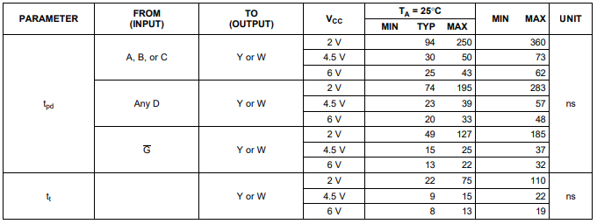

## ADC:

Supply Voltage Range: 3V to 6V

Operating Temperatures: -20°C to 120°C

Max Supply Current: 200mW

Bits: 8 bits

Variable VRef required.

Max VESD = ±800V

Max total adjusted error: ±1/4 LSB

Max total unadjusted error: ±1/2 LSB

Input Impedance: 8kΩ

Power Supply Sensitivity: ±1/8 LSB

# Digital:

## Transducer:

Tolerance: ±0.06%

Accuracy: ±0.2%

Supply Voltage: 3V to 6V

Power Consumption: 250mW max

Resolution: correct up to 2 decimal figures

Minimum Environmental Conditions: IP65

Operating Temperature: -50°C to 200°C

EMI/EMC compliant

Minimum Response Time: 1000ms

Minimum Linearity: ±0.04

JTAG (female) Connector

Protocols: SPI/I2C/UART.

## Signal Attenuator and Conditioning:

Attenuation Factor: 100dB?

Max Accuracy: 0.3%

Drift: 60ppm/°C

Supply Voltage: 3V to 6V

Max Offset: 120 µV

Frequency Range: 1Hz to 200000Hz

Power Handling: 300mW max

Type: Surface Mount

Input Impedance: 5GΩ

Output Impedance: 50Ω

Minimum Environmental Conditions: IP43

Operating Temperatures: -20°C to 120°C

Peak Output Latency: 20µs

JTAG (female connector)

Power Supply: 500mW max

## Multiplexer:

Supply Voltage Range: 3V to 6V

Input Clamp Current: ±20mA

Output Clamp Current: ±20mA

Max Supply Current: 90mA

Operating Temperatures: -20°C to 120°C

